**PROG1003 & PROG1012**

**Programming Assignment 2: Elementary Programming**

**Name: William Gwee Jian Hui**

**Student No: D190067A (IT-19A)**

1. Show the output of the following statements (write a program to verify your result):
   * System.out.println(**"1"** + **1**); Ans: 11
   * System.out.println(**'1'** + **1**); 50
   * System.out.println(**"1"** + **1** + **1**); 111
   * System.out.println(**"1"** + (**1** + **1**)); 12
   * System.out.println(**'1'** + **1** + **1**); 51

1. (Computing the volume of a cylinder) Write a program that reads in the radius and length of a cylinder and computes volume using the following formulas:

area = radius * radius * π volume = area * length

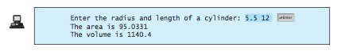

1. (Converting feet into meters) Write a program that reads a number in feet, converts it to meters, and displays the result. One foot is 0.305 meter. Here is a sample run:



1. (*Financial application: payroll*) Write a program that reads the following infor- mation and prints a payroll statement:

Employee’s name (e.g., Smith)Number of hours worked in a week (e.g.,

10) Hourly pay rate (e.g., 6.75)Federal tax withholding rate (e.g., 20%) State tax withholding rate (e.g., 9%)

Write this program in two versions: (a) Use dialog boxes to obtain input and dis- play output; (b) Use console input and output. A sample run of the console input and output is shown below:

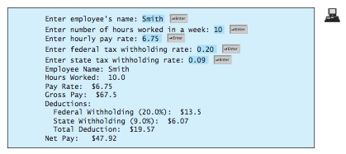

1. *(Health application: computing BMI*) Body Mass Index (BMI) is a measure of health on weight. It can be calculated by taking your weight in kilograms and dividing by the square of your height in meters. Write a program that prompts the user to enter a weight in pounds and height in inches and display the BMI. Note that one pound is **0.45359237** kilograms and one inch is **0.0254** meters. Here is a sample run:

