1. 创建远程用户

GRANT ALL PRIVILEGES ON \*.\* TO ‘zjt’@’110.64.86.13’ IDENTIFIED BY ‘zjt010526’ WITH GRANT OPTION;

1. 刷新权限

flush privileges;

1. 修改配置文件

sudo vim /etc/mysql/mysql.conf.d/mysqld.cnf +43

注释掉 bind-address = 127.0.0.1

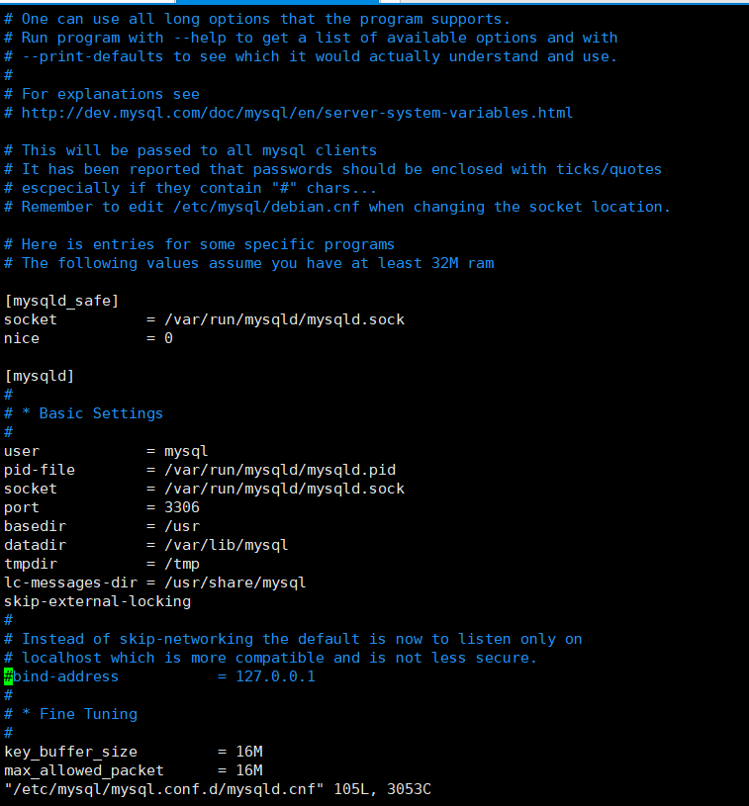

1. 打开3306端口

sudo ufw allow 3306

1. 重启MySQL

sudo service mysql restart

1. 测试

mysql -h 119.29.189.254 -P 3306 -u zjt -p

1. 待定