**Software Engineering Track**

Capstone #1 Project Proposal

Pokemon API Website

1. What goal will your website be designed to achieve?

My website lets users compile a list of cards they own and see the value of their total collection. It makes it easy for users to keep track of values of cards they are interested in for purchase. Helps people in the hobby have the information they need all in one place.

It will be similar to sites like TCG player and apps like Collectr.

1. What kind of demographic are you expecting?

My demographic will mostly be males from ages 10 to 40. The site will be used by primarily North American population therefore I will only be showing English Pokémon Cards.

1. What kind of data do you plan on using?

I will be using the api from <https://docs.pokemontcg.io/>.

1. Schema:

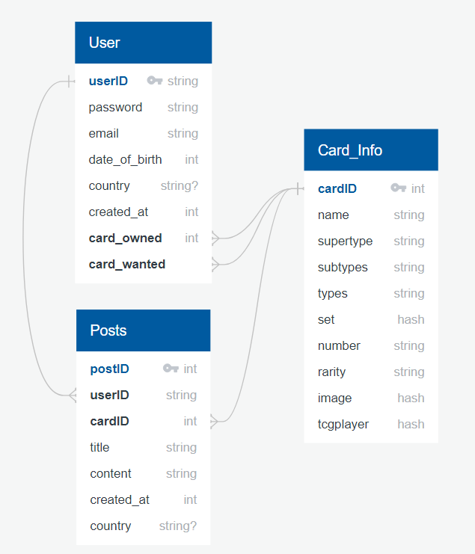

Potential issues with API: too many pull requests and fees associated with it; out of date info; lack of info from cards people aren’t as interested in; older sets won’t have enough information; when user is searching for a card, I won’t be able to provide the search query they are looking for.

Any sensitive information: only password and potentially email and date of birth

Functionality: user will be able to log in and add cards to their lists of owned cards and wanted cards. They will be able to make posts on cards they are interested in selling or buying. They are able to check latest card prices and purchase them through TCG player website.

User Flow:

1. Firstly, user will be shown the index/home page. User will be able to search for cards without logging in
2. User will be able to register for an account
3. User will be able to log in to view their account information
4. When logged in, when searching for cards, they will have the option to add card either into their collection or wanted list or both.
5. When logged in, users are also able to make posts on “forum” offering cards for sale or wanted card ads.
6. Users are able to send email to another user through their posts to sell/buy cards almost like Craigslist.