SHAO TANG

Problem 1

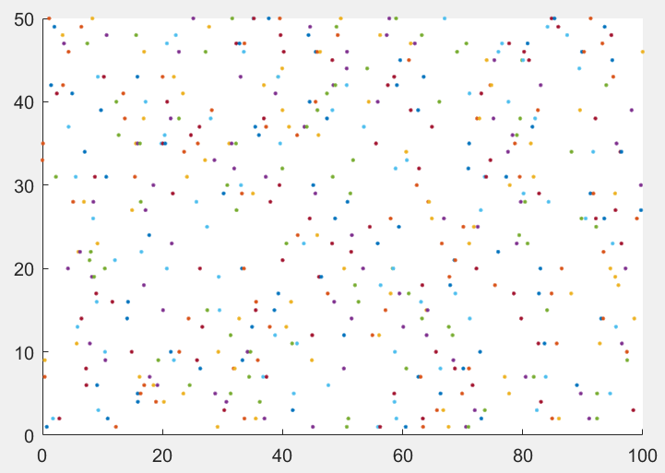

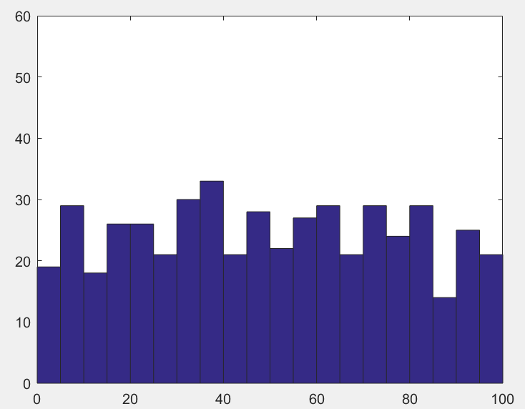

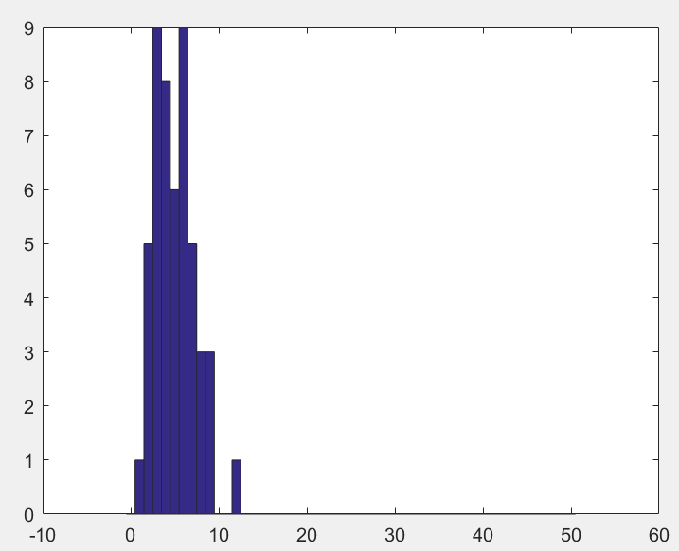

K-S test: h = 0, p = 0.0787.

The sample does follow a Poisson distribution.

clear all;close all;

rng(12345)

lambda = 0.1;

T=100;

M=50;

for i=1:M

x1 = exprnd(1/lambda, 2*lambda*T,50);

y1(:,i)= cumsum(x1(:,i));

y=y1(:,i);

PP{i} = y(y<T);

hold on,

figure (1);

plot(PP{i}',i,'.');

end;

figure(2);

HPP = [];

for i = 1:M

HPP = [HPP PP{i}'];

end

hist(HPP,2.5:5:97.5);

ylim([0 60]);

figure (3);

for i=1:M

r(i) = sum(PP{i}>10 & PP{i}<60);

end;

hist(r, 0:50);

%check whether sample follows Poisson distribution(KS test)

mu = mean(r);

x = 0:50;

test_cdf = poisscdf(x, mu);

[h,p] = kstest(r, [x' test_cdf'])

Problem 2

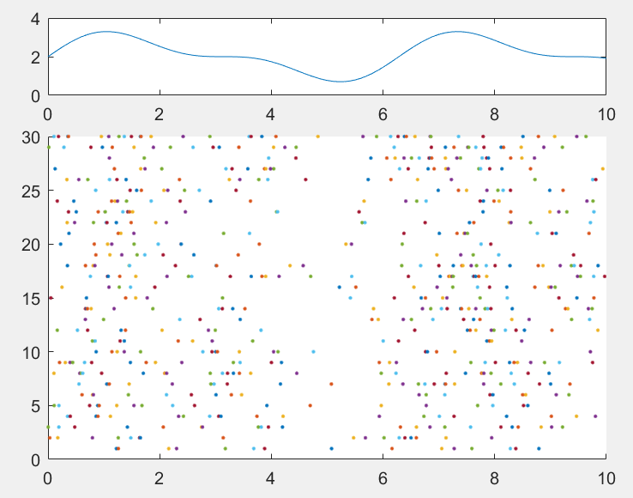

clear all; close all;

T = 10;

M = 30;

t = 0:0.1:T;

lambda = 2 + sin(t) + sin(2.*t)./2;

% display rate function

subplot(4,1,1);

plot(t, lambda);

%Integration of lambda(t)

F = inline('5/4 + 2*s - cos(s) - cos(2*s)/4');

%Derivative of F

DF = inline('2 + sin(s) + sin(2*s)/2');

for i=1:M

k(i) = poissrnd(1*F(T));

x = rand(1,k(i))*F(T);

npp{i} = sort(x);

%Newton-Raphson algorithm to estimate F^(-1)

for j = 1:length(npp{i})

x = T/2; % initial position

ind = 0;

while ind < 100

ind = ind+1;

x_new = x - (F(x)-npp{i}(j))/DF(x);

d = abs(x_new-x);

if d<1e-3;

break;

end

x = x_new;

end

ipp{i}(j) = x;

end;

end;

for i = 1:30

subplot(4,1,2:4)

hold on;

plot(ipp{i},i,'.');

end;