3/a

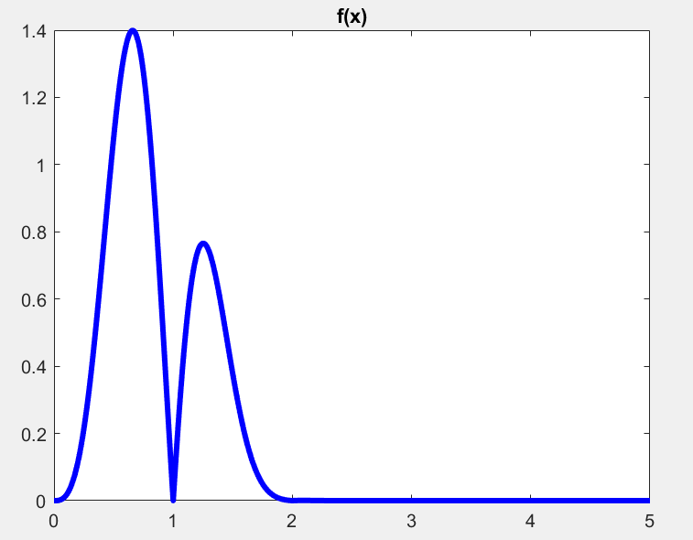

3/b

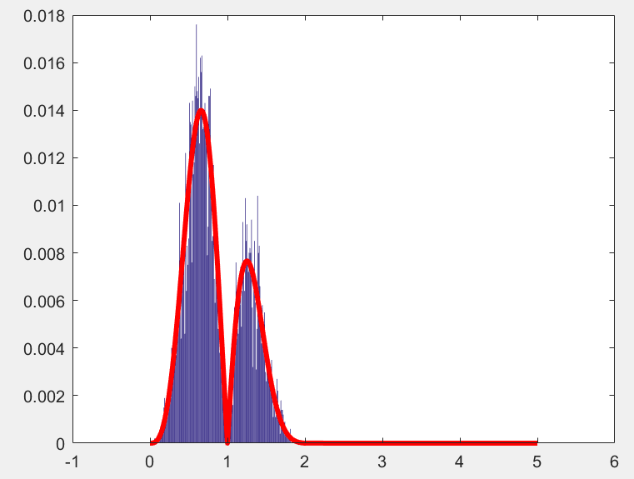

3/c

exp_x =

0.8595

var_x =

0.1418

clear all, close all;

f0 = inline('(x.^2).*abs(sin(pi.*x.^1)).*exp(-x.^3)','x')

c=quad(f0,0,5);

f=inline('(x.^2).*abs(sin(pi.*x.^1)).*exp(-x.^3)/d','x','d');

figure(1); % plot the density function f(x)

t=0:0.01:5;

N=length(t);

plot(t,f(t,c),'b','linewidth',3);

title('f(x)');

K=10000;

x=zeros(1,K);

x(1)=0.5; %initial

for k = 2:K

y = exprnd(1);

rho = min((f(y,c)*exp(-x(k-1)))/(f(x(k-1),c)*exp(-y)),1);

U = rand;

x(k) = y*(U < rho)+ x(k-1)*(U > rho);

exp_x(k) = mean(x);

var_x(k) = var(x);

end

exp_x = mean(x);

var_x = var(x);

h=histc(x,t)/K;

figure(2);

bar(t,h);

hold on;

plot(t,f(t,c)/sum(f(t,c)),'r','linewidth',3);