SHAO TANG

clear all; close all;

alpha = 1.0;

T = 1;

% T = 0.1;

% T = 0.01;

%T = 0.001;

s = alpha\*sqrt(T);

samples = 10;

n = 10/T;

for k = 1:20

for i=1:n

z(i)=(2\*floor(2\*rand)-1)\*s;

end

x= cumsum(z);

x=[0 x];

t=0:T:10;

stairs(t,x);

hold on;

axis([0 10 -10 10]);

xlabel('t');

ylabel('sample path of Xt');

end

T=1

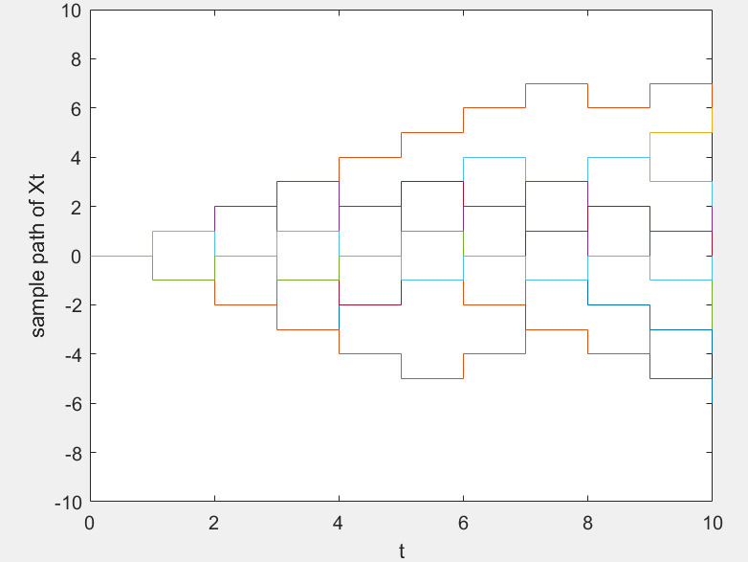

T=0.1

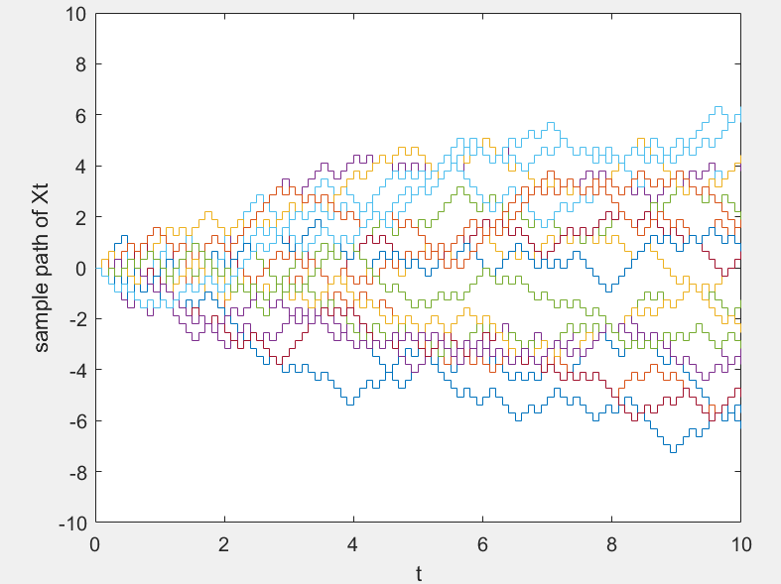

T=0.01

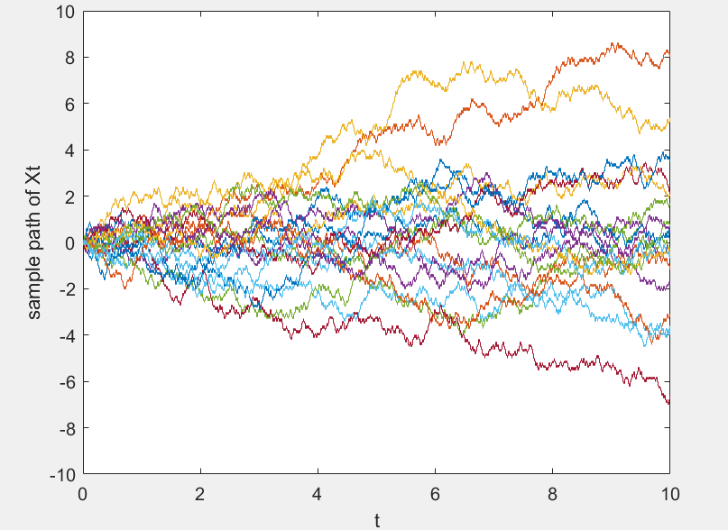

T=0.001

