SHAO TANG

Problem 1

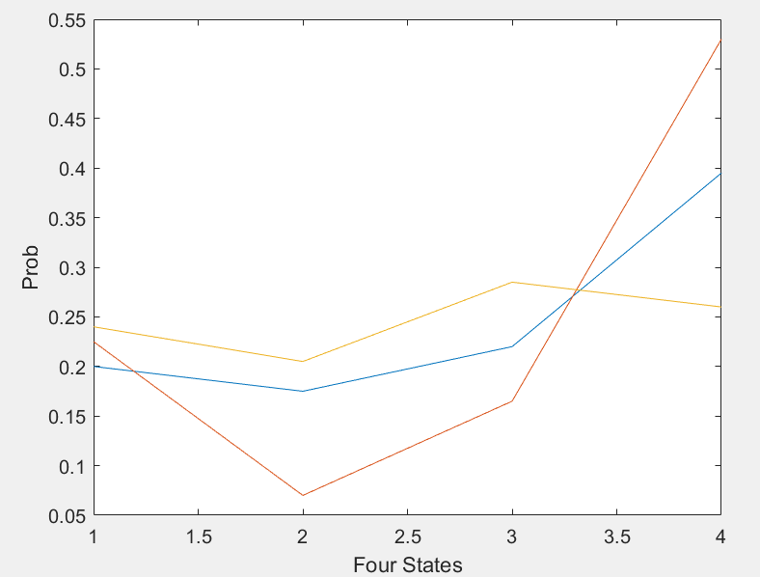

clear all;

K=200; % 200 time steps

M=3; % 3 samples

N=4; % 4 states

transition=[0.2 0.2 0.5 0.1;0.2 0.3 0.4 0.1;0.4 0.2 0.3 0.1;0.1 0.0 0.0 0.9];

rand('seed',1000);

for j=1:M

i=randsample(1:4,1);

for k=2:K-1

x(k+1,j)= randsample(1:4,1,true,transition(i,:));

i=x(k+1,j);

end

j=j+1;

end

for m=1:M

freq(:,m)=histc(x(:,m),1:N);

end

y=freq./200;

figure (1);

plot(y);

xlabel('Four States');

ylabel('Prob');

Problem 2

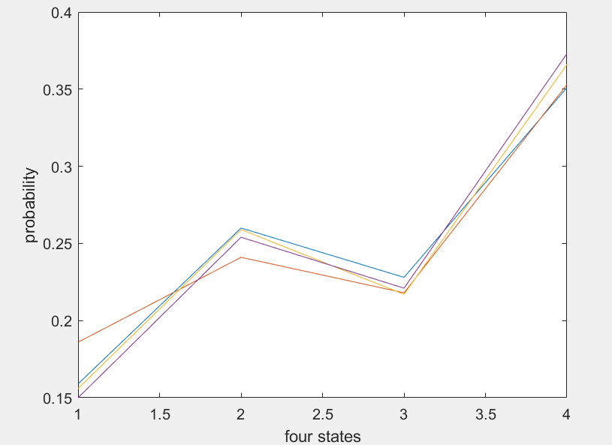

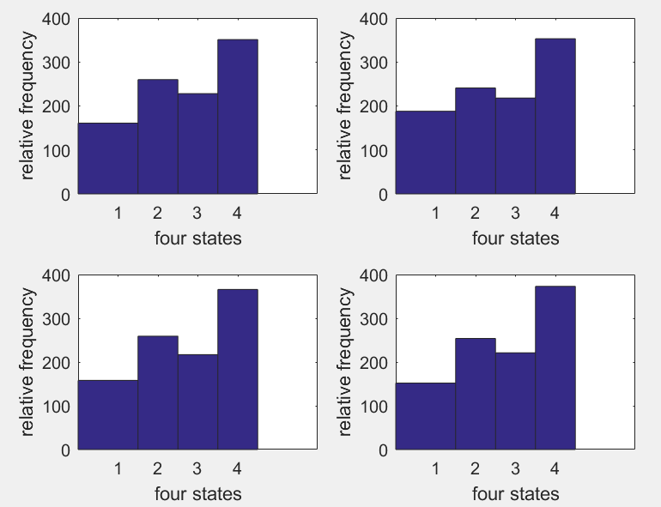

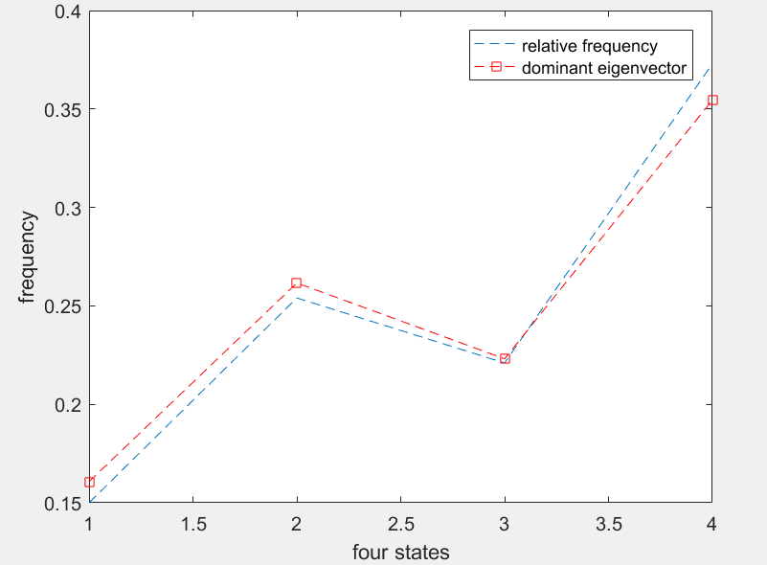

clear all, close all;

K=1000; % 1000 time steps

M=4; % 4 samples

N=4; % 4 states

pi=[0.2 0.2 0.1 0.5;0.1 0.3 0.4 0.2;0.3 0.2 0.3 0.2;0.1 0.3 0.1 0.5];

rand('seed',101);

for j=1:M

i=randsample(1:4,1);

for k=2:K-1

x(k+1,j)= randsample(1:4,1,true,pi(i,:));

i=x(k+1,j);

end

j=j+1;

end

% Part a

figure (2);

for m=1:M

freq(:,m)=histc(x(:,m),1:N);

end

y=freq./1000;

plot(y);

xlabel('four states');

ylabel('probability');

% Plot the relative frequencies for four states

figure (3);

for m=1:M

subplot(2,2,m);

hist(x(:,m),1:N);

xlabel('four states');

ylabel('relative frequency');

end

% Part b

% produce eigenvalues (D) and eigenvectors (V) of matrix PI

[V,D]=eig(pi');

ind=find(abs(diag(D)-1)<1e-6);

for k=1:length(ind)

% rde is the rescaled dominant eigenvector

rde(:,k)=V(:,ind(k))/sum(V(:,ind(k)));

end

% Compare the estimated relative frequency with rde

figure(4);

% plot the relative frequency

plot(y(:,M),'--');

xlabel('four states');

ylabel('probability');

hold on;

% plot the dominant eigenvector of pi

plot(rde,'--rs');

legend('relative frequency','dominant eigenvector');

xlabel('four states');

ylabel('frequency');

Problem 3

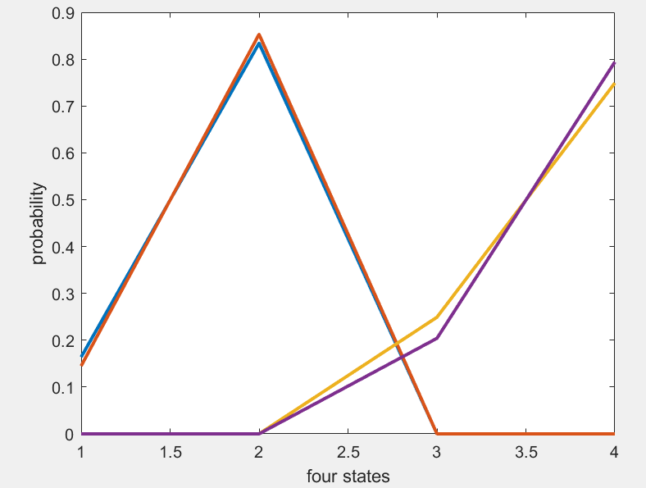

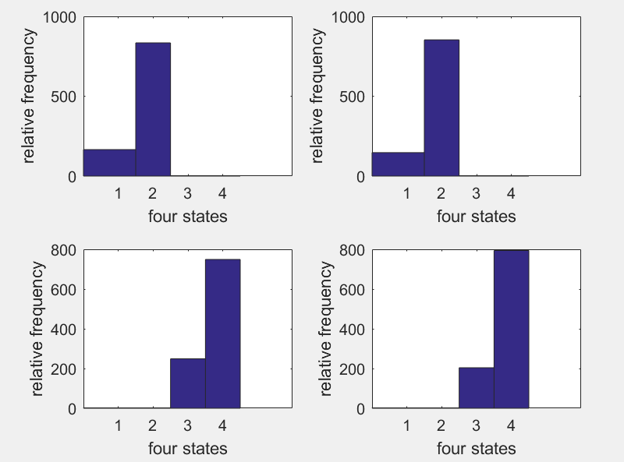

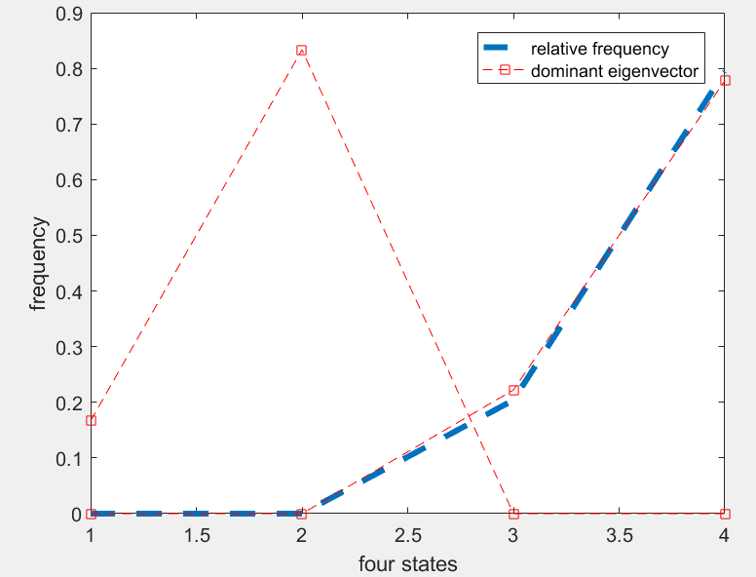

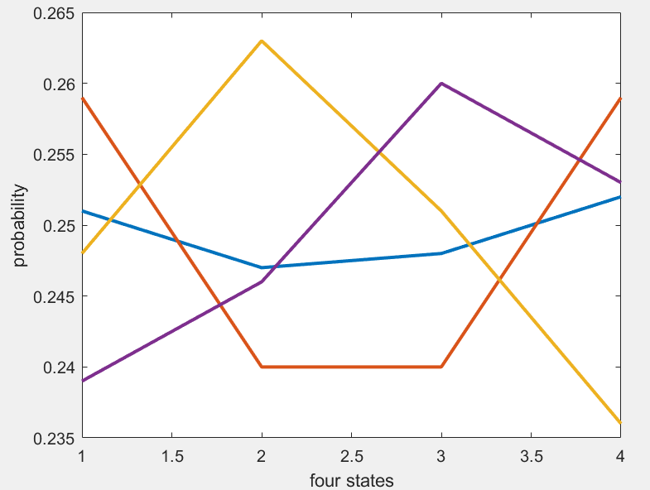

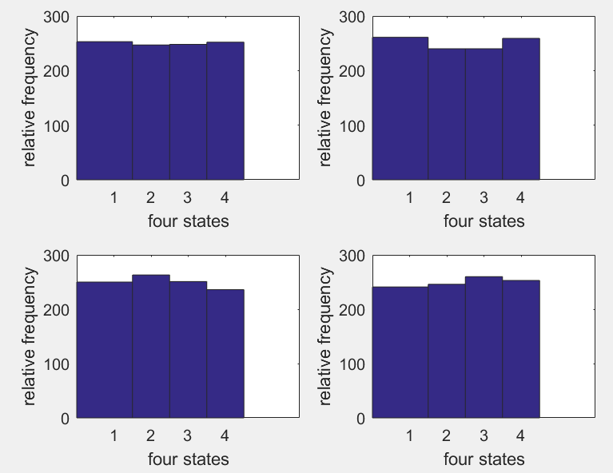

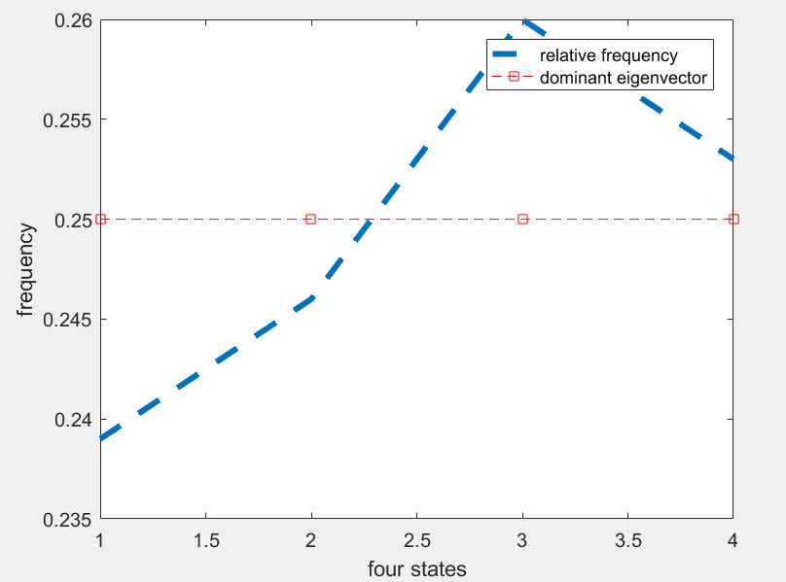

clear all, close all;

K=1000;

M=4;

N=4;

pi=[0.5 0.5 0.0 0.0;0.1 0.9 0.0 0.0;0.0 0.0 0.3 0.7;0.0 0.0 0.2 0.8];

%pi=[0.0 0.5 0.0 0.5;0.5 0.0 0.5 0.0;0.0 0.5 0.0 0.5;0.5 0.0 0.5 0.0];

rand('seed',0);

for j=1:M

i=j;

% randsample(1:4,1);

for k=2:K-1

x(k+1,j)= randsample(1:4,1,true,pi(i,:));

i=x(k+1,j);

end

j=j+1;

end

figure (5);

for m=1:M

freq(:,m)=histc(x(:,m),1:N);

end

y=freq./1000;

plot(y,'LineWidth',2);

xlabel('four states');

ylabel('probability');

figure (6);

for m=1:M

subplot(2,2,m);

hist(x(:,m),1:N);

xlabel('four states');

ylabel('relative frequency');

end

% produce eigenvalues (D) and eigenvectors (V) of matrix pi

[V,D]=eig(pi');

ind=find(abs(diag(D)-1)<1e-6);

for k=1:length(ind)

% rde is the rescaled dominant eigenvector

rde(:,k)=V(:,ind(k))/sum(V(:,ind(k)));

end

% plot the relative freency

figure (7);

plot(y(:,M),'--','LineWidth',3);

xlabel('four states');

ylabel('probability');

hold on;

% plot the dominant eigenvector of pi

plot(rde,'--rs');

legend('relative frequency','dominant eigenvector');

xlabel('four states');

ylabel('frequency');