1/b

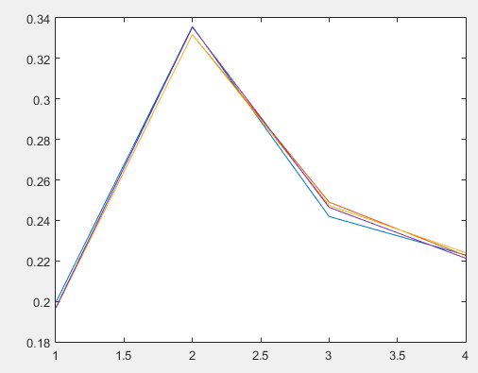

clear all;

K=50000;

M=4;

N=4;

pi= [0.1 0.3 0.4 0.2;0.2 0.4 0.0 0.4;0.0 0.3 0.5 0.2;0.5 0.3 0.2 0.0];

rand('seed',101);

for j=1:M

i=randsample(1:4,1);

for k=2:K-1

x(k+1,j)= randsample(1:4,1,true,pi(i,:));

i=x(k+1,j);

end

j=j+1;

end

for m=1:M

freq(:,m)=histc(x(:,m),1:N);

end

y=freq./K;

plot(y);

% produce eigenvalues (D) and eigenvectors (V) of matrix PI

[V,D]=eig(pi');

ind=find(abs(diag(D)-1)<1e-6);

for k=1:length(ind)

% nv is the rescaled dominant eigenvector

nv(:,k)=V(:,ind(k))/sum(V(:,ind(k)));

end

f=[2.0 1.0 2.5 -1.0];

right = dot(f,nv);

x(1)=ceil(4\*rand);

for i=1:K

[m,n]= sort(pi(x(i),:));

sign=0;

j=1;

u=rand;

while sign==0;

if u<sum(m(1:j));

x(i+1)=n(j);

sign=1;

else

j=j+1;

end

end

end

for i=1:K

left(i)=sum(f(x(i)));

end

avgleft=sum(left)/K;