Traffic Simulation Analysis Report

Objective 1: Scalability Assessment
This section evaluates how the intersection performs under increasing traffic demand. The line chart shows the relationship between total traffic volume and the resulting average queue length for different simulation scenarios.
Interpretation:
- A stable and efficient signal plan should show a gradual increase in queue length as traffic volume rises.
- Sharp spikes or nonlinear increases typically indicate that the signal timing is no longer sufficient.
- Comparing curves allows us to identify which scenarios scale best under heavier congestion.
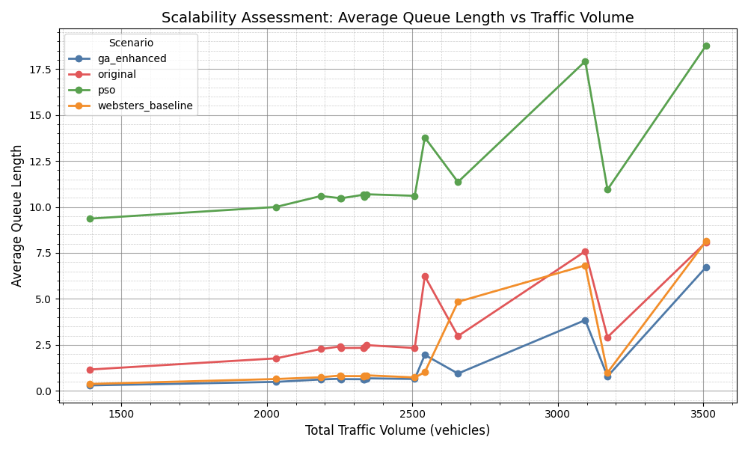
scalability_summary_line

Objective 2: Traffic Flow Efficiency
This section compares traffic signal plans across key operational metrics:
- Average Delay Time (s)
- Average Waiting Time (s)
- Average Number of Stops
- Average Travel Time (s)
Interpretation:
- Lower values across all metrics generally indicate smoother traffic flow.
- A signal plan with low delay but high stops may be overly restrictive.
- A plan with lower travel time but higher waiting time may prioritize certain movements.
- These charts help identify which signal plan provides the best overall efficiency.
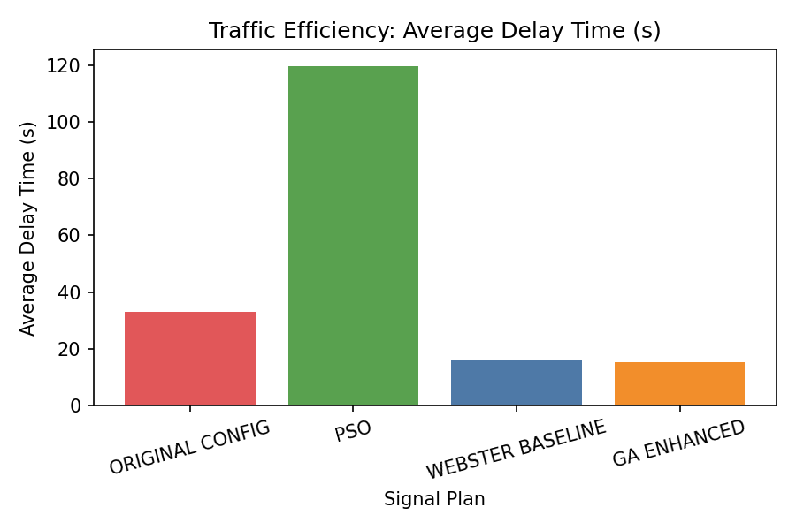
avg_delay_timeLoss_bar
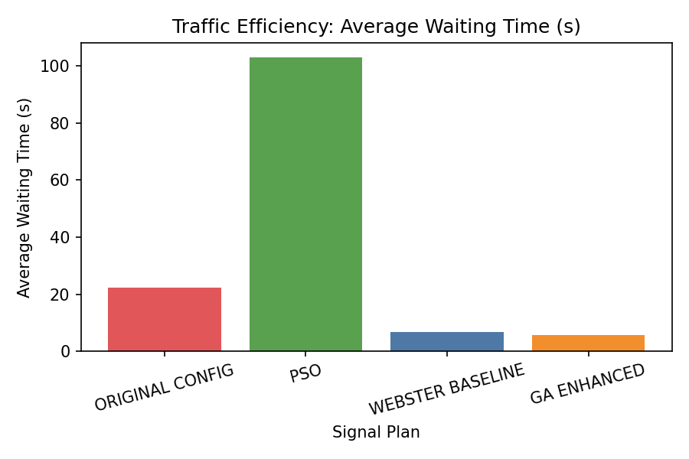
avg_waiting_time_bar
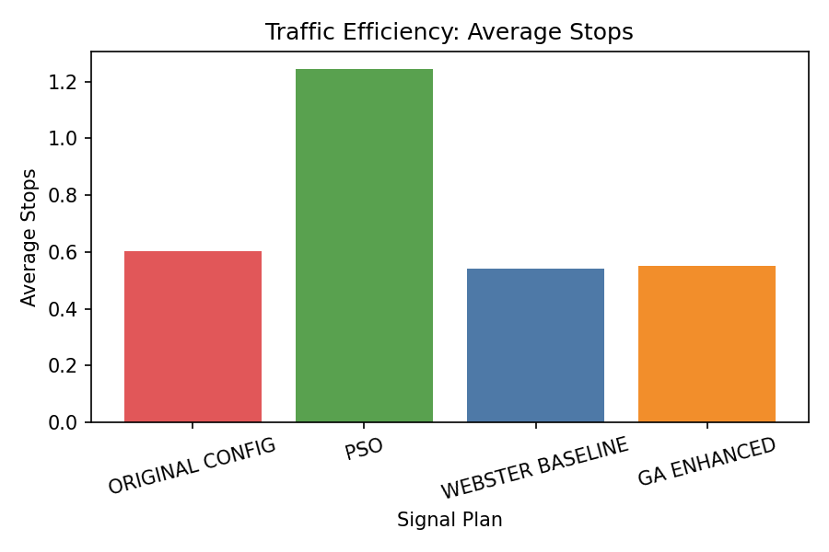
avg_stops_bar
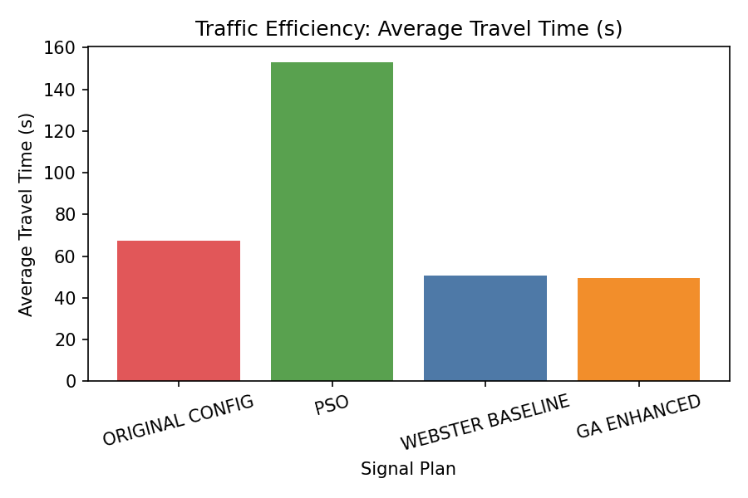
avg_duration_bar

Objective 3: Signal Plan Phase Allocation
This section visualizes the complete signal cycle structure for each plan. Each bar represents the full cycle length, showing the distribution of green, amber, and all-red intervals.
Interpretation:
- Longer green times correspond to heavier or prioritized movements.
- Excessively long red phases may cause unnecessary delay.
- Balanced phase allocation typically improves throughput and reduces queue buildup.
- By comparing cycles across plans, we can determine which timing strategy is most efficient.
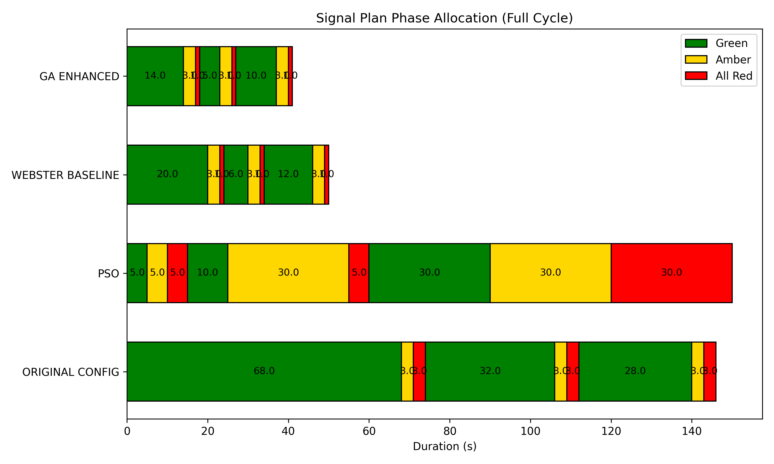
signal_plans_summary_horizontal

