**Materials Informatics – Fall 2017**

**Computer Project 2 – Solutions**

**Due on: Oct 24 2017 11:59pm**

Jianfeng Song

UIN:426009910

[Jsong26@tamu.edu](mailto:Jsong26@tamu.edu)

Assignment 1

1. The picture below is when σ=1

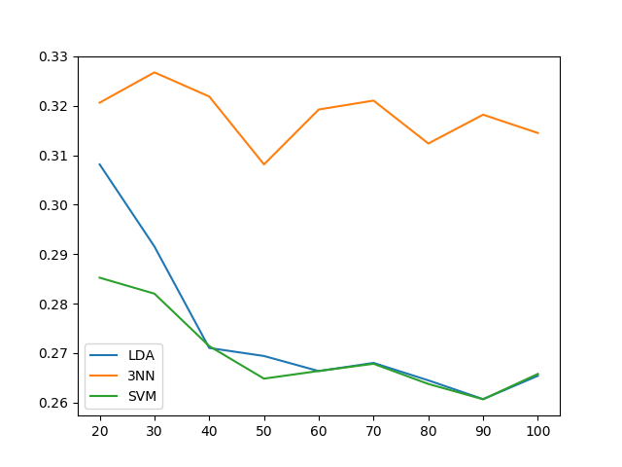

The picture below is when σ=2

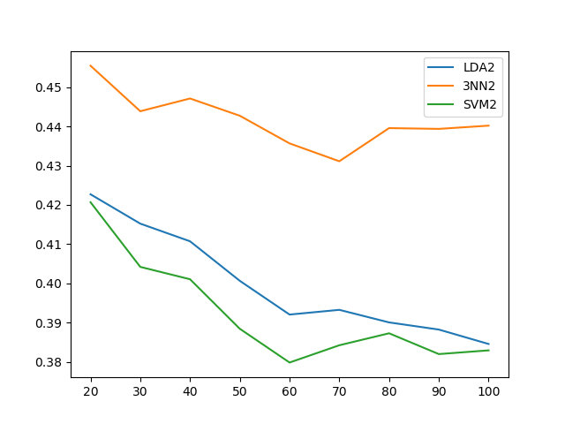

From two pictures above, we can find that SVM is better than LDA, and 3NN is the worst one this result does not depend on the value of σ. When σ is getting large, the corresponding classification error is also increase. When the number of training set increase, the corresponding classification error get decreased

b).

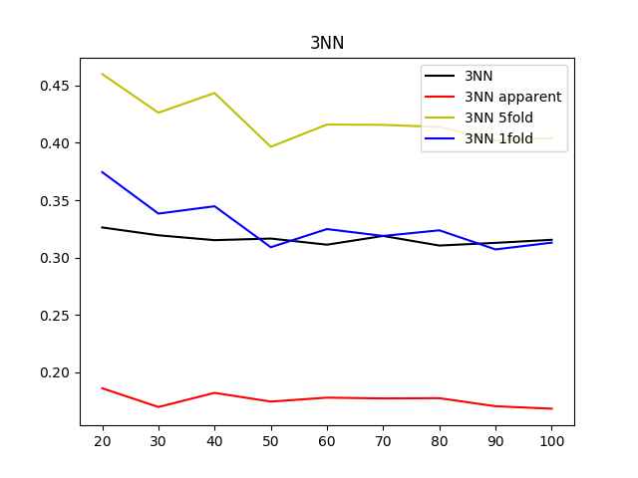

This is 3NN classifier with σ=1

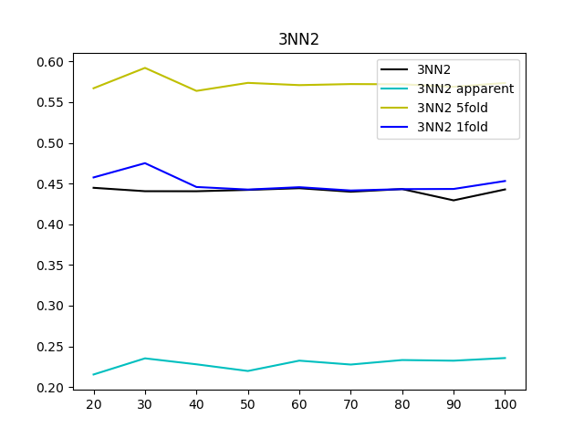

This is 3NN classifier with σ=2

From the pictures above, we can find that the test set error is much close to Leave_one_out error estimates for 3NN with both σ=2 and σ=1. So for 3NN I will choose leave-one-out error estimator.

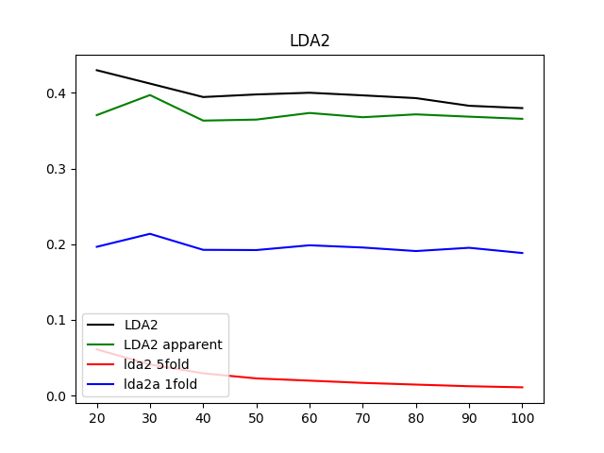

The picture above is LDA classifier with σ=2

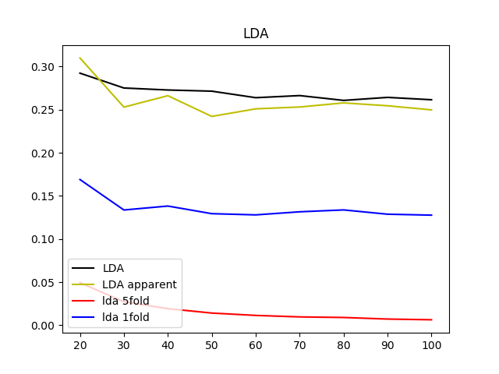

The picture above is LDA classifier with σ=1

From tow above pictures we can find that the test set error is much close to apparent error error estimates for LDA with σ=1 and σ=2. So for LDA I will choose apparent error estimator.

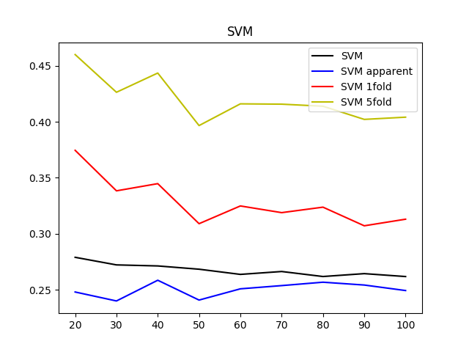

The picture above is SVM with σ=1

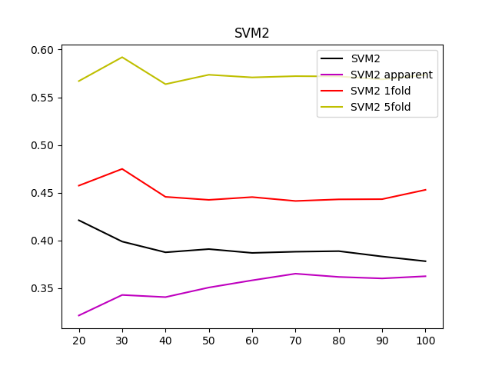

The picture above is SVM with σ=2

From tow above pictures we can find that the test set error is much close to apparent error error estimates for SVM with σ=1 and σ=2. So for SVM I will choose apparent error estimator.

Assignment 2

|  |  |  |
| --- | --- | --- |
| Ehaustive Search LDA | error estimate | test-set estimate |
| Fe | 0.12 | 0.1428 |
| C,Fe | 0.04 | 0.1224 |
| C,Ni,Fe | 0.04 | 0.0612 |
| C,N,Fe,Mn | 0.04 | 0.1122 |
| N,Ni,Fe,Si,Cr | 0 | 0.1632 |
|  |  |  |
| Ehaustive Search 3NN | error estimate | test-set estimate |
| Mn | 0.04 | 0.2551 |
| C,Mn | 0.04 | 0.2346 |
| C,N,Mn | 0.04 | 0.2346 |
| C,N,Ni,Fe | 0.04 | 0.0612 |
| C,N,Ni,Fe,Mn | 0.04 | 0.0612 |
|  |  |  |
| Sequential Forward Search LDA | error estimate | test-set estimate |
| Fe | 0.12 | 0.1428 |
| Fe,C | 0.04 | 0.1224 |
| Fe,C,Ni | 0.04 | 0.0612 |
| Fe,C,Ni,Mn | 0.04 | 0.0612 |
| Fe,C,Ni,Mn,N | 0.04 | 0.0918 |
|  |  |  |
| Sequential Forward Search 3NN | error estimate | test-set estimate |
| Mn | 0.04 | 0.2551 |
| Mn,C | 0.04 | 0.2346 |
| Mn,C,N | 0.04 | 0.2346 |
| Mn,C,N,Si | 0.04 | 0.2244 |
| Mn,C,N,Si,Ni | 0.04 | 0.0918 |
|  |  |  |

**How do you compare the results against each other and against the results obtained with the simple filter feature selection used in Project 1?**

Compare with solution in project 1, I can find that two best individual p values (Ni, Fe) do not form the best apparent error estimator (C, Fe). And from the result, we can find that the variables picked up by Ehaustive Search have minimum true error for both LDA and 3NN, but it will take much longer to finish the computing. On the other hand, if we do not need low test error, sequential forward search can always be a good choice.

**How do you compare the error estimators and feature selection methods used based on the variable sets found and the estimates of the true error?**

For LDA, I will use Sequential Forward Search to find my error estimator, the minimum true error appears when we have only three variables(Fe,C,Ni). Since the Sequential Forward Search method use less energy than Ehaustive Search, so I will use it for LDA.

For 3NN, I will use Ehaustive Search to find my error estimator, if we need to have small true error, but this method will cast more energy. If we do not need very high accuracy Sequential Forward Search will be my first choice.

**How do you think the results might change if there were more training points available?**

If we have more training points, the true error from our error estimator will be more unbiased this will fit both exhaustive search and sequential forward search, and it will make exhaustive search much longer.

Code

Assignment 1

a).

#!/usr/bin/env python3

# -*- coding: utf-8 -*-

"""

Created on Fri Oct 20 12:13:35 2017

@author: jianfengsong

"""

import numpy as np

import matplotlib.pyplot as plt

import scipy.stats as ns

import math

from scipy.linalg import det

from numpy.linalg import inv

from sklearn.neighbors import NearestNeighbors

from sklearn.neighbors import KNeighborsClassifier

from sklearn import svm

p0=np.array([[1,0.2],

[0.2,1]])

p1=np.array([[1,0.2],

[0.2,1]])

pro_p0=1/2

pro_p1=1/2

u0=np.array([0,0])

u1=np.array([1,1])

LDA_error_set=list()

N3N_error_set=list()

LDA_err_set=list()

sample_sizes=np.arange(20,101,10)

large_number=1000

total_train_set=[]

total_test_set=[]

class function:

def firsttime(samplesize):

x1=np.random.multivariate_normal(u1,p1,int(samplesize/2))

x0=np.random.multivariate_normal(u0,p0,int(samplesize/2))

return x1,x0

def secondtime(samplesize):

x1=np.random.multivariate_normal(u1,4*p1,int(samplesize/2))

x0=np.random.multivariate_normal(u0,4*p0,int(samplesize/2))

return x1,x0

def LDA_error(samplesize,x1,x0):#x1 is the trainning set with mean 1, p is coveriance matrix given in the question, u0 is true mean[0,0]

sumx1=0

sumx0=0

for a in x1:

sumx1=a+sumx1

for b in x0:

sumx0=b+sumx0

mean1=sumx1/samplesize*2

mean0=sumx0/samplesize*2

cov=(1/(samplesize-2))*(np.matrix((x1-mean1)).T*np.matrix((x1-mean1))+np.matrix((x0-mean0)).T*np.matrix((x0-mean0)))

an=np.matrix(inv(cov))*np.matrix((mean1-mean0)).T

bn=(-1/2)*np.matrix((mean1-mean0))*np.matrix(inv(cov))*np.matrix(mean1+mean0).T

varx0=(np.dot(an.T,u0)+bn)/np.sqrt(np.dot(np.dot(an.T,cov),an))

varx1=(np.dot(an.T,u1)+bn)/np.sqrt(np.dot(np.dot(an.T,cov),an))

LDA_err=1/2*(ns.norm.cdf(varx0)+ns.norm.cdf(-varx1))

return LDA_err,an,bn,cov

def Cla_error_LDA(an,bn,test1,test0):

clas_x1_y=-bn/an[1]-an[0]*test1[:,0]/an[1]

clas_x0_y=-bn/an[1]-an[0]*test0[:,0]/an[1]

error_time=0

for t in range(200):

if test1[t,1] < clas_x1_y[0,t]:

error_time=error_time+1

if test0[t,1] > clas_x0_y[0,t]:

error_time=error_time+1

return error_time/400

def data (x1_train,x0_train,test1,test0):

train=list()

tar=list()

test=list()

for a in range(len(x1_train)):

train.append(x1_train[a])

for a in range(len(x0_train)):

train.append(x0_train[a])

for a in range(len(test1)):

test.append(test1[a])

for a in range(len(test0)):

test.append(test0[a])

for a in range(int(sample_size/2)):

tar.append(1)

for a in range(int(sample_size/2)):

tar.append(0)

return train,test,tar

def determind(data_set):

number_of_wrong=0

for a in range(0,int(len(data_set)/2)):

if data_set[a]<1:

number_of_wrong+=1

for a in range(int(len(data_set)/2),len(data_set)):

if data_set[a]>0:

number_of_wrong+=1

error_rate=number_of_wrong/len(data_set)

return error_rate

#main function##########################################################################

for z in range(2):

error_perc_set=list()

nn3_error_set=list()

svm_error_set=list()

for sample_size in sample_sizes:

LDA_errs=0

error_percs=0

nn3error=0

nn3errors=0

svmerror=0

svmerrors=0

for a in range(0,100):

nn3mis=0

svmmis=0

if z==0:

x1_train,x0_train=function.firsttime(sample_size)

test1,test0=function.firsttime(400)

if z==1:

x1_train,x0_train=function.secondtime(sample_size)

test1,test0=function.secondtime(400)

#LDA

LDA_err_1,an,bn,cov=function.LDA_error(sample_size,x1_train,x0_train)

error_perc=function.Cla_error_LDA(an,bn,test1,test0)

LDA_errs+=LDA_err_1[0][0]

error_percs+=error_perc

#3NN

train,test,tar=function.data(x1_train,x0_train,test1,test0)

nn3=KNeighborsClassifier(n_neighbors=3)

nn3.fit(train,tar)

nn3_clas=nn3.predict(test)

nn3error=function.determind(nn3_clas)

nn3errors+=nn3error

#SVM

svm_cla=svm.LinearSVC()

svm_cla.fit(train,tar)

svm_cla_set=svm_cla.predict(test)

svmerror=function.determind(svm_cla_set)

svmerrors+=svmerror

#error set

svm_error=svmerrors/100

svm_error_set.append(svm_error)

nn3_error=nn3errors/100

nn3_error_set.append(nn3_error)

error_perc=error_percs/100

error_perc_set.append(error_perc)

if z==0:

plt.figure(1)

plt.plot(sample_sizes,error_perc_set,label='LDA')

plt.legend()

plt.figure(1)

plt.plot(sample_sizes,nn3_error_set,label='3NN')

plt.legend()

plt.figure(1)

plt.plot(sample_sizes,svm_error_set,label='SVM')

plt.legend()

if z==1:

plt.figure(2)

plt.plot(sample_sizes,error_perc_set,label='LDA2')

plt.legend()

plt.figure(2)

plt.plot(sample_sizes,nn3_error_set,label='3NN2')

plt.legend()

plt.figure(2)

plt.plot(sample_sizes,svm_error_set,label='SVM2')

plt.legend()

plt.show()

b).

#!/usr/bin/env python3

# -*- coding: utf-8 -*-

"""

Created on Fri Oct 20 12:13:35 2017

@author: jianfengsong

"""

import numpy as np

import matplotlib.pyplot as plt

from numpy.linalg import inv

from sklearn.neighbors import KNeighborsClassifier

from sklearn import svm

import scipy.stats as ns

from sklearn.model_selection import KFold

from sklearn.model_selection import LeaveOneOut

p0=np.array([[1,0.2],

[0.2,1]])

p1=np.array([[1,0.2],

[0.2,1]])

pro_p0=1/2

pro_p1=1/2

u0=np.array([0,0])

u1=np.array([1,1])

LDA_error_set=list()

N3N_error_set=list()

LDA_err_set=list()

sample_sizes=np.arange(20,101,10)

large_number=1000

total_train_set=[]

total_test_set=[]

class function:

def firsttime(samplesize):

x1=np.random.multivariate_normal(u1,p1,int(samplesize/2))

x0=np.random.multivariate_normal(u0,p0,int(samplesize/2))

return x1,x0

def secondtime(samplesize):

x1=np.random.multivariate_normal(u1,4*p1,int(samplesize/2))

x0=np.random.multivariate_normal(u0,4*p0,int(samplesize/2))

return x1,x0

def LDA_error(samplesize,x1,x0):#x1 is the trainning set with mean 1, p is coveriance matrix given in the question, u0 is true mean[0,0]

sumx1=0

sumx0=0

for a in x1:

sumx1=a+sumx1

for b in x0:

sumx0=b+sumx0

mean1=sumx1/samplesize*2

mean0=sumx0/samplesize*2

cov=(1/(samplesize-2))*(np.matrix((x1-mean1)).T*np.matrix((x1-mean1))+np.matrix((x0-mean0)).T*np.matrix((x0-mean0)))

an=np.matrix(inv(cov))*np.matrix((mean1-mean0)).T

bn=(-1/2)*np.matrix((mean1-mean0))*np.matrix(inv(cov))*np.matrix(mean1+mean0).T

varx0=(np.dot(an.T,u0)+bn)/np.sqrt(np.dot(np.dot(an.T,cov),an))

varx1=(np.dot(an.T,u1)+bn)/np.sqrt(np.dot(np.dot(an.T,cov),an))

LDA_err=1/2*(ns.norm.cdf(varx0)+ns.norm.cdf(-varx1))

return LDA_err,an,bn,cov

def Cla_error_LDA(an,bn,test1,test0):

if len(test1)!=0:

clas_x1_y=-bn/an[1]-an[0]*test1[:,0]/an[1]

if len(test0)!=0:

clas_x0_y=-bn/an[1]-an[0]*test0[:,0]/an[1]

error_time=0

for t in range(len(test1)):

if len(test1)!=0:

if test1[t,1] < clas_x1_y[0,t]:

error_time=error_time+1

if len(test0)!=0:

if test0[t,1] > clas_x0_y[0,t]:

error_time=error_time+1

return error_time/(len(test1)+len(test0))

def data (x1_train,x0_train,test1,test0):

train=list()

tar=list()

test=list()

for a in range(len(x1_train)):

train.append(x1_train[a])

for a in range(len(x0_train)):

train.append(x0_train[a])

for a in range(len(test1)):

test.append(test1[a])

for a in range(len(test0)):

test.append(test0[a])

for a in range(int(sample_size/2)):

tar.append(1)

for a in range(int(sample_size/2)):

tar.append(0)

return train,test,tar

def determind(data_set):

number_of_wrong=0

for a in range(0,int(len(data_set)/2)):

if data_set[a]<1:

number_of_wrong+=1

for a in range(int(len(data_set)/2),len(data_set)):

if data_set[a]>0:

number_of_wrong+=1

error_rate=number_of_wrong/len(data_set)

return error_rate

def kfold_3nn(train1,tar1,num,sample_size):

train=np.asarray(train1)

tar=np.asarray(tar1)

numberofwrong=0

wrong_pro=0

time=0

if num!=1:

kf=KFold(n_splits=num)

kf.get_n_splits(train)

for train_index, test_index in kf.split(train):

time+=1

x_train, x_test = train[train_index], train[test_index]

y_train, y_test = tar[train_index], tar[test_index]

nn3=KNeighborsClassifier(n_neighbors=3)

nn3.fit(x_train,y_train)

nn3_clas=nn3.predict(x_test)

for a in range(len(nn3_clas)):

if nn3_clas[a] != y_test[a]:

numberofwrong+=1

wrong_pro=numberofwrong/(sample_size)

else:

loo = LeaveOneOut()

loo.get_n_splits(train)

for train_index, test_index in loo.split(train):

x_train, x_test = train[train_index], train[test_index]

y_train, y_test = tar[train_index], tar[test_index]

nn3=KNeighborsClassifier(n_neighbors=3)

nn3.fit(x_train,y_train)

nn3_clas=nn3.predict(x_test)

for a in range(len(nn3_clas)):

if nn3_clas[a] != y_test[a]:

numberofwrong+=1

wrong_pro=numberofwrong/(sample_size)

return wrong_pro

def kfold_SVM(train1,tar1,n,sample_size):

train=np.asarray(train1)

tar=np.asarray(tar1)

numberofwrong=0

wrong_pro=0

if n!=1:

kf=KFold(n_splits=n)

kf.get_n_splits(train)

for train_index, test_index in kf.split(train):

x_train, x_test = train[train_index], train[test_index]

y_train, y_test = tar[train_index], tar[test_index]

svm_cla=svm.LinearSVC()

svm_cla.fit(x_train,y_train)

svm_cla_set=svm_cla.predict(x_test)

for a in range(len(svm_cla_set)):

if svm_cla_set[a]!=y_test[a]:

numberofwrong+=1

wrong_pro=numberofwrong/(sample_size)

else:

loo = LeaveOneOut()

loo.get_n_splits(train)

for train_index, test_index in loo.split(train):

x_train, x_test = train[train_index], train[test_index]

y_train, y_test = tar[train_index], tar[test_index]

svm_cla=svm.LinearSVC()

svm_cla.fit(x_train,y_train)

svm_cla_set=svm_cla.predict(x_test)

for a in range(len(svm_cla_set)):

if svm_cla_set[a]!=y_test[a]:

numberofwrong+=1

wrong_pro=numberofwrong/(sample_size)

return wrong_pro

def kfold_LDA(train1,tar1,num,sample_size):

train=np.asarray(train1)

tar=np.asarray(tar1)

numberofwrong=0

wrong_pro=0

if num!=1:

kf=KFold(n_splits=num)

kf.get_n_splits(train)

for train_index, test_index in kf.split(train):

x_train, x_test = train[train_index], train[test_index]

y_train, y_test = tar[train_index], tar[test_index]

x1train,x0train,x1test,x0test=function.kfold_LDA_data(train,tar,x_train,x_test,y_train,y_test)

LDA,an,bn,cov=function.LDA_error(sample_size,x1train,x0train)

numberofwrong+=function.Cla_error_LDA(an,bn,x1test,x0test)

wrong_pro=numberofwrong/sample_size

else:

loo = LeaveOneOut()

loo.get_n_splits(train)

for train_index, test_index in loo.split(train):

x_train, x_test = train[train_index], train[test_index]

y_train, y_test = tar[train_index], tar[test_index]

x1train,x0train,x1test,x0test=function.kfold_LDA_data(train,tar,x_train,x_test,y_train,y_test)

LDA,an,bn,cov=function.LDA_error(sample_size,x1train,x0train)

numberofwrong+=function.Cla_error_LDA(an,bn,x1test,x0test)

wrong_pro=numberofwrong/sample_size

return wrong_pro

def kfold_LDA_data(train,tar,x_train,x_test,y_train,y_test):

x1train=[]

x1test=[]

x0train=[]

x0test=[]

for a in range(len(y_train)):

if y_train[a]==1:

x1train.append(x_train[a])

else:

x0train.append(x_train[a])

for a in range(len(y_test)):

if y_test[a]==1:

x1test.append(x_test[a])

else:

x0test.append(x_test[a])

x1train1=np.asarray(x1train)

x0train0=np.asarray(x0train)

x1test1=np.asarray(x1test)

x0test0=np.asarray(x0test)

return x1train1,x0train0,x1test1,x0test0

#main function##########################################################################

for z in range(2):

error_perc_set=list()

nn3_error_set=list()

nn3_5fold_error_set=list()

nn3_1fold_error_set=list()

svm_error_set=list()

svm_5fold_error_set=list()

svm_1fold_error_set=list()

lda_error_set=list()

lda_5fold_error_set=list()

lda_1fold_error_set=list()

for sample_size in sample_sizes:

LDA_errs=0

error_percs=0

nn3error=0

nn3errors=0

nn3_1fold=0

nn3_5fold=0

nn3_5fold_errors=0

nn3_1fold_errors=0

svmerror=0

svmerrors=0

svm_1fold=0

svm_5fold=0

svm_5fold_errors=0

svm_1fold_errors=0

lda_1fold=0

lda_5fold=0

lda_5fold_errors=0

lda_1fold_errors=0

for a in range(0,100):

nn3mis=0

svmmis=0

if z==0:

x1_train,x0_train=function.firsttime(sample_size)

test1,test0=function.firsttime(400)

if z==1:

x1_train,x0_train=function.secondtime(sample_size)

test1,test0=function.secondtime(400)

train,test,tar=function.data(x1_train,x0_train,test1,test0)

#LDA

LDA_err_1,an,bn,cov=function.LDA_error(sample_size,x1_train,x0_train)

error_perc=function.Cla_error_LDA(an,bn,x1_train,x0_train)

LDA_errs+=LDA_err_1[0][0]

error_percs+=error_perc

lda_1fold=function.kfold_LDA(train,tar,1,sample_size)

lda_1fold_errors+=lda_1fold

lda_5fold=function.kfold_LDA(train,tar,5,sample_size)

lda_5fold_errors+=lda_5fold

#3NN

nn3=KNeighborsClassifier(n_neighbors=3)

nn3.fit(train,tar)

nn3_clas=nn3.predict(train)

nn3error=function.determind(nn3_clas)

nn3errors+=nn3error

nn3_1fold=function.kfold_3nn(train,tar,1,sample_size)

nn3_1fold_errors+=nn3_1fold

nn3_5fold=function.kfold_3nn(train,tar,5,sample_size)

nn3_5fold_errors+=nn3_5fold

#SVM

svm_cla=svm.LinearSVC()

svm_cla.fit(train,tar)

svm_cla_set=svm_cla.predict(train)

svmerror=function.determind(svm_cla_set)

svmerrors+=svmerror

svm_1fold=function.kfold_SVM(train,tar,1,sample_size)

svm_1fold_errors+=nn3_1fold

svm_5fold=function.kfold_SVM(train,tar,5,sample_size)

svm_5fold_errors+=nn3_5fold

# print(a*sample_size)

#error set

svm_error=svmerrors/100

svm_error_set.append(svm_error)

svm_1fold_error=svm_1fold_errors/100

svm_1fold_error_set.append(svm_1fold_error)

svm_5fold_error=svm_5fold_errors/100

svm_5fold_error_set.append(svm_5fold_error)

nn3_error=nn3errors/100

nn3_error_set.append(nn3_error)

nn3_1fold_error=nn3_1fold_errors/100

nn3_1fold_error_set.append(nn3_1fold_error)

nn3_5fold_error=nn3_5fold_errors/100

nn3_5fold_error_set.append(nn3_5fold_error)

error_perc=error_percs/100

error_perc_set.append(error_perc)

lda_1fold_error=lda_1fold_errors/100

lda_1fold_error_set.append(lda_1fold_error)

lda_5fold_error=lda_5fold_errors/100

lda_5fold_error_set.append(lda_5fold_error)

if z==0:

plt.figure(1)

plt.title('LDA')

# plt.subplot(311)

plt.plot(sample_sizes,error_perc_set,'y',label='LDA apparent')

plt.plot(sample_sizes,lda_5fold_error_set,'r',label='lda 5fold')

plt.plot(sample_sizes,lda_1fold_error_set,'b',label='lda 1fold')

plt.legend()

plt.figure(2)

plt.title('3NN')

# plt.subplot(312)

plt.plot(sample_sizes,nn3_error_set,label='3NN apparent')

plt.plot(sample_sizes,nn3_5fold_error_set,label='3NN 5fold')

plt.plot(sample_sizes,nn3_1fold_error_set,label='3NN 1fold')

plt.legend()

plt.figure(3)

plt.title('SVM')

# plt.subplot(313)

plt.plot(sample_sizes,svm_error_set,label='SVM apparent')

plt.plot(sample_sizes,svm_1fold_error_set,label='SVM 1fold')

plt.plot(sample_sizes,svm_5fold_error_set,label='SVM 5fold')

plt.legend()

if z==1:

plt.figure(1)

plt.title('LDA2')

# plt.subplot(311)

plt.plot(sample_sizes,error_perc_set,label='LDA2 apparent')

plt.plot(sample_sizes,lda_5fold_error_set,label='lda2 5fold')

plt.plot(sample_sizes,lda_1fold_error_set,label='lda2a 1fold')

plt.legend()

plt.figure(2)

plt.title('3NN2')

# plt.subplot(312)

plt.plot(sample_sizes,nn3_error_set,label='3NN2 apparent')

plt.plot(sample_sizes,nn3_5fold_error_set,label='3NN2 5fold')

plt.plot(sample_sizes,nn3_1fold_error_set,label='3NN2 1fold')

plt.legend()

plt.figure(3)

plt.title('SVM2')

# plt.subplot(313)

plt.plot(sample_sizes,svm_error_set,label='SVM2 apparent')

plt.plot(sample_sizes,svm_1fold_error_set,label='SVM2 1fold')

plt.plot(sample_sizes,svm_5fold_error_set,label='SVM2 5fold')

plt.legend()

plt.show()

Assignment 2

#!/usr/bin/env python3

# -*- coding: utf-8 -*-

"""

Created on Sat Oct 21 16:00:46 2017

@author: jianfengsong

"""

import xlrd as xl

import numpy as np

from sklearn.neighbors import KNeighborsClassifier

from sklearn.discriminant_analysis import LinearDiscriminantAnalysis as LDA

from itertools import combinations

class fun():

def excel_data(n):

train_rows_value=list()

train_cols_value=list()

excel=xl.open_workbook(n)

data_table=excel.sheet_by_index(0)

rows=data_table.nrows

cols=data_table.ncols

for a in range(rows):

train_rows_value.append(data_table.row_values(a))

train_row=np.asarray(train_rows_value)

return train_row

########################################################

def data (x1_train,x0_train,test1,test0):

train=list()

tar=list()

test=list()

test_tar=list()

for a in range(len(x1_train)):

train.append(x1_train[a])

for a in range(len(x0_train)):

train.append(x0_train[a])

for a in range(int(len(x1_train))):

tar.append(1)

for a in range(int(len(x0_train))):

tar.append(0)

for a in range(len(test1)):

test.append(test1[a])

for a in range(len(test0)):

test.append(test0[a])

for a in range(int(len(test1))):

test_tar.append(1)

for a in range(int(len(test0))):

test_tar.append(0)

return train,test,tar,test_tar

##################################################

def two_class(data_set):

data_high=list()

data_low=list()

data_label=list()

for a in range(len(data_set)):

b=len(data_set[a])-1

if data_set[a][b] == 'High':

data_set[a][b]=1

data_high.append(data_set[a])

if data_set[a][b]=='Low':

data_set[a][b]=0

data_low.append(data_set[a])

if data_set[a][b] =='SFE':

data_label.append(data_set[a])

data_high1=np.asarray(data_high)

data_low1=np.asarray(data_low)

return data_high1,data_low1,data_label

##################################################

def feature_sample(data_set):

feature_data=[[] for i in range(len(data_set[1])-1)]

for b in range(len(data_set[1])-1):

for a in range(len(data_set)):

feature_data[b].append(float(data_set[a][b]))

feature_data1=np.asarray(feature_data)

return feature_data1

#########################################################

def get_feature_sample(): #find the feature matrix, for example j[0]is all value of 'C'

train_row=fun.excel_data('SFE_Train_Data.xlsx')

test_row=fun.excel_data('SFE_Test_Data.xlsx')

train_high,train_low,train_label=fun.two_class(train_row)

test_high,test_low,test_label=fun.two_class(test_row)

train_set,test_set,train_label,test_label=fun.data(train_high,train_low,test_high,test_low)

feature_col=fun.feature_sample(train_set)

test_col=fun.feature_sample(test_set)

# feature_col1=np.asarray(feature_col.append(train_label))

return feature_col,train_label,test_col,test_label

##########################################################

def ehaustive(num):

x=fun.get_feature_sample()

selected_feature_set=list()

selected_feature1=combinations(range(7),num)

selected_feature=np.asarray(list(selected_feature1))

return selected_feature

############################################################

def determind(data_set,tar):

number_of_wrong=0

for a in range(len(tar)):

if data_set[a]!=tar[a]:

number_of_wrong+=1

else:

number_of_wrong+=0

error_rate=number_of_wrong/len(data_set)

return error_rate

###########################################################

def NN3_err(train,tar,test,test_tar,n):

nn3=KNeighborsClassifier(n_neighbors=3)

nn3.fit(train,tar)

if n==1:

nn3_clas=nn3.predict(train)

nn3error=fun.determind(nn3_clas,tar)

if n==0:

nn3_clas=nn3.predict(test)

nn3error=fun.determind(nn3_clas,test_tar)

return nn3error

###############################################################

def LDA_error(train,tar,test,test_tar,n):

clf=LDA()

clf.fit(train,tar)

if n ==1:

LDA_cla=clf.predict(train)

error=fun.determind(LDA_cla,tar)

if n==0:

LDA_cla=clf.predict(test)

error=fun.determind(LDA_cla,test_tar)

return error

########################################################

############### MAIN() ########################################

feature_data,feature_label,test_set,test_label=fun.get_feature_sample()

min_ind_set, min_err_set,min_cla_err_set=list(),list(),list()

min3nn_ind_set, min3nn_err_set,min3nn_cla_err_set=list(),list(),list()

for a in range(1,6):

selected_feature=fun.ehaustive(a)

min_err=1

min3nn_err=1

for b in range(len(selected_feature)):

selected_feature_set1=list()

LDA_feature1set,LDA_feature0set,test1,test0=list(),list(),list(),list()

for c in range(len(selected_feature[b])):

indice=selected_feature[b][c]

selected_feature_set1.append(feature_data[indice])

selected_feature_set=np.asarray(selected_feature_set1)

LDA_feature_1,LDA_feature_0,test_1,test_0=list(),list(),list(),list()

for d in range(0,12): #with SFE high

LDA_feature_1.append(feature_data[indice][d])

# test_1.append(test_set[indice][d])

for e in range(12,len(feature_data[c])): #with SFE low

LDA_feature_0.append(feature_data[indice][e])

# test_0.append(test_set[indice][e])

for f in range(0,50):

test_1.append(test_set[indice][f])

for g in range(50,98):

test_0.append(test_set[indice][g])

LDA_feature1set.append(LDA_feature_1)

LDA_feature0set.append(LDA_feature_0)

test1.append(test_1)

test0.append(test_0)

#LDA APPARENT

LDA_feature1_set=(np.asarray(LDA_feature1set)).T #as my x1

LDA_feature0_set=(np.asarray(LDA_feature0set)).T #as my x0

test1set=(np.asarray(test1)).T

test0set=(np.asarray(test0)).T

train,test,tar,test_tar=fun.data(LDA_feature1_set,LDA_feature0_set,test1set,test0set)

#find min for LDA

LDA_err=fun.LDA_error(train,tar,test,test_tar,1)

LDA_cla_err=fun.LDA_error(train,tar,test,test_tar,0)

# print(LDA_cla_err)

nn3error=fun.NN3_err(train,tar,test,test_tar,1)

# print(nn3error,a)

nn3_cla_error=fun.NN3_err(train,tar,test,test_tar,0)

#LDA

if min_err>LDA_err:

min_err=LDA_err

min_ind=b

min_cla_err=LDA_cla_err

else:

min_err=min_err

min_ind=min_ind

# 3NN

if min3nn_err>nn3error:

min3nn_err=nn3error

min3nn_ind=b

min3nncla=nn3_cla_error

else:

min3nn_err=min3nn_err

min3nn_ind=min3nn_ind

min_err_set.append(min_err)#min LDA apparent error

min_ind_set.append(selected_feature[min_ind])#min LDA error index

min_cla_err_set.append(min_cla_err)# classification error

min3nn_err_set.append(min3nn_err)#min 3NN apparent error

min3nn_ind_set.append(selected_feature[min3nn_ind])#min 3nn error index

min3nn_cla_err_set.append(min3nncla)# classification error

############################################################################

# SFS for LDA

sfs_lda=list()

sfs_lda_ind=list()

sfs_ldatrain,sfs_ldatest=list(),list()

sfs_lda_app,sfs_lda_cla=list(),list()

sfs_lda_app.append(min_err_set[0])

sfs_lda_cla.append(min_cla_err_set[0])

for a in range(7):

sfs_lda.append(a)

sfs_lda.remove(min_ind_set[0][0])

sfs_lda_ind.append(min_ind_set[0][0])

for a in range (4):

sfs_ldatrain.append(feature_data[sfs_lda_ind[a]])

sfs_ldatest.append(test_set[sfs_lda_ind[a]])

sfs_min=1

for b in sfs_lda:

sfs_ldatrain.append(feature_data[b])

sfs_ldatest.append(test_set[b])

sfs_lda_train=(np.asarray(sfs_ldatrain)).T

sfs_lda_test=(np.asarray(sfs_ldatest)).T

sfs_lda_app_err=fun.LDA_error(sfs_lda_train,tar,sfs_lda_test,test_label,1)

sfs_lda_cla_err=fun.LDA_error(sfs_lda_train,tar,sfs_lda_test,test_label,0)

if sfs_min>sfs_lda_app_err:

sfs_min=sfs_lda_app_err

sfs_ind=b

min_cla_err=sfs_lda_cla_err

else:

sfs_min=sfs_min

sfs_ind=sfs_ind

sfs_ldatrain.pop(a+1)

sfs_ldatest.pop(a+1)

sfs_lda.remove(sfs_ind)

sfs_lda_app.append(sfs_min)

sfs_lda_cla.append(min_cla_err)

sfs_lda_ind.append(sfs_ind)

# SFS 3NN

sfs_3nn=list()

sfs_3nn_ind=list()

sfs_3nntrain,sfs_3nntest=list(),list()

sfs_3nn_app,sfs_3nn_cla=list(),list()

sfs_3nn_app.append(min3nn_err_set[0])

sfs_3nn_cla.append(min3nn_cla_err_set[0])

#sfs_3nn_app.append(3)

#sfs_3nn_cla.append(min3nn_cla_err_set[0])

for a in range(7):

sfs_3nn.append(a)

sfs_3nn.remove(min3nn_ind_set[0][0])

sfs_3nn_ind.append(min3nn_ind_set[0][0])

#sfs_3nn.remove(3)

#sfs_3nn_ind.append(3)

for d in range (4):

sfs_3nntrain.append(feature_data[sfs_3nn_ind[d]])

sfs_3nntest.append(test_set[sfs_3nn_ind[d]])

sfs3nn_min=1

for c in sfs_3nn:

sfs_3nntrain.append(feature_data[c])

sfs_3nntest.append(test_set[c])

sfs_3nn_train=(np.asarray(sfs_3nntrain)).T

sfs_3nn_test=(np.asarray(sfs_3nntest)).T

sfs_3nn_app_err=fun.NN3_err(sfs_3nn_train,tar,sfs_3nn_test,test_label,1)

sfs_3nn_cla_err=fun.NN3_err(sfs_3nn_train,tar,sfs_3nn_test,test_label,0)

if sfs3nn_min>sfs_3nn_app_err:

sfs3nn_min=sfs_3nn_app_err

sfs3nn_ind=c

min3nn_cla_err=sfs_3nn_cla_err

else:

sfs3nn_min=sfs3nn_min

sfs3nn_ind=sfs3nn_ind

sfs_3nntrain.pop(d+1)

sfs_3nntest.pop(d+1)

sfs_3nn.remove(sfs3nn_ind)

sfs_3nn_app.append(sfs3nn_min)

sfs_3nn_cla.append(min3nn_cla_err)

sfs_3nn_ind.append(sfs3nn_ind)