3.results

**Conclusion**

Based on the analysis of three sets of Granger causality test results, we found that only a few specific news topic categories show statistically significant causal relationships to stock prices across different lag periods (one day, two days, and three days). Most notably, negative entertainment news demonstrates significant causal effects (P-values below the 0.1 significance threshold) across all three lag periods, indicating that this type of news content has consistent and stable predictive power for stock prices, regardless of whether the impact is short-term (one day), medium-term (two days), or longer-term (three days).

As the lag period changes, the influence of other news types also exhibits time dependency: at a one-day lag, negative technology news and positive sports news significantly impact stock prices; at a two-day lag, positive technology news and positive health/fitness news begin to show significant influence; by the three-day lag period, neutral entertainment news, positive political news and neutral health/fitness news demonstrate significant predictive power.

This temporal evolution pattern reveals the time dynamics of different types of news affecting stock prices, suggesting that investors' reaction speeds vary for different news content. The persistent influence of negative entertainment news may reflect the market's continued sensitivity to this type of information, while other news types may require more time to be fully absorbed and reflected by the market. These findings provide important insights into the temporal relationship between information dissemination and market reaction, offering potential value for investment decisions and market predictions.

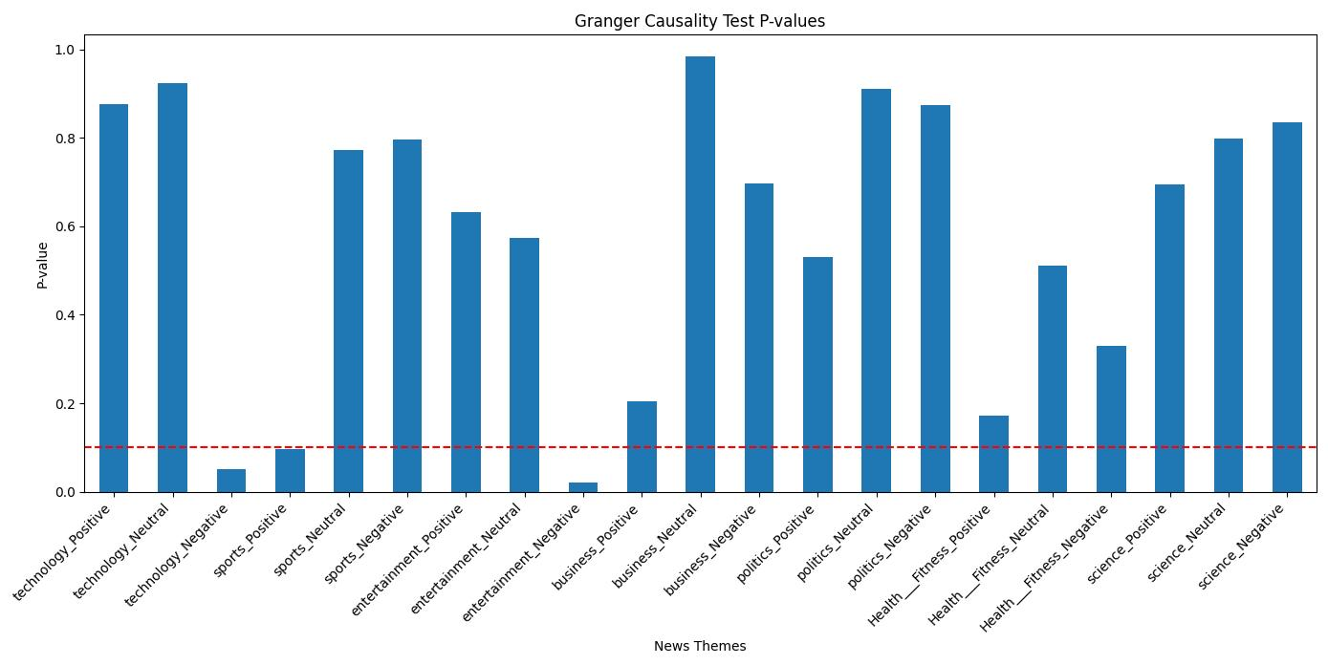

Figure 1

图表, 条形图

AI 生成的内容可能不正确。

Figure 2

图表, 条形图

AI 生成的内容可能不正确。

Figure 3

While the multi-lag analysis revealed distinct temporal patterns in news-stock price relationships—most notably the persistent influence of negative entertainment news across all lag periods—our subsequent dataset segmentation analysis further underscores the inherent complexity and conditional nature of these associations. By splitting the data into two independent subsets (Part 1 and Part 2), we observed significant heterogeneity in Granger causality results. For example, neutral/negative entertainment sentiment, which showed stable significance across all lag periods in the full dataset analysis, maintained its statistical significance only in Part 1. Conversely, business and political negative sentiment emerged as significant drivers in Part 2, suggesting that external contextual factors (e.g., market phases, policy shifts) may modulate the dominance of specific news themes over time. Notably, categories like political positive sentiment and health/fitness neutral sentiment exhibited significance in only one subset, implying their effects may be context-dependent rather than universally robust. These findings align with—and extend—the time-dependent patterns identified earlier: while some news types (e.g., negative entertainment) demonstrate remarkable temporal consistency, others exhibit instability not only across lag periods but also across data subsets, likely due to unobserved variables or sampling limitations. Methodologically, this dual-layered analysis—combining multi-lag and dataset-splitting approaches—highlights the necessity of integrating both temporal and contextual dimensions when modeling news-driven market behaviors. For investors, these results reinforce the importance of adaptive strategies that account for both the *persistence* of certain news effects (e.g., negative entertainment) and the *ephemeral* nature of others, which may dominate only under specific conditions or timeframes. Collectively, this study advances a nuanced framework for understanding how news sentiment interacts with financial markets—one that balances universal patterns with context-driven variability.