“Changes in the Distribution of Black and White Wealth Since the US Civil War”

Ellora Derenoncourt, Chi Hyun Kim, Moritz Kuhn, and Moritz Schularick

ReadMe last updated: September 11, 2023

This document describes the replication archive for the above paper. The archive contains the programs required to replicate the results in the paper. Datasets that can be shared in the archive are included. Instructions for how to download datasets that cannot be shared are also included. **Users should read this document in its entirety to successfully run the replication archive.** Questions regarding this archive may be directed to [ckim@uni-bonn.de](mailto:ckim@uni-bonn.de) and/or [ellora.derenoncourt@princeton.edu](mailto:ellora.derenoncourt@princeton.edu).

**Statement about Rights**

* ☐ I certify that the author(s) of the manuscript have legitimate access to and permission to use the data used in this manuscript.
* ☐ I certify that the author(s) of the manuscript have documented permission to redistribute/publish the data contained within this replication package. Appropriate permissions are documented in the LICENSE.txt file.

Contents:

1. COMPUTATIONAL REQUIREMENTS
2. DESCRIPTION OF SOURCES FOR DATA NOT INCLUDED IN THE ARCHIVE
3. DESCRIPTION OF SOURCES FOR DATA INCLUDED IN THE ARCHIVE (NO NEED TO DOWNLOAD)
4. BUILDING DATASETS FOR ANALYSIS & REPLICATING THE ANALYSIS



1. **Computational requirements**

Software Requirements: We conducted analysis using Stata/MP 17.0 and Matlab R2020a.

Computational Requirements: We run all code on a Princeton server (744 GB).

Time Requirements: Takes approximately 3 hours to run.

Package installation: Any STATA packages that might needed are installed by 0_MASTER.do. The Matlab package Statistics and Machine Learning Toolbox needs to be installed if not already in the version of Matlab the user is using.

1. **Description of sources for data not included in the archive**

**Replication Data for: “Wealth of Two Nations: The U.S. Racial Wealth Gap, 1860-2020”**

Availability: The replication archive for “Wealth of Two Nations: The U.S. Racial Wealth Gap, 1860-2020” (forthcoming, *Quarterly Journal of Economics*) is publicly accessible via <https://doi.org/10.7910/DVN/H6NXUH>. Construction of required datasets using this package requires web registration with ICPSR: <https://www.icpsr.umich.edu/web/pages/>.

Citation: Derenoncourt, Ellora; Kim, Chi Hyun; Kuhn, Moritz; Schularick, Moritz, 2023, "Replication Data for: 'Wealth of Two Nations: The U.S. Racial Wealth Gap, 1860-2020'", https://doi.org/10.7910/DVN/H6NXUH, Harvard Dataverse, V1

Users should download the above replication package into the same directory where they have stored jep_replication. Users should then follow the instructions in the readme file “ReadMe_DKKS_QJE_2024.pdf” included in jep_replication (also available as “ReadMe_DKKS.pdf” in qje_replication). This will build the datasets called by 2_main_figures_jep.do.

Among other datasets, the replication archive for “Wealth of Two Nations: The U.S. Racial Wealth Gap, 1860-2020” contains the SCF+ data originally constructed by:

Kuhn, Moritz, Moritz Schularick, and Ulrike I. Steins, "Income and wealth inequality in America, 1949–2016." Journal of Political Economy 128.9 (2020): 3469-3519.

We use the Derenoncourt, Kim, Kuhn, and Schularick (2023) version of the SCF+ data.

1. **Description of sources for data included in the archive (no need to download)**

**IPUMS USA**

Availability: Extracts permitted for replication purposes.

Access Modality: IPUMS Extract included with this package were obtained by first registering an account with IPUMS at usa.ipums.org. The dataset is comprised of 1% samples from years 1850-1880 and 1900-1950, and the following variables:

year serial cluster statefip urban gq ownershp mortgage perwt relate sex marst raced hispand bpld school educd empstat labforce occ1950 incwage realprop deducts

sample hhwt stateicp countyicp strata farm ownershpd pernum famsize related age race hispan bpl nativity educ lit empstatd occ ind incnonwg persprop occscore

Download the extract as a .dta file, and then place the extract into data\micro_census\raw folder of the replication directory and change its name to CensusData1850_1950Covariates.dta

Citation: Ruggles, Steven, Sarah Flood, Ronald Goeken, Josiah Grover, Erin Meyer, Jose Pacas, and Matthew Sobek, “IPUMS USA: Version 11.0 [dataset],” Minneapolis, Minnesota: IPUMS, 2021. <https://doi.org/10.18128/D010.V11.0> (accessed November 2021)

**PSZ**

Availability for 1913-2022: Publicly accessible via <https://gabriel-zucman.eu/usdina/>

Access Modality: To access the data, visit the link above and download [Tables II: distributional series](https://gabriel-zucman.eu/files/PSZ2022AppendixTablesII(Distrib).xlsx) (highlighted yellow in the screenshot below) for the February 2022 data.

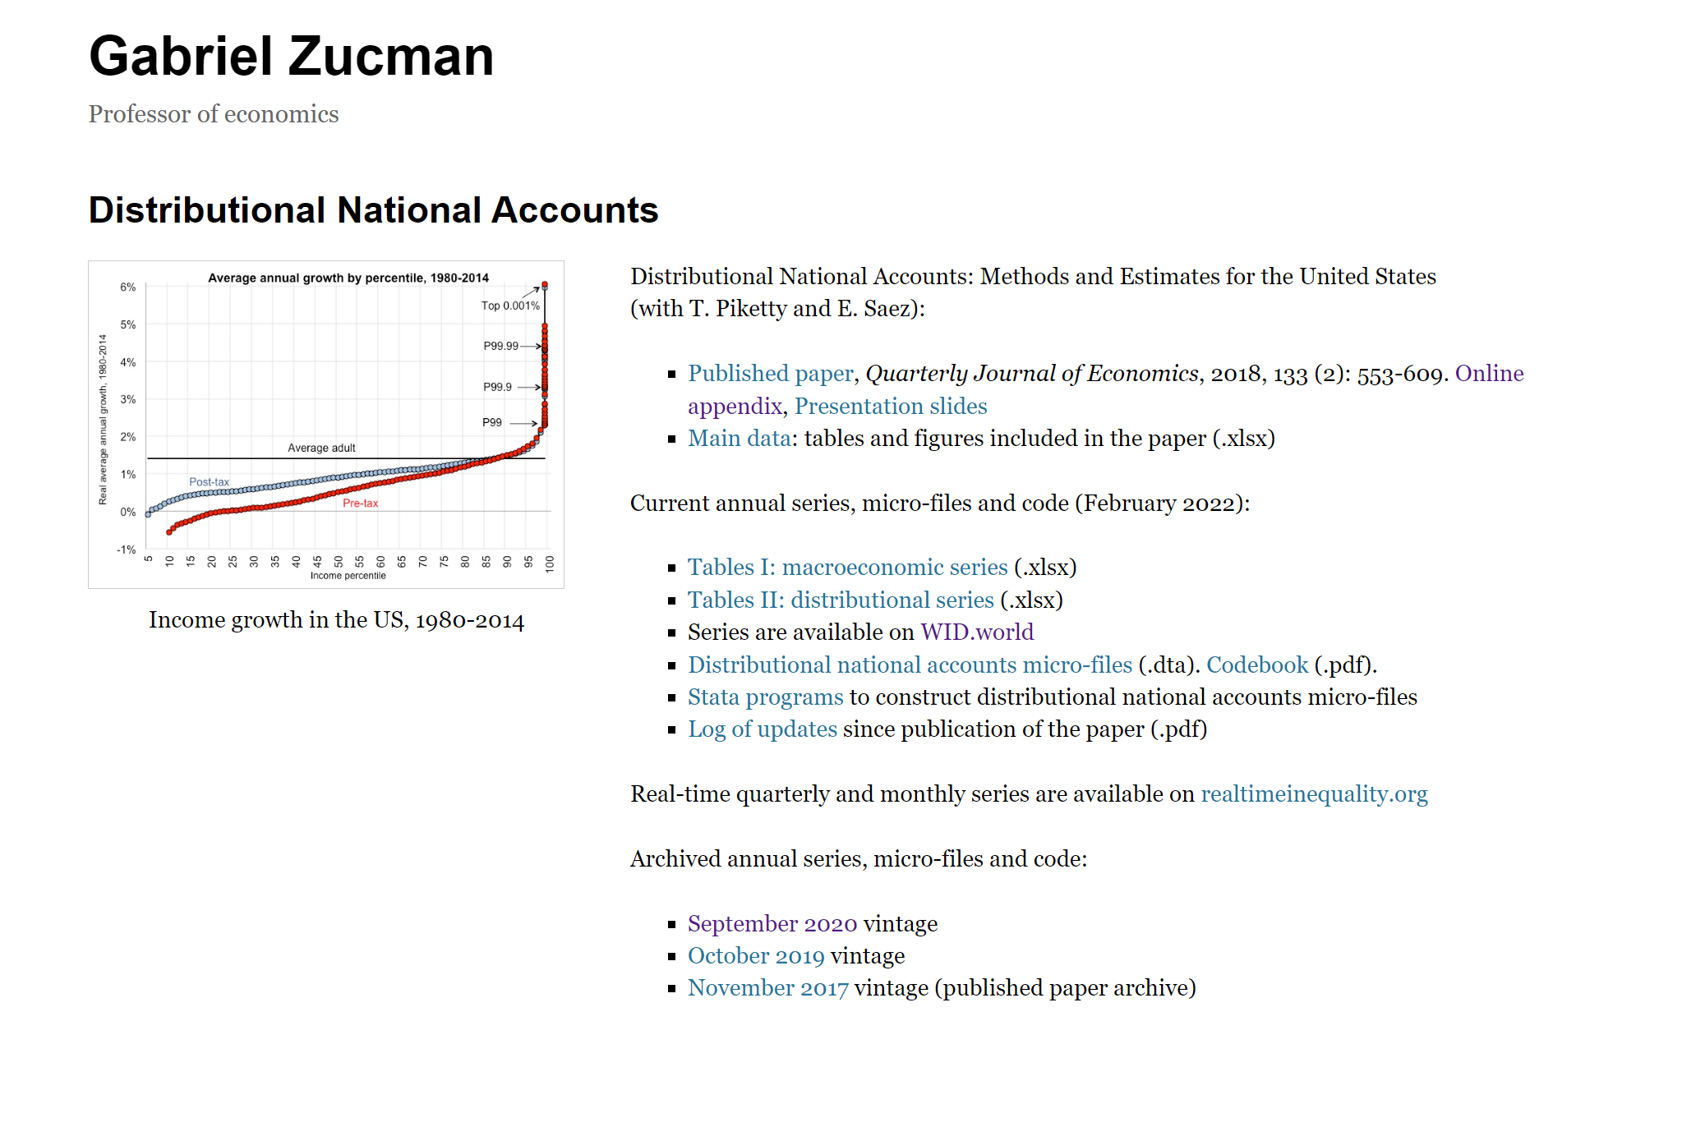



In the future, should the “Current annual series” data no longer correspond to Februrary 2022, replicators must instead click the February 2022 vintage link (an example for September 2022 is highlighted in red). This will download a .zip archive. Within it, replicators should download “PSZ2022AppendixTablesII(Distrib).xlsx” This dataset should be renamed to PSZ2022AppendixTables.xlsx and placed in data\psz.

Citation: Piketty, Thomas, Emmanuel Saez, and Gabriel Zucman. 2022. “Distributional National Accounts (Tables II: distributional series, 2022 vintage).” <https://gabriel-zucman.eu/files/PSZ2022AppendixTablesII(Distrib).xlsx> (accessed XXX)

**4. Building datasets for analysis and replicating the analysis**



1. **Building datasets for analysis and replicating the analysis**

To build datasets used for main analysis and to replicate the main results, first open code/0_MASTER.do in STATA and change the home directory path to the replication directory on your drive.

* 0_MASTER.do will run the following do-files in directory code/: 1a_generate_datasets_1860_1870.do, 1b_generate_datasets_regression.do, 1c_regression_poswealth_forward.do, 1d_regression_poswealth_backward.do, and 2_main_figures_tables_jep.do
* 1a_generate_datasets_1860_1870.do: This do-file builds final datasets using the 1860 and 1870 census.
* 1b_generate_datasets_regression.do: This do-file builds datasets that are used for the imputation analysis.
* 1c_regression_poswealth_forward.do: This do-file conducts the forward-looking imputation analysis to approximate personal wealth holdings of individuals based on their socio-economic characteristics (coefficients are based on 1860 and 1870 census data)
* 1d_regression_poswealth_backward.do: This do-file conducts the backward-looking imputation analysis to approximate personal wealth holdings of individuals based on their socio-economic characteristics (coefficients are based on the 1950 SCF data)
* 2_main_figures_tables.do: This do-file produces the main figures and tables of the paper.

1. **References**

Derenoncourt, Ellora; Kim, Chi Hyun; Kuhn, Moritz; Schularick, Moritz, 2023, "Replication Data for: 'Wealth of Two Nations: The U.S. Racial Wealth Gap, 1860-2020'", https://doi.org/10.7910/DVN/H6NXUH, Harvard Dataverse, V.1

Piketty, Thomas, Emmanuel Saez, and Gabriel Zucman, 2022, “Distributional National Accounts (Tables II: distributional series, 2022 vintage).” https://gabriel-zucman.eu/files/PSZ2022AppendixTablesII(Distrib).xlsx (December 2022).

Ruggles, Steven, Sarah Flood, Ronald Goeken, Josiah Grover, Erin Meyer, Jose Pacas, and Matthew Sobek, “IPUMS USA: Version 11.0 [dataset],” Minneapolis, Minnesota: IPUMS, 2021. <https://doi.org/10.18128/D010.V11.0> (accessed November 2021).