
Diagnostic Test Items Specification

Pi7

Revision v0.5

Sep. 11 ,2026
Accton Technology Corporation
No. 1, Creation Rd. III, Science-Based Industrial Park,
Hsinchu 300, Taiwan, R.O.C.
Copyright © 2026 Accton Technology Corporation. All rights reserved.
Contents
1 Introduction 4
1.1 Purpose 4
1.2 Scope 4
1.3 Software Requirements 4
1.4 Hardware Requirements 4
1.5 Reference Documents 4
2 Accton Diag Function Description 6
2.1 Commands for function test 7
2.1.1 DIAG VERSION 7
2.1.2 POWER MODE TEST 7
2.1.3 BATTERY MODE TEST 8
2.1.4 FUEL GAUGE TEST 8
2.1.5 LED TEST 8
2.1.6 WDT TEST 9
2.1.7 Writing to GPIO output pins 9
2.1.8 Reading GPIO pins 10
2.1.9 I2C SCAN TEST 10
2.1.10 I2C GET TEST 10
2.1.11 I2C SET TEST 11
2.1.12 I2C DUMP TEST 11
2.1.13 MFG TEST 11
2.1.14 MM TEST 12
2.1.15 MM SCAN TEST 12
2.1.16 MM SCAN STOP 13
2.1.17 BLE TEST 13
2.1.18 WiFi TEST 15
2.1.19 Check Version 16
2.1.20 MAC/SN/MODEL/HWVER WRITE 16
2.1.21 MAC/SN/MODEL/HWVER READ 17

Revision History
Revision | Date | Author | Description
0.1 | 2025/10/2 | Brian Lin | - Add Diag code CLI command
0.2 | 2026/01/21 | Brian Lin | - Set default country code to JP
0.3 | 2026/04/08 | Brian Lin | - Change MP2720A_OTP battery charger init value  - Support fuel gauge new chip : SY6410 on i2c0, i2c1
0.4 | 2026/08/27 | Lanqly Chou | - Add version check
0.5 | 2026/09/11 | Brian Lin | - Add MAC/SN/MODEL/HWVER read/write command

Introduction

Purpose
This document provides the functional specification for the Accton Diagnostic.
User can get information about what functions provided by Accton Diagnostic and it also how to use that to test the condition and stability of Pi7 hardware. Also describes the detail of the function test item and result for User to use.

Scope
The scope of this document is to present the complete functional test description of Pi7 products. The intended audience for this document includes the Hardware Engineering Design Team, Manufacture Automation Team, Development Team, Quality Assurance and the Technical Writing Team responsible for developing the user documentation.

Software Requirements
The software requirements for the diagnostic programs to bring up CPU Qualcomm_QCC748 , the software provide a minimal operation system and additional drivers and the diagnostic program. The message of the diagnostic program is provided via a host computer with hyper-terminal tool.

Hardware Requirements
The Hardware requirements for the diagnostic programs consist of the unit under test, a hyper-Terminal connect, USB type -C cable.

Reference Documents

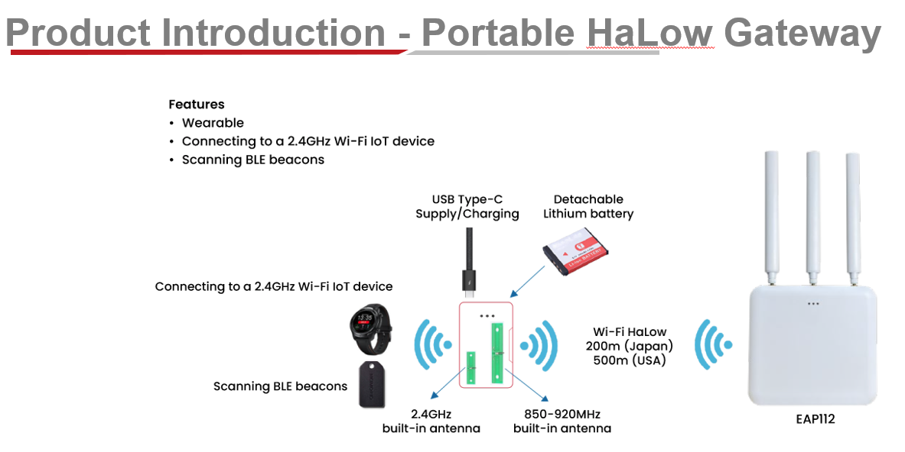
For more information, please see the following documentation:

- Portable IoT_Pi7 Series_product requirement document_20250625

Accton Diag Function Description

This section contains the full description on functions which provided by Accton Diag to the user. Each command is shown by a simple description, command syntax description and usage example.

Commands for function test
This section details the test commands that comprise the CPU, all memory devices and its peripheral test. Each utility can cover the hardware signal and quality. Those commands are only for RD engineer debug usage.

The user can easy to use and it favors to H/W functional performance test.
All the items will base on H/W spec, the CPU command to write the script files into our diagnostic, that can very easy to let Quality Assurance to use and quick to perform. We also provide the PASS/FAIL criteria, that can reduce QA tasks. Once has the problem that can let diagnostic programmer to know which device has problem.

Commands for function test
The test commands of this section contain its peripheral devices.

DIAG VERSION
Command | diag_version
Description | display diag version information
Syntax | diag_version
Test Result | qcc74x /> diag_version  Pi7 diag software version :Pi7_V0.3

Command | mm_version
Description | display Morse micro software version information
Syntax | mm_version
Test Result | qcc74x /> mm_version  Morse Micro V1.4

POWER MODE TEST
Command | power_mode
Description | To check the power supply source type.
Syntax | power_mode
Test Result | #PASS LOG:  qcc74x /> power_mode 0  Read Charger power mode from I2C0  Power Mode: USB power (OK)  or  Power Mode: Battery power (OK)  #FAIL LOG:  qcc74x /> power_mode 1  I2C read error  Failed to get power mode status (FAILED)

BATTERY MODE TEST
Command | battery_mode
Description | To check the power supply source type in battery charging process
Syntax | battery_mode <i2c bus 0,1>
Test Result | #PASS LOG:  qcc74x /> battery_mode 0  Read Charger battery mode from I2C0  Reg13 raw: 0xA0  Reg11 raw: 0x80  Battery Discharging => OK  #FAIL LOG:  qcc74x /> battery_mode 0  I2C read error => FAILED  Battery Missing! => FAILED

FUEL GAUGE TEST
Command | fuel_gauge
Description | To display battery status from SY62510 fuel gauge IC
Syntax | Fuel_gauge
Test Result | qcc74x /> fuel_gauge 0  I2C0 SY6410 FUEL GAUGE STATUS:  Fail to read from I2C0 0x30 register 0x02.  qcc74x /> fuel_gauge 1  I2C1 SY6410 FUEL GAUGE STATUS:  Fail to read from I2C1 0x30 register 0x02.

LED TEST
Command | led
Description | Pi7 LED on/off command
Syntax | usage: led [1-4|all] [on|off|flash] [on time in 100ms unit (default:1)] [off time in 100ms unit (default:1)]
Test Result | qcc74x />led all on  Pi7 LED all on  qcc74x />led 1 flash 5 5  Pi7 LED 1 flash on 500ms off 500ms  qcc74x />

WDT TEST
Command | wdt_reboot
Description | Stop the External WDT trigger task then force Ext.  WDT to reboot the system
Syntax | wdt_reboot
Test Result | qcc74x />wdt_reboot  Force WDT reboot after 6 seconds

Writing to GPIO output pins
Command | gpioset
Description | Set GPIO to High/Low
Syntax | usage: gpioset <gpio_number> <0|1>
Test Result | #Set GPIO port 3 pin to High :  qcc74x />gpioset 3 1  GPIO_3=1  qcc74x />  #Set GPIO port 3 pin to Low :  qcc74x />gpioset 3 0  GPIO_3=0

Reading GPIO pins
Command | gpioget
Description | Read GPIO status
Syntax | usage: gpioget <gpio_number>
Test Result | #Get GPIO port 3 pin status  qcc74x />gpioget 3  GPIO_3=1

I2C SCAN TEST
Command | i2c_scan,i2c_scan1
Description | Scanning I2C device from I2C bus 0, 1
Syntax | usage:i2c_scan
Test Result | qcc74x />i2c_scan  Scanning I2C bus 0:  ...............................................................................  .0x3F  .0x55  .0x60  .........................................  qcc74x />i2c_scan1  Scanning I2C bus 1:  ................................................................

I2C GET TEST
Command | i2cget
Description | Read data from I2C device
Syntax | usage: i2cget <slave_address> <register_address>
Test Result | qcc74x />i2cget 50 00  I2C get 0x50 register 0x00 = 0xDF:  i2cget 0 30 00

I2C SET TEST
Command | i2cset
Description | Write data to I2C device
Syntax | usage: i2cset <slave_address> <register_address> <value>
Test Result | qcc74x />i2cset 50 00 01  I2C set 0x50 register 0x00 = 0x01

I2C DUMP TEST
Command | i2cdump
Description | Dump data from I2C device
Syntax | usage: i2cdump i2c_bus slave_address dump_data_length
Test Result | qcc74x />i2cdump 0 0x50 0x2f  I2C0 Dump from device 0x50  00 01 02 03 04 05 06 07 08 09 0A 0B 0C 0D 0E 0F  00 DF 54 DF 54 DF 54 DF 54 DF 54 DF FF FF DF FF DF  10 50 F0 00 03 00 FF 00 FF FF FF FF FF FF FF FF FF  20 00 FF FF FF FF FF FF FF FF FF FF FF FF FF FF FF

MFG TEST
Command | mfg
Description | QCC74x mfg test
Syntax | mfg
Test Result | 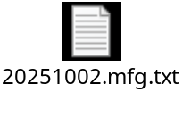

MM TEST
Command | mm_test
Description | Morse micro Porting Assistant
Syntax | mm_test
Test Result | qcc74x />mm_test  MM-IoT-SDK Porting Assistant  ----------------------------  Memory allocation [ PASS ]  Memory reallocation [ PASS ]  Passage of time [ PASS ]  Task creation and preemption [ PASS ]  WLAN HAL initialisation Succesful init  Hard reset device Succesful reset  SDIO/SPI Startup [ PASS ]  Read chip id from the MM chip Chip read  Chip read successful  [ PASS ]  Verify BUSY pin [ PASS ]  Bulk write/read into the MM chip [ PASS ]  Raw throughput test [ PASS ]  Note: This will not be the final WLAN TPUT. See test step for more info.  Time spent (ms): 2502  Transaction count: 1795  Bytes xferred: 5370640  Raw TPUT (kbit/s): 17172  Validate MM firmware [ PASS ]  Validate BCF [ PASS ]  13 total test steps. 11 passed, 0 failed, 2 no result, 0 skipped

MM SCAN TEST
Command | mm_scan
Description | The command line utility mm_scan porting from Morse Micro V1.4.  If you want to launch mm_scan command , you should use mm_scan_stop command to stop the previous mm_scan process to prevent from failed at function qcc74x_malloc.
Syntax | mm_scan
Test Result | qcc74x />mm_scan  Morse Scan Demo (Built Sep 26 2025 10:45:40)  Morse firmware version 1.16.0, morselib version 2.9.4-nfp-qcc74x, Morse chip ID 0x809  Scan started on AU channels, Waiting for results...  qcc74x />  qcc74x />MorseMicro  Operating BW: 8 MHz  BSSID: 0c:bf:74:06:96:0a  RSSI: -85  Beacon Interval(TUs): 100  Capability Info: 0x0031  Security: SAE  S1G Operation:  Operating class: 25  Primary channel: 42  Primary channel width: 2 MHz  Operating channel: 44  Operating channel width: 8 MHz  Scanning completed.  qcc74x />

MM SCAN STOP
Command | mm_scan_stop
Description | The command mm_scan_stop is used to stop the previous mm_scan process to prevent from out of memory situation.
Syntax | mm_scan_stop
Test Result | qcc74x />mm_scan_stop  done!!!!!  qcc74x />

BLE TEST
2.1.17.1 BLE SCAN TEST

Command | ble_start_scan  ble_stop_scan
Description | BLE scan commands.
Test Result | 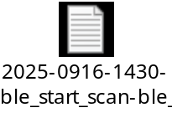

2.1.17.2 BLE PERIPHERAL TEST

Command | ble_init  ble_auth  ble_unpair  ble_set_adv_channel  ble_set_device_name  ble_start_adv  ble_stop_adv
Description | BLE peripheral test commands
Test Result | 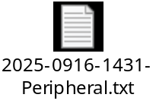  使用iphone LightBlue app抓取到的畫面。  Iphone app url path:  https://apps.apple.com/tw/app/lightblue/id557428110  Google app url path:  https://play.google.com/store/apps/details?id=com.punchthrough.lightblueexplorer&hl=zh_TW  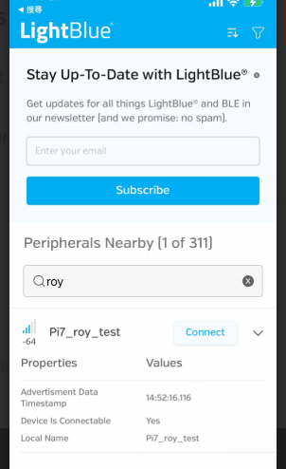

WiFi TEST

Command | wifi_scan  wifi_sta_connect  wifi_sta_info  wifi_sta_rssi  set_ipv4  ping  iperf  wifi_sta_info  wifi_sta_rssi
Description | WiFi test commands.
Test Result | 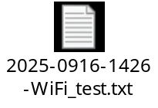

Check Version

Command | qcc74x />mm_version  1.5.0-295  Verify the shopfloor software version is 1.5.0-295
Description | Check the software version
Test Result | 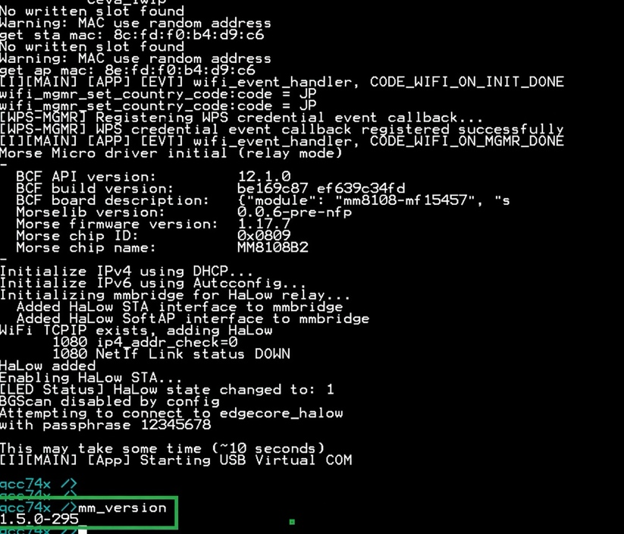

MAC/SN/MODEL/HWVER WRITE

Command | factory w
Description | Write MAC,SN , MODEL,HWVER
Syntax | usage: factory w <MAC> <SN> <MODEL> <HWVER>
Test Result | qcc74x />factory w 02:00:0a:0b:0c:ff ECSN11225678 Pi7 R0C  erase flash 0x7f8000  Pi7 Factory info:  halow_mac: 02:00:0A:0B:0C:FF  wifi_mac: 02:00:0A:0B:0D:00  ble_mac: 02:00:0A:0B:0D:01  S/N : ECSN11225678  Model: Pi7  HWver: R0C

MAC/SN/MODEL/HWVER READ

Command | factory r
Description | Read MAC,SN , MODEL,HWVER
Syntax | usage: factory r
Test Result | qcc74x />factory r  Pi7 Factory info:  halow_mac: 00:11:22:33:44:55  wifi_mac: 00:11:22:33:44:66  ble_mac: 00:11:22:33:44:77  S/N : ECSN012345678  Model: Pi7a  HWver: R0B

