א ב ג ד ה ו ז ח ט י

1 2 3 4 5 6 7 8 9 10

כ ל מ נ ס ע פ

20 30 40 50 60 70 80

צ ק ר שׁ שׂ ת

90 100 200 300 300 400

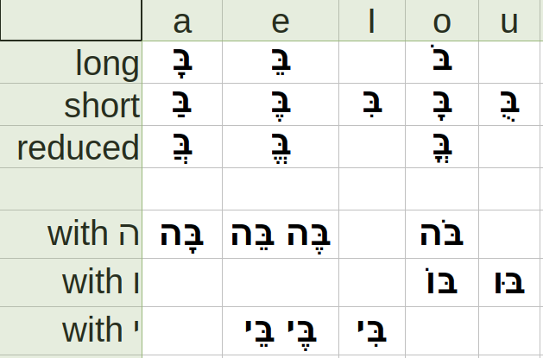

**2.11 Shewa**

Silent Shewa has a zero value.

Vocal shewa maintains a hurried pronunciation and sounds like the a in “amuse”.

**2.13 Daghesh Forte**

Is to double the consonant in which it occurs.

But gutturalsאעהח and ר can not take it.

**3.2 Two Rules of Syllabification**

1.Every syllable must begin with one consonant and have only one vowel.

2.There are only two types of syllables: open and colsed.

**3.3 Hebrew Accents**

Hebrew words are usually accented on the last syllable.

If not, there will be an accent mark over the streesed syllable.

**3.6 The Shewa and Syllabification**

The Shewa is Silent if the previous vowels is short. מַלְ

The Shewa is vocal if not immediately preceded by a short vowel.

**3.7 Qamets and Qamets Hatuf**

The **QametsHatuf** occurs only in a **closed** and **unaccented** syllable.

The **Qamets** prefers an **open, pretonic** syllable or a **closed, accented** syllable.

**3.8 Furtive Pathach**

When a word ends in ח or ע, a Pathach may appear beneath this consonant and must be pronounced and transliterated before the guttural.

**4.2 Plural and Dual Endings on Masculine and Feminine Nouns**

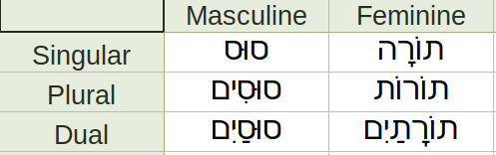

**4.7.2 Exception to Normal Pluralization**

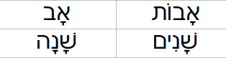

**4.8.1 Pluralization with No Changes**

Pluralized simply with the addition of the masculine or feminine plural ending.

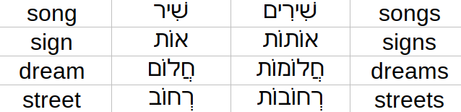

**4.8.2 Pluralization with Propretonic Reduction**

In an open, propretonic syllable, The Qamets or the Tsere will reduce to Shewa. Guttural cannot take a Vocal Shewa but prefer Hateph Pathach.

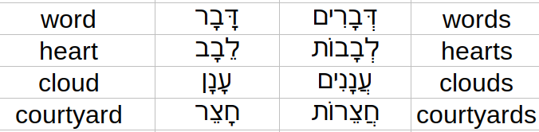

**4.8.5 Irregular Pluralization**

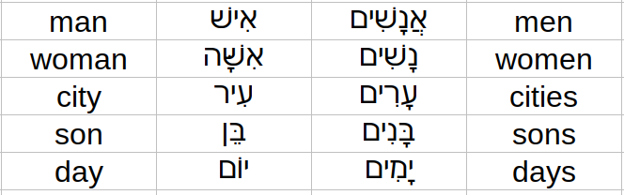

**5.2 Form of the Hebrew Definite Article**

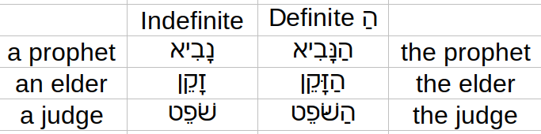

**5.4 The Article and Initial Guttural Consonants**

**5.4.1 Compensatory Lengthening.**

With the initial gutturals א ר ע

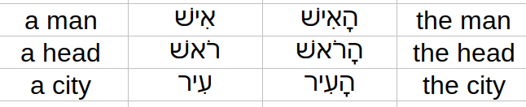

**5.4.2 Virtual Doubling.**

When ה or ח is the first consonant of a noun, the rejection of the Daghesh Forte without the lengthening of the Pathach vowel.

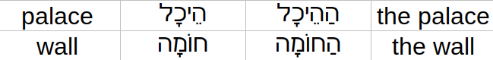

**5.4.3 Irregular Seghol Vowel.**

Nouns that begin with an unaccented עָ הָ חָ , the definite article appears with Seghol and without the Daghesh Forte.



**5.7.2 Two circumstances which conjunction will appear as וּ**

1.Before the consonants ב מ פ, referred to as the bump rule.

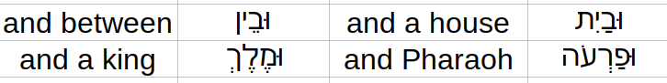

2.Before most consonants having a Vocal Shewa.

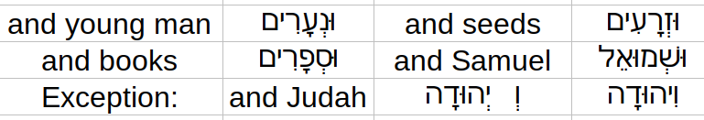

**5.7.3** Before a reduced or Hateph vowel, the conjunction is spelled with the corresponding short vowel of the Hateph vowel.

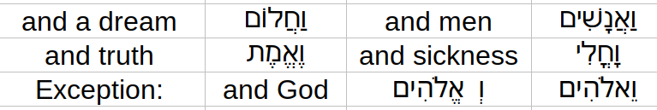

**5.7.4** The conjunction may also be spelled with a Qamets before monosyllabic words and certain words with an initial accent.



**When you see the consonant ו at the beginning of a Hebrew word, you should expect the conjunction over 99% of the time.**