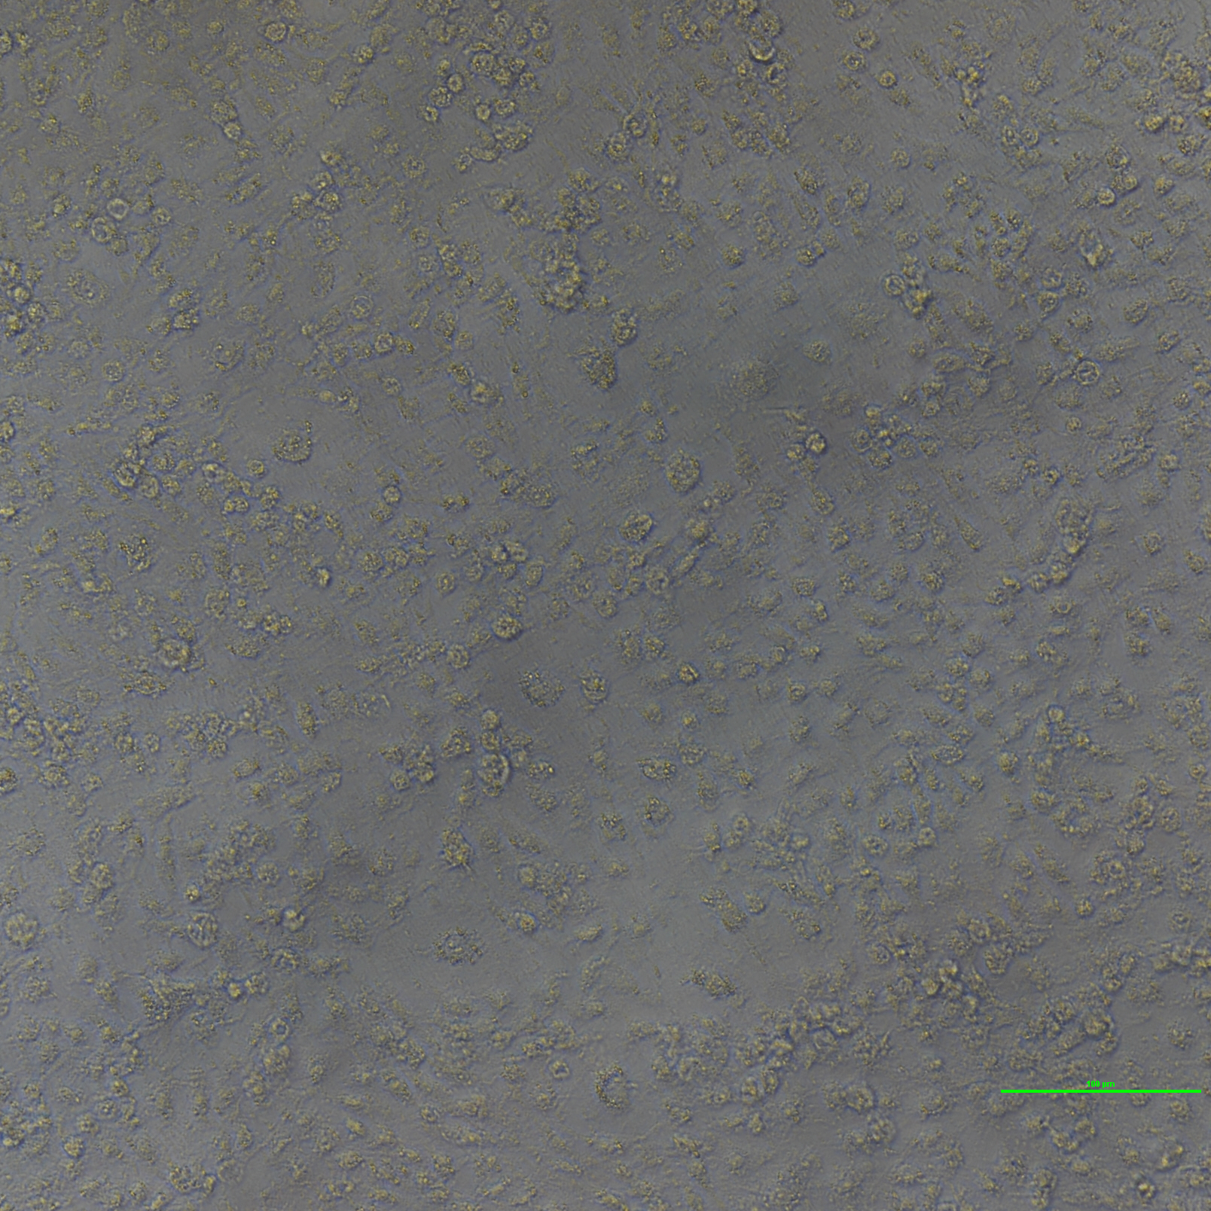Figure 1: Transgene CHO-K1(DsRed2-NUC and EGFP-Action) cell Brigh Field(scale bar is 100micrometer, following are same scale bar)
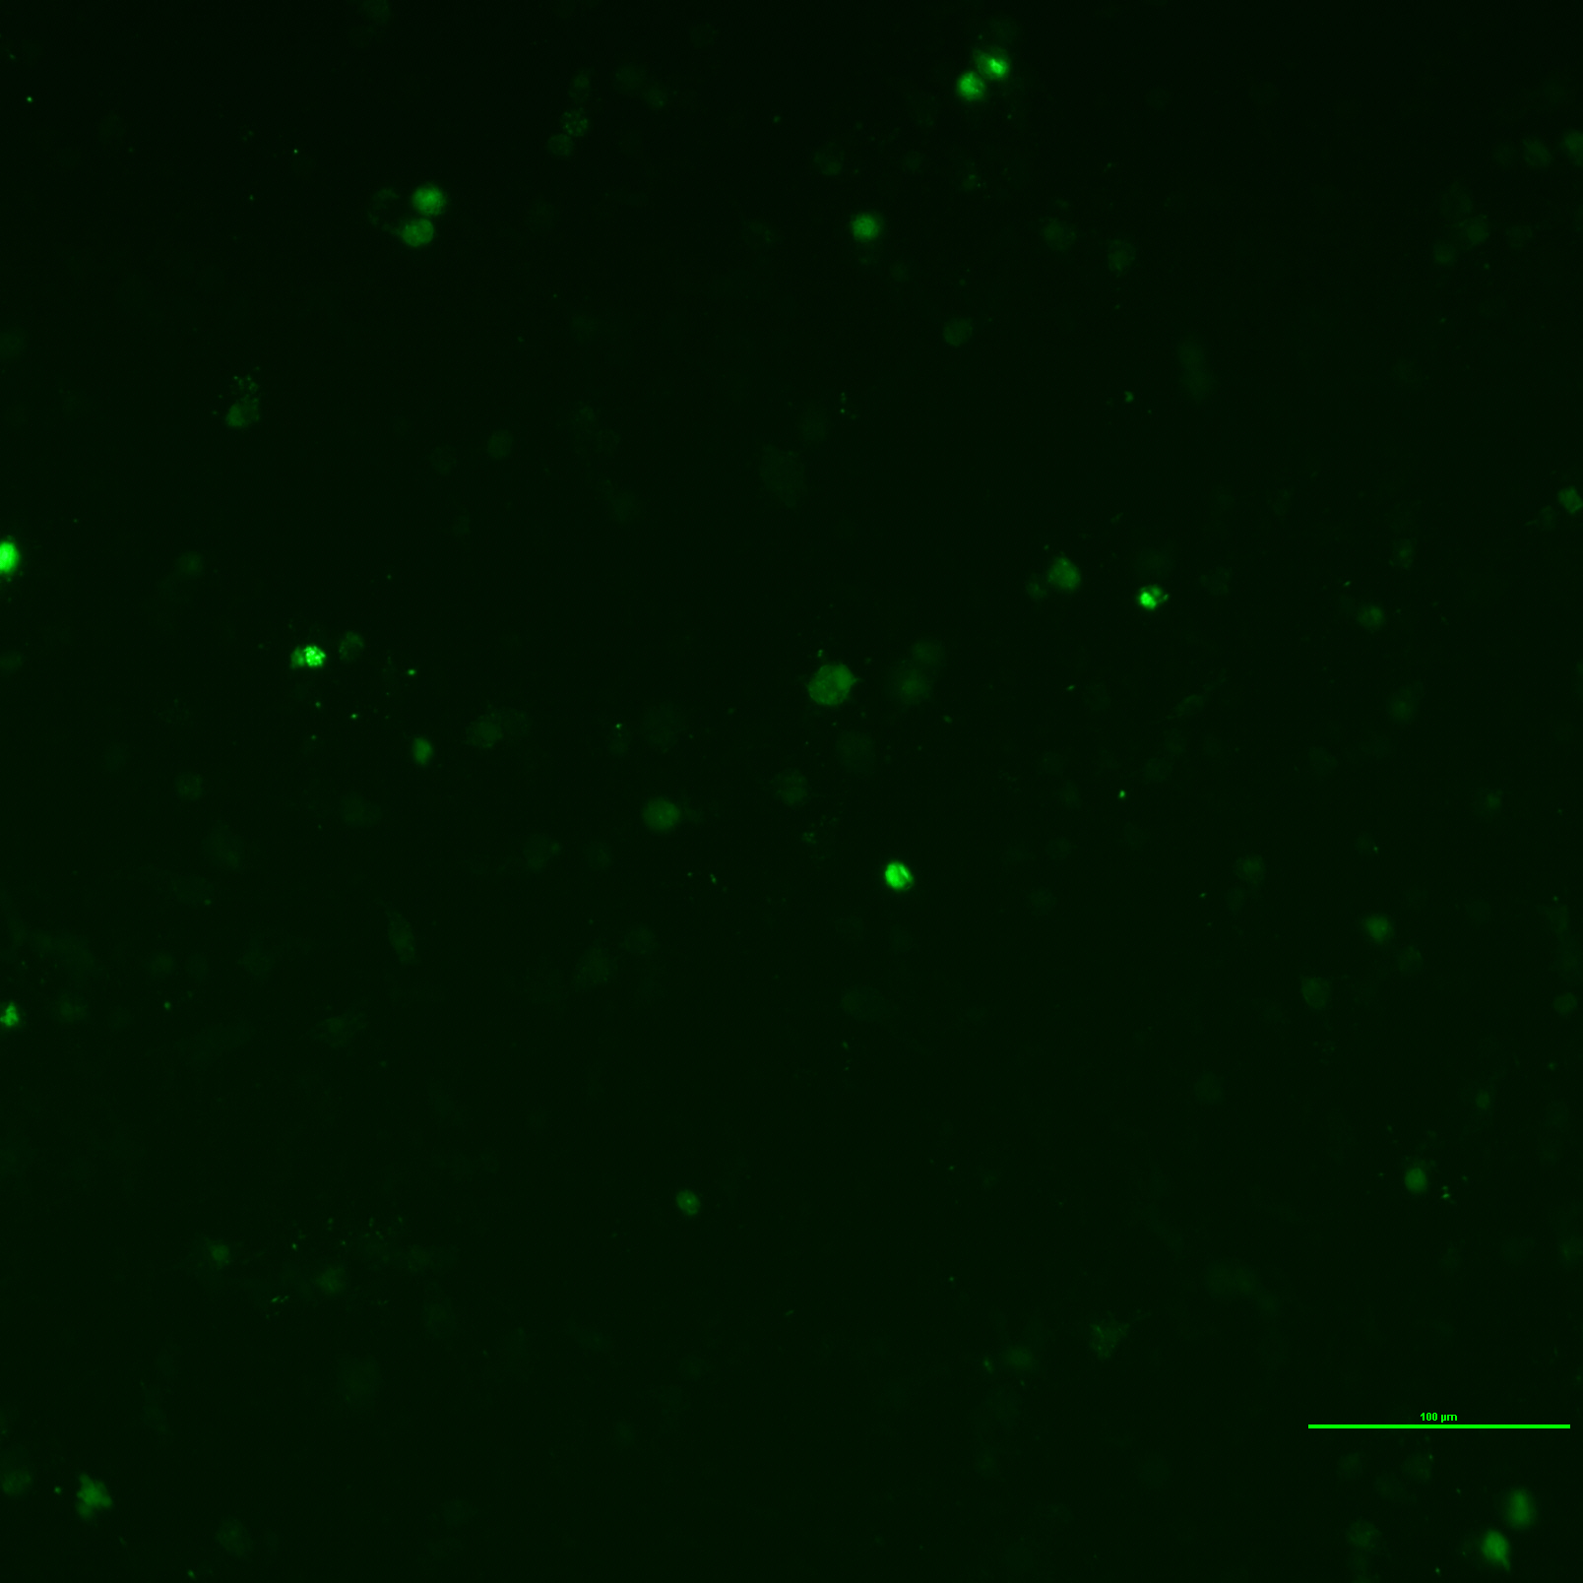Figure 2: Transgene CHO-K1(DsRed2-NUC and EGFP-Actin) cell under fluorescence microscopy in red channel. The green region is cell cytoplasm

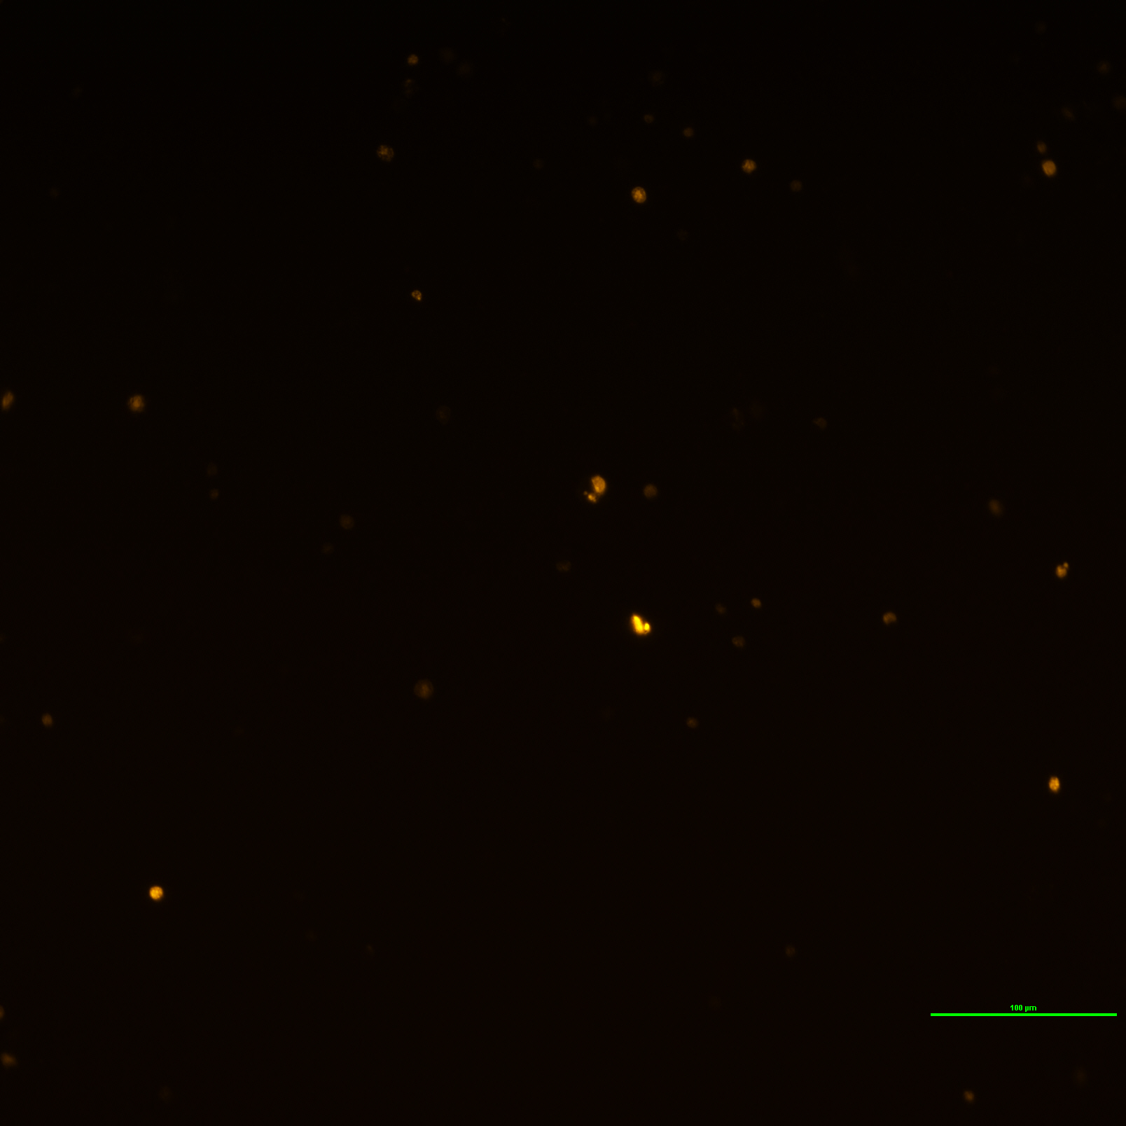Figure 3: Transgene CHO-K1 (DsRed2 and EGFP-Actin) cell under fluorescence microscopy in green channel. The red region is cell nucleus.
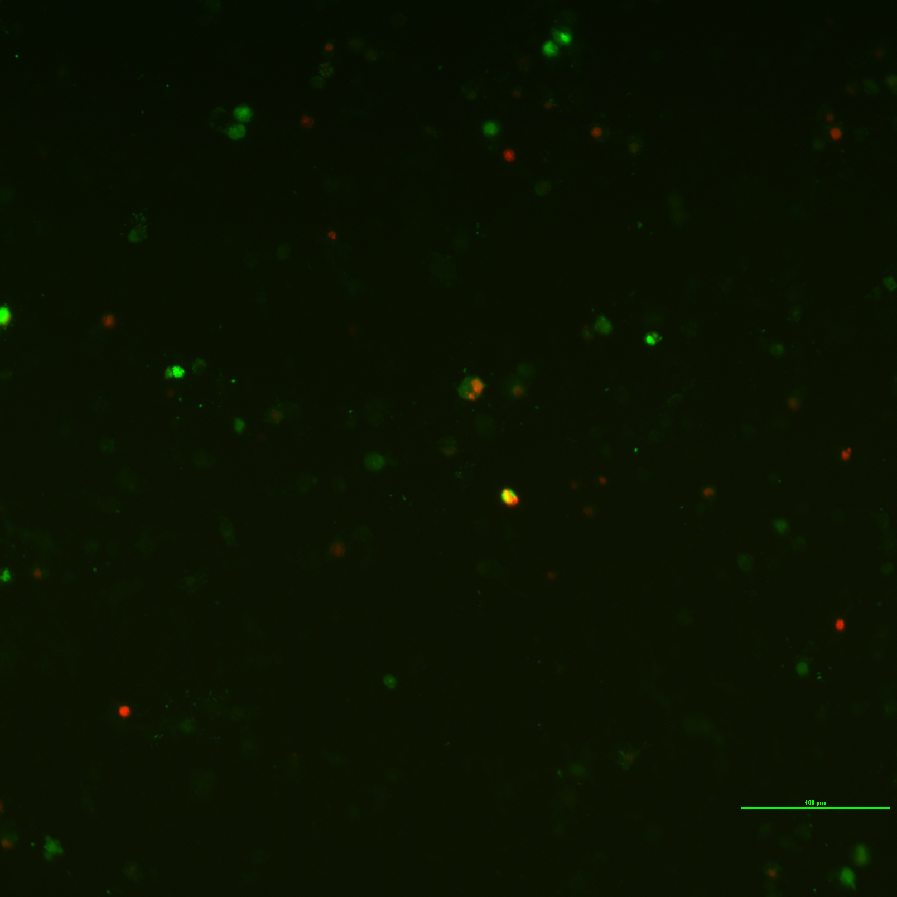Figure 4: Transgene CHO-K1 (Red2-NUC and EGFP-Actin) cell under fluorescence microscopy. This image merge the red channel and green channel.

