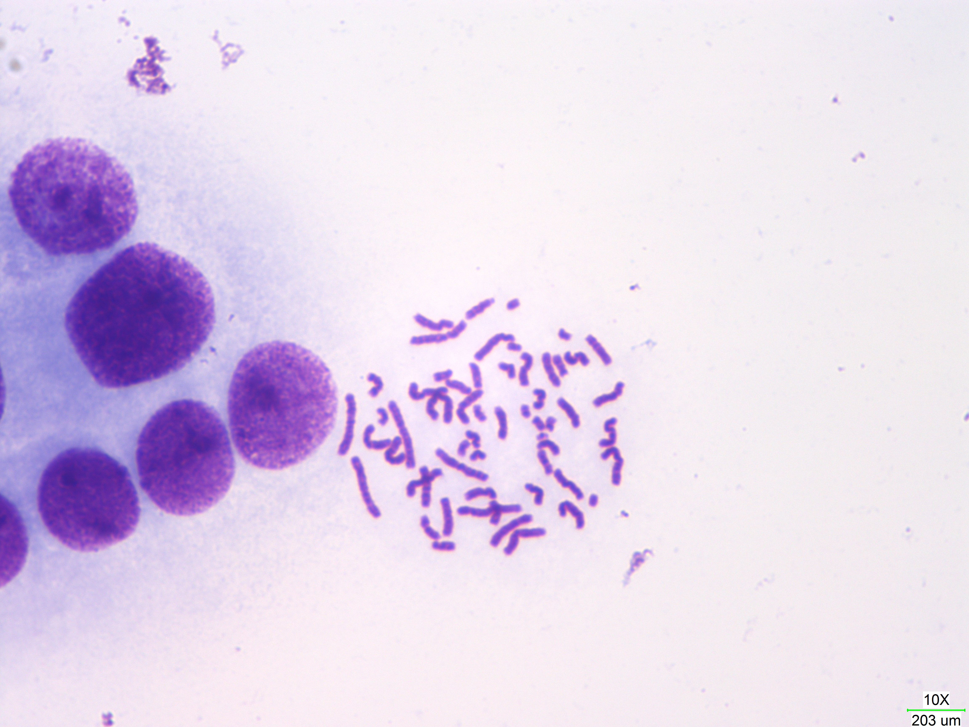Figure 1: The Chromosomes of U-937 cell stained by Giemsa(scal bar is 20.3 micrometer, incorret in images). Some banding pattern can be observered

