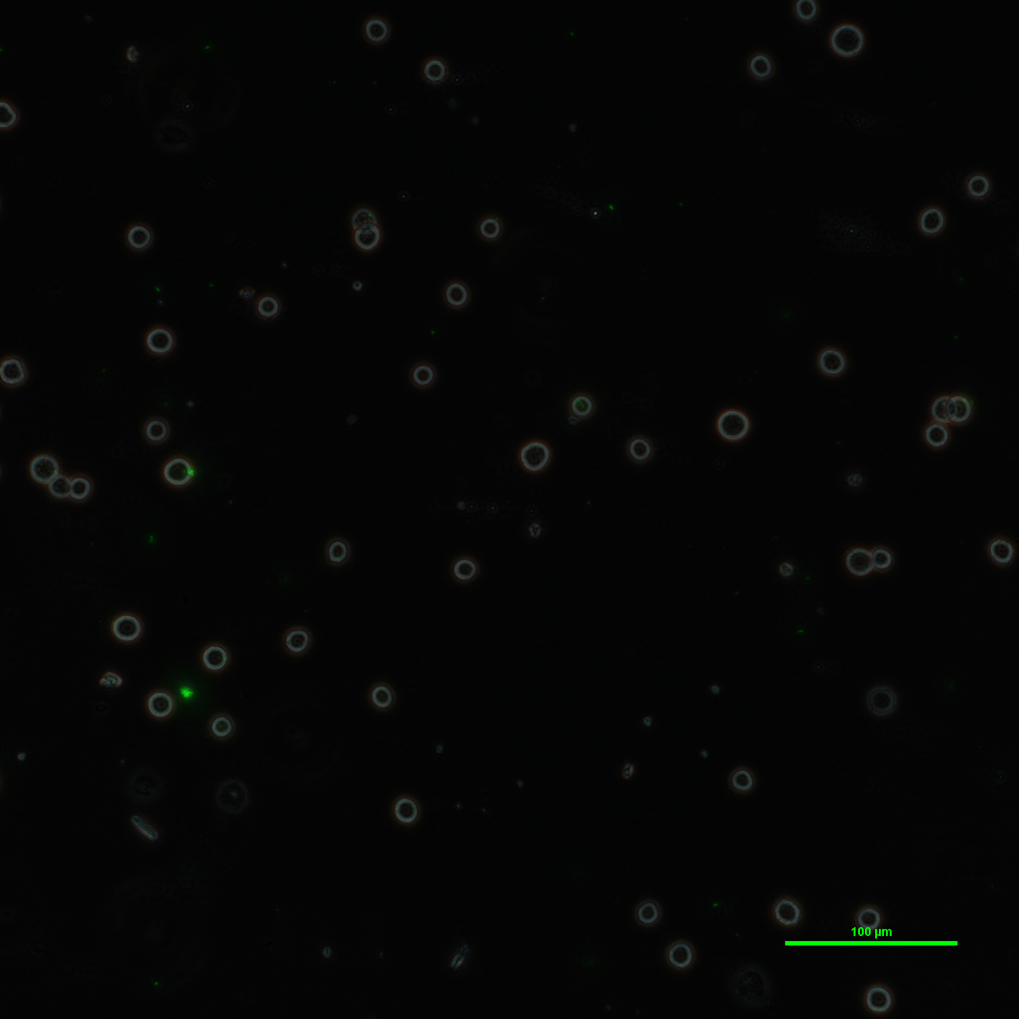Figure 3: Control Group: No-treated U-937 under fluorescence microscopy
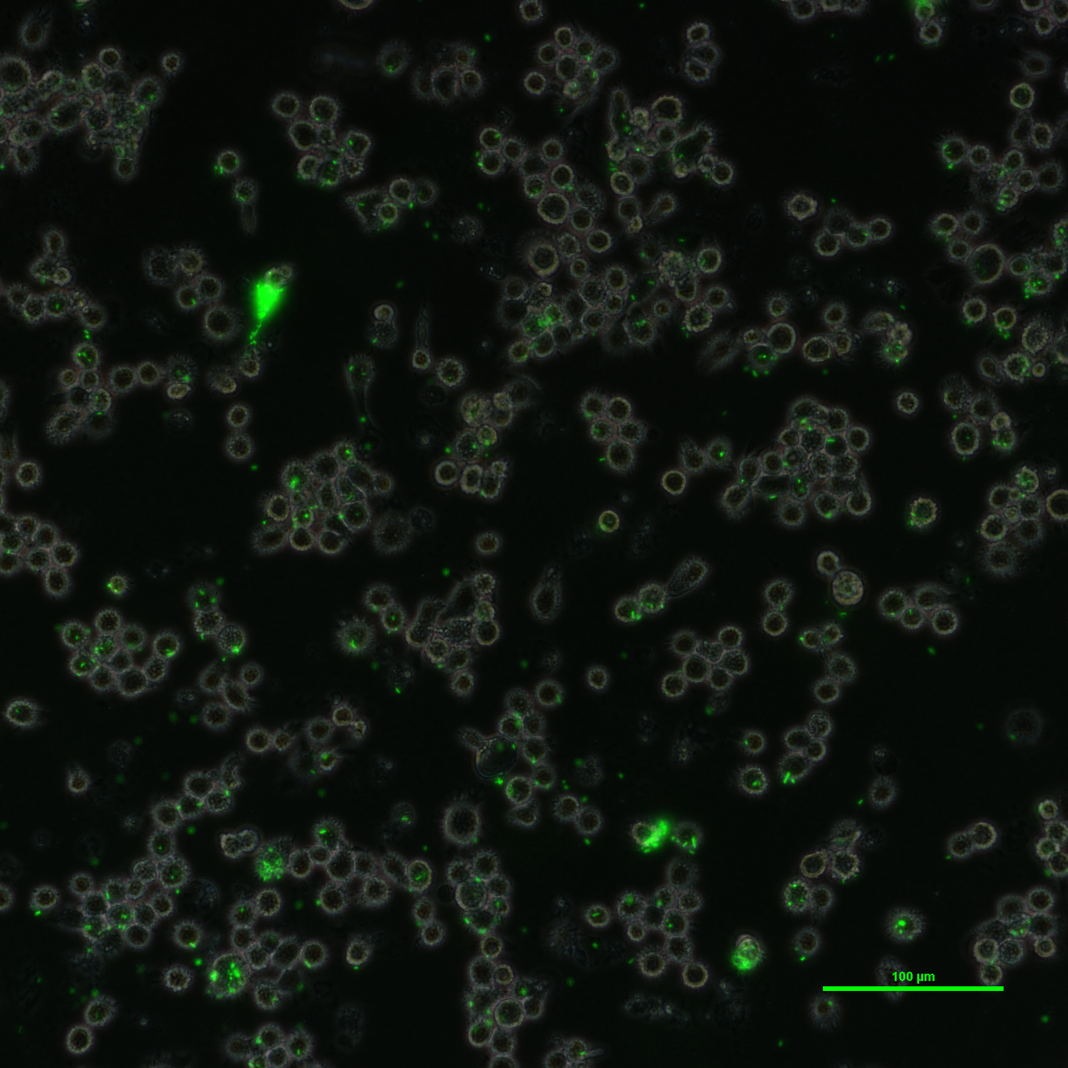Figure 2: PMA-treated U-937 cell's phagoctosis by E.Coli with GFP under fluorescence microscopy
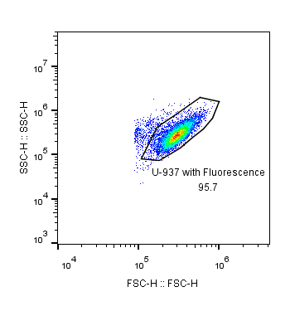Figure 5: PMA-treated U-937's cytometry result
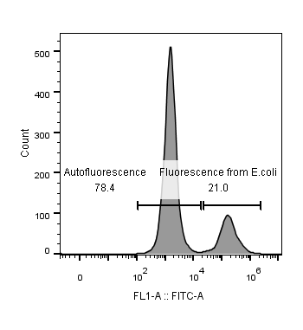Figure 4: PMA-treated U-937's GFP fluorescence distribution
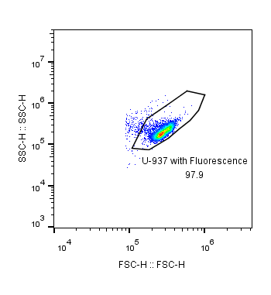Figure 6: No-treated U-937's cytometry result
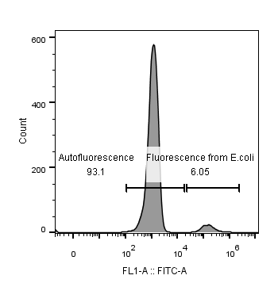Figure 1: No-treated U-937's GFP fluorescence distribution

