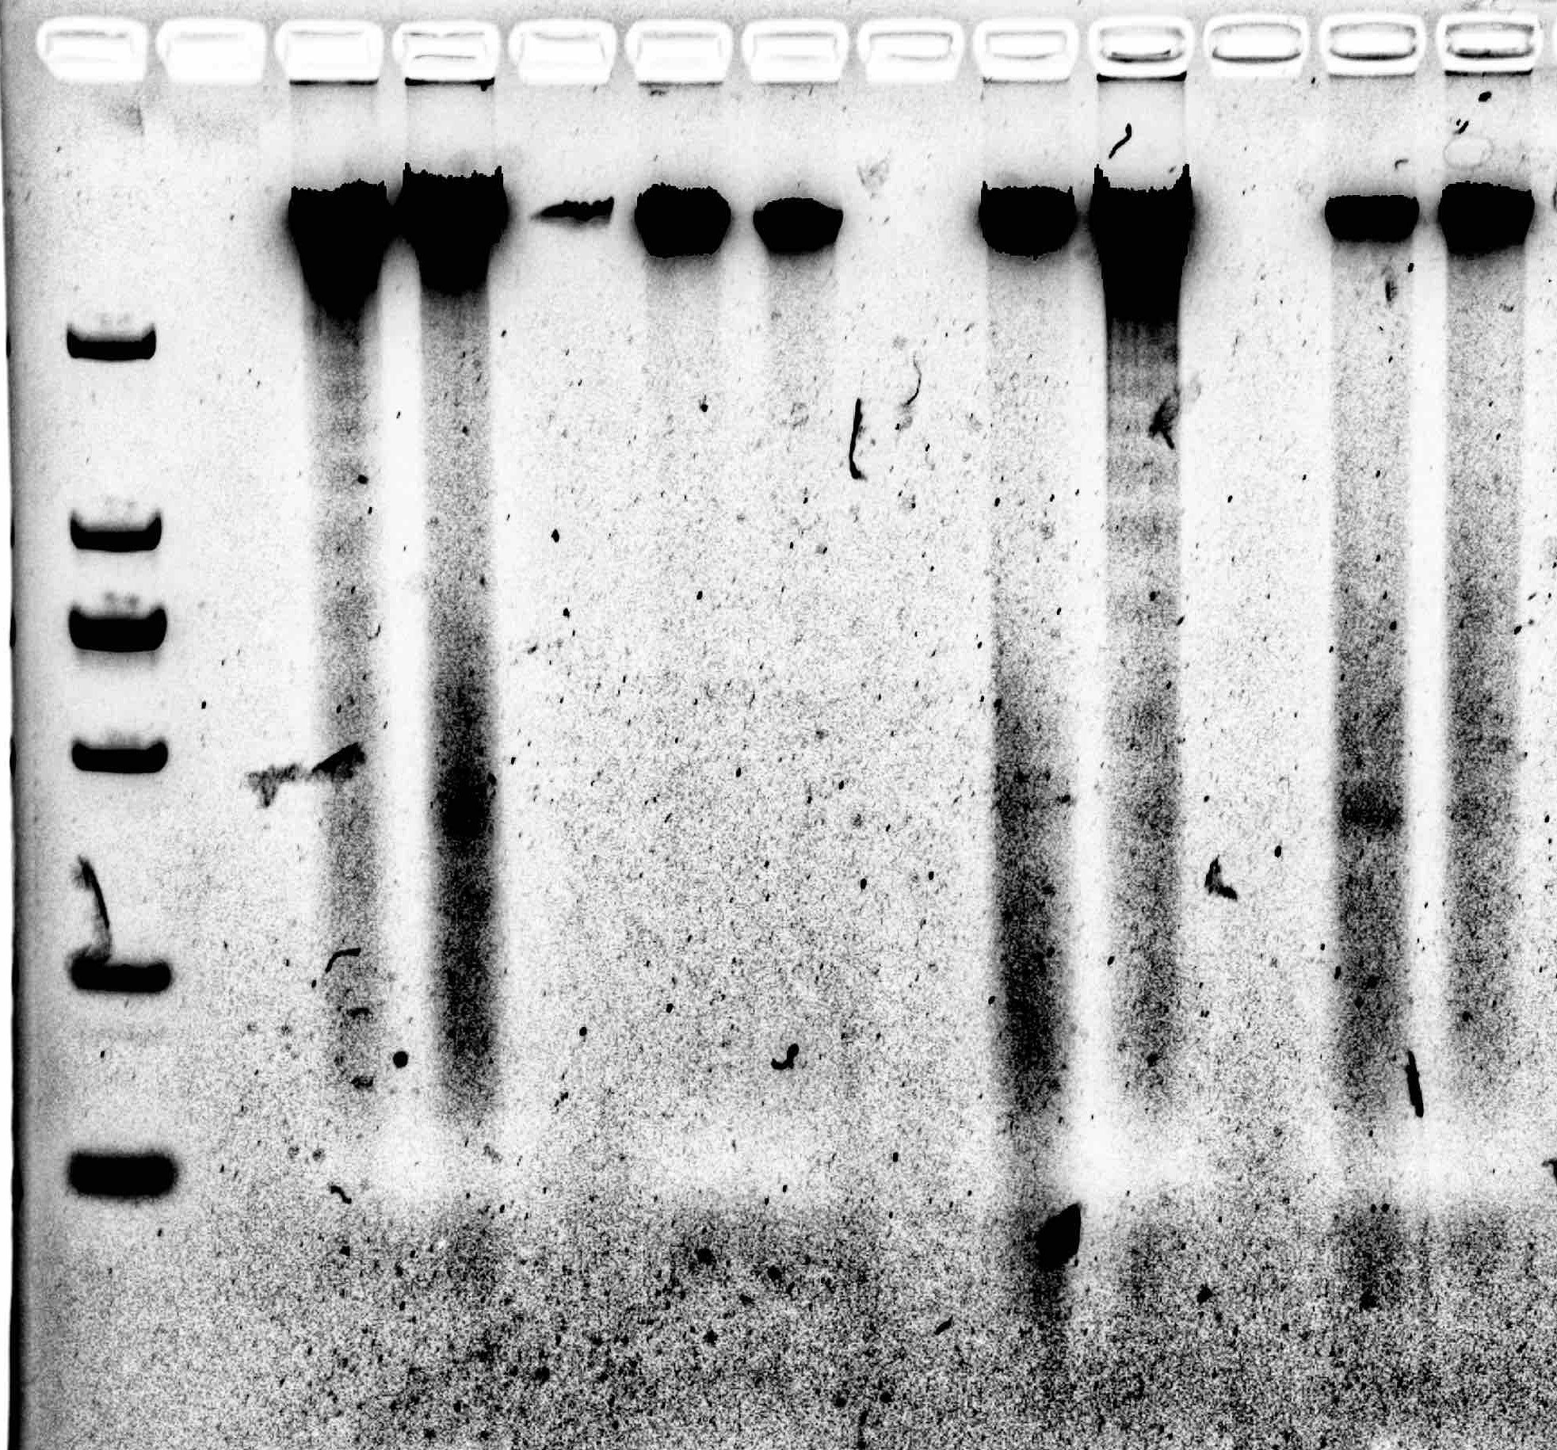Figure 3: DNA lader.
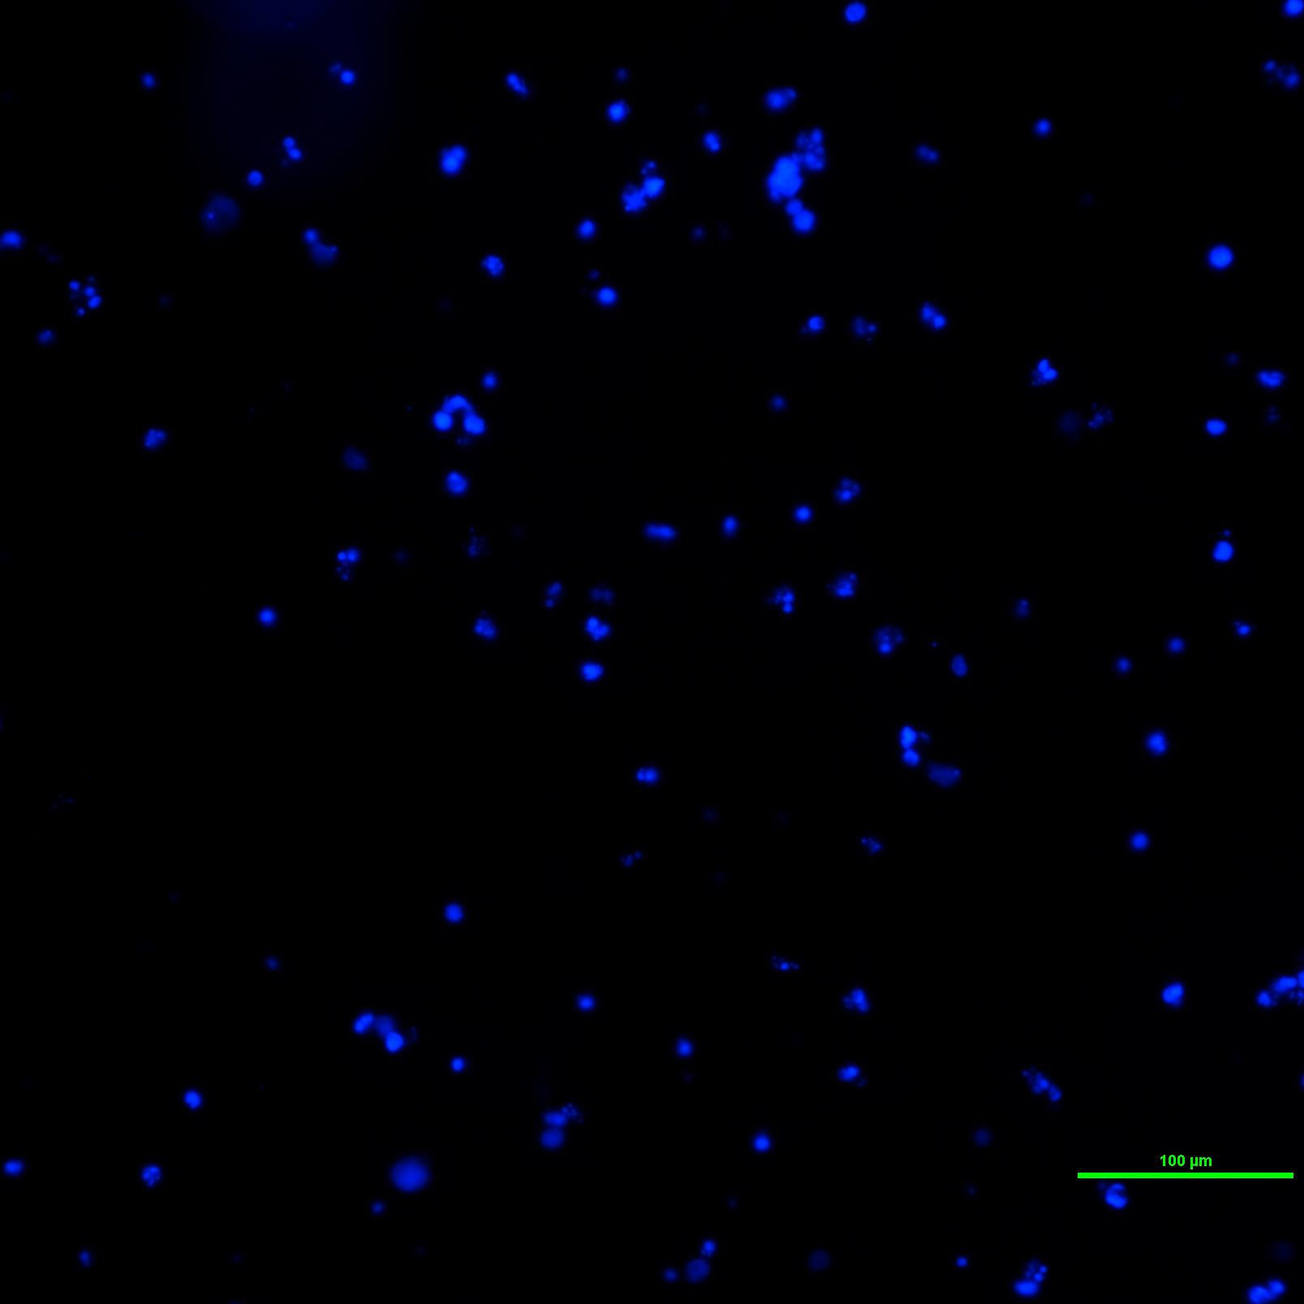Figure 2: Exp Group: Treated Cell
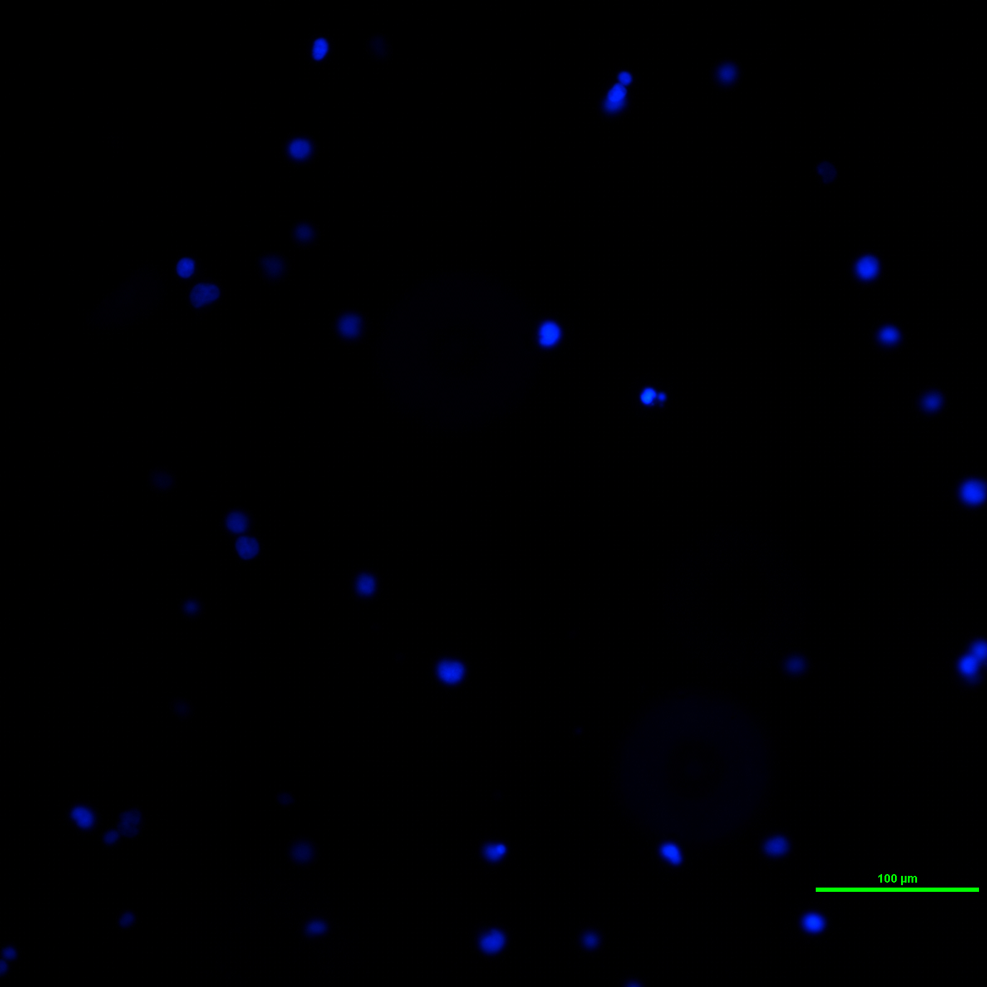Figure 1: Control Group: Normal Cell

