FABP4_MOUSE
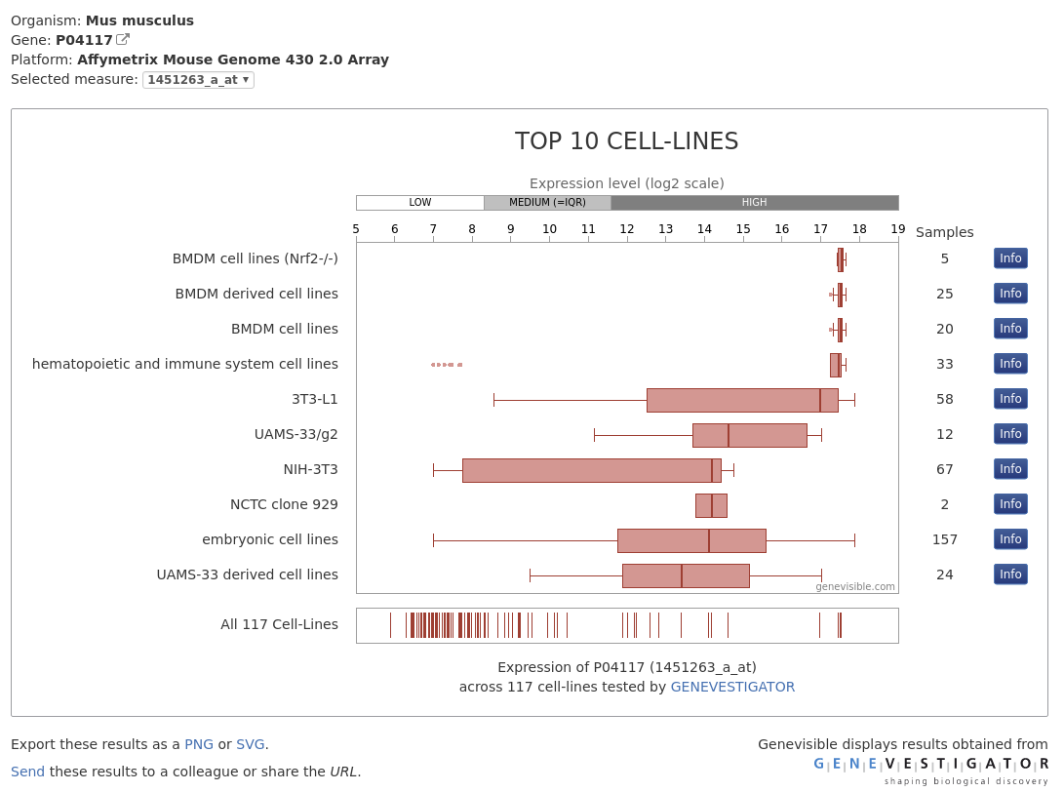
http://www.uniprot.org/uniprot/P04117#expression

https://www.ncbi.nlm.nih.gov/nuccore/NM_024406.3?report=genbank
ORIGIN
1 … gggcatcttt aaaagtgagc tatctggact tcagaggctc atagcaccct cctgtgctgc
61 agcctttctc acctggaaga cagctcctcc tcgaaggttt acaaaatgtg tgatgccttt
121 gtgggaacct ggaagcttgt ctccagtgaa aacttcgatg attacatgaa agaagtgg…ga
181 gtgggctttg ccacaaggaa agtggcaggc atggccaagc ccaacatgat catcagcgta
241 aatggggatt tggtcaccat ccggtcagag agtactttta aaaacaccga gatttccttc
301 aaactgggcg tggaattcga tgaaatcacc gcagacgaca ggaaggtgaa g…agcatcata
361 accctagatg gcggggccct ggtgcaggtg cagaagtggg atggaaagtc gaccacaata
421 aagagaaaac gagatggtga caagctggtg gtg…gaatgtg ttatgaaagg cgtgacttcc
481 acaagagttt atgaaagggc atgagccaaa ggaagaggcc tggatggaaa tttgcatcaa
541 acactacaat agtcagtcgg atttattgtt tttttttaaa gatatgattt tccactaata
601 agcaagcaat taattttttc tgaagatgca ttttattgga tatggttatg ttgattaaat
661 aaaacctttt tagacttaga aaaaaaaaaa aaaaaa
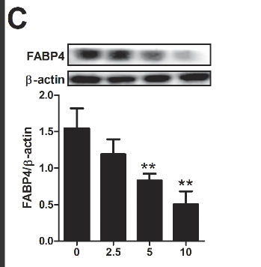

Ursolic Acid Inhibits Adipogenesis in 3T3-L1 Adipocytes through LKB1/AMPK Pathway. (n.d.). Retrieved February 28, 2018, from http://journals.plos.org/plosone/article?id=10.1371/journal.pone.0070135

