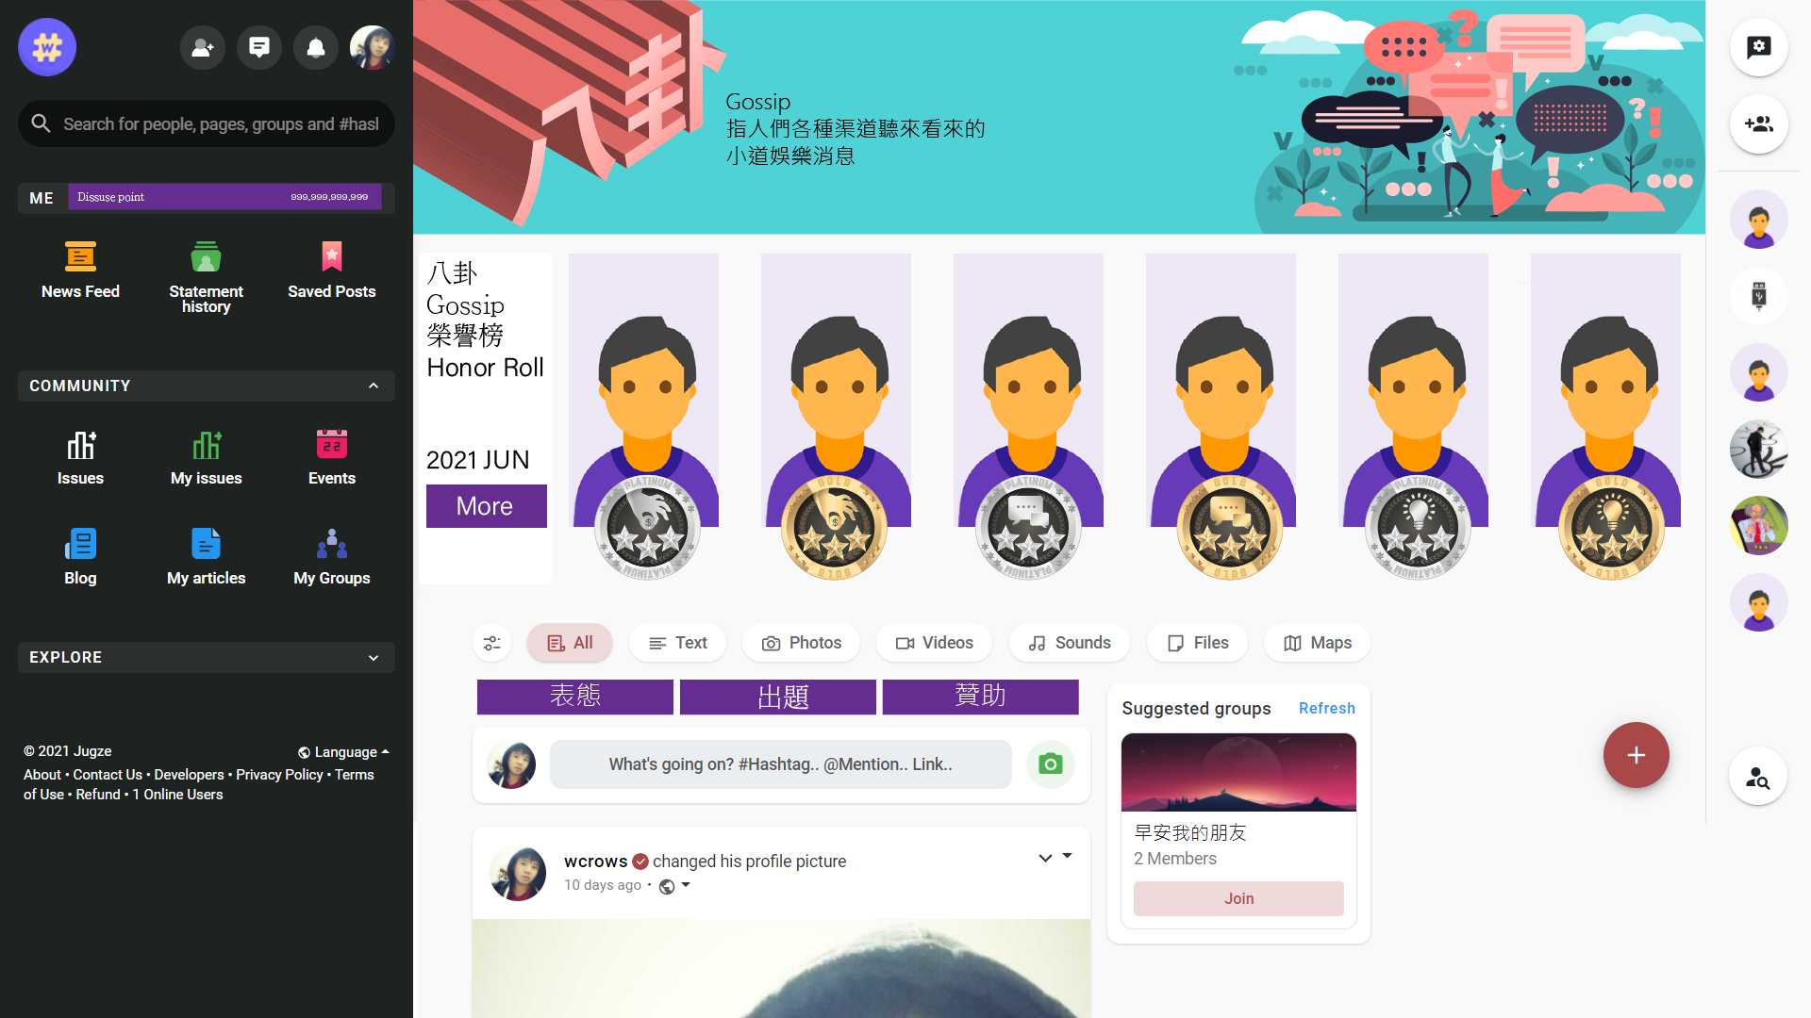

Jugze.in 2022/07/13  
Public issue social points website for public issues introduces Taiwan's social points website for public issues, hoping to have the most basic social functions, and it is written in PHP Laravel & Vue.js:

1. Live Chat users can private message users
2. Ban System site and topic construction Users can block bad users
3. Notifications notify users of website dynamics4
4. @Mentions
5. User Timeline
6. Delete & Edit Posts
7. Multilingual (including at least Chinese and Chinese)
8. RWD
9. Login with Facebook and Google account.

Issue function:

1. Display favorite topics on your personal page.
2. Display the current IP geographic location on the personal page.
3. There are Mostly agree, agree, undecided, oppose and Mostly oppose, and there will be a preview image when sharing to Facebook, as follows:
   1. https://codepen.io/Origin10/pen/wvGYvZK
4. There are issues under each category, and each issue is limited to 50 Chinese characters. The same topic can be repeated by different users.
5. The issue is divided into two groups. Mostly agree and agree for the positive side, and oppose and Mostly oppose for the negative side. The number of registrations on both sides is more than 3, and the system randomly decides to attack first and then attack!
   1. Round 1: Set questions for the first attacking team for 30 minutes, and design 20 questions with 5 points each, all of which are multiple-choice questions!
   2. Round 2: Give the attacking team 30 minutes to answer the questions.
   3. Round 3: Set questions for the first attacking team for 30 minutes, and design 20 questions with 5 points each, all of which are multiple-choice questions!
   4. Round 4: Give the attacking team 30 minutes to answer the questions.
6. The above scores are calculated for both parties. The disputed topics are handed over to the referee of the issue sponsor. Those who raise objections will be sent a reference discussion of more than 50 Chinese characters, which will be handed over to the sponsor referee for a period of one day.If the referee wins the case against the accuser, the accuser will add 5 points; if the referee wins the case against the accuser, the accuser will deduct 5 points.
7. The scores of both parties are calculated. If there is a party with a higher score, a new sub-issue can be proposed to provide the opinions of users who have expressed their opinions on the previous issue,If the scores are the same, this stage is skipped.
8. Issue creators can exclude other issues' score statistics, and create issues title and creator IDs by blacklisting. If the user who has obtained points has both points, they need to choose to display one of the accumulated points.
9. The issue of construction needs to be classified into fields. The optional fields are as follows: Politics, Cross-Strait, International, National Defense, History, Acts, Trends, Environmental Protection, People's Livelihood, Human Rights, Economy, Energy, Transportation, Education, Diplomacy, Medical Care, Public Health, Food Safety, Welfare,Employment, Taxation, Social Welfare, Labor, Religion, International, Public Security, Gossip, Consumption, Women and Children and Others.
10. For this issue, you can fill in the relevant Expenses, Liabilities, Gains, and Losses fields for the issue. If the relevant data and materials are found to be wrong in the official review, we have the right to suspend for more than one month.
11. On the issue page, when everyone publishes a statement, the user's current statement will be displayed next to the avatar of the comment. If the commenter updates the comment, the display will also change.
12. The personal page should have a keyword search engine for searching topics. You can search here for a user's issue statement and the historical statement record of the same issue.
13. Users can invite other users to express their opinions on specific issues, and the user's personal page will count the number of issues that have been expressed and the number of issues that have not been expressed!
14. The homepage and topic category page, design monthly ranking issue battle statistics, and the champion, second, third, and fourth virtual medals are recorded on the personal issue battle page, and award the medal NFT to the winner.
15. Publish the issue and pass the official review. On the homepage and issue category page, design the monthly best issue host, and record: (total number of user’s statement ÷ 100) + (number of issue battle \* 20) - negative comments on issue dispute handling, and awarding the champion, second, third, and fourth virtual medals are recorded on the personal best issue host page, and award the medal NFT to the winner.
16. Create a page called "Transparent Management" to record the monthly revenue of the Jugze.in website. At the same time, there are groups or individuals who want to donate to Jugze.in and hold this poll.