This should be clickable. When you click the wallet, should show the following info.

[Address 0x94750771b13886bef8f595b67ff982daf5f2839b | Etherscan](https://etherscan.io/address/0x94750771b13886bef8f595b67ff982daf5f2839b)

[Address 0x94750771b13886bef8f595b67ff982daf5f2839b | Etherscan](https://etherscan.io/address/0x94750771b13886bef8f595b67ff982daf5f2839b#tokentxns)

Need a timestamp

Make a button like a launchpad and faucet

**Search doesn’t work and you need to add contracts to search.**

Two words Contract Details

Contract Details need to show all this info here…Follow the links here

[ATAI | Address 0xdbfd10f8c32f96470eeef40f2d1dcda5dfe497bc | Etherscan](https://etherscan.io/address/0xdbfd10f8c32f96470eeef40f2d1dcda5dfe497bc)

Token Tracker

[ATAI | Address 0xdbfd10f8c32f96470eeef40f2d1dcda5dfe497bc | Etherscan](https://etherscan.io/address/0xdbfd10f8c32f96470eeef40f2d1dcda5dfe497bc)

Contract creator (deployer)

[Address 0x94750771b13886bef8f595b67ff982daf5f2839b | Etherscan](https://etherscan.io/address/0x94750771b13886bef8f595b67ff982daf5f2839b)

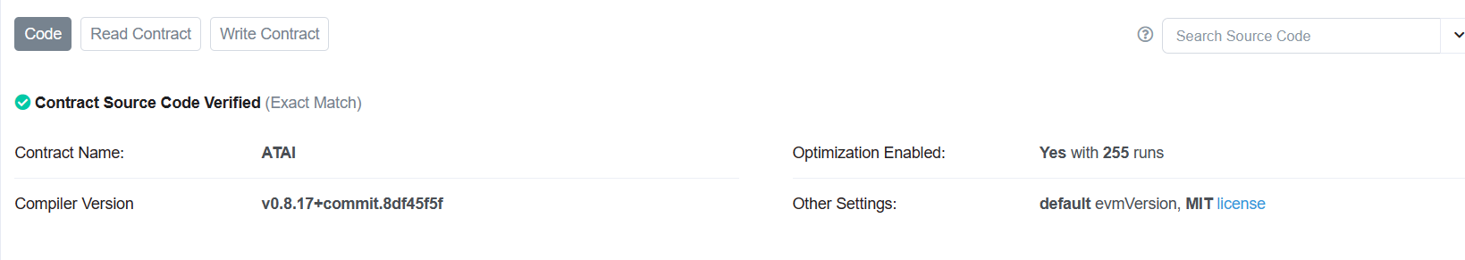

Read/Write a contract. Don’t want people to use remix. Want an intuitive solution…Launchpad feature? (This can be used with Remix)

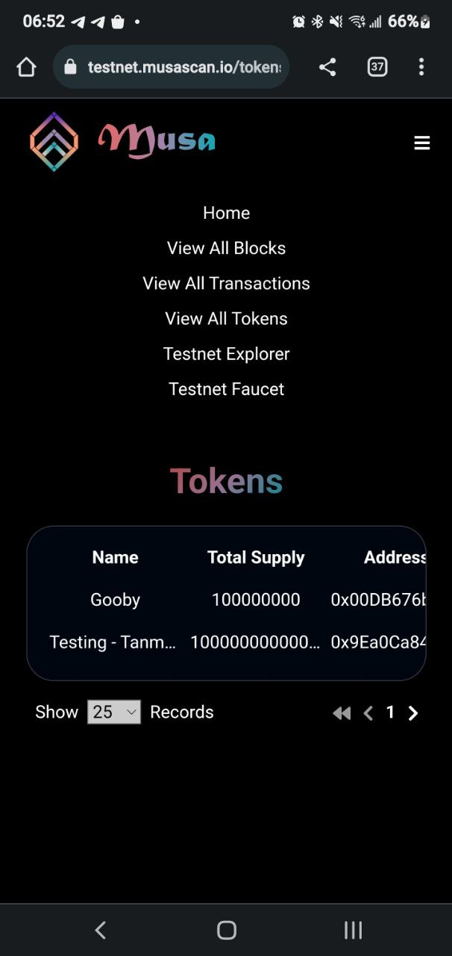

Explorers need to be optimized for mobile

Add this to the footer and make it enter RPC into metamask. Same idea as bscscan…Please check

[Binance (BNB) Blockchain Explorer (bscscan.com)](https://bscscan.com/)