**Change register setting style for XMC 1300 boostpfc hardware driver**

Changed from V67 to V68

17.7.14

Reason:

To save flash memory space, registers shall be set in as few lines of code as possible fort he sake of little less readability of the code.

Status quo:

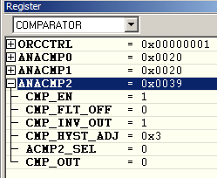COMPARATOR🡪ANACOMP2

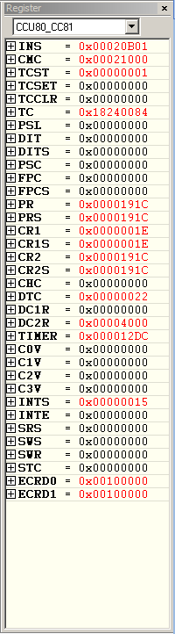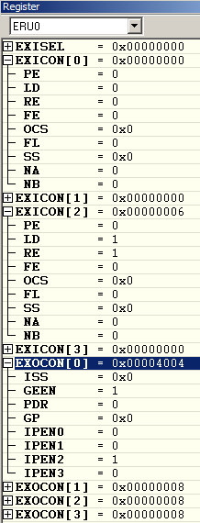

ERU0🡪EXISEL CCU80_CC81🡪INS

ERU0🡪EXICON CCU80_CC81🡪CMC

ERU0🡪EXOCON CCU80_CC81🡪TC

CCU80_CC81🡪DTC

CCU80_CC81🡪DC2R