Project Title

International Student Chef Handbook

Concept Description

We are proposing to develop a web app tailored specifically for international students, aiming to transform the way they approach cooking and dining in a foreign country.

Our primary objective is to simplify the process of finding suitable recipes, learning about diverse cuisines, and managing their daily meals. By integrating multiple open - source culinary APIs, we plan to enable users to search for recipes based on a variety of criteria, such as available ingredients in local markets, budget constraints, cooking time, and personal taste preferences.

Functionally, the envisioned app will not only provide a powerful multi criteria search function but also offer unique features tailored to international students. For instance, it will include cultural insights for each recipe, explaining the origin and significance of the dish in its native culture. It will also have a section dedicated to substituting hard to find ingredients with local alternatives. Additionally, users will be able to create and manage their own meal plans, syncing them across different devices. The app will present recipes in an easy to follow format, with step by step instructions, high quality images, and even video tutorials for more complex dishes.

In contrast to general recipe apps, which lack the specific focus on international students' needs, our proposed app will be a one - stop solution for this unique user group. It will be publicly accessible and free of charge, removing any financial barriers for students.

The target user base of this app will be international students studying in various countries around the world. Whether they are undergraduate students just starting to learn cooking or postgraduate students juggling a busy academic schedule, this app will be an invaluable resource. This initiative holds great potential to fill an existing gap in the market by providing a comprehensive, user friendly, and cost effective solution for international students' culinary needs.

API Integration Plan

1.External API Selection

We choose Yummly API.

2. Purpose of the API

It was chosen firstly because it is free and secondly because the amount of data it provides is very large. Yummly has more data and higher quality than other free recipes.

3. Type of Data to Retrieve

The Yummly API is used to get data about recipes, but only the main fields are listed here.

Recipe: *Recipe name, Recipe Description, Classification of cuisines, Cooking time, Difficulty level*

Ingredients: *The ingredients list, Pictures of ingredients, Food substitution information*

Tutorial: *Detailed steps, Step pictures or videos*

Healthy Data: *Calorie, protein, fat, carbohydrate content, Nutrition Label, Score data*

Feedback: *User Reviews, Menu picture, Cooking video link*

4. Combining API Data with My Database

When we use our app to search for a recipe, we get the results from the Yummly API in real time. Due to the large amount of data on this site, the results of live queries are not saved to our database.

If a user follows a recipe or adds it to their meal plan, we save the recipe data to our database.

Custom Database Plan

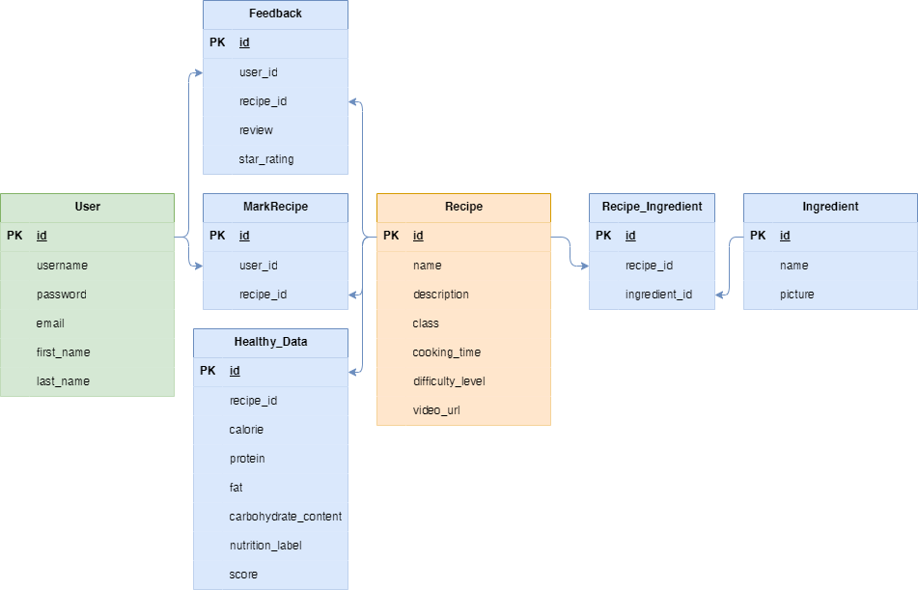

User Service Description

**Story 1** - Multicriteria Recipe Search: Users can create filters specifying ingredients available in local markets, budget limits, cooking time, cuisine type, and taste preferences to obtain relevant recipe search results.

**Story 2** - Recipe Collection by Meal Plan: Users can create meal plans (like weekly or monthly) and save all relevant recipe search results under these plans.

**Story 3** - Recipe List Display: Search results are presented in an organized list, including essential details such as recipe names, cooking times, difficulty levels, and cuisine categories.

**Story 4** - Recipe Sharing: Users can share favorite recipes via social media platforms, email, or messaging apps with friends and fellow students.

**Story 5** - Video Guided Cooking: For complex recipes, users can access video tutorials that guide them step by step through the cooking process.

**Story 6** - User Review and Rating: Users can rate recipes and leave reviews, sharing their experiences and providing feedback for other users.

Team Collaboration Plan

Team roles and responsibilities: Currently there is only me on the team, so my role is project management and development.

Responsible for functional design, back-end development, functional testing, documentation and final presentation.

Communication strategies: Divide the project into multiple milestones by function and regularly communicate with my tutor using zoom video.

Tools or platforms you will use for collaboration

Code Management: github

Timeline management: trello, excel

Development Timeline

