climateType_adm*.csv

* "ADM1_id": The object_ID of the admin **, very important. We use it to link to the spatial data or the tables
* "rs": the code of the climatic zone, see below for details

# Climatic Zone

Data source: **re-analyzed Köppen-Geiger map**

Data source: <http://koeppen-geiger.vu-wien.ac.at/present.htm>

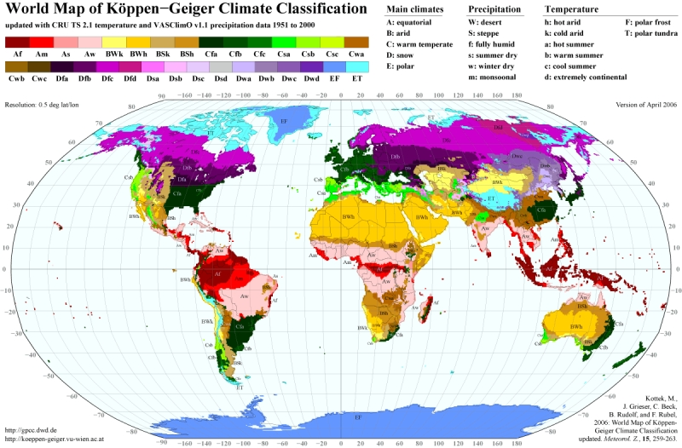

Spatial resolution: 5 arc minutes

Time: 25-year period 1986-2010

Climate Code

ID climate  
1 1 Af  
2 2 Am  
3 3 As  
4 4 Aw  
5 5 BSh  
6 6 BSk  
7 7 BWh  
8 8 BWk  
9 9 Cfa  
10 10 Cfb  
11 11 Cfc  
12 12 Csa  
13 13 Csb  
14 14 Csc  
15 15 Cwa  
16 16 Cwb  
17 17 Cwc  
18 18 Dfa  
19 19 Dfb  
20 20 Dfc  
21 21 Dfd  
22 22 Dsa  
23 23 Dsb  
24 24 Dsc  
25 25 Dsd  
26 26 Dwa  
27 27 Dwb  
28 28 Dwc  
29 29 Dwd  
30 30 EF  
31 31 ET  
32 32 Ocean

|  |  |  |  |
| --- | --- | --- | --- |
| **Main climates** | **Precipitation** | **Temperature** |  |
| A：equatorial | W：desert | h：hot arid | F：polar frost |
| B：arid | S：steppe | k：cold arid | T：polar tundra |
| C：warm temperate | f：fully humid | a：hot summer |  |
| D：snow | s：summer dry | b：warm summer |  |
| E：Polar | w：winter dry | c：cool summer |  |
|  | m：monsoonal | d：extremely continental |  |