**Identify Reasons Why Fitness Clubs Lose Customer**

1. State the problem described by the client & desired outcomes.
   1. Problem: What should Fitness Clubs do to retain monthly subscribers? Will a new marketing strategy of converting customer payment mechanisms or targeting different type of customers help Fitness Clubs maintain monthly customer base? How can the new strategy improve economic impact to the Fitness Clubs?
   2. Desired outcomes: Converting payment type and targeting different type of customers are good strategies that Fitness Clubs should perform in order to maintain customer base and increase monthly revenue.
2. Describe your hypothesis identifying the business drivers (influences).
   1. Influences: payment type, targeting customers (gender, age..)
3. Identify data issues that might influence model selection.
   1. Missing data in current database: according to the given data, the value of customer’s age is missing
   2. Unclear description: missing the description for the data (for example, we do not know if 1 represent female or male in the gender column)
   3. Other data that might be included in the database:
      1. Overall store traffic (per day/per month)
      2. Customer rating about their experience in the Fitness Club
      3. Loyalty program (if any). To be specific, identify if the customer in the system sign in to the program or not (illustrated by Y/N). Track if customers like the loyalty program or not (rating). Cost & benefit analysis of the loyalty program (how much does Fitness Club sacrifice for this program per person, and in average, how many new customers one existing customer bring because of the good experience on loyalty program)
      4. Economy & market (do horizontal comparison with other fitness business, and collect data such as price, down payment across the industry)
      5. Customer arriving & leaving time (in order to further targeting valuable customers, Fitness Club should choose the best time to open in order to balance the cost and benefit)
4. Identify all factors that might influence model selection process
   1. Accuracy of data
   2. Data availability and cost to make data ready to use
   3. Data privacy and confidentiality
   4. Resources, infrastructure and tools availability
   5. Method of payment

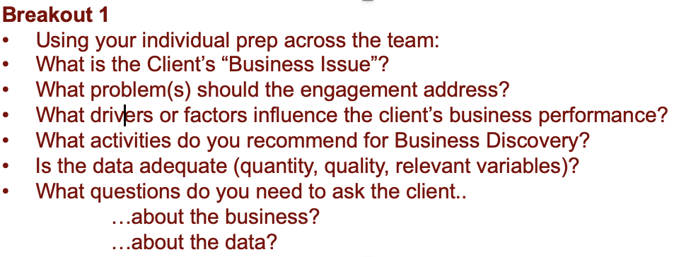

* Creating the new marketing strategy
* Price

activities in business discovery:

* Organizational insight questions:
  + Describe the main functional domains within your organization
* Business environment analysis
  + What changes did your organization observe in its environment the last years? Either general trends, or specific changes.
  + How did – or will – your organisation respond to these changes?
  + Describe the market / environment according to Porter’s 5-forces model:Describe the main functional domains within your organization
* Stakeholders, stakes & interactions
* What is the Client’s “Business Issue”?

This fitness club is having problems with retaining members. People are signing up and after a certain period leaving, but they have not been able to pinpoint why this is happening.

* What problem(s) should the engagement address?

What should Fitness Clubs do to retain monthly subscribers? Will a new marketing strategy of converting customer payment mechanisms or targeting different types of customers help Fitness Clubs maintain monthly customer base? How can the new strategy improve economic impact to the Fitness Clubs?

* What drivers or factors influence the client’s business performance?
* Payment type
* Pricing
* Targeting Customers (age, gender..)
* Customer experience
* What activities do you recommend for Business Discovery?

interview the customers and management team inside the Fitness club

* Is the data adequate (quantity, quality, relevant variables)?
  + Missing data in current database: according to the given data, the value of customer’s age is missing
  + Unclear description: missing the description for the data (for example, we do not know if 1 represents female or male in the gender column), how many clubs in the dataset? Is it only one or multiple
  + Other data that might be included in the database:
    - Overall store traffic (per day/per month)
    - Customer rating about their experience in the Fitness Club
    - Loyalty program (if any). To be specific, identify if the customer in the system signed in to the program or not (illustrated by Y/N). Track if customers like the loyalty program or not (rating). Cost & benefit analysis of the loyalty program (how much does Fitness Club sacrifice for this program per person, and in average, how many new customers one existing customer bring because of the good experience on loyalty program)
    - Economy & market (do horizontal comparison with other fitness business, and collect data such as price, down payment across the industry)
    - Customer arriving & leaving time (in order to further targeting valuable customers, Fitness Club should choose the best time to open in order to balance the cost and benefit)
* What questions do you need to ask the client..

  …about the business?

  …about the data?

