**互感器测试报告**

|  |  |  |  |
| --- | --- | --- | --- |
| **互感器类型:** | **电流互感器** | **CT编号:** | **1758** |
| **试验项目:** | **电阻、励磁、变比/极性** | **绕组编号:** | **1S1-1S2** |
| **线路编号:** | **DDG113H01** | **试验时间:** | **2023-11-03 11:35:59** |
| **相别:** | **A** |  |  |

**CT试验参数:**

|  |  |  |  |
| --- | --- | --- | --- |
| **参数名** | **值** | **参数名** | **值** |
| **额定二次电流Isn:** | **5 A** | **额定一次电流:** | **?** |
| **级别:** | **P** | **额定负荷:** | **?** |
| **当前温度:** | **25 ℃** | **功率因数:** | **?** |
| **额定频率:** | **50 Hz** | **额定准确限值系数ALF:** | **?** |
| **最大测试电流:** | **10 A** |  |  |

**电阻信息:**

|  |  |  |  |
| --- | --- | --- | --- |
| **结果** | **值** | **结果** | **值** |
| **电阻[25 ℃]** | **0.8952 Ω** | **电阻[75 ℃]:** | **1.071 Ω** |

**励磁信息:**

|  |  |  |  |
| --- | --- | --- | --- |
| **结果** | **值** | **结果** | **值** |
| **拐点电压Vkn:12** | **183.8 V** | **不饱和电感Lu:** | **9.313 H** |
| **拐点电流Ikn:** | **0.07504 A** | **剩磁系数Kr:** | **0.672** |
| **极限电动势Eal:** | **?** | **二次时间常数Ts:** | **?** |
| **复合误差εal:** | **?** | **实测准确限值系数ALF:** | **?** |

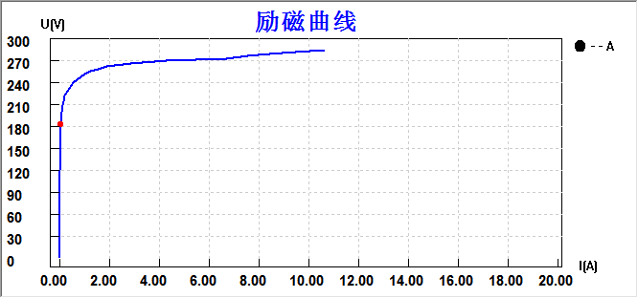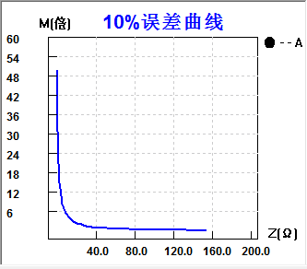

**励磁取整数据:**

|  |  |  |  |  |  |
| --- | --- | --- | --- | --- | --- |
| **序号** | **电压(V)** | **电流(A)** | **序号** | **电压(V)** | **电流(A)** |
| **拐点** | **183.8 V** | **0.07504 A** | **12** | **251.675** | **1.00000** |
| **1** | **9.11349** | **0.00500** | **13** | **263.572** | **2.00000** |
| **2** | **22.7286** | **0.01000** | **14** | **267.639** | **3.00000** |
| **3** | **56.3226** | **0.02000** | **15** | **270.015** | **4.00000** |
| **4** | **155.598** | **0.05000** | **16** | **271.567** | **5.00000** |
| **5** | **198.997** | **0.10000** | **17** | **272.864** | **6.00000** |
| **6** | **219.180** | **0.20000** | **18** | **274.908** | **7.00000** |
| **7** | **238.155** | **0.50000** | **19** | **278.159** | **8.00000** |
| **8** | **241.778** | **0.60000** | **20** | **280.986** | **9.00000** |
| **9** | **244.865** | **0.70000** | **21** | **283.477** | **10.0000** |
| **10** | **247.451** | **0.80000** | **22** | **284.772** | **10.5488** |
| **11** | **249.688** | **0.90000** |  |  |  |

**误差10%实测数据:**

|  |  |  |  |  |  |
| --- | --- | --- | --- | --- | --- |
| **序号** | **10%->Z[Ω]** | **10%->M[倍]** | **序号** | **10%->Z[Ω]** | **10%->M[倍]** |
| **1** | **148.249** | **0.282** | **17** | **5.347** | **8.475** |
| **2** | **129.314** | **0.330** | **18** | **3.062** | **13.312** |
| **3** | **112.069** | **0.388** | **19** | **2.651** | **14.936** |
| **4** | **97.450** | **0.453** | **20** | **2.279** | **16.759** |
| **5** | **84.574** | **0.529** | **21** | **1.944** | **18.803** |
| **6** | **71.607** | **0.634** | **22** | **1.642** | **21.098** |
| **7** | **59.889** | **0.768** | **23** | **1.395** | **23.207** |
| **8** | **50.054** | **0.931** | **24** | **1.171** | **25.528** |
| **9** | **41.644** | **1.133** | **25** | **0.967** | **28.081** |
| **10** | **34.325** | **1.390** | **26** | **0.782** | **30.889** |
| **11** | **28.605** | **1.683** | **27** | **0.614** | **33.978** |
| **12** | **23.903** | **2.028** | **28** | **0.460** | **37.376** |
| **13** | **19.738** | **2.472** | **29** | **0.321** | **41.113** |
| **14** | **15.897** | **3.070** | **30** | **0.195** | **45.225** |
| **15** | **13.002** | **3.757** | **31** | **0.080** | **49.747** |
| **16** | **8.413** | **5.664** |  |  |  |

**误差10%取整数据:**

|  |  |  |  |  |  |
| --- | --- | --- | --- | --- | --- |
| **序号** | **10%->Z[Ω]** | **10%->M[倍]** | **序号** | **10%->Z[Ω]** | **10%->M[倍]** |
| **1** | **10.010** | **5.0000** | **7** | **1.2219** | **25.000** |
| **2** | **6.4104** | **7.5000** | **8** | **0.8405** | **30.000** |
| **3** | **4.6265** | **10.000** | **9** | **0.5676** | **35.000** |
| **4** | **3.6817** | **12.000** | **10** | **0.3624** | **40.000** |
| **5** | **2.6379** | **15.000** | **11** | **0.2018** | **45.000** |
| **6** | **1.7864** | **20.000** | **12** | **0.080** | **49.747** |

**变比信息:**

|  |  |  |  |
| --- | --- | --- | --- |
| **结果** | **值** | **结果** | **值** |
| **变比:** | **397.8 : 5.0000** | **比值差:** | **?** |
| **匝数比:** | **79.563** | **相位差:** | **?** |
| **极性:** | **同极性/－** |  |  |

实 验 人 : ______________

审 核 人 : ______________

校 阅 人 : ______________