root@master:/opt/playbook# cat rabbitmq.yml
---
- hosts: web
become: yes

vars:
rabbitmq_users:
- { name: "admin", password: "admin", tags: "administrator" }
- { name: "openstack", password: "openstack", tags: "" }

tasks:

- name: 设置主机名为 ctrl
hostname:
name: ctrl

- name: 安装 RabbitMQ Server
apt:
name: rabbitmq-server
state: present
update_cache: yes

- name: 启动并启用 RabbitMQ
service:
name: rabbitmq-server
state: started
enabled: yes

- name: 启用 RabbitMQ 管理插件
command: rabbitmq-plugins enable rabbitmq_management
args:
creates: /etc/rabbitmq/enabled_plugins

- name: 创建 RabbitMQ 用户
shell: |
rabbitmqctl add_user {{ item.name }} {{ item.password }} || true
rabbitmqctl set_permissions -p / {{ item.name }} ".*" ".*" ".*"
{% if item.tags %}
rabbitmqctl set_user_tags {{ item.name }} {{ item.tags }}
{% endif %}
loop: "{{ rabbitmq_users }}"
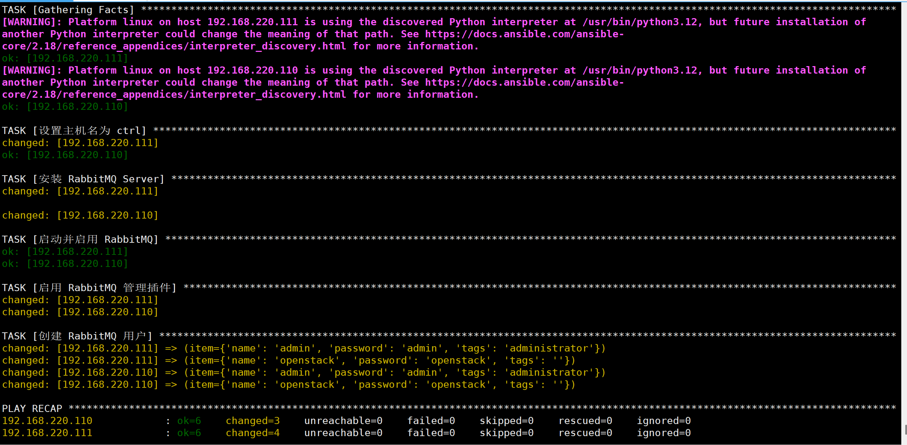
root@master:/opt/playbook# cat install_php.yml
---
- name: Install PHP 8.3 and required extensions
hosts: hosts
become: true

vars:
php_packages:
- php
- php-cli
- php-common
- php8.3-fpm
- php-mysql
- php-xml
- php-curl
- php-gd
- php-mbstring
- php-zip

tasks:
- name: Update apt cache
ansible.builtin.apt:
update_cache: yes

- name: Install PHP and extensions
ansible.builtin.apt:
name: "{{ php_packages }}"
state: present

- name: Start and enable php8.3-fpm
ansible.builtin.service:
name: php8.3-fpm
state: started
enabled: true
