Paper PA-04

The Hitchhiker’s Guide to Github: SAS Programming Goes Social

Jiangtang Hu

d-Wise Technologies, Inc., Morrisville, NC

ABSTRACT
Don't Panic! Github is a fantastic way to host, share, and collaborate your codes (of course, SAS included). You will like it: first, it’s totally free (for all public repositories); and second, it has an easy use GUI client, Github for Windows if you work in Windows OS and you don’t feel comfortable to write Git commands on which Github is based. There is no additional installation and configuration needed to use Github.
In this paper, I will go through Github client set up and how to create a repository, push files online and how to go social by following a user, watch a repository and most important, fork a repository and make pull request.

Introduction
SAS programmers have pretty much social network systems to play around, such like Linkedin, Facebook and SASCommunity.org, while SAS programs, scatters around SAS-L, blogs, personal websites and conference papers. Recent years, more and more SAS programmers put their piece of codes to online programming collaborative systems and Github, is the most popular one among them.
In a nutshell, Github in the world of online code hosting and version control system is just like Dropbox in file sync service, or Gmail in email. They are all best in their vertical markets. Getting a free account of Github (yes, it’s FREE), you then get a web-based hosting service and a Git based version control system. The intriguing part of Github is that you even don’t need to know anything about Git commands to begin your social programming journey.
A side story. In October 2012, FDA/PhUSE Standard Script Working Group decided to use Google Code, another online code hosting service (https://code.google.com/p/phuse-scripts/) to distribute “standard scripts for data transformations and analyses across and/or within a therapeutic area and exploratory analysis”. Google Code is good, but I hate to say, the group didn’t made a good choice. Half a year later, Google Code planned to kill its download services ([3]).
The lesson is, use Github!

A. Set Up

A.1 Get a Free Github Account
To begin with, sign up a free Github account at:
https://github.com/

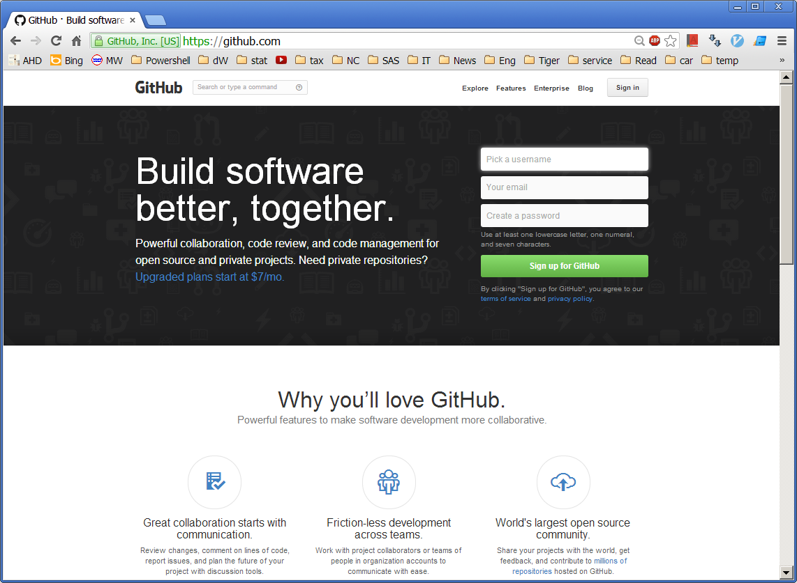
A free account can get unlimited public repositories and spaces. You should pay for private repository, but for social programming, the free account is enough (and a MUST somehow).

A.2 Set Up Client
Actually you do not need to install Git software literally to play with Github, also you can forget about SSH, Putty and such (if you don’t understand what they mean, just skip them and you’re good). Github offers a wonderful clients, “Github for Windows”, which is the easiest way to play with Github in Windows machines:
http://windows.github.com/
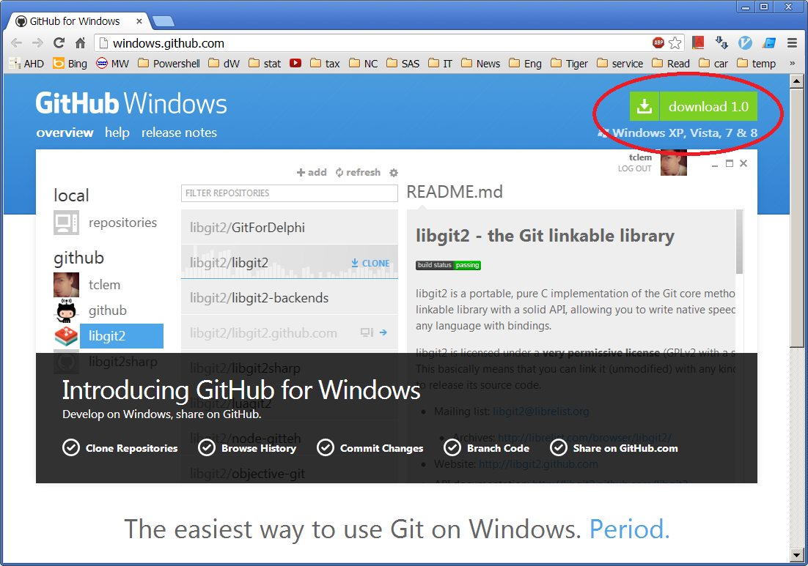
Download the installer then install it with default options and you’re set. You will get two components, a Git Shell (if you want to play cool but not required) and a client (which is what we need to keep move):
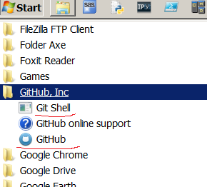
By the way, there is also a bonus by installing “Github for Windows”: you will also get a basic Linux shell (anyway, it won’t hurt):

B. Get Started

B.1 Log into Client
Launch the program “Github” and enter the credentials (your Github account) then hit “LOG IN”:

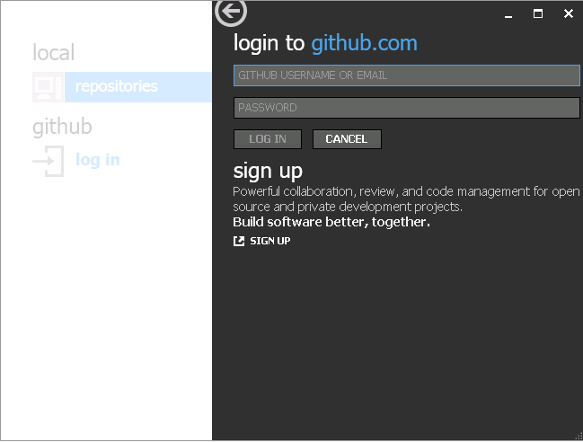

B.2 Create a Repository
To start over, create a new repository by clicking “create” (or “add” in old versions):

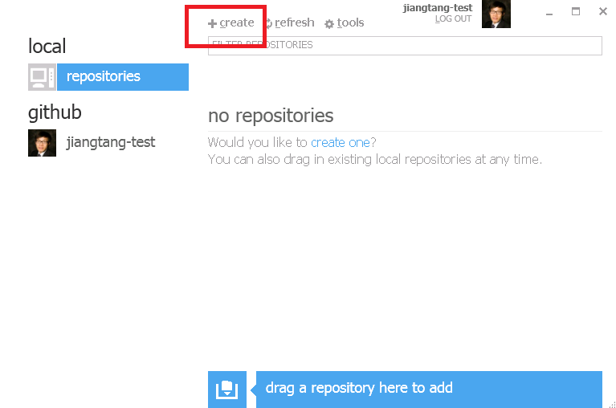

Then fill out all the requirements:
NAME: name of the repository (a name for a folder in Windows Explore);
DISCRIPTION: optional;
Directory: Don’t touch; use default.

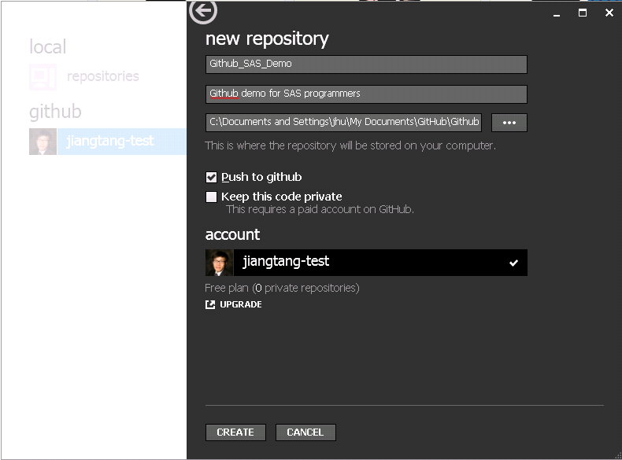

Return to Windows Explore (C:\Documents and Settings\<YOUR_ID>\My Documents\GitHub\), and you will see a folder was created:
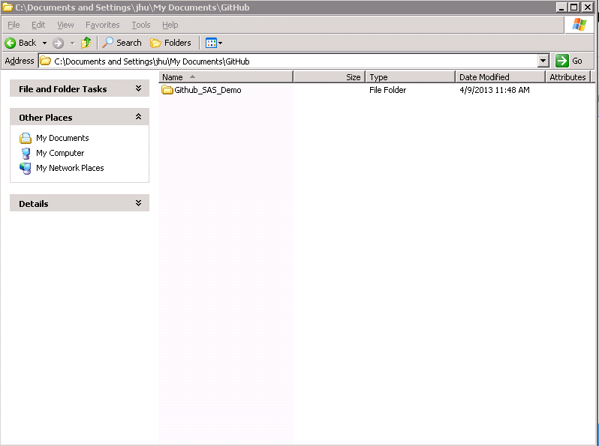
Open the folder, there are some initial setting files. Ignore them.

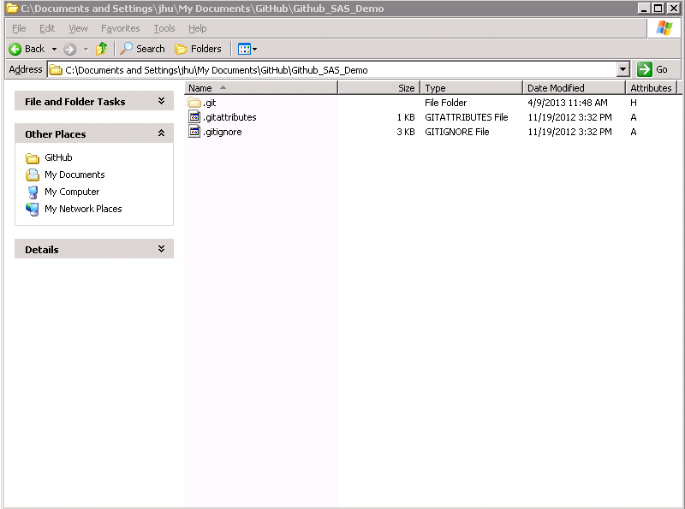

B.3 Push First File
It is conventional to add a “read me” file for your repository to address anything you want your readers know about. Github supports Markdown, so you can simply add a readme.txt or readme.md if you prefer the rich format by Markdown.
In the following demo, I use my favorite text editor Notepad++ to create a readme.md:

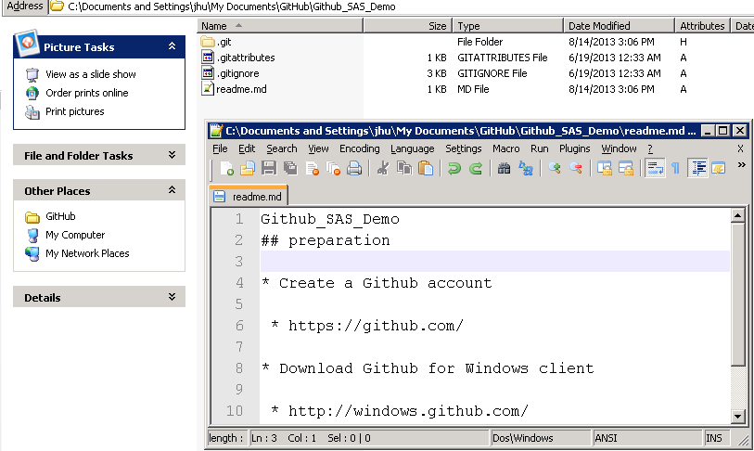

Then launch the Github client and navigate into the repository:

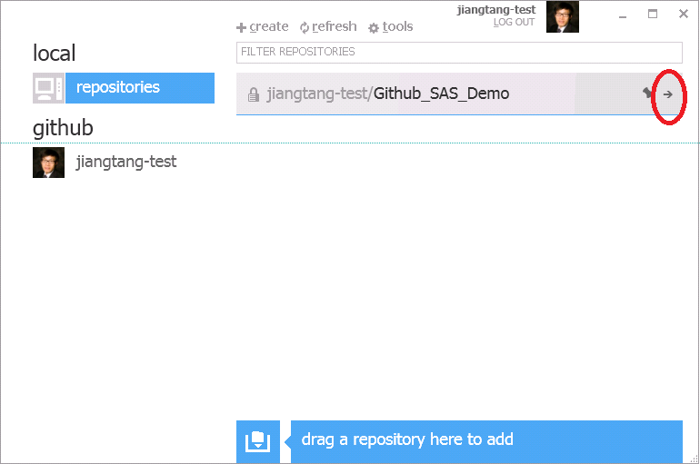

You will see all new files in the local repository are marked as “New” which you are supposed to push to the server:
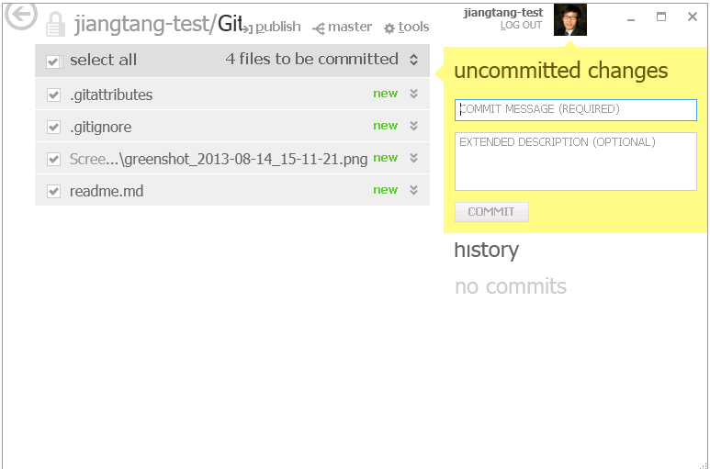

Write something as commit comments and click “COMMIT”:
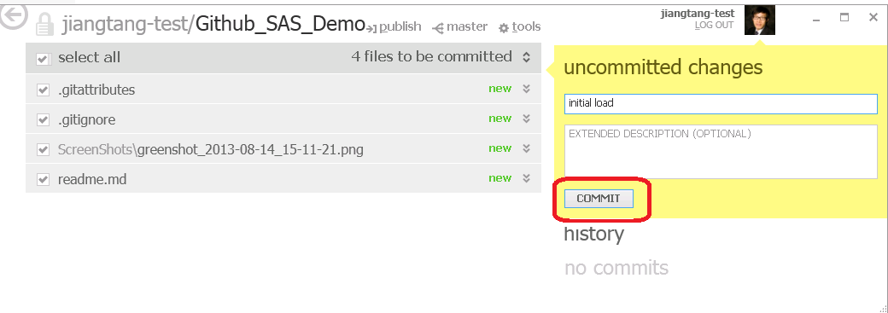

The “COMMIT” action will keep track your code in the local repository (in your Github folder). To make it universally accessible (in the server, or “remote repository” which you can browse online), click “Publish”:
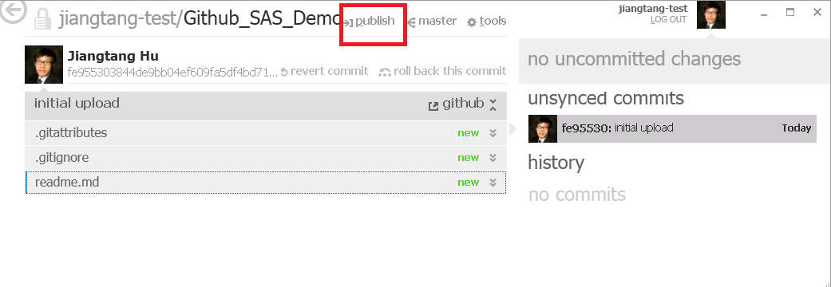
This “Publish” action (after “COMMIT”) will push your locally committed files to the remote repository (which is Github hosted). If all goes well, you will see gray “in sync” indicating your local files are in sync with the server:

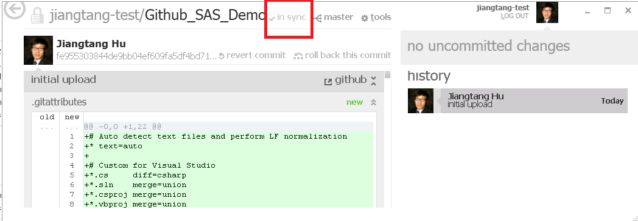

To check it, open a web browser to navigate to Github.com by supplying your credentials:

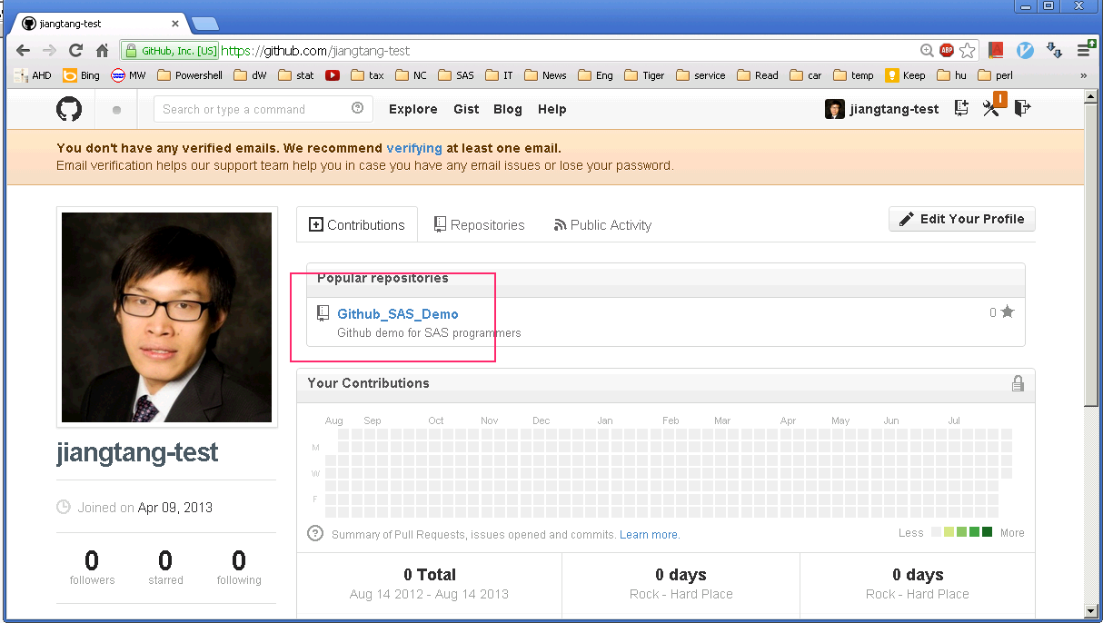

Navigate the repository you just created and you will find all your committed files (and the readme.md looks good):
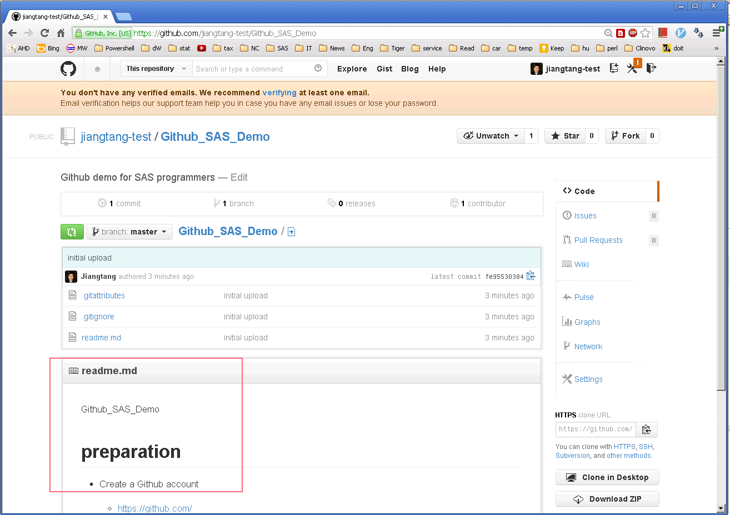

B.4 Summary
If you only need a closed version control and web hosting system, the above is all you needed:
- Create and edit files on your local machine
- If you feel good for the files, launch the Github client, click the following two buttons in sequence
  - “COMMIT” all modification against the files and then
  - “Publish” them to the server

C. Play Around and Be Social

If you want to play cool and take the best advantage of Github, you will learn how to interact with other users worldwide. Literally, you can follow a user, watch a repository, clone a repository and, the most exiting (while little ambiguous) action, fork a repository (you will get it soon).

C1. Follow A User
In Github website, find anyone you are interested in and click “Follow” in their Github homepage:
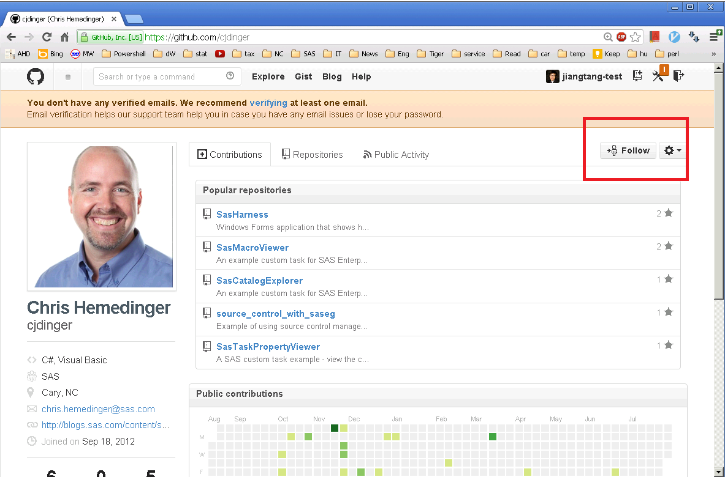

By following a user, you will get all the notifications about his/her GitHub activities on your online dashboard:
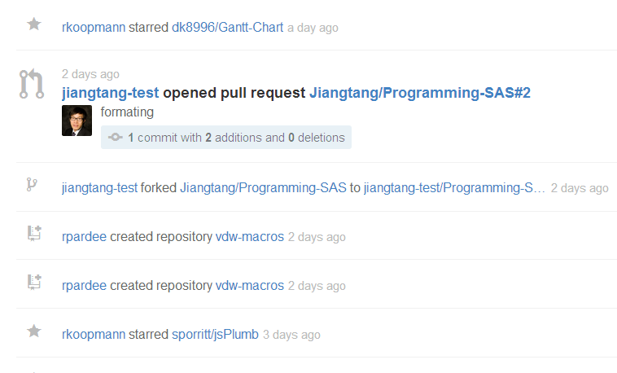

C2. Watch A Repository
You can also watch a repository by click “Watch” in a repository page if you want to keep tuned with any activities against a specific project:

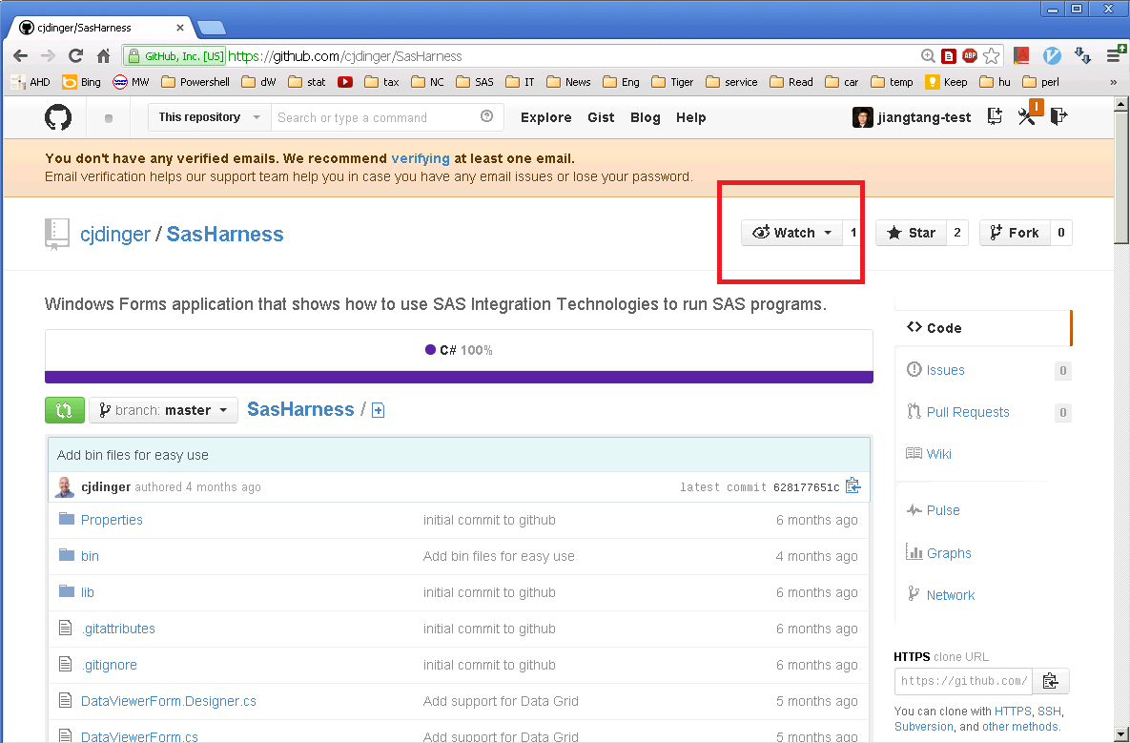

C3. Clone A Repository
You can clone a repository from other user if you need a local copy. Navigate a repository online, click “Clone in desktop”:
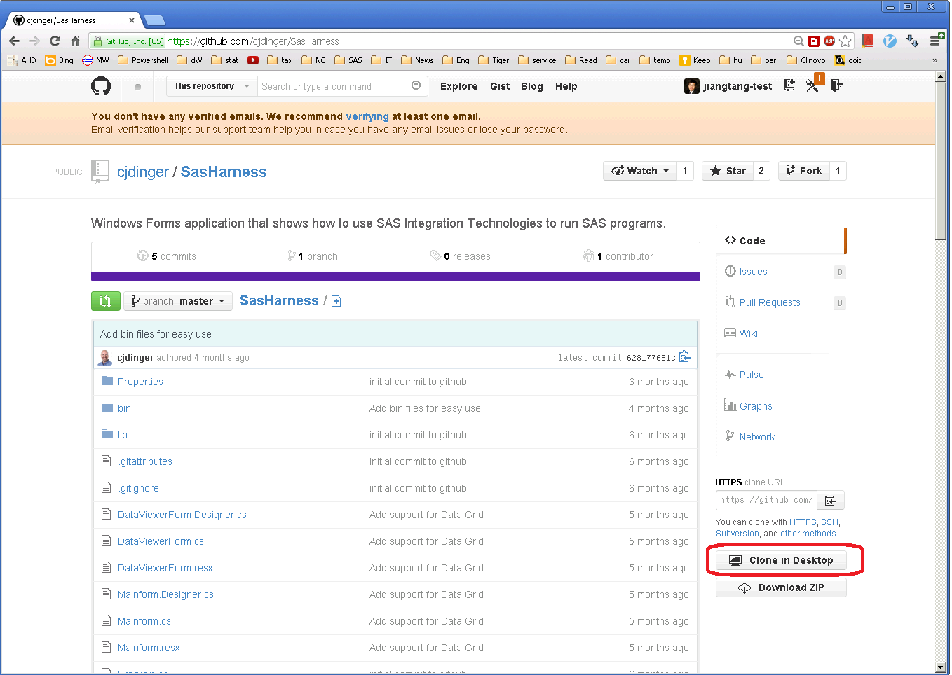

If you happen to have used a SVN system, the “Clone” is just like the ”Check out” action. You will get a local copy (with all committed information) in your Github folder (C:\Users\<Your_ID>\Documents\GitHub\).
You can also get a compress file by clicking “Downloaded ZIP”: you just get a local copy in your download folder (like C:\Users\<Your_ID>\Downloads) but without the committed comments.

C4. Fork A Repository
The heart of Github social programming is the concept of “Fork”. To participate a project through a traditional version control system like CVS and SVN, you server as a collaborator after you get the permissions: you can make modification to the original works or you can make a “Branch” away from the original repository (and if all goes well, you can push your branch back to the original work, again, if you have permissions).
Github can do this way, mostly in private repositories. Here is the modern Web 2.0 way:
- You “Fork” a repository in a repository homepage by click “Fork”. To fork a repository is like making a “branch” somehow but not exactly the same. You should have permissions to make a branch, but you don’t even need to notice the original owners (but they can get it through dashboard).
- To fork is to make a connection and to get a remote repository. You still need a local repository. As showed in section C3, you click click “Clone in desktop”.
- You modify the local copy just like your own files: commit them, publish them (to your own Github page). You can also get synced from the original development.
- If you feel obligated that the original developer should incorporate some of your modifications, you make a “pull request” online. The owner will see it and if he/she feels good, the modifications will be pushed back to the original work by clicking a “yes” button (the “merge” process).

Here I play with two accounts, “Jiangtang” and “Jiangtang-test”.
User “Jiangtang-test”: navigate to a Jiangtang’s repository and click “Fork”:
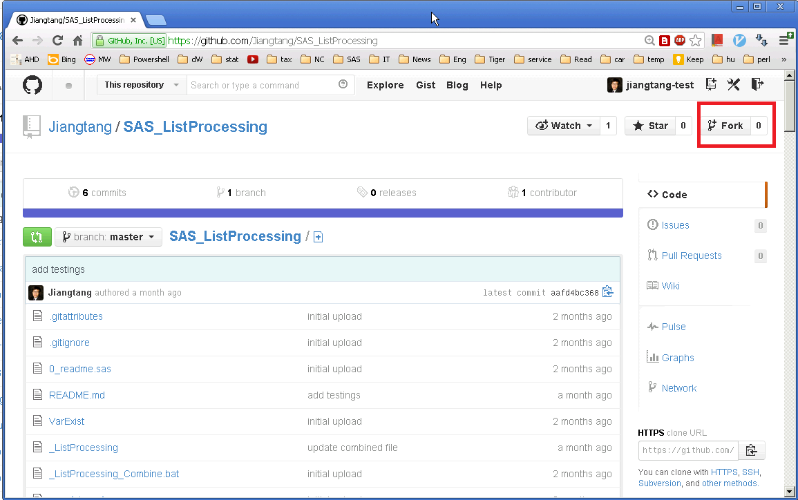

After a while, Jiangtang-test will get a same repository but under his name and it is totally isolated with the original work:

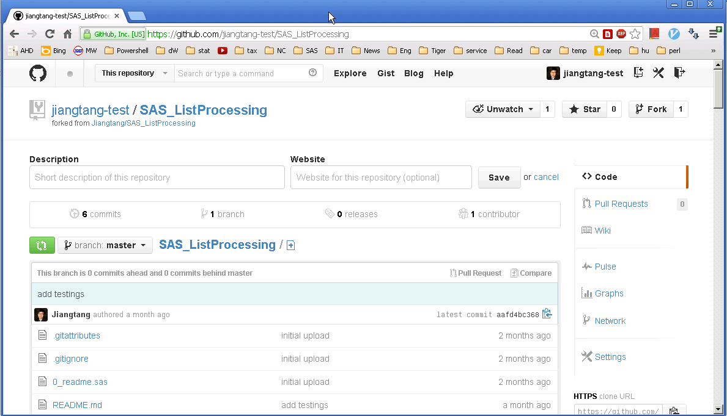

The forked repository will also be showed up in the Github client. Jiangtang-test can clone it to a local repository by click “CLONE”:
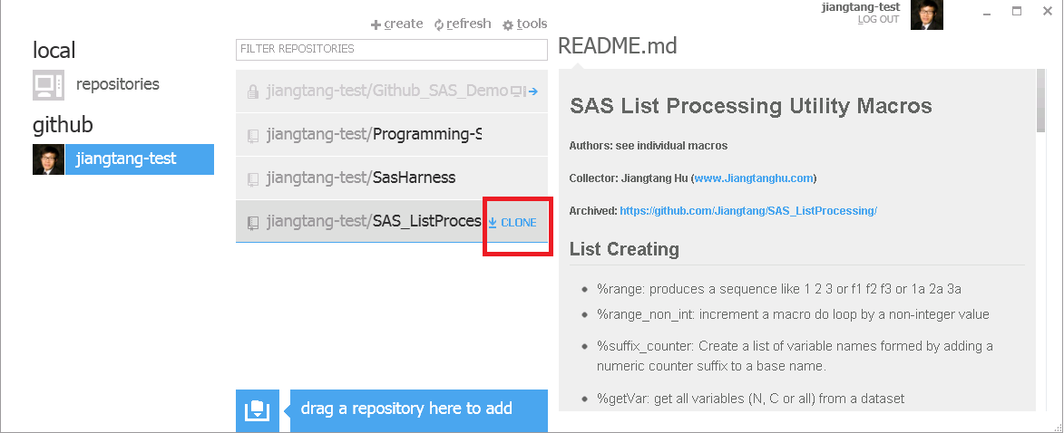

Then you will get a local copy:
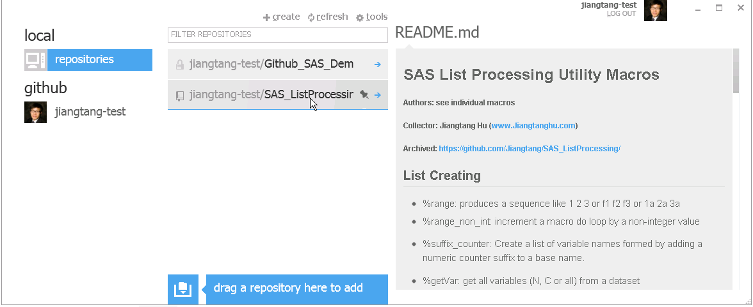

Jiangtang-test adds a “of” in Line 17 of README.md:
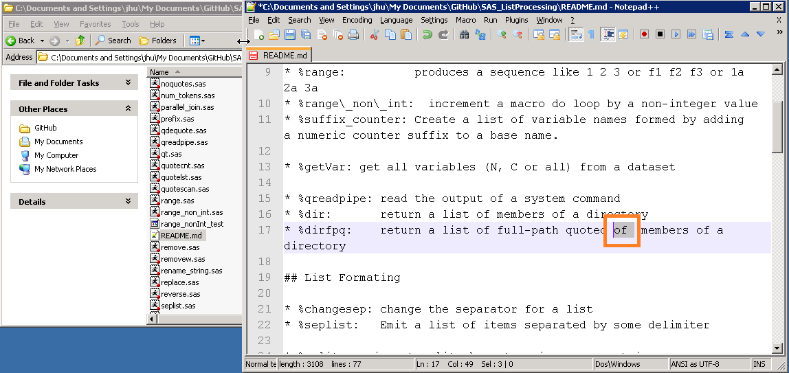

Jiangtang-test then commits it and syncs it with remote repository. After that, he opens this repository in his Github page and want to make this modification available to the original developer (Jiangtang) by clicking “Pull Requests” and then “New pull request”:

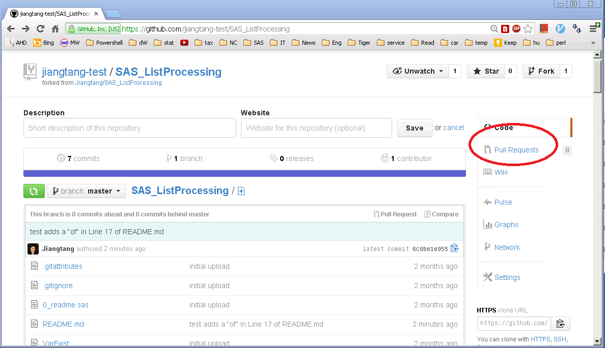

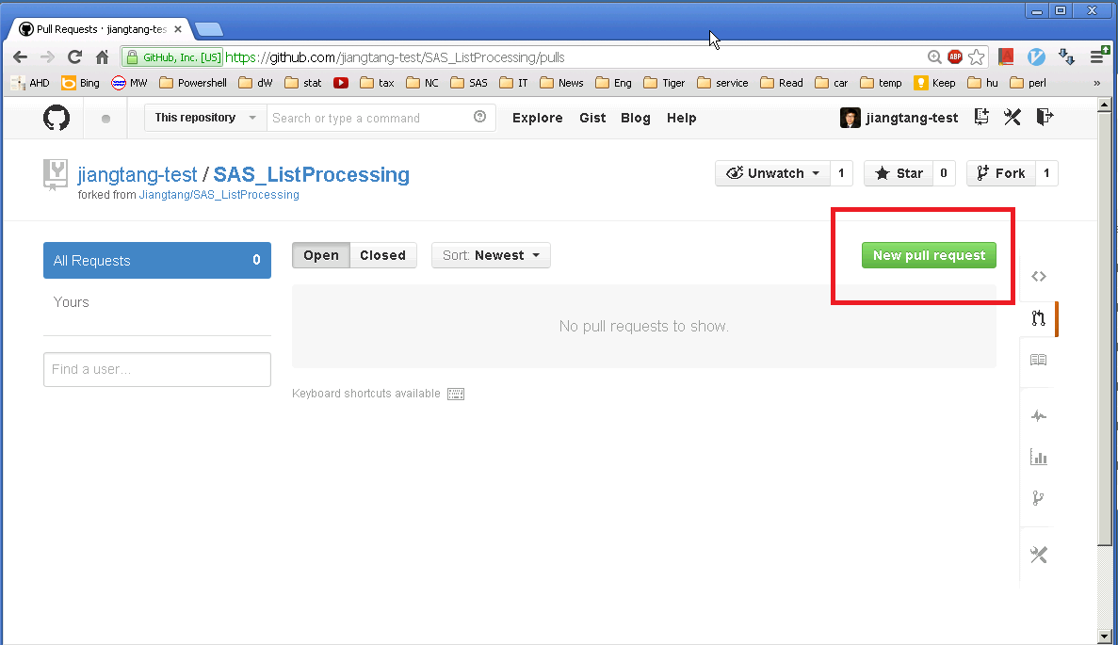

After clicking “New pull request”, Jiangtang-test can take a look at the modification made and then “Click to create a pull request for this comparion”:

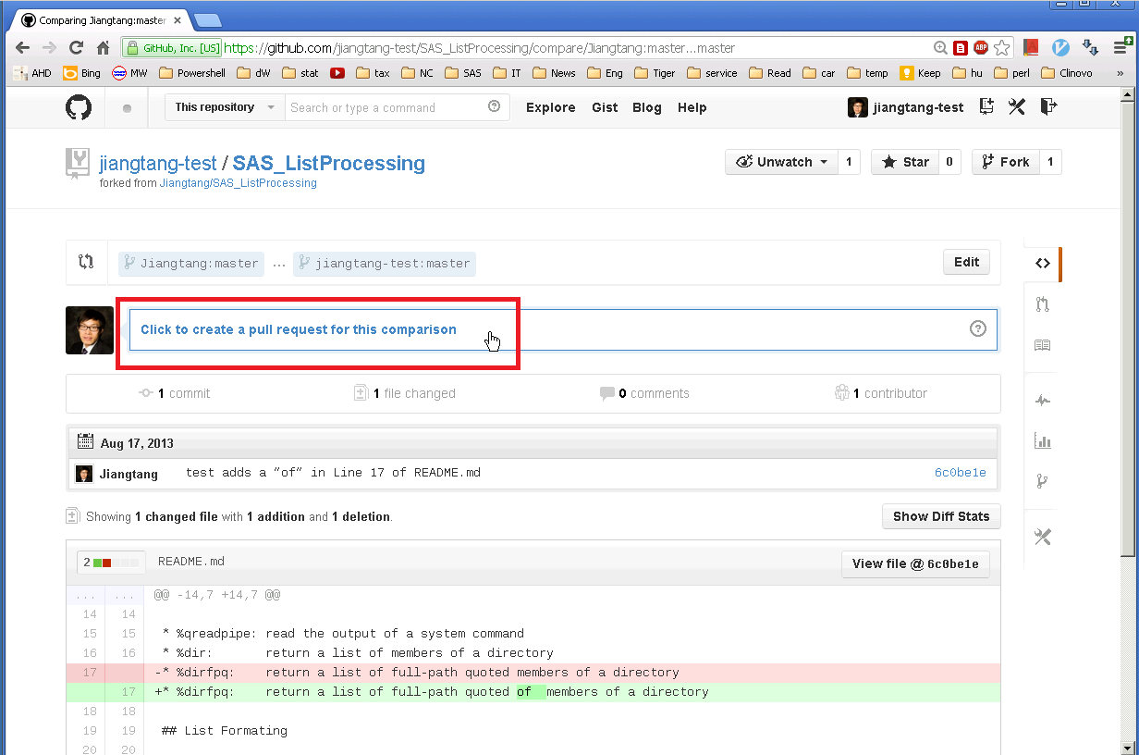
After filling out the request form, Jiangtang-test clicks “Send pull request” and wait for Jiangtang’s response:
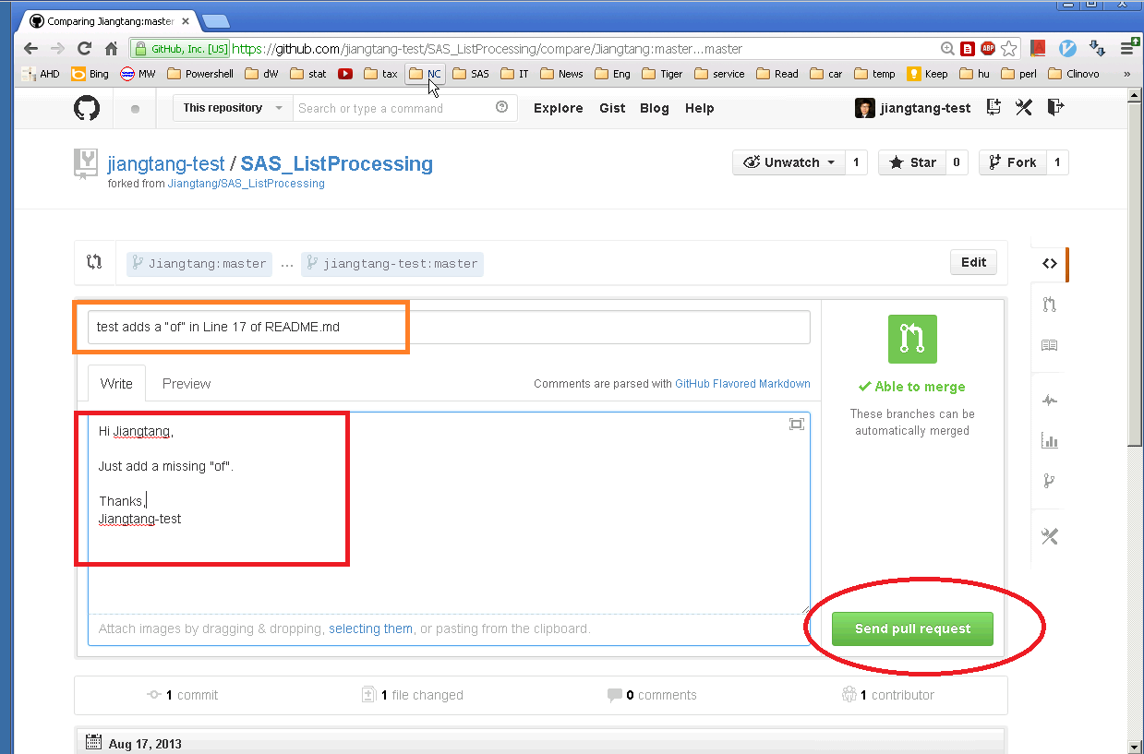

Now Jiangtang’s turn. Jiangtang opens his Github page as usual and gets a notification in the dashboard (also in email) that a pull request is waiting for moderate:
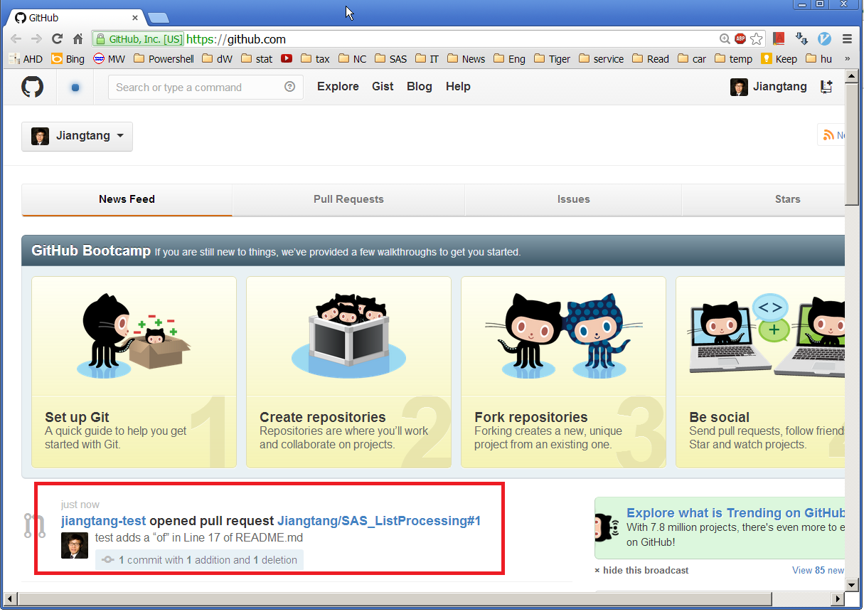

Jiangtang opens this thread for details. Jiangtang thinks such modification makes sense then click “Merge pull request” to merge the new edits:
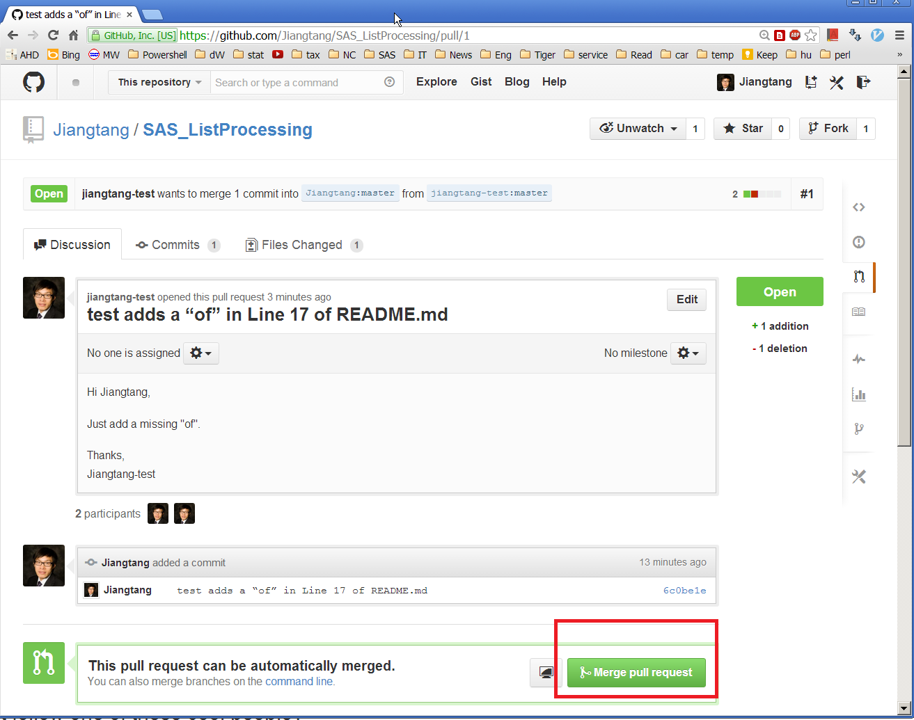

If Jiangtang doesn’t think it’s good, he can just cancel it.

C5. Sumarry

To clone is to make a local repository.
To fork is to make a remote (online) repository.
To work smoothly, fork then clone. Make modifications on local copies, commit them, and publish them. To participate, make a “pull request” to the original repository.

D. What’s to Do Next
Everything is online and it’s quick and simple. Get a Github account, publish your codes repository, find someone (watch them) and/or some projects interesting (fork them) and you’re all set.

CONCLUSION
As a user, I tried SVN, CVS while Git (via Github) is the most intuitive service I even got. To begin with the wonderful client, Github for Windows, you will the amazing part of Git/Github is that it’s uncreditable easy and efficient.
Have fun.

References
[1] An Introduction to Git Version Control for SAS Programmers by Stephen Philp (WUSS 2012)
[2] Github online help
https://help.github.com/
[3] Google Code planned to kill its download services
http://google-opensource.blogspot.com/2013/05/a-change-to-google-code-download-service.html

ACKNOWLEDGMENTS
Very appreciate the encouragement from Yihui Xie to convince me to get start with Git and Github.

Contact Information
Your comments and questions are valued and encouraged. Contact the author at:
Jiangtang Hu
Life Sciences Consultant
d-Wise Technologies, Inc.
1500 Perimeter Park Dr., Suite 150, Morrisville, NC, 27560
www.d-Wise.com

(O) 919-334-6096
(C) 919-801-9659
(F): 888-563-0931
(O) Jiangtang.Hu@d-Wise.com
(P) jiangtanghu@gmail.com
http://jiangtanghu.com/

SAS and all other SAS Institute Inc. product or service names are registered trademarks or trademarks of SAS Institute Inc. in the USA and other countries. ® indicates USA registration.
Other brand and product names are trademarks of their respective companies.

