Paper SD102

When Bad Things Happen to Good SAS Programmers

Jiangtang Hu

d-Wise, Morrisville, NC

ABSTRACT
It’s not the doom days for SAS programmers by any means, but we can’t call it Golden Age anymore. As SAS programmers in their daily work, they face the much more aggressive control from IT department: they might not be able to use their favorite text editors to write/edit SAS codes, and they might even have no choices of the SAS interface to run the codes but have to the stick to the new game in town like SAS Enterprise Guide, SAS Studio, SAS Data Integration Studio, SAS Drug Development.
In the external world, SAS language itself is facing the strong completion from R, Python and it raises the even more profound question: would SAS programmers as profession exist in the near future? We can see the volumes of traffic in main SAS mailing list is slow down, the bloggers in SAS are not active as before and even worse, the SAS user conferences at all levels are also facing challenges of funding and participations.
In this paper, I will not focus on “why” these bad things happened, but rather launch an open discussion on how we SAS programmer response to these challenges when the bad things happened or is happening.

Introduction

It is year of 2015!
If you kept eyes on SAS blogsphere like me, you might read a wildly discussed blog post by Bob Muenchen in 2012, titled as ‘Will 2015 be the Beginning of the End for SAS and SPSS?’ [1]. And in 2013, Bob might collect more evidence and have much more confidence and he even declared that, ‘Will 2014 be the Beginning of the End for SAS and SPSS?’[2]
As a SAS programmer, I know today is not the end of SAS by any means, but I do appreciate Bob’s insights on how R and even Python affect the SAS user base. Besides the external threat, some internal IT deployment and even SAS Institute itself which owns the proprietary software, is deeply impacting the SAS user ecosystem. In this paper, I will present some personal observation (which can’t be regarded as solid statistical survey) on some ‘bad’ things for SAS programmers. The purpose is rather to encourage discussions on SAS as software and SAS programmers as career.

Change Management!!!!!!!!!!!!!!!!!!!!!!!!!!!!!!!!!!!!!!!!!!!!!!!!!!!!!!!!!!!!!!!!!!!!!!!!!!!!!!!!!!!!!!!!!!!!!!!!!!!!!!!!!!!!!!!!!!!!

A. Internal Chanllenges

A.1 IT
I have heard lots of complains from SAS programmers on how IT department restrict the way they work. The bad things includes:
- Your favorite text editors were not installed/available in the new computing system;
[JT] It’s bad. I love my favorite text editors (namely, Notepad++, Vim and Sublime Text) available in any machines I work. If not, I will
- Ask IT for system security requirement and if they can help to install any open source text editors. In some instances, you can even do it by yourself (ask first of course) to just move the green version of Notepad++, Vim and Sublime Text to the new system.
- If the IT policy is very strict, please spend some time to explore the advanced editing features of SAS Display Manager, Enterprise Guide, SAS Studio or any interfaces available. They might not be productive as your favorite text editors, but first it’s nice to have and second, even the old Display Manager can do column selection, parentheses matching and other cool stuff.
- You can’t use the traditional SAS Display Manager anymore to write, interactively debug your SAS codes and check temporary datasets. The new and only interface to write SAS codes is now SAS Enterprise Guide, or SAS Studio. It takes time to switch and most frustrated thing is, the whole customized configurations in the Display Manager can’t be migrated to the new interfaces.
[JT] The advantage of SAS Enterprise and SAS Studio is they are very controllable and resource-respecting from IT point of view. I love to have Display Manager as choice, but unfortunately, SAS Enterprise and SAS Studio are the future. To be fair, SAS Studio is still on development, but Enterprise Guide is pretty mature product and it’s the modern IDE compared to the old Display Manager. Sometimes we SAS programmers just change, with or without any nostalgia.

One of the pain of the transition is we lost lots of customized configurations in Display Manager. Some stuff can’t migrated like the editor settings, autoexec macros, while others are not, like customized toolbar. Explore Enterprise Guide (or SAS Studio) and make the pain as minimal as possible.

- Even worse, the only SAS editor available for you to complete your SAS job is SAS Drug Development, or SAS Data Integration Studio.
[JT] I must say it’s terrible terrible terrible. If had choice, I would rather to avoid it. If it’s the only card you can play,
- Utilize your local favorite text editors or even SAS editors
- Modularize your codes/jobs, and make the exposal to SAS Drug Development or SAS Data Integration Studio at minimal level

A.2 Outsourcing
It’s about job security and I don’t have much to say. It’s about personal skills and sometimes, luckiness. Fortunately, the market for programming and analysis is still booming, and if you can’t get it here, you can get it somewhere else.

B. External Chanllenges

B.1 Competors: R
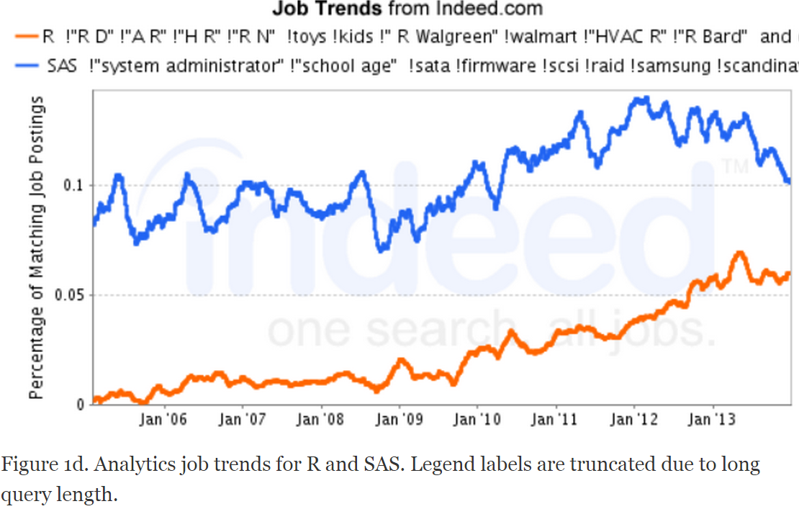
(Source: see Reference [3])

R is keeping considered as the largest one single threat to SAS ecosystem. But first, let’s be positive. Basically the emerging of R is to create more jobs and it’s an indicator of the booming analytical market, and SAS programmers can also benefit from it as whole.
Currently, R programmers is not replacing SAS programmers, but it will impact the new hiring decisions. I pieces of option is, although R and SAS can be competitors as software and programming language, but for any personnel, they are not exclusive at all! As SAS programmer, you learn SAS, you learn some scripts, and it’s not bother at all to learn another new skill, R in this case, right?
My first analytical programming language was SAS back to 2006, and I use SAS for my whole statistical programming career by far and it didn’t hurt to learn R (my first Coursera course of R in 2013):
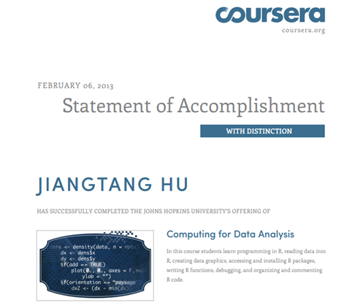

B.2 Big Data
Everyone is talking big data and as a SAS programmer, I felt I was left behind the game. SAS product family does offer big data solution, but it’s not available not most of SAS programmers and this is another reason why SAS programmers should embrace R: you can have a taste of big data infrastructure by deploying R packages in your own machine!

B.3 The Talent Pool of New SAS Programmers
R is dominating the statistical departments worldwide. The lack of new SAS talents is the big problem when we consider we’re in the beloved SAS community.
Compared to R, much fewer bloggers are blogging SAS:
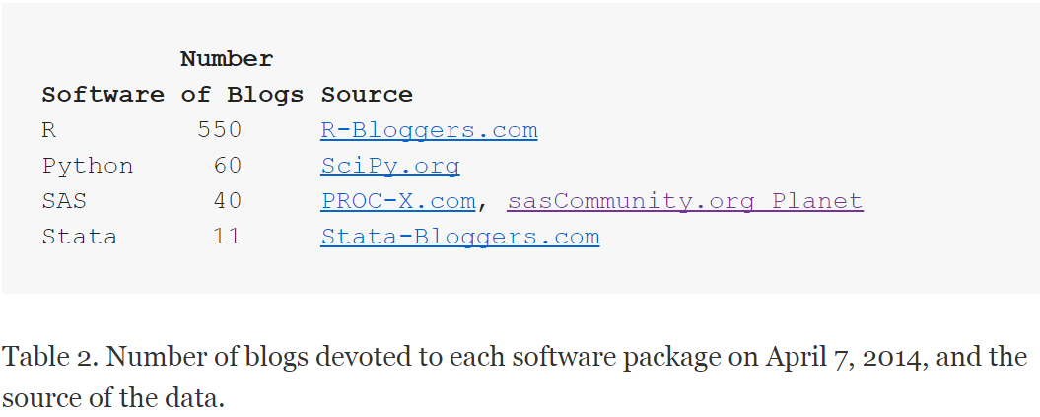
(Source: see Reference [3])

And the traffic of the main SAS discussion board (SAS-L) is slashing:
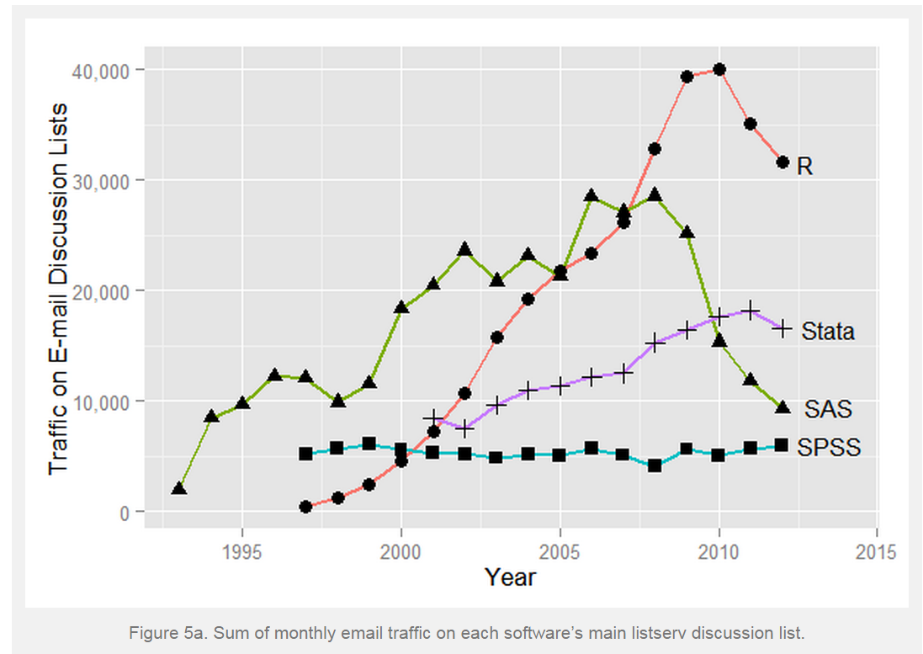
(Source: see Reference [3])

This is the real BAD SAD thing. The SAS community is shrinking. We can’t do much if it’s the long term trending, but we can at least do:
- Post your question to SAS-L, instead send emails to a single SAS helper.
- Answer questions if possible.
- Stackoverflow is another good place to post and answer SAS questions.
- Start a SAS blog.
- Spread the news.

CONCLUSION
This paper is full of personal observation, thoughts and inevitably, bias. I present the internal and external challenges for SAS programmers for more discussion.

References
[1] Will 2015 be the Beginning of the End for SAS and SPSS? By Bob Muenchen, http://r4stats.com/2012/05/09/beginning-of-the-end/
[2] Will 2014 be the Beginning of the End for SAS and SPSS? By Bob Muenchen, http://r4stats.com/2013/05/14/beginning-of-the-end-v2/
[3] The Popularity of Data Analysis Software. By Bob Muenchen, http://r4stats.com/articles/popularity/

ACKNOWLEDGMENTS
I appreciate Bob Muenchen’s continuous efforts on comparing trends of SAS and other analytical software in his blog.

Contact Information
Your comments and questions are valued and encouraged. Contact the author at:
Jiangtang(‘JT’) Hu
Life Sciences Consultant
d-Wise Technologies, Inc.
1500 Perimeter Park Dr., Suite 150, Morrisville, NC, 27560
www.d-Wise.com

(O) 919-334-6096
(C) 919-801-9659
(F): 888-563-0931
(O) Jiangtang.Hu@d-Wise.com
(P) jiangtanghu@gmail.com
http://jiangtanghu.com/

SAS and all other SAS Institute Inc. product or service names are registered trademarks or trademarks of SAS Institute Inc. in the USA and other countries. ® indicates USA registration.
Other brand and product names are trademarks of their respective companies.

