Paper SD103

Confidence Intervals for Binomial Proportion Using SAS®:

The All You Need to Know and No More…

Jiangtang Hu

d-Wise, Morrisville, NC

ABSTRACT
Confidence Intervals (CI) are extremely important in presenting clinical results. The choosing of right algorithms of CI is the plate of statisticians, and this paper is for SAS programmers where more than 14 methods to compute CI for single proportion is presented with executable SAS codes, by SAS procedures and customized codes from the scratch.
These codes is currently hosted in my Github page:
https://raw.githubusercontent.com/Jiangtang/Programming-SAS/master/CI_Single_Proportion.sas
Some commentaries from A SAS programmer’s point of view will also be presented.

Introduction
Suppose n is the sample size, r the number of count of interested outcome, and p = r / n is so called binomial proportion (sample proportion). A confidence interval (CI) is a range of values, computed from the sample, which is with probability of 95% to cover the population proportion, π (well, you may use any pre-specified probabilities, but 95% is the most common one).
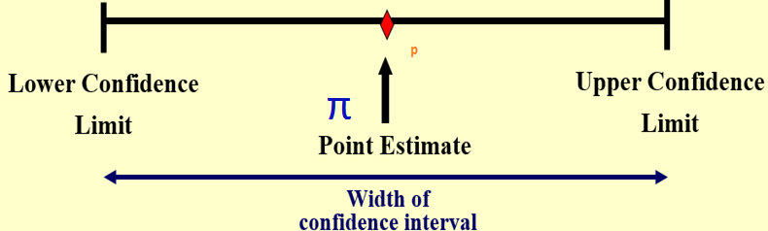

From statistical point of view, confidence intervals are generally more informative than p-value. In clinical studies, the size of difference of the outcome between groups (measured by confidence intervals) is much more useful for researchers than the single significant indicator, namely, p-value [1].
For SAS programmers, it’s nice to know that the confidence interval is much preferred to p-value for presenting clinical outcomes. Computing varieties of confidence intervals (there are A LOT!) is part of SAS programmers’ daily job. The selection of the right type of CI is decided by statisticians, and this paper is primary for SAS programmers: you might not be very familiar with the story behind the different CIs, but with this paper and SAS codes attached, you can always get the right results given the type of CIs is articulated in the Statistical Analysis Plan (SAP).
I will leave the calculation of confidence interval for the difference between independent proportions [2] to another paper and this one is only for single binomial proportion. Particularly, 14 methods will be presented with fully executable SAS programs:
- Simple asymptotic, without Continuity Correction (CC), mostly know as Wald
- Simple asymptotic, with CC
- Score method, without CC, also known as Wilson
- Score method, with CC
- Binomial-based, 'Exact' or Clopper-Pearson
- Binomial-based, Mid-p
- Likelihood-based
- Jeffreys
- Agresti-Coull, pseudo frequency, z^2/2 successes| psi = z^2/2
- Agresti-Coull, pseudo frequency, 2 successes and 2 failures| psi = 2
- Agresti-Coull, pseudo frequency, psi = 1
- Agresti-Coull, pseudo frequency, psi = 3
- Logit
- Blaker

To get a quick impression, just run the following piece of code:
filename CI url 'https://raw.github.com/Jiangtang/Programming-SAS/master/CI_Single_Proportion.sas';
%include CI;
%CI_Single_Proportion(r=81,n=263);

The output (note: CC is short for Continuity Correction):
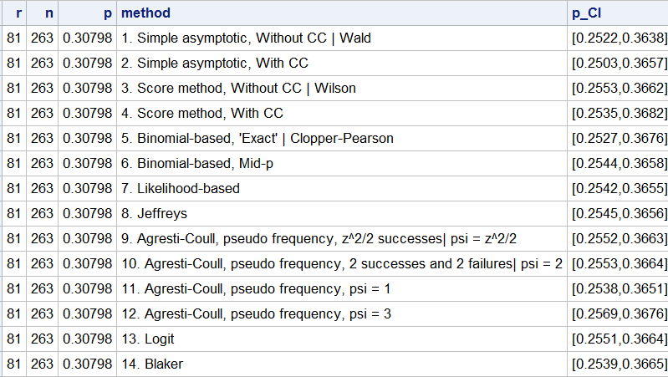
Method #1-7 was well documented in a famous paper by Robert Newcombe, Two-sided confidence intervals for the single proportion: comparison of seven methods [3] where the corresponding output is:
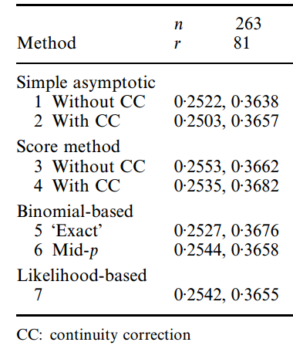

A. Basic Algorithms and Comments

A1 Method #1 and #2
The most popular method in introductory textbooks (note not in practice) is method #1 (‘Wald’) due to its simplest form:
p ± z × SE
where
p is the empirical estimate of the proportion, r / n,
SE, standard error = √(p(1-p)/n)
z, the quantile of the standard normal distribution (1.960 for the usual two-sided 95% interval).
Despite its popularity, the Wald method is very deficient. For example, it is not boundary-respecting and it can extend beyond 0 or 1.
When p = 0 or 1, method #1 (‘Wald’) will get a zero width interval [0, 0]. To avoid this degeneracy issue, method #2 (‘Wald with CC’) introduces a continuity correction (CC), namely, 1 / (2n). But be aware of the trade-off, the problem of adding the continuity correction is that it would lead to more instances of overshoot. A step-by-step approach to demonstrate these two methods is as follows:

data m1;
r = 81;
n = 263;
alpha = 0.05;
p = r / n;
z = probit (1-alpha/2);

*standard error;
se = (sqrt(n*p*(1-p)))/n;

L = p - z * se;
U = p + z * se;

put L= U= ;
run;

data m2;
r = 81;
n = 263;
alpha = 0.05;
p = r / n;
z = probit (1-alpha/2);

*standard error;
se = (sqrt(n*p*(1-p)))/n;

*continuity correction;
cc = 1/(2*n);

L = p - (z * se + cc);
U = p + (z * se + cc);

put L= U=;
run;

A2 Method #13
The Logit method (#13) is actually very similar to Wald method in structure. Instead using p = r / n as the empirical proportion, a logit transformation is applied in Logit method, namely, exp[log (p / (1-p))]:

data m13;
r = 81;
n = 263;
alpha = 0.05;
p = r / n;
z = probit (1-alpha/2);

L = exp(log(p/(1-p)) - z*sqrt(n/(r*(n-r)))) /
(1+exp(log(p/(1-p)) - z*sqrt(n/(r*(n-r)))));
U = exp(log(p/(1-p)) + z*sqrt(n/(r*(n-r)))) /
(1+exp(log(p/(1-p)) + z*sqrt(n/(r*(n-r)))));
put L= U=;
run;
Logit method is often used for odds ratios. Like the Wald method, it is not guaranteed satisfactory when n is small or p is close to 0 or 1.

A3 Method #3, #4
Wilson score method (#3) is considered the simplest acceptable alternative to the Wald approach. It gets better performance when n is small and when p is close to 0 or 1.
Wilson method is also not boundary-respecting. A continuity correction can be applied to get method #4:

data m3;
r = 81;
n = 263;
alpha = 0.05;
p = r / n;
q = 1-p;
z = probit (1-alpha/2);

L = ( 2*r+z**2 - (z*sqrt(z**2+4*r*q)) ) / (2*(n+z**2));
U = ( 2*r+z**2 + (z*sqrt(z**2+4*r*q)) ) / (2*(n+z**2));
put L= U=;
run;

data m4;
r = 81;
n = 263;
alpha = 0.05;
p = r / n;
q = 1-p;
z = probit (1-alpha/2);

L = ( 2*r+z**2 -1 - z*sqrt(z**2 - 2- 1/n + 4*p*(n*q+1))) / (2*(n+z**2));
U = ( 2*r+z**2 +1 + z*sqrt(z**2 + 2- 1/n + 4*p*(n*q-1))) / (2*(n+z**2));
put L= U=;
run;

A4 Method #5
The Wald-like intervals described as above are all asymptotic intervals. The so called Clopper-Pearson ‘exact’ method (#5) is quite different since it’s very conservative. It’s very computationally convenient and only one inverse Beta function is used:
data m5;
r = 81;
n = 263;
alpha = 0.05;

L = 1 - betainv(1 - alpha/2,n-r+1,r);
U = betainv(1 - alpha/2,r+1 ,n-r);
put L= U=;
run;

A5 Method #6
The method #5 is so conservative that sometimes it’s even unnecessary. A similar ‘mid-p’ (#6) is used to reduce the conservatism. Method #6 accumulates the tail areas and it’s relatively complicated compared to any methods mentioned above. The full code is available in the master code (of session ‘method 6’):
https://raw.github.com/Jiangtang/Programming-SAS/master/CI_Single_Proportion.sas

A6 Method #7
Likelihood-based approach (#7) is said to be theoretically appealing. The full program is available here (of session ‘method 7’):
https://raw.github.com/Jiangtang/Programming-SAS/master/CI_Single_Proportion.sas
A7 Method #9-#12
Methods #9-#12 come from the family of ‘pseduo-frequency methods’. Instead of using p = r / n, 4 methods are developed when ψ (pronounced as psi) gets values z2/2, 2, 1, 3:
pψ = (r + ψ)/(n + 2ψ)

data m9_12;
r = 81;
n = 263;
alpha = 0.05;
z = probit (1-alpha/2);

do psi = z**2/2, 2, 1, 3;
p2=(r+psi)/(n+2*psi);

L = p2 - z*(sqrt(p2*(1-p2)/(n+2*psi)));
U = p2 + z*(sqrt(p2*(1-p2)/(n+2*psi)));
put L= U=;
output;
end;
run;
A8 Method #8
The methods mentioned above are all frequentist methods. The alternative Bayesian methods are sometimes preferable because they incorporate prior information. I’m not well equipped with Bayesian methods, but one called ‘Jeffreys’ method is pretty straightforward from programing point of view:
data m8;
r = 81;
n = 263;
alpha = 0.05;

L = betainv( alpha/2, r+0.5,n-r+0.5);
U = betainv(1-alpha/2, r+0.5,n-r+0.5);
put L= U=;
run;

A9 Method #14
Although CIs using the Blaker method are available with options from a SAS FREQ procedure, the program below manually computes the CI lower and upper bounds using the Blaker method:

data m14;
r = 81;
n = 263;
alpha = 0.05;

tolerance=1e-05;
lower = 0;
upper = 1;

if r ^= 0 then do;
lower = quantile('BETA',alpha/2, r, n-r+1);
do while (acceptbin(r, n, lower + tolerance) < (alpha));
lower = lower + tolerance;
end;
end;

if r ^= n then do;
upper = quantile('BETA',1 - alpha/2, r+1, n-r);
do while (acceptbin(r, n, upper - tolerance) < (alpha));
upper = upper - tolerance;
end;
end;

L=lower;
U =upper;
put L= U=;
run;

B. The Workhorse: SAS FREQ
The individual SAS programs above can be used for educational purpose to better understand the various methods one can use to calculate CIs. I compiled them together into a macro and can be called as

filename CI url 'https://raw.github.com/Jiangtang/Programming-SAS/master/CI_Single_Proportion.sas';
%include CI;
%CI_Single_Proportion(r=81,n=263);

which can print out all outputs from the14 methods together for comparison.
Alternatively, SAS PROC FREQ (I use SAS 9.4 TS1M2 in Windows 7 when writing this paper) can be used to compute most of the confidence intervals (11 to be precisely):

data test;
input grp outcome $ count;
datalines;
1 f 81
1 u 182
;

/*2.3 CL=enumeration: #1,#3, #5,#6, #7,#8, #9,#13, #14*/
ods select BinomialCLs;
proc freq data=test;
tables outcome / binomial (CL=
WALD
WILSON
CLOPPERPEARSON
MIDP
LIKELIHOODRATIO
JEFFREYS
AGRESTICOULL
LOGIT
BLAKER
);
weight Count;
run;

/*2.4 CL=CC : #2,#4*/
ods select BinomialCLs;
proc freq data=test;
tables outcome / binomial (CL =
WILSON(CORRECT)
WALD(CORRECT)
);
weight Count;
run;
The output:
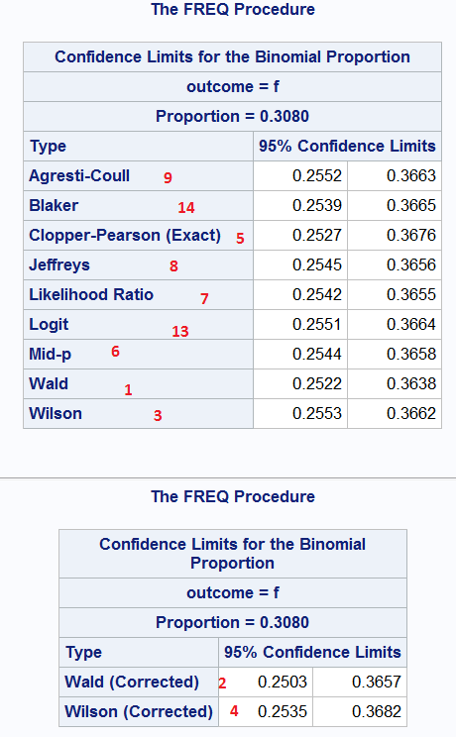

Only methods #10 - #12 from ‘pseduo-frequency methods’ family are not available in SAS PROC FREQ.
A programming note:
- If no confidence interval option assigned, the Wald and the ‘exact’ CIs will be presented.
- If option CL = All is applied, the following 5 CIs will be computed: Agresti-Coull, Clopper-Pearson (Exact), Jeffreys, Wald, Wilson.
- A binomialc option can be also used to compute intervals with a continuity correction in SAS 9.4 but it doesn’t show up in the documentation. You can get the help doc from SAS 9.2 and 9.3.
ods select BinomialCLs;
proc freq data=test;
tables outcome / binomialc (CL=ALL);
weight Count;
run;

C. Other SAS Precedures
SAS PROC MCMC can be used to compute Bayesian confidence interval but I’m not studying it yet.

D. CONCLUSION
SAS PROC FREQ is pretty impressive to compute varieties of confidence intervals. The customized SAS programs in this paper are best used for educational purposes, or to serve as a start to customize your own pieces of CI programs.

References
[1] Confidence Intervals for Proportions and Related Measures of Effect Size by Robert Newcombe, 2012, CRC Press
[2] Interval estimation for the difference between independent proportions: comparison of eleven methods by Robert Newcombe, 1998, STATISTICS IN MEDICINE
[3] Two-sided confidence intervals for the single proportion: comparison of seven methods by Robert Newcombe, 1998, STATISTICS IN MEDICINE
[4] A SAS Implementation of Confidence Intervals for Single Proportion: Eleven Methods by Jiangtang Hu,
http://www.jiangtanghu.com/blog/2011/07/14/a-sas-implementation-of-confidence-intervals-for-single-proportion-eleven-methods/
[5] Statistical Notes (3): Confidence Intervals for Binomial Proportion Using SAS by Jiangtang Hu,
http://www.jiangtanghu.com/blog/2012/09/15/confidence-intervals-binomial-proportion/
[6] Confidence Intervals for Binomial Proportion: A SAS 9.4/STAT 12.3 Update by Jiangtang Hu,
http://www.jiangtanghu.com/blog/2013/08/22/confidence-intervals-for-binomial-proportion-a-sas-9-4stat-12-3-update/
[7] Confidence Intervals for Binomial Proportion (Again): A Quick Note by Jiangtang Hu,
http://www.jiangtanghu.com/blog/2015/05/05/ci-mcmc/
[8] Statistical Notes (3B): Confidence Intervals for Binomial Proportion Using SAS, Updated by Jiangtang Hu,
http://www.jiangtanghu.com/blog/2015/05/22/statistical-notes-3b-confidence-intervals-for-binomial-proportion-using-sas-updated/

ACKNOWLEDGMENTS
I highly recommend Robert newcombe’s book and papers to jump into the world of confidence intervals. I personally gain a lot from them.

Contact Information
Your comments and questions are valued and encouraged. Contact the author at:
Jiangtang(‘JT’) Hu
Life Sciences Consultant
d-Wise Technologies, Inc.
1500 Perimeter Park Dr., Suite 150, Morrisville, NC, 27560
www.d-Wise.com

(O) 919-334-6096
(C) 919-801-9659
(F): 888-563-0931
(O) Jiangtang.Hu@d-Wise.com
(P) jiangtanghu@gmail.com
http://jiangtanghu.com/

SAS and all other SAS Institute Inc. product or service names are registered trademarks or trademarks of SAS Institute Inc. in the USA and other countries. ® indicates USA registration.
Other brand and product names are trademarks of their respective companies.

