
学生实验报告

实验课名称：Internet开发技术
实验项目名称：个人网站的搭建
专业名称：计算机科学与技术（交通信息工程）
班级：2016240203
学号：2016902094
学生姓名：瞿强鑫
教师姓名：张绍阳

2019 年 5 月 1 日
实验日期： 年 月 日 实验室名称：
一．实验名称：
个人网站的搭建

二．实验目的与要求：
熟悉B/S架构应用程序工作原理
学习掌握课本上关于静态网页编程和ASP动态网页编程
运用上学到的技术，ASP对象及方法、CSS页面布局
Ajax开发技术、JS脚本语言的学习和运用
安装Microsoft IIS（Internet Information Server）服务组件完成网页服务器的部署
ASP访问数据库（ADO）
运用以上技术搭建自己的个人网站

三．实验内容：
登录页面输入账户信息（邮箱+密码），连接数据库验证账户
主页分为个人评价、我的相册、我的日志、关于更多四个模块组成
每个模块做文字相应的内容，其中相册包括文件的上传、相册的创建、相片的删除、相册的删除，日志的删除等功能，其中文件的相应属性存放在数据库的各张表中

四．实验设备与软件环境：
硬件：个人 Windows10操作系统电脑一台
服务器：IIS服务组件
数据库：Access2019
文本编辑器：Notepad++
浏览器：QQ浏览器

五．实验原理：
采用B/S模式开发的应用程序，也称为Web应用程序。通俗来讲，Web程序就是一种通过浏览器发送HTTP请求，由服务器响应后返回HTML文本供浏览器进行显示的应用程序。

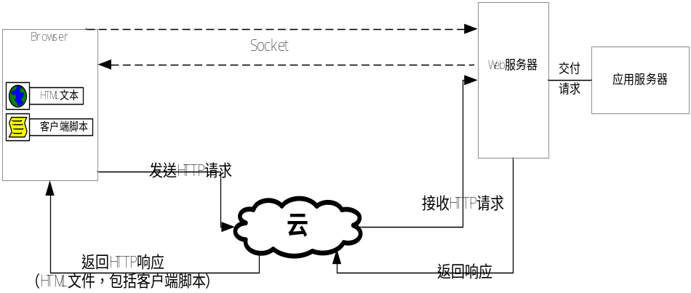
一个完整的Web应用程序的基本组成部分包括：
1.解析网页并显示网页给用户浏览的客户端浏览器；
2.在客户端和Web服务器端提供通讯的HTTP网络协议；
3.提供服务的Web服务器，---供浏览器进行链接访问；
4.由网页组成的Web应用程序，---存储在web服务器上；
5.执行用户逻辑的应用服务器；---应用服务器软件
6.可能还包括数据库服务器等。---数据库软件
B/S架构程序执行的内部机理：
浏览器接收用户输入的URL地址
浏览器解析地址，得到IP和端口号
浏览器建立Stream_Socket，与远程web服务器进行连接
web服务器响应请求，双方建立连接
web服务器返回默认主页的内容（HTML文件）
浏览器进行解析、展示
用户操作页面上的内容，通过超链接请求新的链接地址，或者通过Post提交内容到指定网页
web服务器接收请求，调用应用服务器、数据库服务器等完成请求，生成ＨＴＭＬ页面返回

六．实验过程及代码：
登陆界面asp文件：
<!DOCTYPE html>
<html style="height: 100%;">
<head>
<meta http-equiv="Content-Language" content="zh-cn">
<meta http-equiv="Content-Type" content="text/html; charset=utf-8">
<title>Log In</title>
<link href="\css\global.css" rel="stylesheet">
<script language="javascript">
function check()
{
if(document.getElementById("username").value=="")
{
alert("请填写Email Address一栏");
return false;
}
else
{
if(document.getElementById("password").value=="")
{
alert("请填写Password一栏");
return false;
}
else
{
return true;
}
}
}
</script>
</head>
<body class="login_body">
<div class="web_fluid_container">
<div class="web_vcenter">
<div id="login_container">
<div id="login_module">
<a href="http://192.168.174.1:8088/" class="login-element"></a>

<form action="login_check.asp" method="post" name="form1" id="form1" onsubmit="return check();">
<input type="hidden" name="action" value="normal">
<input type="hidden" name="login_type" value="normal">
<div class="login-email">
<input name="username" type="text" class="flexwidth100" placeholder="Email Address" />
</div>
<hr>
<div class="login-password">
<input name="password" type="password" class="flexwidth100" placeholder="Password" />
</div>
<hr>
<div style="clear: both"></div>
<input type="submit" value="Login" />
<hr>
Help, I <a href="back1.asp">forgot my password</a>.
</form>
</div>
</div>
</div>
</div>
</body>
</html>

索引界面asp文件：
<!DOCTYPE html>
<html style="height: 100%;">
<head>
<meta http-equiv="Content-Language" content="zh-cn">
<meta http-equiv="Content-Type" content="text/html; charset=gb2312">
<title>个人主页</title>
<link href="\css\global.css" rel="stylesheet">
</head>
<body class="web_body">
<h2>Hi, <%=Request.QueryString("username")%>！Welcome home!</h2>
<div class="divcss5" style="position: absolute;left: 30px;top: 40px;width:150px; height:150px;background:url(/images/11.jpg) ;background-size: 150px; background-repeat: no-repeat; background-position:center;">

<span>自我评价</span>
<a href="self_introduction.asp" class="now">&nbsp;</a>
</div>
<div class="divcss5" style="position: absolute;left: 430px;top: 240px;width:150px; height:150px;background:url(/images/12.jpg) ;background-size: 150px; background-repeat: no-repeat; background-position:center;">
<span>我的相册</span>
<a href="My_album.asp" class="now">&nbsp;</a>
</div>
<div class="divcss5" style="position: absolute;left: 830px;top: 440px;width:150px; height:150px;background:url(/images/13.jpg) ;background-size: 150px; background-repeat: no-repeat; background-position:center;">
<span>我的日志</span>
<a href="My_dailyrecord.asp" class="now">&nbsp;</a>
</div>
<div class="divcss5" style="position: absolute;left: 1230px;top: 640px;width:150px; height:150px;background:url(/images/14.jpg) ;background-size: 150px; background-repeat: no-repeat; background-position:center;">
<span>更多</span>
<a href="back1.asp" class="now">&nbsp;</a>
</div>
</body>
</html>

自我评价页面asp文件：
<!DOCTYPE html>
<html style="height: 100%;">
<head>
<meta http-equiv="Content-Language" content="zh-cn">
<meta http-equiv="Content-Type" content="text/html; charset=gb2312">
<title>自我评价</title>
<link href="\css\global.css" rel="stylesheet">
</head>
<body class="selfintro_body">
<div class="web_fluid_container">
<div class="web_vcenter">
<div id="selfintro_container">
<div id="selfintro_module">
<table width="900" height="800" border="1" align="center" >
<tr>
<th bgcolor="#fffafa" width="160" height="800" valign="top"

scope="row"><table width="100%" height="800" border="0">
<tr>
<th width="36%" scope="col">@</th>
<th width="64%" scope="col" style="font-weight:normal ;">
<div align="left">
<a href="self_introduction.asp">自我评价</a>
</div>
</th>
</tr>
<tr>
<th scope="row">@</th>
<td><div align="left">
<a href="My_album.asp">我的相册</a>
</div></td>
</tr>
<tr>
<th scope="row">@</th>
<td><div align="left">
<a href="My_dailyrecord.asp">我的日志</a>
</div></td>
</tr>
<tr>
<th scope="row">@</th>
<td><div align="left">
<a href="/back1.asp">关于更多</a>
</div></td>
</tr>
</table>
</th>
<td width="700" valign="top"><table width="100%" height="800" border="0">
<tr>
<th height="20" align="center" bgcolor="#f8f8ff" scope="col">
<div align="center">
<h3>自我评价</h3>
</div></th>
</tr>
<tr>
<th height="500" align="center" valign="top" scope="row" >
<div align="center" >

<p><img src="images\self_introduction.jpg" width="600" height="700" /></p>
</div>
</th>
</tr>
</table></td>
</tr>
</table>
</div>
</div>
</div>
</div>
</body>
</html>

相册列表页面asp文件：
<!DOCTYPE html>
<html style="height: 100%;">
<head>
<meta http-equiv="Content-Language" content="zh-cn">
<meta http-equiv="Content-Type" content="text/html; charset=gb2312">
<title>相册列表</title>
<!--#include file="conn_head.asp"-->
<link href="\css\global.css" rel="stylesheet">
</head>
<body class="album_body">
<div class="web_fluid_container">
<div class="web_vcenter">
<div id="album_container">
<div id="album_module">
<table width="900" height="800" border="1" align="center" >
<tr>
<th bgcolor="#fffafa" width="160" height="800" valign="top" scope="row"><table width="100%" height="800" border="0">
<tr>
<th width="36%" scope="col">@</th>
<th width="64%" scope="col" style="font-weight:normal ;">
<div align="left">
<a href="self_introduction.asp">自我评价</a>
</div>
</th>

</tr>
<tr>
<th scope="row">@</th>
<td><div align="left">
<a href="My_album.asp">我的相册</a>
</div></td>
</tr>
<tr>
<th scope="row">@</th>
<td><div align="left">
<a href="My_dailyrecord.asp">我的日志</a>
</div></td>
</tr>
<tr>
<th scope="row">@</th>
<td><div align="left">
<a href="/back1.asp">关于更多</a>
</div></td>
</tr>
</table>
</th>
<td width="700" valign="top"><table width="100%" height="800" border="0">
<tr>
<th height="20" align="center" bgcolor="#f8f8ff" scope="col">
<div align="center">
<h3>我的相册</h3>
</div></th>
</tr>
<tr>
<th height="500" align="center" bgcolor="#f5fffa" valign="top" scope="row" >
<div align="center" width="600" height="700">
<table style="font-size:12px" width="590pxpx" border="0" bordercolor="#000000" cellpadding="5" cellspacing="15" >
<tr>
<td align="center" colspan="2"><hr color="#dcdcdc" width="100%" />
</td>
</tr>

<%
dim ors
set ors=server.CreateObject("ADODB.recordset")
sql="select * from album order by id desc"
ors.open sql,oConn,1,1
if not ors.eof then
for i=1 to ors.recordcount
%>
<div align="center">
<tr>
<td rowspan="5" width="350px" align="center"><a href="album_content.asp?id=<%=ors("id")%>" ><img src="<%=ors("album_url")%>" width="250px" height="200px" style="border:4px outset #ffff00" /></a>
</td>
</tr>
<tr>
<td align="left" height="20px"><b>相册名称:<%=ors("album_name")%></b></td>
</tr>
<tr>
<td align="left" height="20px"><b>创建时间:<%=ors("establish_time")%></b></td>
</tr>
<tr>
<td align="left" height="20px" ><b><a href="photo_upload.asp?id=<%=ors("id")%>" style="text-decoration:none;">上传照片</a>|
<a href="album_del.asp?id=<%=ors("id")%>" style="text-decoration:none;">删除相册</a></b></td>
</tr>
<tr>
<td align="left" height="20px" ><b><a href="album_content.asp?id=<%=ors("id")%>" style="text-decoration:none;">浏览相册</a></b></td>
</tr>
<tr>
<td height="10px" ><hr color="#d3d3d3" align="center" width="160%" /></td>
</tr>
</div>

</table>
</div>
</th>
<tr>
<td height="100px" width="350px" align="center" bgcolor="#f8f8ff" scope="row"><a href="album_create.asp" style="text-decoration:none; font-size:15px;"><b>创建新相册</b></a></td>
</tr>
</tr>
</table></td>
</tr>
</table>
</div>
</div>
</div>
</div>
</body>
</html>

相册创建关键代码：
<tr>
<td align="center" colspan="2">
<form action="album_creating.asp" method="post" name="form1" id="form1">
<div style="login-email">
<input type="text" name="album_name" class="flexwidth100" id="album_name" placeholder="相册名称"/>
<input name="establish_time" type="text" class="flexwidth100" id="establish_time" placeholder="创建时间 例'2019/4/25'" />
</div>
<hr color="#dcdcdc">
<div style="clear: both"></div>
<input type="submit" value="提交" />
<input type="reset" value="重置" />
</form>
</td>
</tr>

删除相册关键代码：
<%
id=request("id")
dim ors
set ors=server.CreateObject("ADODB.recordset")
sql="delete * from album where id="&id&""
ors.open sql,oConn,1,3
ors.close()
sql="delete * from photo where album_id="&id&""
ors.open sql,oConn,1,3
if not err then
response.Redirect("My_album.asp")
else
response.Write("ERROR")
end if
%>

上传相册封面关键代码：
<%
Dim Upload,path
'===============================================================================
set Upload=new AnUpLoad '创建类实例 '设置单个文件最大上传限制,按字节计；默认为不限制
Upload.openProcesser=false '禁止进度条功能，如果启用，需配合客户端程序
Upload.GetData() '获取并保存数据,必须调用本方法
'===============================================================================
if Upload.ErrorID>0 then
response.Write("出现错误") '判断错误号,如果myupload.Err<=0表示正常
response.write Upload.Description '如果出现错误,获取错误描述
else
if Upload.files(-1).count>0 then '这里判断你是否选择了文件
path=server.mappath("images/album_ground") '文件保存路径(这里是files文件夹)
dim dbpath,oConn,sConn,album_url
dbpath="database\datasource.mdb"
sConn="provider=Microsoft.Jet.OLEDB.4.0;Data Source="&server.mappath(dbpath)
set oConn=Server.CreateObject("ADODB.Connection")
oConn.Open sConn

album_url="images/album_ground/"&session("name")
set ors=server.CreateObject("ADODB.recordset")
ors.open "select * from album where album_name<>"" and album_url="" order by id desc",oConn,1,3
ors.update()
ors("album_url")=album_url
ors.update()
if err then
response.Write("ACCESS ERROR")
end if
ors.close
set ors=nothing
oConn.close
set oConn=nothing

else
response.Write "您没有上传任何文件！"
end if
end if
set Upload=nothing
if not err then
response.Redirect("My_album.asp")
end if '销毁类实例
%>

我的日志关键代码：
<%
dim ors
set ors=server.CreateObject("ADODB.recordset")
sql="select * from dailyrecord order by id desc"
ors.open sql,oConn,1,1
%>
<table style="font-size:17px" width="590pxpx" border="0" bordercolor="#000000" cellpadding="5" cellspacing="5" >
<tr>
<td align="left" valign="middle" style="font-size:17px; font-weight:bold;" colspan="3">日志列表
</td>
</tr>

<%
for i=1 to ors.recordcount
%>
<tr>
<td width="50%" align="left">
<a href="dailyrecord_content.asp?id=<%=ors("id")%>" style="text-decoration:none; font-weight:bold"><%=ors("title")%></a></td>
<td align="center"><b>发表于:<%=ors("writing_time")%></b></td>
<td><a href="dailyrecord_del.asp?id=<%=ors("id")%>" style="text-decoration:none; font-weight:bold">删除此日志</a></td>
</tr>
<%
ors.movenext
next
ors.close()
set ors=nothing
oConn.close()
set oConn=nothing
%>

数据库连接头文件：
<%
On Error Resume Next

dim dbpath,oConn,sConn

dbpath="database\datasource.mdb"
sConn="provider=Microsoft.Jet.OLEDB.4.0;Data Source="&server.mappath(dbpath)

set oConn=Server.CreateObject("ADODB.Connection")
oConn.Open sConn

if err then
response.write("连接数据库出错")
end if
%>

文件上传功能头文件：
<%
Dim StreamT
Class AnUpLoad
Private Form, Fils
Private vCharSet, vMaxSize, vSingleSize, vErr, vVersion, vTotalSize, vExe, pID,vOP
'==============================
'设置和读取属性开始
'==============================
Public Property Let MaxSize(ByVal value)
vMaxSize = value
End Property

Public Property Let SingleSize(ByVal value)
vSingleSize = value
End Property

Public Property Let Exe(ByVal value)
vExe = LCase(value)
End Property

Public Property Let CharSet(ByVal value)
vCharSet = value
End Property

Public Property Get ErrorID()
ErrorID = vErr
End Property

Public Property Get Description()
Description = GetErr(vErr)
End Property

Public Property Get Version()
Version = vVersion
End Property

Public Property Get TotalSize()
TotalSize = vTotalSize
End Property

Public Property Get ProcessID()
ProcessID = pID
End Property

Public Property Let openProcesser(ByVal value)
vOP = value
End Property
'==============================
'设置和读取属性结束，初始化类
'==============================

Private Sub Class_Initialize()
set StreamT=server.createobject("ADODB.STREAM")
set Form = server.createobject("Scripting.Dictionary")
set Fils = server.createobject("Scripting.Dictionary")
vVersion = "艾恩无组件上传类V9.9.9"
vMaxSize = -1
vSingleSize = -1
vErr = -1
vExe = ""
vTotalSize = 0
vCharSet = "gb2312"
vOP=false
pID="AnUpload"
setApp "",0,0,""
End Sub

Private Sub Class_Terminate()
Form.RemoveAll()
Fils.RemoveAll()
Set Form = Nothing
Set Fils = Nothing
Set StreamT = Nothing
End Sub
'==============================
'函数名:GetData
'作用:处理客户端提交来的所有数据
'==============================

Public Sub GetData()
If vMaxSize > 0 And Request.TotalBytes > vMaxSize Then '判断上传数据总大小
vErr = 1
Exit Sub
End If
if vOP then pID=request.querystring("processid")
Dim value, str, bcrlf, fpos, sSplit, slen, istart
Dim TotalBytes,BytesRead,ChunkReadSize,PartSize,DataPart,tempdata,formend, formhead, startpos, endpos, formname, FileName, valueend, NewName,localname,type_1,contentType
dim fileExe
If checkEntryType = True Then
vTotalSize = 0
StreamT.Type = 1
StreamT.Mode = 3
StreamT.Open
TotalBytes = Request.TotalBytes
BytesRead = 0
ChunkReadSize = 1024 * 36
'循环分块读取
Do While BytesRead < TotalBytes
'分块读取
PartSize = ChunkReadSize
If PartSize + BytesRead > TotalBytes Then PartSize = TotalBytes - BytesRead
DataPart = Request.BinaryRead(PartSize)
StreamT.Write DataPart
BytesRead = BytesRead + PartSize
setApp "uploading",TotalBytes,BytesRead,""
Loop
setApp "uploaded",TotalBytes,BytesRead,""
StreamT.Position = 0
tempdata = StreamT.Read
bcrlf = ChrB(13) & ChrB(10)
fpos = InStrB(1, tempdata, bcrlf)
sSplit = MidB(tempdata, 1, fpos - 1)
slen = LenB(sSplit)
istart = slen + 2
Do
formend = InStrB(istart, tempdata, bcrlf & bcrlf)
formhead = MidB(tempdata, istart, formend - istart)

str = Bytes2Str(formhead)
startpos = InStr(str, "name=""") + 6
endpos = InStr(startpos, str, """")
formname = LCase(Mid(str, startpos, endpos - startpos))
valueend = InStrB(formend + 3, tempdata, sSplit)
If InStr(str, "filename=""") > 0 Then
startpos = InStr(str, "filename=""") + 10
endpos = InStr(startpos, str, """")
type_1=instr(endpos,lcase(str),"content-type")
contentType=trim(mid(str,type_1+13))
FileName = Mid(str, startpos, endpos - startpos)
If Trim(FileName) <> "" Then
LocalName = FileName
FileName = Replace(FileName, "/", "\")
FileName = Mid(FileName, InStrRev(FileName, "\") + 1)
setApp "processing",TotalBytes,BytesRead,FileName
If instr(FileName,".")>0 Then
fileExe = Split(FileName, ".")(UBound(Split(FileName, ".")))
else
fileExe = ""
End If
If vExe <> "" Then '判断扩展名
If checkExe(fileExe) = True Then
vErr = 3
Exit Sub
End If
End If
NewName = LocalName
session("name")=NewName
vTotalSize = vTotalSize + valueend - formend - 6
If vSingleSize > 0 And (valueend - formend - 6) > vSingleSize Then '判断上传单个文件大小
vErr = 5
Exit Sub
End If
If vMaxSize > 0 And vTotalSize > vMaxSize Then '判断上传数据总大小
vErr = 1
Exit Sub
End If

If Fils.Exists(formname) Then
vErr = 4
Exit Sub
Else
Dim fileCls:set fileCls=New fileAction
fileCls.ContentType=contentType
fileCls.Size = (valueend - formend - 6)
fileCls.Position = (formend + 3)
fileCls.NewName = NewName
fileCls.LocalName = FileName
Fils.Add formname, fileCls
Form.Add formname, LocalName
Set fileCls = Nothing
End If
End If
Else
value = MidB(tempdata, formend + 4, valueend - formend - 6)
If Form.Exists(formname) Then
Form(formname) = Form(formname) & "," & Bytes2Str(value)
Else
Form.Add formname, Bytes2Str(value)
End If
End If
istart = valueend + 2 + slen
Loop Until (istart + 2) >= LenB(tempdata)
vErr = 0
Else
vErr = 2
End If
setApp "processed",TotalBytes,BytesRead,""
if err then setApp "faild",1,0,err.description
End Sub

Public sub setApp(stp,total,current,desc)
Application.lock()
Application(pID)="{ID:""" & pID & """,step:""" & stp & """,total:" & total & ",now:" & current & ",description:""" & desc & """,dt:""" & now() & """}"
Application.unlock()
end sub

'==============================
'判断扩展名
'==============================
Private Function checkExe(ByVal ex)
Dim notIn: notIn = True
If vExe="*" then
notIn=false
elseIf InStr(1, vExe, "|") > 0 Then
Dim tempExe: tempExe = Split(vExe, "|")
Dim I: I = 0
For I = 0 To UBound(tempExe)
If LCase(ex) = tempExe(I) Then
notIn = False
Exit For
End If
Next
Else
If vExe = LCase(ex) Then
notIn = False
End If
End If
checkExe = notIn
End Function

'==============================
'把数字转换为文件大小显示方式
'==============================
Public Function GetSize(ByVal Size)
If Size < 1024 Then
GetSize = FormatNumber(Size, 2) & "B"
ElseIf Size >= 1024 And Size < 1048576 Then
GetSize = FormatNumber(Size / 1024, 2) & "KB"
ElseIf Size >= 1048576 Then
GetSize = FormatNumber((Size / 1024) / 1024, 2) & "MB"
End If
End Function

'==============================
'二进制数据转换为字符
'==============================

Private Function Bytes2Str(ByVal byt)
If LenB(byt) = 0 Then
Bytes2Str = ""
Exit Function
End If
Dim mystream, bstr
Set mystream =server.createobject("ADODB.Stream")
mystream.Type = 2
mystream.Mode = 3
mystream.Open
mystream.WriteText byt
mystream.Position = 0
mystream.CharSet = vCharSet
mystream.Position = 2
bstr = mystream.ReadText()
mystream.Close
Set mystream = Nothing
Bytes2Str = bstr
End Function
'==============================
'获取错误描述
'==============================
Private Function GetErr(ByVal Num)
Select Case Num
Case 0
GetErr = "数据处理完毕!"
Case 1
GetErr = "上传数据超过" & GetSize(vMaxSize) & "限制!可设置MaxSize属性来改变限制!"
Case 2
GetErr = "未设置上传表单enctype属性为multipart/form-data或者未设置method属性为Post,上传无效!"
Case 3
GetErr = "含有非法扩展名文件!只能上传扩展名为" & Replace(vExe, "|", ",") & "的文件"
Case 4
GetErr = "对不起,程序不允许使用相同name属性的文件域!"
Case 5
GetErr = "单个文件大小超出" & GetSize(vSingleSize) & "的上传限制!"
End Select
End Function

'==============================
'根据日期生成随机文件名
'==============================
Public Function Getname()
Dim y, m, d, h, mm, S, r
y = Year(Now)
m = Month(Now): If m < 10 Then m = "0" & m
d = Day(Now): If d < 10 Then d = "0" & d
h = Hour(Now): If h < 10 Then h = "0" & h
mm = Minute(Now): If mm < 10 Then mm = "0" & mm
S = Second(Now): If S < 10 Then S = "0" & S
Getname = y & m & d & h & mm & S
End Function

'==============================
'检测上传类型是否为multipart/form-data
'==============================
Private Function checkEntryType()
Dim ContentType, ctArray, bArray,RequestMethod
RequestMethod=trim(LCase(Request.ServerVariables("REQUEST_METHOD")))
if RequestMethod="" or RequestMethod<>"post" then
checkEntryType = False
exit function
end if
ContentType = LCase(Request.ServerVariables("HTTP_CONTENT_TYPE"))
ctArray = Split(ContentType, ";")
if ubound(ctarray)>=0 then
If Trim(ctArray(0)) = "multipart/form-data" Then
checkEntryType = True
Else
checkEntryType = False
End If
else
checkEntryType = False
end if
End Function

'==============================
'获取上传表单值,参数可选,如果为-1则返回一个包含所有表单项的一个dictionary对象
'==============================
Public Function Forms(ByVal formname)
If trim(formname) = "-1" Then
Set Forms = Form
Else
If Form.Exists(LCase(formname)) Then
Forms = Form(LCase(formname))
Else
Forms = ""
End If
End If
End Function
'==============================
'获取上传的文件类,参数可选,如果为-1则返回一个包含所有上传文件类的一个dictionary对象
'==============================
Public Function Files(ByVal formname)
If trim(formname) = "-1" Then
Set Files = Fils
Else
If Fils.Exists(LCase(formname)) Then
Set Files = Fils(LCase(formname))
Else
Set Files = Nothing
End If
End If
End Function
'==============================
'简便文件保存函数
'==============================
Public Function SaveAs(ByVal formname,ByVal path, ByVal saveType )
dim vfileAction
set vfileAction=Files(formname)
if vfileAction.FileName<>"" then
if vfileAction.SaveToFile(path,saveType) then
SaveAs=vfileAction.FileName
else
SaveAs="Has Error!"
end if

end if
set vfileAction=nothing
end function
End Class

'==============================
'文件类,存储文件的详细信息
'==============================
Class fileAction
Private vSize, vPosition, vName, vNewName, vLocalName, vPath, saveName,vContentType
'==============================
'设置属性
'==============================
Public Property Let NewName(ByVal value)
vNewName = value
End Property

Public Property Get NewName()
NewName = vNewName
End Property

Public Property Let ContentType(vData)
vContentType = vData
End Property
Public Property Get ContentType()
ContentType = vContentType
End Property

Public Property Let LocalName(ByVal value)
vLocalName = value
vName = value
End Property

Public Property Get LocalName()
LocalName = vLocalName
End Property

Public Property Get FileName()
FileName = vName
End Property

Public Property Let Position(ByVal value)
vPosition = value
End Property

Public Property Let Size(ByVal value)
vSize = value
End Property
Public Property Get Size()
Size = vSize
End Property

'==============================
'函数名:SaveToFile
'作用:根据参数保存文件到服务器
'参数:参数1--文件保存的路径
' 参数2--文件保存的方式,有两个可选项0表示以新名字(时间+随机数)为文件名保存,1表示以原文件名保存文件
'==============================
Public Function SaveToFile(ByVal path, ByVal saveType)
On Error Resume Next
Err.Clear
vPath = Replace(path, "/", "\")
If Right(vPath, 1) <> "\" Then vPath = vPath & "\"
CreateFolder vPath
Dim mystream
Set mystream =server.createobject("ADODB.Stream")
mystream.Type = 1
mystream.Mode = 3
mystream.Open
StreamT.Position = vPosition
StreamT.CopyTo mystream, vSize
vName = vNewName
If saveType = 1 Then vName = vLocalName
mystream.SaveToFile vPath & vName, 2
mystream.Close

Set mystream = Nothing
If Err Then
SaveToFile = False
Else
SaveToFile = True
End If
End Function

'==============================
'函数名:GetBytes
'作用:获取文件的二进制形式
'参数:无
'==============================
Public Function GetBytes()
StreamT.Position = vPosition
GetBytes = StreamT.Read(vSize)
End Function

'==============================
'函数名:CreateFolder
'作用:自动创建文件夹
'参数:要创建文件夹的路径
'==============================

Private Function CreateFolder(ByVal FolderPath)
on error resume next
Dim FolderArray
Dim i
Dim DiskName
Dim Created
Dim FSO : Set FSO = Server.CreateObject("Scripting.FileSystemObject")
If FSO.FolderExists(FolderPath) Then
Set Fso = Nothing
Exit Function
End If
FolderPath = Replace(FolderPath, "/", "\")
If Mid(FolderPath, Len(FolderPath), 1) = "\" Then FolderPath = Mid(FolderPath, 1, Len(FolderPath) - 1)
FolderArray = Split(FolderPath, "\")
DiskName = FolderArray(0)
Created = DiskName

For i = 1 To UBound(FolderArray)
Created = Created & "\" & FolderArray(i)
If Not FSO.FolderExists(Created) Then FSO.CreateFolder Created
Next
Set FSO = Nothing
err.clear
End Function
End Class
%>

CSS层叠样式表css文件：
/*#################共用#################*/
.web_fluid_container {
display: flex;
align-items: center;
justify-content: center;
height: 100%;
width: 100%;
}
.web_vcenter {
margin: 120px 0px;
}
body{
margin:0px 0px 100px 40px;
color:#616366;
font-family:"Raleway", Helvetica, Arial, sans-serif;
font-size:15px;
font-weight:300;
line-height:25px;
}
* { box-sizing:border-box;
}
input[type=text],
input[type=number],
input[type=file],
input[type=password],
input[type=email],

select{
border:1px solid #DCDEE0;
vertical-align:middle;
border-radius:3px;
height:50px;
padding:0px 16px;
font-size:20px;
color:#555555;
background-color:#ffffff;
font-family:"Raleway";
font-weight:inherit;
}

.flexwidth100{ width:100%; }

input[type=submit],
input[type=reset],
a.button{
display:inline-block;
vertical-align:middle;
padding:12px 143px;
margin:0px;
font-size:20px;
font-weight:bold;
font-family:"Raleway";
line-height:24px;
text-align:center;
white-space:nowrap;
vertical-align:middle;
cursor:pointer;
color:#778899;
border-radius:20px;
border:none;
-webkit-appearance: none;
transition: all ease-in .1s;
}

h2{
text-shadow: 1px 1px 5px #FF0000;
}
h3{
font-weight:bold;
font-family:"Raleway";
}
p{
font-weight:bold;
font-family:"Raleway";
}

/*#################登陆界面#################*/
.login_body {
background: linear-gradient(0deg, #ffffff 1%, #1e88e5 50%);
display: flex;
}

.login_container {
display: flex;
align-items: center;
justify-content: center;
height: 100%;
width: 100%;
}

.web_vcenter > div#login_container > div#login_module > a {
display: block;
height: 126px;
width: 330px;
margin: 0 auto 10px auto;
background-image: url(/images/1.png);
background-size: auto 85px;
background-repeat: no-repeat;
background-position:center;
}

.web_vcenter > div#login_container > div#login_module {
min-height: 420px;
min-width: 365px;
max-width: 420px;
padding: 40px;
background-color: #ffffff;
margin-left: auto;
margin-right: auto;
border-radius: 4px;
overflow-x: hidden;
}

/*#################未开发提示界面#################*/
.back1_body{
background: linear-gradient(0deg, #ffffff 1%, #696969 90%);
display: flex;
color:#1e88e5;
font-family:"Raleway";
}

/*#################登陆index界面#################*/
.web_body{
background: linear-gradient(0deg, #ffffff 1%, #b0c4de 90%);
display: flex;
}

body{behavior:url("csshover.htc");text-align:center;}/* css注释说明：兼容ie6 支持标签使用hover */
.divcss5{ }
.divcss5 a,.divcss5 span{display:none; text-decoration:none}
.divcss5:hover{cursor:pointer}
.divcss5:hover a.now{cursor:pointer; position:absolute; top:0; width:100%; height:100%;
z-index:100; left:0; display:block;}
.divcss5:hover span{ display:block;position:absolute; bottom:0; left:0;color:#FFF;width:150px;
z-index:10;height:36px; line-height:36px; background:#000;filter:alpha(opacity=60);-moz-opacity:0.5;opacity: 0.5;}
/* 设置显示文字定位位置，背景半透明 */

/*#################个人评价界面#################*/
.selfintro_body{
background: linear-gradient(0deg, #ffffff 1%, #9932cc 90%);
background-repeat:no-repeat;
display: flex;

}
.selfintro_container {
display: flex;
align-items: center;
justify-content: center;
height: 100%;
width: 100%;
}
.web_vcenter > div#selfintro_container > div#selfintro_module {
min-height: 800px;
min-width: 1200px;
max-width: 1300px;
padding: 40px;
background-color: #ffffff;
margin-left: auto;
margin-right: auto;
border-radius: 10px;
overflow-x: hidden;
}
/*#################相册界面#################*/
.album_body{
background: linear-gradient(0deg, #ffffff 1%, #ffff00 90%);
background-repeat:no-repeat;
display: flex;
align-items: center;
justify-content: center;
}
.album_container {
display: flex;
align-items: center;
justify-content: center;
height: 100%;
width: 100%;
}

.web_vcenter > div#album_container > div#album_module {
min-height: 800px;
min-width: 1200px;
max-width: 1300px;
padding: 40px;
background-color: #ffffff;
margin-left: auto;
margin-right: auto;
border-radius: 10px;
overflow-x: hidden;
}
/*#################日志界面#################*/
.dailyrecord_body{
background: linear-gradient(0deg, #ffffff 1%, #7fff00 90%);
background-repeat:no-repeat;
display: flex;
align-items: center;
justify-content: center;
}
.dailyrecord_container {
display: flex;
align-items: center;
justify-content: center;
height: 100%;
width: 100%;
}
.web_vcenter > div#dailyrecord_container > div#dailyrecord_module {
min-height: 800px;
min-width: 1200px;
max-width: 1300px;
padding: 40px;
background-color: #ffffff;
margin-left: auto;
margin-right: auto;
border-radius: 10px;
overflow-x: hidden;
}

七．实验结果与分析：
登陆界面：
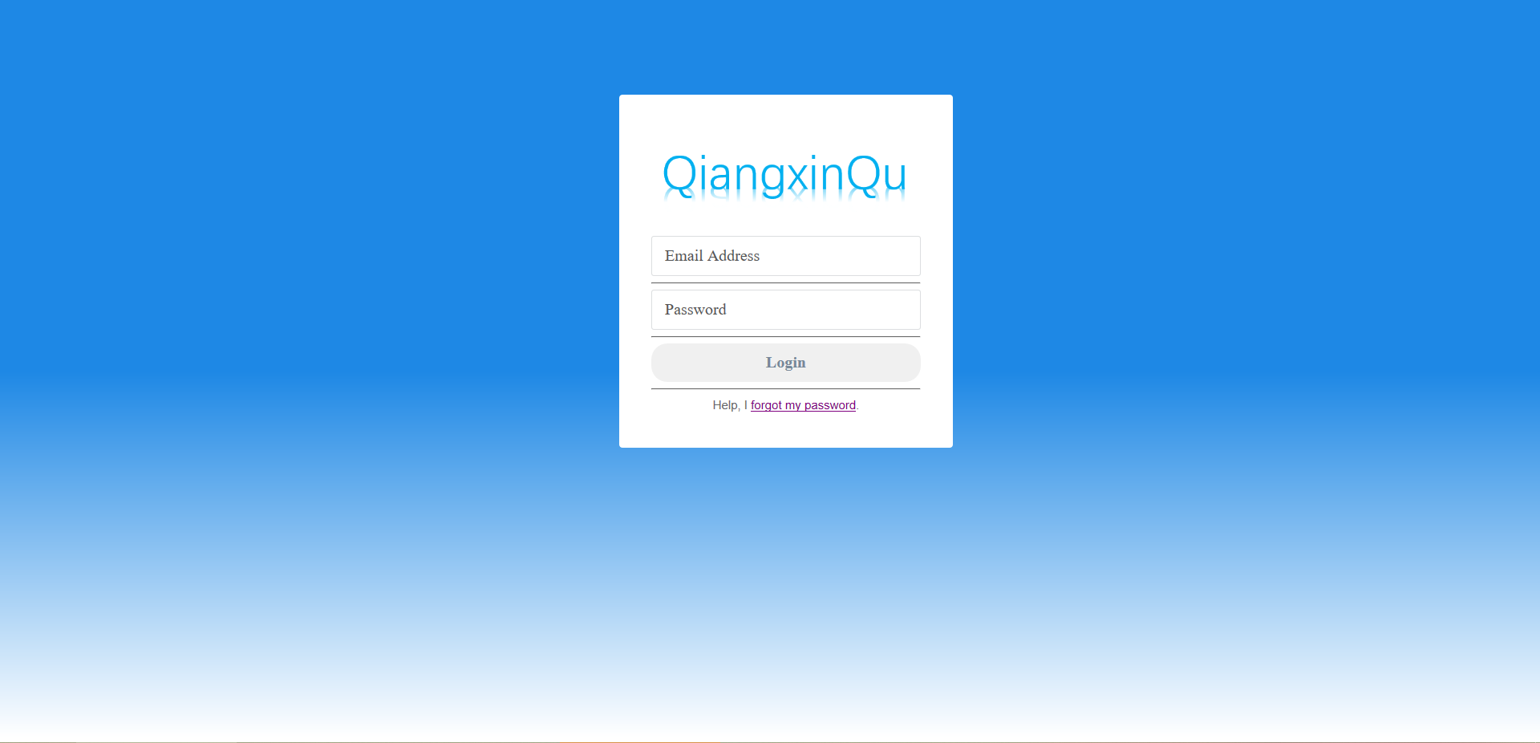

索引界面：
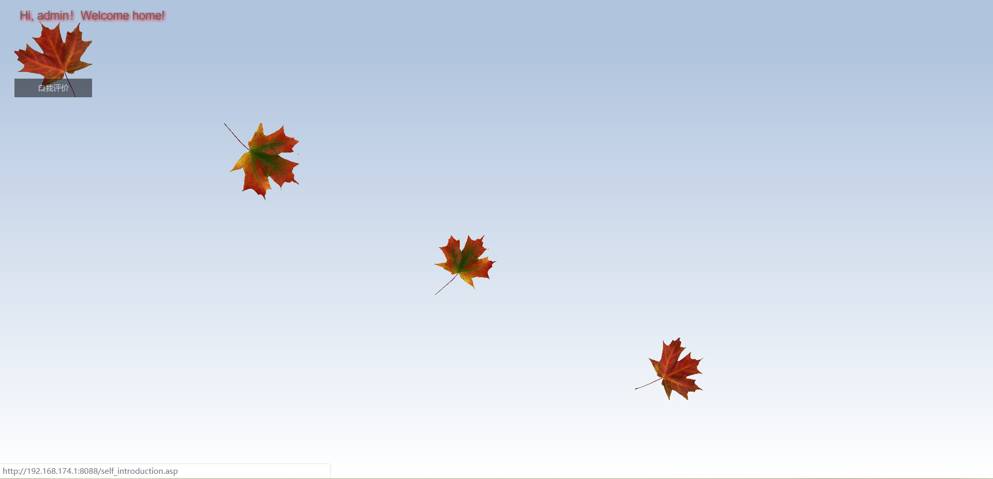

自我评价界面：
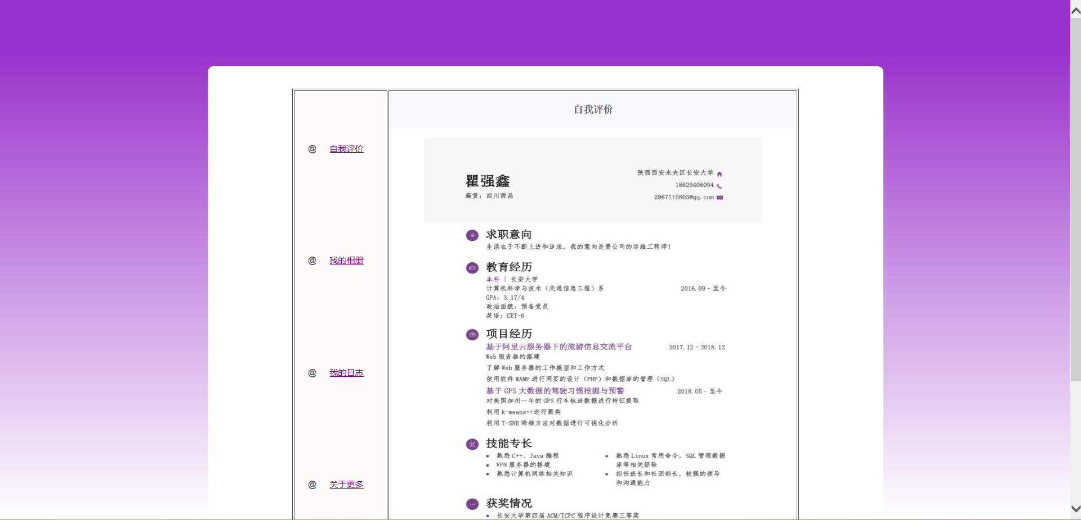
我的相册列表界面：
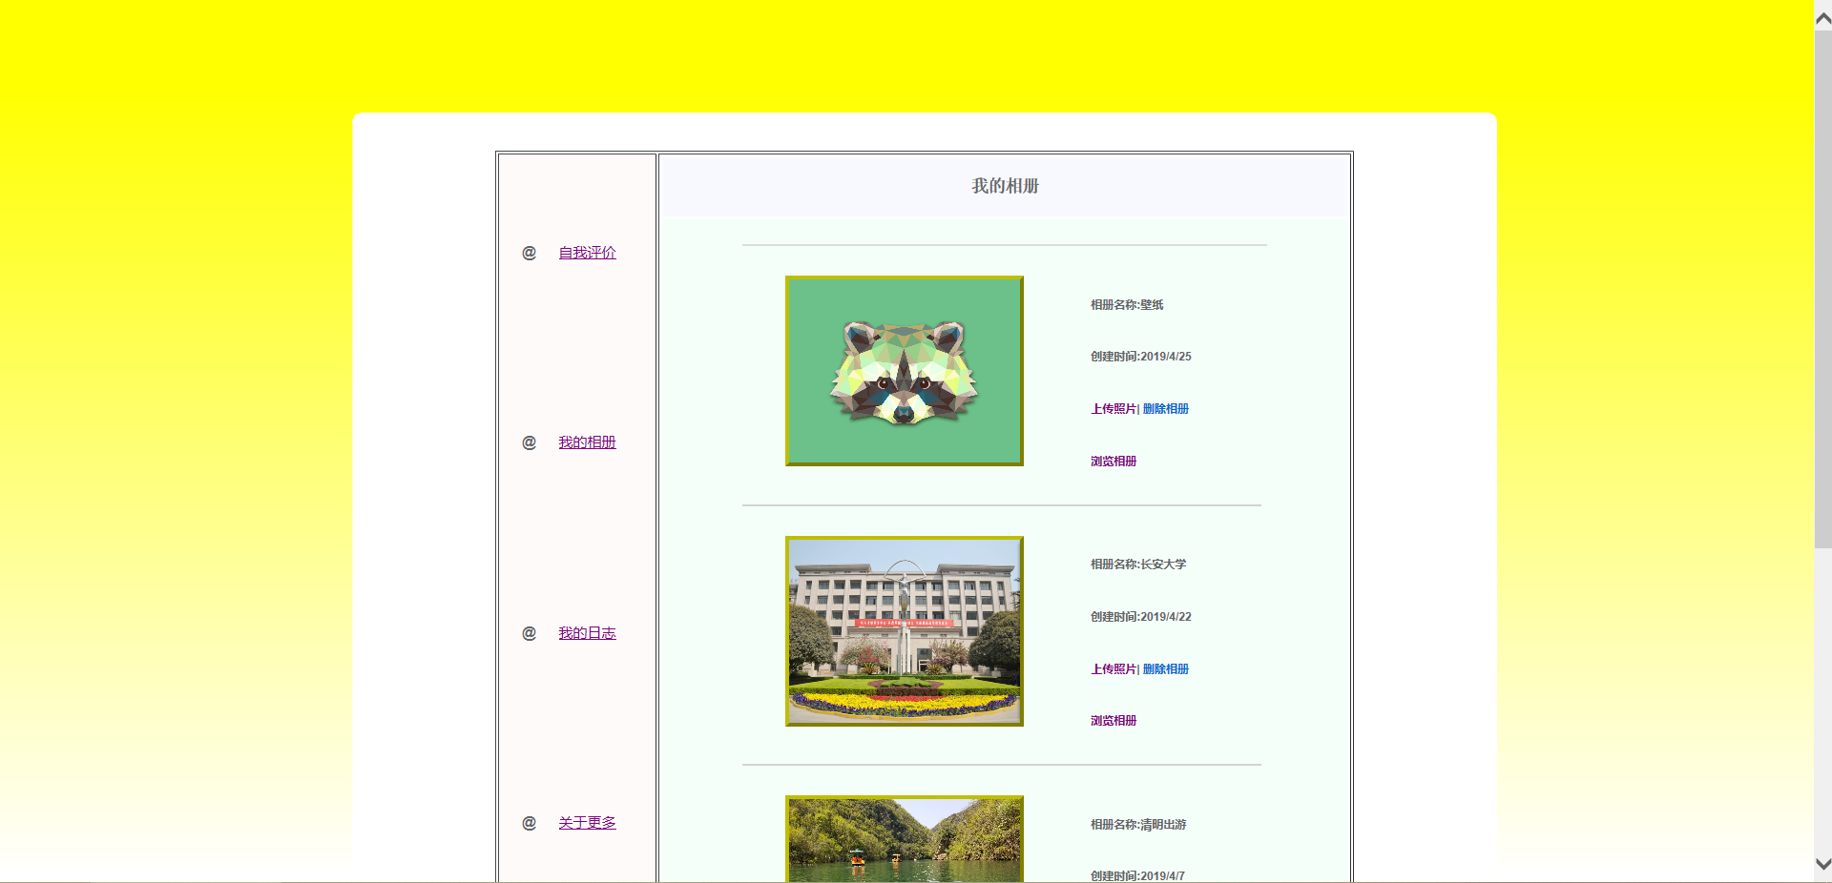
相册详情界面：
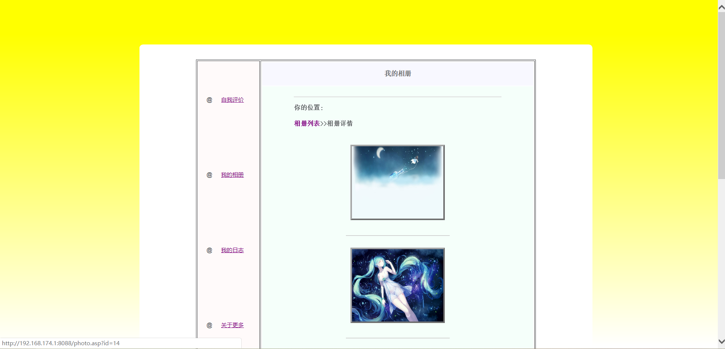

上传照片界面：
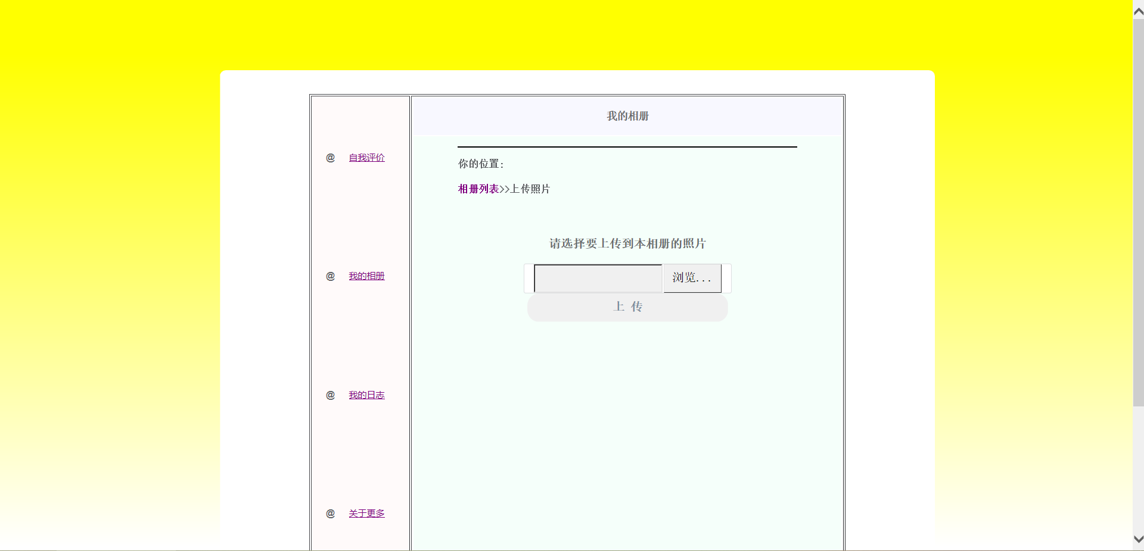
新建相册界面：
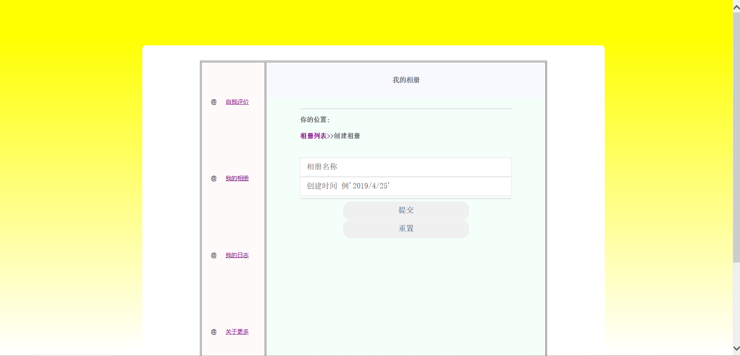
上传相册封面界面：
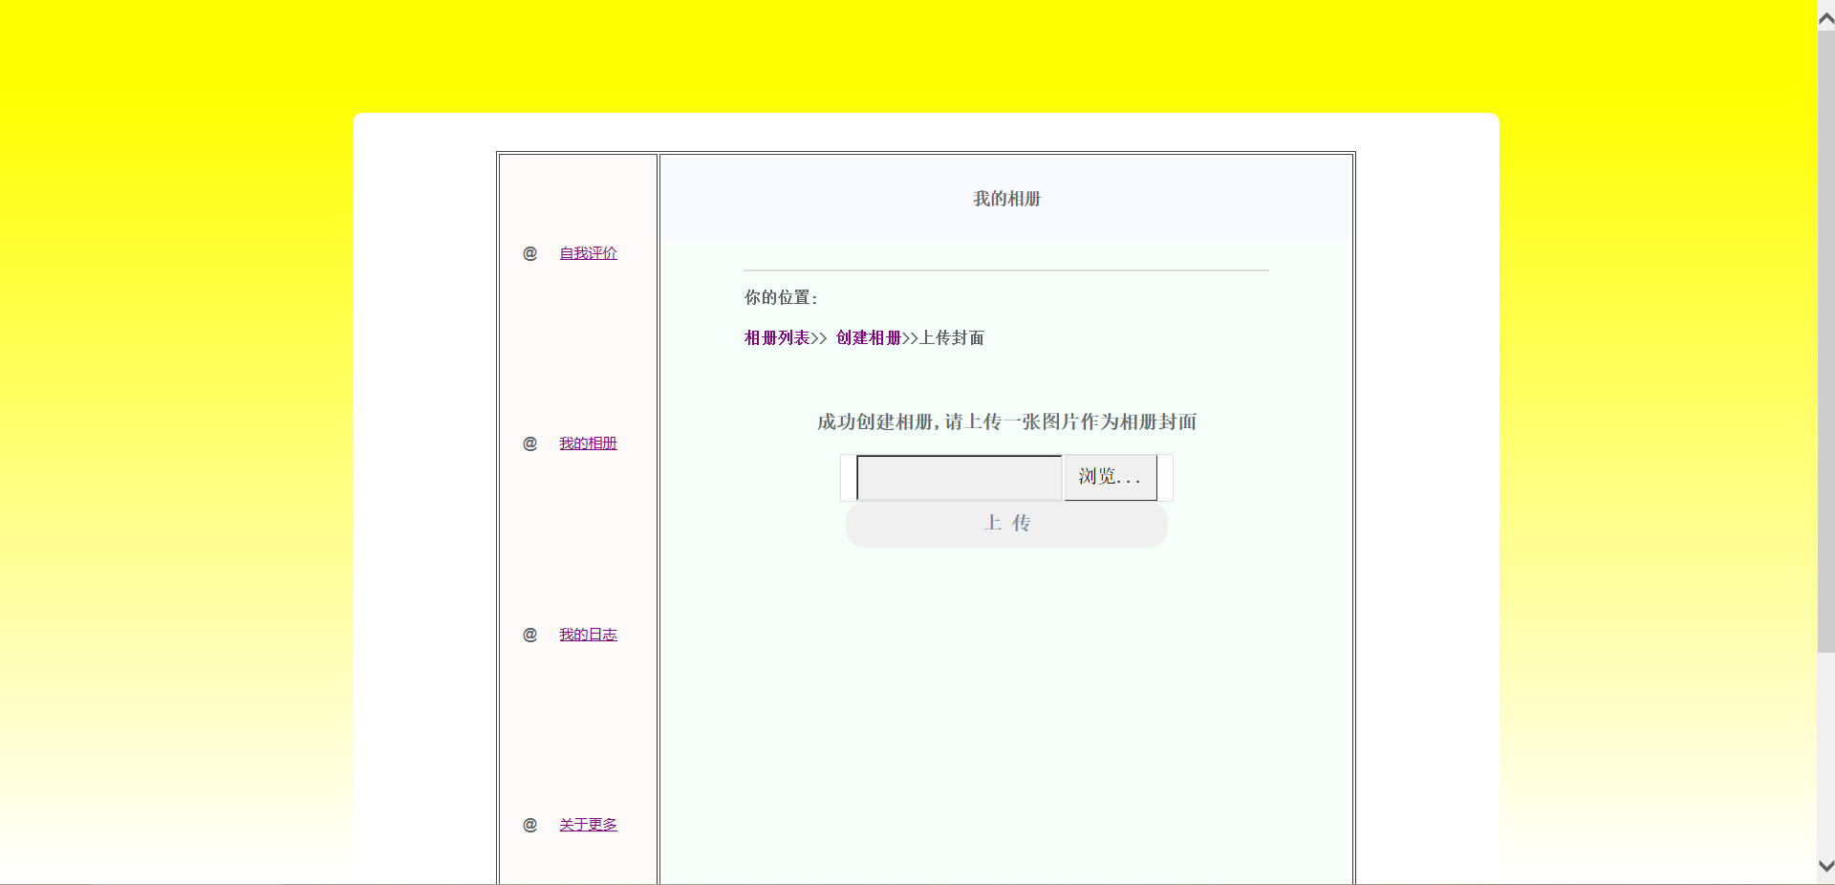

我的日志界面：
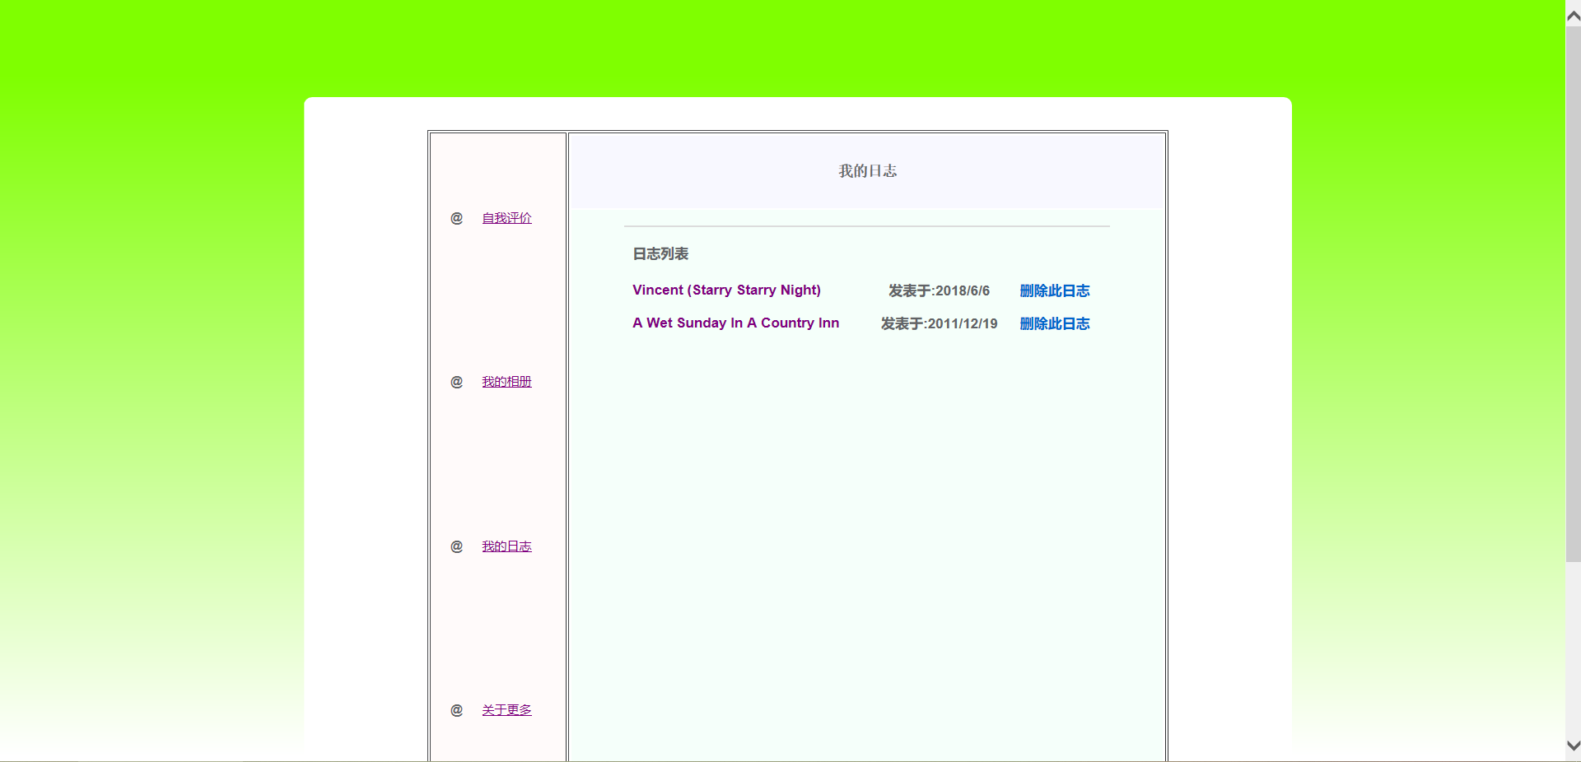

日志详情界面：
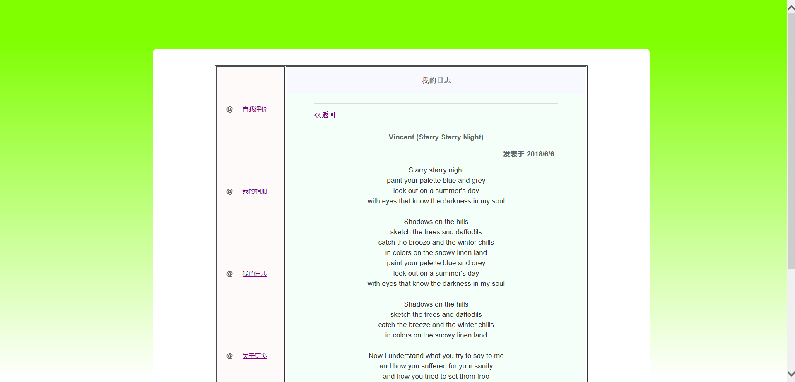

八．实验总结及心得体会
本次实验历时较长，从开课两周老师讲到B/S架构静态网页的搭建时，便开始做自己的个人主页，从一开始的HTML静态网页到老师讲到ASP动态编程，我才知道每个页面之间并不是单独工作的，通过ASP的几个对象我们可以实现ID、name等变量的传递，通过变量再调用数据库的内容可以实现更多强大的功能。（这比起我之前做数据库静态网站课程设计时更有深度更有技术！）
最大的一个收获，是CSS层叠样式表的学习和使用，虽然现在只是简单的会用一点布局，但是已经对我个人网站设计有了很大的促进和改善，美观程度上升了很多；其次是对html标签属性有了更深入的了解，对style属性的使用随着CSS的同步学习，二者相互协调各自弥补，在标签使用的时候体现出了更加灵活的展现方式。
最后是几个在编写个人网页的时候遇到的有趣的问题：
①下面是一部分我用到的将数据库相册表调用的asp代码：
<%
now_album_id=request("id")
session("now_album_id")=now_album_id
dim ors
set ors=server.CreateObject("ADODB.recordset")
sql="select * from photo where album_id="&now_album_id&" order by id desc"
ors.open sql,oConn,1,1
if not ors.eof then
for i=1 to ors.recordcount
%>
在这段代码中，now_album_id用于存放从相册列表页面传过来的相册id，但是在写sql语句时sql="select * from photo where album_id="&now_album_id&" order by id desc"却出现了问题，这句sql语句无法实现select功能，这个语句是错的！但是发现这个错误花了我一天多的时间，到底错在哪呢？在我逛遍论坛贴吧，终于找到了2010年一位博主写的博客，对于我自己申明的变量如果在sql语句中调用时，除了引号和&符号，还需要再加一层引号用于使用从当前asp代码段中申明的临时变量，即是sql="select * from photo where album_id='"&now_album_id&"' order by id desc"，注意now_album_id外的两层引号，发挥的作用也是不一样的。
②层叠样式表中的继承关系：
input[type=submit],
input[type=reset],
a.button{
display:inline-block;
vertical-align:middle;
padding:12px 143px;
margin:0px;
}
通过input[type=submit]这一句我们可以实现在之后所有的form标签里的type属性为submit

的input标签的具体属性如display、padding、margin的设置，这不仅仅是对某个元素标签进行设置，而是对其每个type分类别进行设置，非常强大。
最后，答辩时候自己觉得表现还是不够好，对某些控件的理解还是不够深入，只会用不够理解还是不行的，希望自己在之后继续努力努力钻研网页的前端设计！

