URSC 689 Coding Challenge 1 research log for Nathanael Rosenheim

# February 11, 2020

How to make a function that prints the state name given the FIPS code?

When writing a program (and debugging it) have to remember to use program drop.

Error when program gets a FIPS code that does not have a state such as 3

Made an if statement to check this error

I wanted to make my program more “Full proof” by providing an error message. I know other programs do this. I tried to google search but did not find anything helpful

I looked at an existing do file

C:\ado\plus\a\asdoc.ado – using notepad++ to open the file… I found some helpful ideas for program writing.

Finished working on program

I can envision using the program to generate urls to download Census Data

# February 10, 2020

Email instructions from Nathanael Rosenheim:

During class next week – we will have our first in-class coding demonstration.

The coding challenge is to make a program that lists the full names of all US States using a loop. Bonus points if you use a loop and an abstraction. To make the challenge competitive, I will give bonus points to the best code. Please have you code ready to share at the start of class.

## Plan - Loops

Review Readings:

Long, J. S. (2009). The workflow of data analysis using Stata. College Station, TX: Stata Press.  
https://www.stata.com/bookstore/workflow-data-analysis-stata/  
Gentzkow, M., & Shapiro, J. M. (2014). Code and data for the social sciences: A practitioner’s guide.  
University of Chicago mimeo.  
https://people.stanford.edu/gentzkow/sites/default/files/codeanddata.pdf

Scott Long Loops – Look up in index – wow lots of entries on loops – this must be an important topic

Pages 92-106

Stata has foreach and forvalues

Stata Example Code

forvalues i = 40(5)80 {

}

## Plan Abstraction

What is an abstraction?

* Not mentioned in Scott Long’s book

Gentzkow and Shapiro – “In programming, turning the specific instances of something into a general-purpose tool is known as abstraction.” (p. 24)

* Good for reducing redundancy (which reduces chances of error), code more readable

Abstraction example

program leaveout_mean

syntax, invar(varname) outvar(name) byvar(varname)

tempvar tot_invar count_invar

egen `tot_invar'= total(`invar'), by(`byvar')

egen `count_invar'= count(`invar'), by(`byvar')

gen `outvar' = (`tot_invar' - `invar') / (`count_invar' - 1)

end

leaveout_mean, invar(pc_potato) outvar(leaveout_state_pc_potato) byvar(state)

leaveout_mean, invar(pc_potato) outvar(leaveout_metro_pc_potato) byvar(metro)

leaveout_mean, invar(hh_potato) outvar(leaveout_metro_hh_potato) byvar(metro)

Scott Long also discusses programs on Page 111-119

### Look at example code from previous programs

### Example 1: SAS Program

P:\SVACS\Work\SVACS_0cv2_2010Census_2018-03-09.sas

Loops through list of states to run programs related to reading in Census Data. Census files use state abbreviations and names.

Example

<https://www2.census.gov/acs2013_5yr/summaryfile/2009-2013_ACSSF_By_State_All_Tables/>

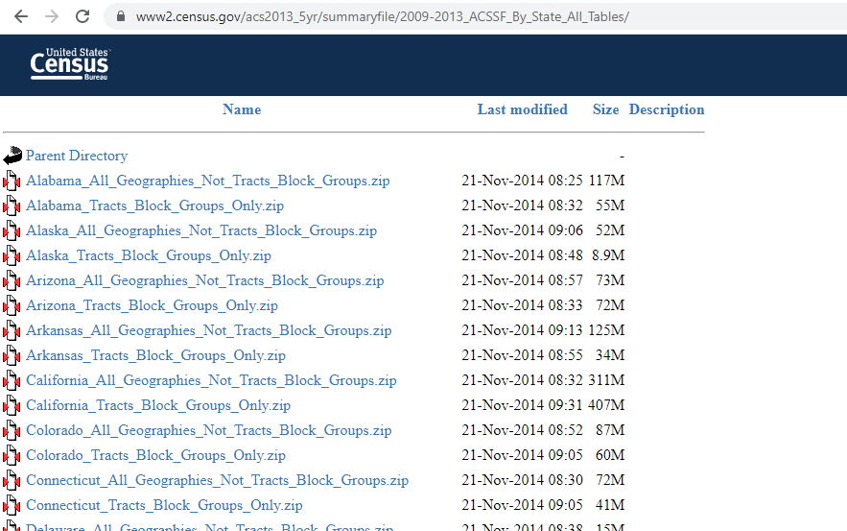

/*-------------------------------------------------------------------*/

/* Macro to call states */

/*-------------------------------------------------------------------*/

%macro CallSt;

/*The CallSt macro is used to generate State 2 digit abbreviations see Appendix B

of the technical documentation for a list of state codes */

/*The Census summary file contains state 2 digit numeric codes from 1 to 72

Note: FIPS codes are NOT sequential so if a code does not exist such as 71

The call execute statement will NOT run because there is no state abbrev */

/*If you want just a single state, such as Alabama set the do statement to start

and end at that state code such as %do i=1 %to 1; for Alabama */

%do i=&f_state %to &l_state;

data _null_;

stabbrv=compress(trim(lowcase(FIPSTATE(&i))));

* Folder Is state name with _ for spaces;

stname=compress(tranwrd(trim(FIPNAMEL(&i))," ","_"));

/*Note: DC and PR are not covered in FIPS state function, and the two digit

function is not required to be 0 filled */

if &i=0 then stabbrv = 'us';

if &i=11 then stabbrv = 'dc';

if &i=72 then stabbrv = 'pr';

/*FIPS Codes 60 and 66 are fpr American Samoa and Guam */

if &i>56 and &i<72 then stabbrv = "--";

/*If the function returns a state abbreviation then run the AllSeqs macro */

if stabbrv ^= "--" then do;

put stabbrv stname;

call execute('%Read2010Census(' || compress(stabbrv) ||','|| compress(stname) || ')');

end;

run;

%end;

%mend;

%CallSt;

### Example 2: LODES Bulk Download

Program: LODES7_D0av1_bulkDownload_LEHDv72_2016-03-25.r

# What year do you want to download? e.g. _2013

# use _20 to download all years

year <- "_20"

# need a list of states with abbreviated state names (US postal abbrev.

# state name = STUSAB)

if (!file.exists("state.txt")){

download.file("http://web.archive.org/web/20141125122851/http://www.census.gov/geo/reference/docs/state.txt", destfile = "state.txt")

} else {

states <- read.table("state.txt", sep = "|", header = T, colClasses = "character")

states <- states[order(as.numeric(states$STATE)), ]

states.keep <- states[-c(52:57),]

nstates <- dim(states.keep)[1]

}

for (i in 1:51) {

stusab <- tolower(states.keep[i, 2])

fname <- paste0("lodes_", stusab)

### Google Search:

“stata loop through states” – no immediate results examples of loops

Some help with

<https://jearl.faculty.arizona.edu/sites/jearl.faculty.arizona.edu/files/Introduction%20to%20Loops%20in%20Stata.pdf>

nothing stands out in google search

### Plan – I need a list of all states

Google search – Census is a reputable source

<https://www.census.gov/library/reference/code-lists/ansi.html>

[https://www2.census.gov/geo/docs/reference/state.txt?#](https://www2.census.gov/geo/docs/reference/state.txt?)

This file is available on the internet and has states and state equivalents

#### **State and State Equivalents**

National FIPS and GNIS Codes File

This file contains pipe delimited records for each state. The records are of the format:  
  
FIPS State Code | Official United States Postal Service (USPS) Code | Name | Geographic Names Information System Identifier (GNISID)  
  
For example:  
  
23|ME|Maine|01779787

### How to read in data – Template Workflow Example and Scott Long

insheet using "filename", clear

When I use insheet I only get 1 variable

help insheet

set delimiter to the pipe

Data is in Stata – time to write a do file

Using do file template

G:\Team Drives\URSC689_S2020\TMPWF\Posted\00_templatedofile_2020-02-10.do

Saving work in WORKNPR Folder

G:\My Drive\MyCourses\URSC689\WorkNPR\URSC689_01_IntroLoopsFunctions_2020-02-10\

### Data is read in – how do I loop over observations?

Google: stata loop through observations

Example code

<https://www.stata.com/statalist/archive/2007-03/msg00525.html>

sysuse auto, clear

gen domestic = .

local N = _N

forvalues i = 1/`N' {

if foreign[`i'] == 0 {

qui replace domestic = 1 in `i'

}

else {

qui replace domestic = 0 in `i'

}

}

### How to make an abstraction (program) that returns state name given state fips?

Googled stata look up observation

Found

<https://www.stata.com/statalist/archive/2008-08/msg00302.html>

gen long obsn = _n

su obsn if name == "Jones", meanonly

local Jones_age = age[`r(min)']