基于FRDM-KE02Z40M的ucos-ii移植
作者：Jianhui Tong
邮箱：Jianhui.tong@nxp.com

第一部分 准备工作
- 下载FRDM-KEXX Driver Library Package，即KEXX_DRIVERS_V1.2.1_DEVD.zip文件。

下载链接为：
http://www.nxp.com/webapp/sps/download/license.jsp?colCode=KEXX_DRIVERS_V1.2.1_DEVD&location=null&fromsite=zh-Hans&fsrch=1&sr=1&pageNum=1&Parent_nodeId=&Parent_pageType

- 下载KL02 SDK2.0，下载时需要勾选ucos-ii。
访问Kinetis Expet网站：http://kex.nxp.com/en/welcome，点击“Build an SDK”。

选择”Configuration”标签页，并点击”New Configuration”新建配置。
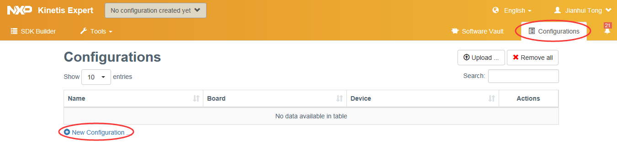
选择FRDM-KL02Z开发板，并点击”Select Configuration”。
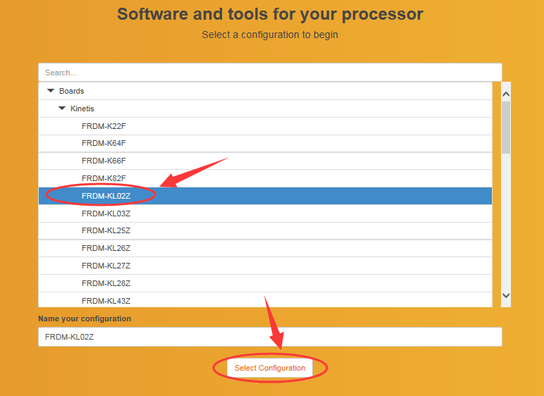
勾选ucos-ii，并点击”Build SDK Package”。
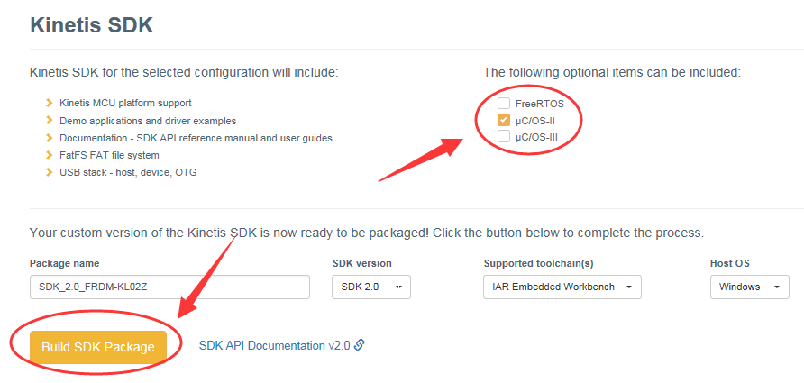
切换到”Software Vault”标签页，并下载刚刚Build完成的SDK。
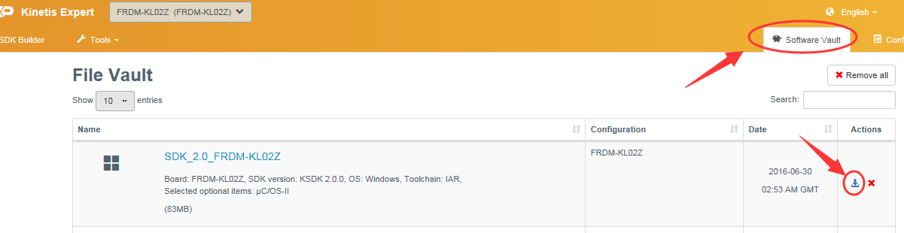
- 将下载好的KE驱动库和SDK库解压
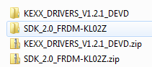
- 运行..\KEXX_DRIVERS_V1.2.1_DEVD\kexx_drv_lib\build\iar\ke02目录下的make_new_project_ke02.exe文件。
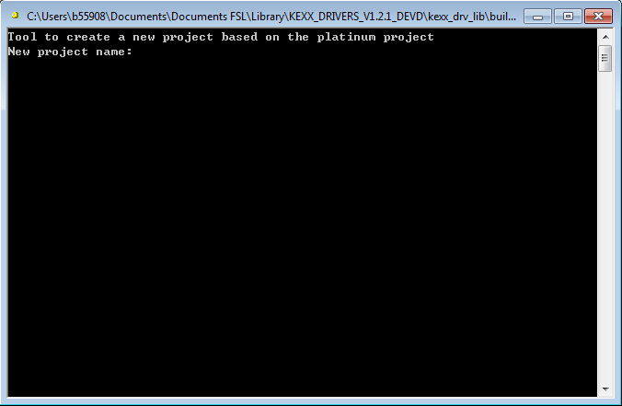
- 输入新建工程名字，如ucosii_ke02，回车确认。
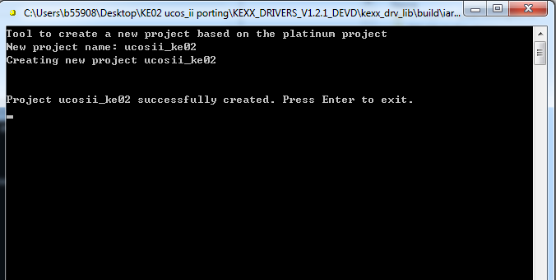
- 新建完成后，再次按下回车键退出。
- 打开..\KEXX_DRIVERS_V1.2.1_DEVD\kexx_drv_lib\build\iar\ke02\ucosii_ke02目录下的ucosii_ke02.eww文件，并编译工程。
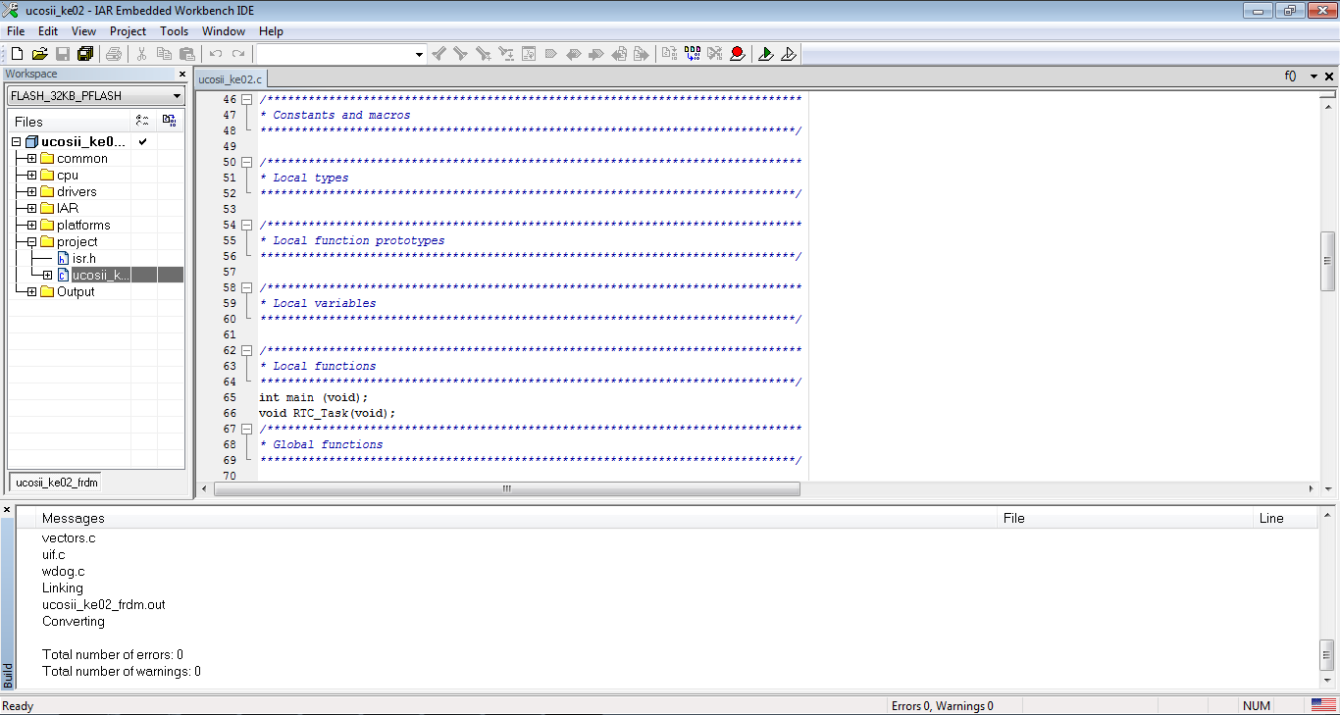
- 此时，即得到了使用KE driver库的Demo工程，后面移植工作将基于此工程进行修改。

第二部分 移植ucos-ii
- ..\KEXX_DRIVERS_V1.2.1_DEVD\kexx_drv_lib\src\projects\KE02\ucosii_ke02
目录下新建两个文件夹，并分别命名为“ports”，“uCOS-II”。
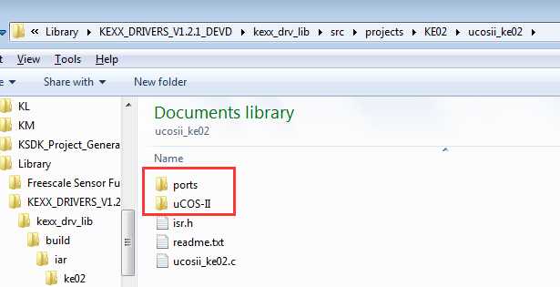
- 将..\SDK_2.0_FRDM-KL02Z\rtos\ucosii_2.92.11\uCOS-II\Ports\ARM-Cortex-M0\Generic\IAR目录下的4个文件 os_cpu.h, os_cpu_a.asm, os_cpu_c.c, os_dbg.c复制到
..\KEXX_DRIVERS_V1.2.1_DEVD\kexx_drv_lib\src\projects\KE02\ucosii_ke02\ports
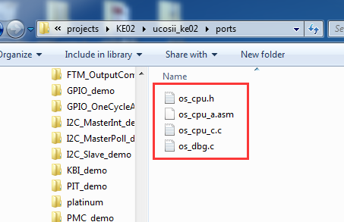
- 将..\SDK_2.0_FRDM-KL02Z\rtos\ucosii_2.92.11\uCOS-II\Source目录下的11个文件os_core.c, os_flag.c, os_mbox.c, os_mem.c, os_mutex.c, os_q.c, os_sem.c, os_task.c, os_time.c, os_tmr.c, ucos_ii.h复制到
..\KEXX_DRIVERS_V1.2.1_DEVD\kexx_drv_lib\src\projects\KE02\ucosii_ke02\uCOS-II
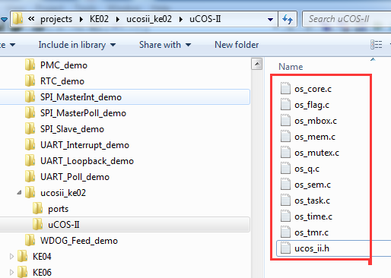
- 将..\SDK_2.0_FRDM-KL02Z\rtos\ucosii_2.92.11\template_application目录下的4个文件app_cfg.h, app_hooks.c, cpu_cfg.h, os_cfg.h 复制到
..\KEXX_DRIVERS_V1.2.1_DEVD\kexx_drv_lib\src\projects\KE02\ucosii_ke02
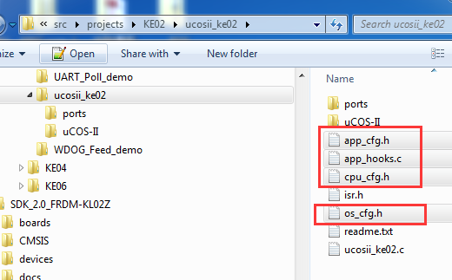在IAR工程目录中新建两个文件夹“ports”和“ucos ii”。
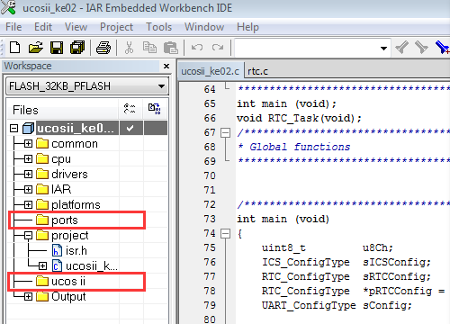
- 将上述步骤中复制的文件添加到IAR工程中，如下图所示。
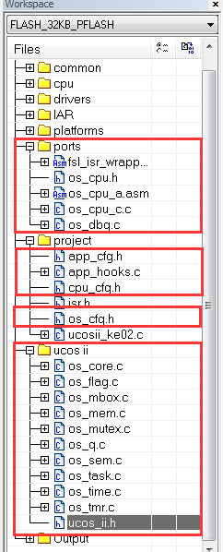
- 修改编译器搜索路径。在IAR中打开Project > Options > C/C++ Compiler >Preprocessor，在“Additional include directories”一栏中添加上文复制文件所在的路径。
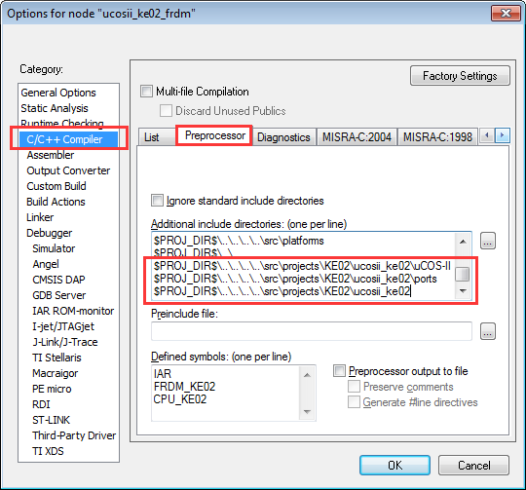
- 修改app_cfg.h文件，添加下图红框中圈出的代码。

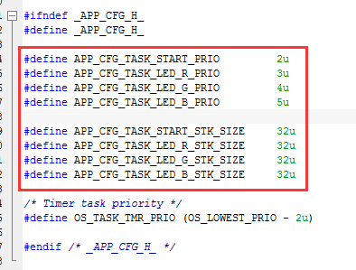

- 修改ucosii_ke02.c文件，用下面的代码替换。
/******************************************************************************
*
* Freescale Semiconductor Inc.
* (c) Copyright 2013 Freescale Semiconductor, Inc.
* ALL RIGHTS RESERVED.
*
***************************************************************************
*
* THIS SOFTWARE IS PROVIDED BY FREESCALE "AS IS" AND ANY EXPRESSED OR
* IMPLIED WARRANTIES, INCLUDING, BUT NOT LIMITED TO, THE IMPLIED WARRANTIES
* OF MERCHANTABILITY AND FITNESS FOR A PARTICULAR PURPOSE ARE DISCLAIMED.
* IN NO EVENT SHALL FREESCALE OR ITS CONTRIBUTORS BE LIABLE FOR ANY DIRECT,
* INDIRECT, INCIDENTAL, SPECIAL, EXEMPLARY, OR CONSEQUENTIAL DAMAGES
* (INCLUDING, BUT NOT LIMITED TO, PROCUREMENT OF SUBSTITUTE GOODS OR
* SERVICES; LOSS OF USE, DATA, OR PROFITS; OR BUSINESS INTERRUPTION)
* HOWEVER CAUSED AND ON ANY THEORY OF LIABILITY, WHETHER IN CONTRACT,
* STRICT LIABILITY, OR TORT (INCLUDING NEGLIGENCE OR OTHERWISE) ARISING
* IN ANY WAY OUT OF THE USE OF THIS SOFTWARE, EVEN IF ADVISED OF
* THE POSSIBILITY OF SUCH DAMAGE.
*
***************************************************************************//*!
*
* @file uCOS-II_KE02.c
*
* @author Freescale
*
* @version 0.0.1
*
* @date Jun. 25, 2013
*
* @brief providing framework of demo cases for MCU.
*
*******************************************************************************/

#include "common.h"
#include "ics.h"
#include "uart.h"
#include "sysinit.h"
#include "ucos_ii.h"
#include "system_MKE02Z2.h"

/******************************************************************************
* Global variables
******************************************************************************/

/******************************************************************************
* Constants and macros
******************************************************************************/

/******************************************************************************
* Local types
******************************************************************************/

/******************************************************************************
* Local function prototypes
******************************************************************************/

/******************************************************************************
* Local variables
******************************************************************************/
static OS_STK AppTaskStartStk[APP_CFG_TASK_START_STK_SIZE];
static OS_STK AppTaskLedRStk[APP_CFG_TASK_LED_R_STK_SIZE];
static OS_STK AppTaskLedGStk[APP_CFG_TASK_LED_G_STK_SIZE];
static OS_STK AppTaskLedBStk[APP_CFG_TASK_LED_B_STK_SIZE];

static OS_EVENT* RSem;
static OS_EVENT* GSem;
static OS_EVENT* BSem;
static OS_EVENT* OffSem;
/******************************************************************************
* Local functions
******************************************************************************/
int main (void);
static void AppTaskStart (void *p_arg);
static void AppTaskLedR(void *p_arg);
static void AppTaskLedG(void *p_arg);
static void AppTaskLedB(void *p_arg);
/******************************************************************************
* Global functions
******************************************************************************/

/********************************************************************/
int main (void)
{

OSInit();

OSTaskCreate(AppTaskStart, (void*)0, &AppTaskStartStk[APP_CFG_TASK_START_STK_SIZE-1], (INT8U)APP_CFG_TASK_START_PRIO );

OSStart();

return (1);

}

static void AppTaskStart (void *p_arg)
{
INT8U err;

(void)p_arg;

sysinit();
OS_CPU_SysTickInit(20000000/OS_TICKS_PER_SEC);

PORT->HDRVE |=0x02;

LED0_Init();
LED1_Init();
LED2_Init();
LED0_Off();
LED1_Off();
LED2_Off();

RSem = OSSemCreate(1);
GSem = OSSemCreate(1);
BSem = OSSemCreate(1);
OffSem = OSSemCreate(1);

OSTaskCreate(AppTaskLedR, (void*)0, &AppTaskLedRStk[APP_CFG_TASK_LED_R_STK_SIZE-1], (INT8U)APP_CFG_TASK_LED_R_PRIO );
OSTaskCreate(AppTaskLedG, (void*)0, &AppTaskLedGStk[APP_CFG_TASK_LED_G_STK_SIZE-1], (INT8U)APP_CFG_TASK_LED_G_PRIO );
OSTaskCreate(AppTaskLedB, (void*)0, &AppTaskLedBStk[APP_CFG_TASK_LED_B_STK_SIZE-1], (INT8U)APP_CFG_TASK_LED_B_PRIO );

while (1)
{
OSTimeDlyHMSM(0,0,3,0);
OSSemPost(RSem);
OSSemPend(OffSem, 0, &err);

}
}

static void AppTaskLedR(void *p_arg)
{
INT8U err;

while(1)
{
OSSemPend(RSem,0,&err);
LED0_On();LED2_Off();
OSTimeDlyHMSM(0,0,1,0);
OSSemPost(GSem);
}
}

static void AppTaskLedG(void *p_arg)
{
INT8U err;

while(1)
{
OSSemPend(GSem,0,&err);
LED1_On();LED0_Off();
OSTimeDlyHMSM(0,0,1,0);
OSSemPost(BSem);
}
}

static void AppTaskLedB(void *p_arg)
{
INT8U err;

while(1)
{
OSSemPend(BSem,0,&err);
LED2_On();LED1_Off();
OSTimeDlyHMSM(0,0,1,0);
OSSemPost(OffSem);
}
}

- 修改os_cfg.h文件，用下面的代码替换。（由于KE02的RAM较小，因此关闭了部分未使用的功能）
/*
*********************************************************************************************************
* uC/OS-II
* The Real-Time Kernel
* uC/OS-II Configuration File for V2.9x
*
* (c) Copyright 2005-2013, Micrium, Weston, FL
* All Rights Reserved
*
*
* File : OS_CFG.H
* By : Jean J. Labrosse
* Version : V2.92.11
*
* LICENSING TERMS:
* ---------------
* uC/OS-II is provided in source form for FREE evaluation, for educational use or for peaceful research.
* If you plan on using uC/OS-II in a commercial product you need to contact Micrium to properly license
* its use in your product. We provide ALL the source code for your convenience and to help you experience
* uC/OS-II. The fact that the source is provided does NOT mean that you can use it without paying a
* licensing fee.
*********************************************************************************************************
*/

#ifndef OS_CFG_H
#define OS_CFG_H

/* ---------------------- MISCELLANEOUS ----------------------- */
#define OS_APP_HOOKS_EN 0u /* Application-defined hooks are called from the uC/OS-II hooks */
#define OS_ARG_CHK_EN 0u /* Enable (1) or Disable (0) argument checking */
#define OS_CPU_HOOKS_EN 1u /* uC/OS-II hooks are found in the processor port files */

#define OS_DEBUG_EN 0u /* Enable(1) debug variables */

#define OS_EVENT_MULTI_EN 0u /* Include code for OSEventPendMulti() */
#define OS_EVENT_NAME_EN 0u /* Enable names for Sem, Mutex, Mbox and Q */

#define OS_LOWEST_PRIO 63u /* Defines the lowest priority that can be assigned ... */
/* ... MUST NEVER be higher than 254! */

#define OS_MAX_EVENTS 10u /* Max. number of event control blocks in your application */
#define OS_MAX_FLAGS 5u /* Max. number of Event Flag Groups in your application */
#define OS_MAX_MEM_PART 5u /* Max. number of memory partitions */
#define OS_MAX_QS 4u /* Max. number of queue control blocks in your application */
#define OS_MAX_TASKS 10u /* Max. number of tasks in your application, MUST be >= 2 */

#define OS_SCHED_LOCK_EN 1u /* Include code for OSSchedLock() and OSSchedUnlock() */

#define OS_TICK_STEP_EN 1u /* Enable tick stepping feature for uC/OS-View */
#define OS_TICKS_PER_SEC 1000u /* Set the number of ticks in one second */

#define OS_TLS_TBL_SIZE 0u /* Size of Thread-Local Storage Table */

/* --------------------- TASK STACK SIZE ---------------------- */
#define OS_TASK_TMR_STK_SIZE 64u /* Timer task stack size (# of OS_STK wide entries) */
#define OS_TASK_STAT_STK_SIZE 64u /* Statistics task stack size (# of OS_STK wide entries) */
#define OS_TASK_IDLE_STK_SIZE 64u /* Idle task stack size (# of OS_STK wide entries) */

/* --------------------- TASK MANAGEMENT ---------------------- */
#define OS_TASK_CHANGE_PRIO_EN 1u /* Include code for OSTaskChangePrio() */
#define OS_TASK_CREATE_EN 1u /* Include code for OSTaskCreate() */
#define OS_TASK_CREATE_EXT_EN 1u /* Include code for OSTaskCreateExt() */
#define OS_TASK_DEL_EN 0u /* Include code for OSTaskDel() */
#define OS_TASK_NAME_EN 0u /* Enable task names */
#define OS_TASK_PROFILE_EN 0u /* Include variables in OS_TCB for profiling */
#define OS_TASK_QUERY_EN 0u /* Include code for OSTaskQuery() */
#define OS_TASK_REG_TBL_SIZE 1u /* Size of task variables array (#of INT32U entries) */
#define OS_TASK_STAT_EN 0u /* Enable (1) or Disable(0) the statistics task */
#define OS_TASK_STAT_STK_CHK_EN 0u /* Check task stacks from statistic task */
#define OS_TASK_SUSPEND_EN 0u /* Include code for OSTaskSuspend() and OSTaskResume() */
#define OS_TASK_SW_HOOK_EN 1u /* Include code for OSTaskSwHook() */

/* ----------------------- EVENT FLAGS ------------------------ */
#define OS_FLAG_EN 0u /* Enable (1) or Disable (0) code generation for EVENT FLAGS */
#define OS_FLAG_ACCEPT_EN 1u /* Include code for OSFlagAccept() */
#define OS_FLAG_DEL_EN 1u /* Include code for OSFlagDel() */
#define OS_FLAG_NAME_EN 1u /* Enable names for event flag group */
#define OS_FLAG_QUERY_EN 1u /* Include code for OSFlagQuery() */
#define OS_FLAG_WAIT_CLR_EN 1u /* Include code for Wait on Clear EVENT FLAGS */
#define OS_FLAGS_NBITS 16u /* Size in #bits of OS_FLAGS data type (8, 16 or 32) */

/* -------------------- MESSAGE MAILBOXES --------------------- */
#define OS_MBOX_EN 0u /* Enable (1) or Disable (0) code generation for MAILBOXES */
#define OS_MBOX_ACCEPT_EN 1u /* Include code for OSMboxAccept() */
#define OS_MBOX_DEL_EN 1u /* Include code for OSMboxDel() */
#define OS_MBOX_PEND_ABORT_EN 1u /* Include code for OSMboxPendAbort() */
#define OS_MBOX_POST_EN 1u /* Include code for OSMboxPost() */
#define OS_MBOX_POST_OPT_EN 1u /* Include code for OSMboxPostOpt() */
#define OS_MBOX_QUERY_EN 1u /* Include code for OSMboxQuery() */

/* --------------------- MEMORY MANAGEMENT -------------------- */
#define OS_MEM_EN 0u /* Enable (1) or Disable (0) code generation for MEMORY MANAGER */
#define OS_MEM_NAME_EN 1u /* Enable memory partition names */
#define OS_MEM_QUERY_EN 1u /* Include code for OSMemQuery() */

/* ---------------- MUTUAL EXCLUSION SEMAPHORES --------------- */
#define OS_MUTEX_EN 0u /* Enable (1) or Disable (0) code generation for MUTEX */
#define OS_MUTEX_ACCEPT_EN 1u /* Include code for OSMutexAccept() */
#define OS_MUTEX_DEL_EN 1u /* Include code for OSMutexDel() */
#define OS_MUTEX_QUERY_EN 1u /* Include code for OSMutexQuery() */

/* ---------------------- MESSAGE QUEUES ---------------------- */
#define OS_Q_EN 0u /* Enable (1) or Disable (0) code generation for QUEUES */
#define OS_Q_ACCEPT_EN 1u /* Include code for OSQAccept() */
#define OS_Q_DEL_EN 1u /* Include code for OSQDel() */
#define OS_Q_FLUSH_EN 1u /* Include code for OSQFlush() */
#define OS_Q_PEND_ABORT_EN 1u /* Include code for OSQPendAbort() */
#define OS_Q_POST_EN 1u /* Include code for OSQPost() */
#define OS_Q_POST_FRONT_EN 1u /* Include code for OSQPostFront() */
#define OS_Q_POST_OPT_EN 1u /* Include code for OSQPostOpt() */
#define OS_Q_QUERY_EN 1u /* Include code for OSQQuery() */

/* ------------------------ SEMAPHORES ------------------------ */
#define OS_SEM_EN 1u /* Enable (1) or Disable (0) code generation for SEMAPHORES */
#define OS_SEM_ACCEPT_EN 1u /* Include code for OSSemAccept() */
#define OS_SEM_DEL_EN 1u /* Include code for OSSemDel() */
#define OS_SEM_PEND_ABORT_EN 1u /* Include code for OSSemPendAbort() */
#define OS_SEM_QUERY_EN 1u /* Include code for OSSemQuery() */
#define OS_SEM_SET_EN 1u /* Include code for OSSemSet() */

/* --------------------- TIME MANAGEMENT ---------------------- */
#define OS_TIME_DLY_HMSM_EN 1u /* Include code for OSTimeDlyHMSM() */
#define OS_TIME_DLY_RESUME_EN 1u /* Include code for OSTimeDlyResume() */
#define OS_TIME_GET_SET_EN 1u /* Include code for OSTimeGet() and OSTimeSet() */
#define OS_TIME_TICK_HOOK_EN 1u /* Include code for OSTimeTickHook() */

/* --------------------- TIMER MANAGEMENT --------------------- */
#define OS_TMR_EN 0u /* Enable (1) or Disable (0) code generation for TIMERS */
#define OS_TMR_CFG_MAX 16u /* Maximum number of timers */
#define OS_TMR_CFG_NAME_EN 1u /* Determine timer names */
#define OS_TMR_CFG_WHEEL_SIZE 7u /* Size of timer wheel (#Spokes) */
#define OS_TMR_CFG_TICKS_PER_SEC 10u /* Rate at which timer management task runs (Hz) */

#endif

- 修改isr.h文件。
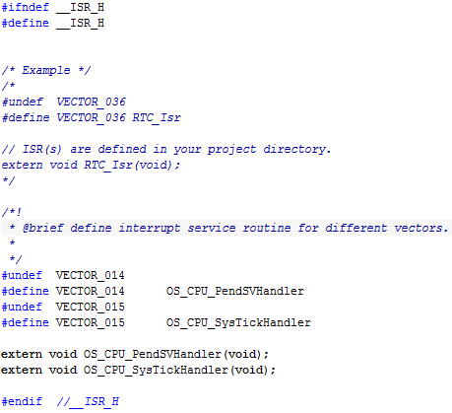
- 完成后保存，并重新编译工程。将下载程序到FRDM-KE02Z40M中，复位运行程序就可以看到LED灯的颜色随时间变化啦！

