**Introduction：**

**section1**

The purpose of this research report is to investigate how people use state library of Queensland. 本篇报告主要研究图书馆二楼的区域。State library of Queensland作为一个位于市中心的开放空间，与布里斯班的重要枢纽cultural centre station相邻。The library is used by both local resident as well as people who travel up to one hour by car or public transport from the adjoining suburbs. 通常使用该区域的是学生，退休者以及有借阅需求的人。学生通常寻求安静的学习空间。退休人员常常利用图书馆阅读书籍或使用公共电脑以及打印机。

**Section2**

The human-centred research methods used in this study focused on understanding how people interact with the public library space and its services. Three main methods were applied:

**semi-structured interviews** with regular library users to gather insights into their behaviours, needs, and preferences,

**direct observations** of people’s activities and movement within different areas of the library, and a **digital probe** in the form of a emotion mapping prompt。Give users a map of the library and ask them to mark how they feel in different areas.The data analysis involved four key steps:

1.Identifying the **values and motivations** expressed by participants during interviews and probe responses.

**2.Recognising recurring themes** and grouping relevant data into these thematic categories to uncover patterns in user behaviours and perceptions.

3.the main challenges that people were facing when interacting with the library

4.the design opportunities to improve the user experience of the library

*Section3*

After analysing the data collected through interviews, observations, and emotion mapping, several key insights emerged about how users interact with the library space.

The major insight discovered was that the primary source of frustration was that people People always spend a lot of time looking for locations.特别是当人们作为一个小组来到图书馆想找一个整张的桌子，这会花费更多时间。许多人根据不同需求对环境有着不同要求。大多数人更喜欢安静和专注的环境。此外，携带电子设备的人表示图书馆里许多区域并不具备电源插头。最后，有人还表示图书馆的椅子并不舒服，这对长时间待在图书馆的人很不友好*。*

**Section4:**

The key challenges identified through human-centred research revealed several promising design opportunities to enhance the library experience for users. The major issues that presented design opportunities were:a）**Lack of clearly defined quiet and collaborative zones**, which often led to noise disruptions and frustration among users seeking a focused study environment. b）缺少学习空间。C）缺少小组学习场所，可能是一整张桌子或者会议室。D）**Insufficient access to power outlets**, particularly in high-demand seating areas.

**Analysis：**

**Observation1:**

During an observation session in the library,a user carrying a laptop, walking slowly along the edges of the study area. She paused several times, looking underneath tables and along the walls, visibly searching for a power outlet. At one point, she crouched slightly to check behind a desk, then stood up and sighed quietly. Her body language—small frowns, glances from side to side, and shifting her weight—**conveyed** a growing sense of frustration and uncertainty. After several minutes, she eventually chose a seat without an outlet nearby, opened her laptop hesitantly. She turned on the computer and worked for about ten minutes, then left the library.This behavior shows that many users who carry electronic devices need power outlets. When there are no electrical outlets, they may spend less time in the library.The situation **suggests** that although the physical space appears functional on the surface, it lacks the infrastructure to support current user habits and needs. What’s missing here is clearly visible and accessible charging options throughout the study area. This situation shows that many of the library's seats lack the power outlets needed to support users with electronic devices. This situation can be improved in two ways: 1. Increase the number of power plugs and try to install power plugs on every desk. 2. Mark the outlet on the desk with the outlet. This can reduce the time people spend searching for an outlet.

**Interview2:**

During the interview, one of the questions was:“Is there anything about the library that you'll find difficult to use? ”.此问题的目的时引导人们反思在使用图书馆的过程中遇到的障碍和不便，接收机用户痛点。五个受访者都针对这个问题做出了回答。受访者1回答道：“no”。用户似乎觉得图书馆没有难以使用的地方。但在问到最后一个问题：“If you could redesign or improve one part of the library, what would it be ? ”这时受访者1却说道：”redesign. More meeting rooms so we can like, cause sometimes it's really loud when people are talking, like, just outside.”.在问这一问题时，受访者更像在被邀请思考，他会认真去回顾体验。受访者在回答图书馆有没有难以使用的地方时他似乎没有不满，但这不代表他没有需求。从受访者1对于这一问题的回答可以发现他认为图书馆缺少meeting room。

受访者2mentioned：“Sometimes there's large groups of school students and sometimes they can be a bit noisy in the library.”It shows that while the library is a shared public space, the coexistence of different user groups—such as school students can lead to conflicting needs. 这个回答还意味着图书馆内缺乏明确定义的安静区域。可以通过管理空间分区，明确各区域的是安静区或讨论区。

受访者3回答道：“I think when i go there with my friends and like we study together, it is often very difficult for us to find a table i can accommodate both of us.Most of time we have to sit like separate, but sometimes we may be seated close to each other, but more often we end up sitting far apart with it is so troublesome for us to make discussions, and not all the decks I think have the charging system, you know, most of the time I have to use my own power bank to charge my computer. and also I think the seats in the library some of them are sofa. They are very low soft and they. I think that is in one uncomfortable when i studying there for a long time.”这一受访者表达了在使用图书馆时遇到的多方面的困难。她使用了‘troublesome和‘very difficult’这类词语表达她对于在图书馆内难以找到一整张桌子的不满情绪。她还指出并非所有的桌子都具有充电系统。这对于长时间使用电子设备的用户来说，这个问题尤为紧迫。此外，她还表达了她对某些座位的不满，她认为有些座位并不适用于学习。

受访者4对于这一问题的回答是：“not really, no.”。这与受访者2一样，虽然她在回答这一问题时没有明确指出她的不满。但当被询问道图书馆哪个方面可以被improve或redesign时，她给出了建议：“More rooms, just like they kind of like high demand.”从这一问题可以发现她认为图书馆的房间不足够。

受访者5回答道：“I think it's like really hard to find a space. sometime at libraries and there's a lot of like empty spaces, but there's not enough chairs, so, like it's really hard to find a spot at the library or to book a medium room because they're always booked out.”受访者5回答道虽然有些地方很空，但没有足够的椅子。这凸显了空间存在的情况下，设计效率低下，缺乏足够的设备（椅子）。她还提到预定一个房间是非常困难的，受访者还多次用到‘really’这一词传达她对于座位不够的不满。通过这一受访者的回答可以发现，座位不够并不是因为空间太小，而是椅子不够。可以通过增加桌椅数量，提高空间利用率来解决用户的需求。

Emotion mapping3

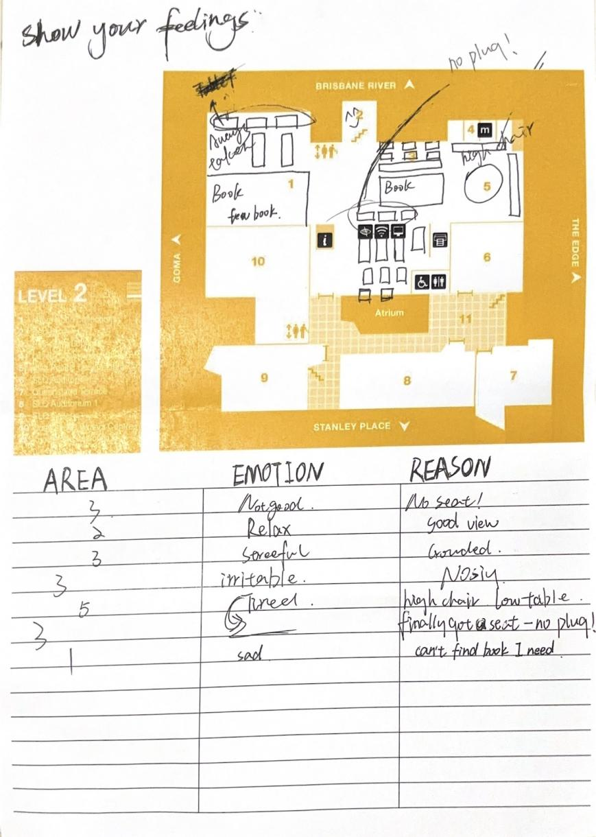

使用emotion mapping这一探针方法，探索用户在图书馆各区域的情绪体验。用户可以任意在地图上标记或者写下自己在各区域的emotion和原因。通过观察这个emotion mapping，可以发现只有一条积极的情绪：Area2的‘relax’情绪。区域 2 提供了一个“good view”的空间，使用户感到放松。这表明视觉环境在提升用户情绪方面发挥了积极作用。多数回应都出现在区域3，这一区域出现的都是较负面的情绪，主要原因有：没有座位，环境吵闹和没有插座。有一位用户提到了区域1内的书籍过少，并不能满足用户的借书需求。除此之外，位于区域5的一名用户表示非常累，这是因为该区域的桌子过低，椅子过高。这种不合适的设计并不适合长时间的学习。

**Themes in a table (interview quotes)**

|  |  |
| --- | --- |
| Themes | Relevant |
| Lack of Collaborative Space | Quote from Interviewee2 :”I would prefer more sections of the library, so more quiet areas and more meeting rooms, so that there's is silence space to work and a room to also do collaborative work. ” |
| Quote from Interviewee3 :”I think when i go there with my friends and like we study together, it is often very difficult for us to find a table i can accommodate both of us.Most of time we have to sit like separate, but sometimes we may be seated close to each other, but more often we end up sitting far apart with it is so troublesome for us to make discussions.” |
| Quote from Interviewee4:” More rooms, just like they kind of like high demand.” |
| Quote from Interviewee5 :”It's really hard to find a spot at the library or to book a medium room because they're always booked out.” |
| Users prefer a quiet library environment | Quote from Interviewee1 :”More meeting rooms so we can like, cause sometimes it's really loud when people are talking, like, just outside.” |
| Quote from Interviewee2 :“so more quiet areas ... so that um there's is silence space to work ...... ” |
| Quote from Interviewee2 :”Sometimes there's large groups of school students and sometimes they can be a bit noisy in the library.” |
| Quote from Interviewee3 :“I think silence, because if there are so much noises around I will be easily distracted.A quiet |
| Themes | Relevant |
|  | environment will make me focus better.” |
| Inadequate Library Infrastructure | Quote from Interviewee3 :”Not all the decks I think have the charging system, you know, most of the time I have to use my own power bank to charge my computer.” |
| Quote from Interviewee3 :”I think the seats in the library some of them are sofa. They are very low soft.I think that is in one uncomfortable when i studying there for a long time.” |
| “I think it's like really hard to find a space. Quote from Interviewee5 :”sometime at libraries and there's a lot of like empty spaces, but there's not enough chairs, so, like it's really hard to find a spot at the library” |

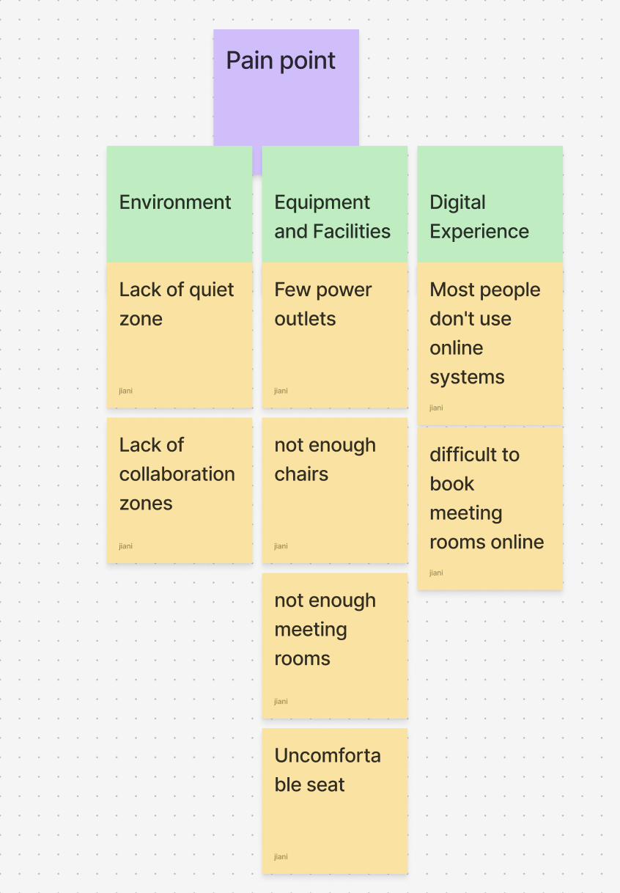

**Annotated site maps**

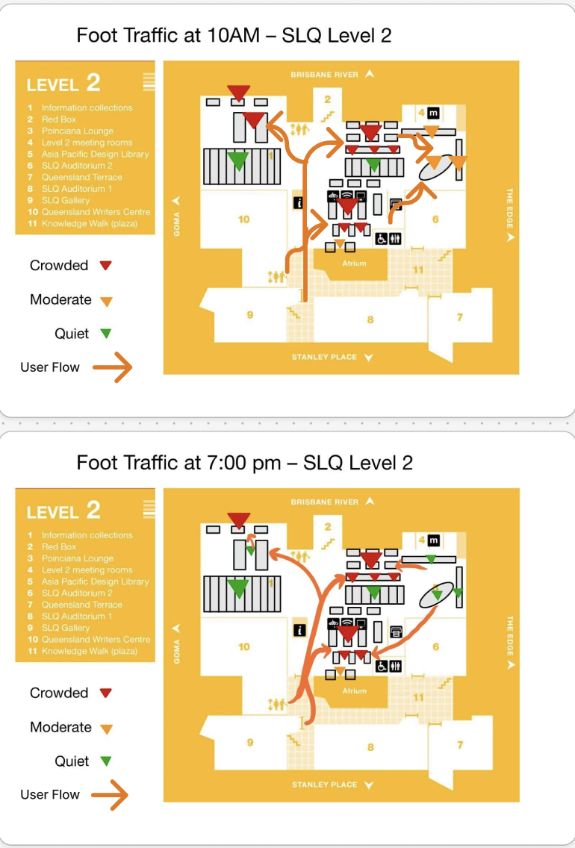

state library of Queensland的大多数区域在全天都保持较高的人流量，尤其是区域3。只有一个区域：information collection相对安静。这一区域的功能是为用户提供书籍和杂志。  
图书馆晚上人流量明显减少，但区域3使用密度依然很高，说明这些区域即使在非高峰时段也具有高使用频率。在晚上7点图书馆内有一个明显的人流动向是由区域5到区域3，这可能与文章前面提到的区域5的桌椅不适合学习有关。人流移动到更舍和学习的区域三，这使得区域3一直保持较高的人流量。

**Outliers**

**在用户研究期间观察到的主要异常群体是临时进入图书馆以躲避突如其来的雨水的个体。** 该组不属于图书馆的常规用户，例如学生、研究人员或读者。 **区分这个群体的主要特征之一是他们逗留的时间短和被动。** 观察到许多人只是在图书馆内无所事事地坐着，或者在没有接触图书馆资源的情况下查看手机。这些人在天气变好时就会立即离开图书馆。 **因此，他们的存在影响了空间使用模式，尤其是在入口区和没有桌子的沙发区。 此组被视为异常值的另一个原因是，它们的出现是由外部的计划外事件（天气）触发的，这些用户**在图书馆空间的总用户中所占的比例非常小，**不代表正常的使用模式。**

Insights & implication

Insight1

Multiple participants expressed frustration over limited access to seating and meeting rooms.The interviewee explained, “It’s really hard to find a spot at the library or to book a meeting room because they’re always booked out,” while another mentioned, “There are empty spaces but not enough chairs.”**The research showed a direct correlation between** the lack of space and users’ decreased satisfaction with the library experience.Interviewee needs a way to **secure accessible study spaces** because the current supply of rooms and seating does not meet demand.

The interviewee4 noted, “For some subjects I prefer silence, but for others I think it’s better to collaborate with friends.”And interviewee mentioned，“it depends if l'm kind with my friends, they're like more collaborative, but if I come by myself, they might be more silent. ”还有其他的受访者表达出了对某些用户的不满，受访者2指出：”Sometimes there's large groups of school students and sometimes they can be a bit noisy in the library.”他们希望根据自己的学习情况和任务内容自主决定学习方式(quiet/collaborative).While most students preferred silence, several highlighted the value of collaborative areas when studying with peers. 当图书馆无法提供灵活的环境时，用户会感到吵闹或者协作困难。**They need a way to switch between silent and collaborative zones** because their learning mode depends on the subject, study partners, and personal preference at different times.Having analysed and reviewed the data, some potential design opportunities are 划分deep focus zone和collaboration zone，用表示对其进行区分。使用可移动家具，可按需拖动桌子组成collaboration zone。除此之外，还可以增加meeting room的数量。

**Insight2**

受访者3提到：“not all the decks I think have the charging system, you know, most of the time I have to use my own power bank to charge my computer.”这一问题在其他两种研究中也有体现： 通过emotion mapping也可以观察到一个用户在地图上的一个区域标记了：“no plug”。通过observation观察到一个用户在图书馆内不停徘徊寻找可以充电的座位。用户长时间依赖数字设备学习需要持续的供电，否则会中断学习。除此之外，受访者3还提到“I think the seats in the library some of them are sofa. They are very low soft and they cannot be moved. I think that is in one uncomfortable when i studying there for a long time.”这一问题也被体现在emotion mapping的‘Asia pacific design library’这一区域被标记了：“high chair”。长时间的静坐学习对座椅的舒适度有要求，用户追求更高的身体舒适度。Several interviewees mentioned that they typically stay in the library for **2 to 6 hours**, especially during exam periods. Interview 5 mentioned “But usually during the holidays I stay here for like, I guess five to six hours, especially before the final exams.” Long-stay users need a way to **study comfortably and power their devices reliably** because physical discomfort and lack of charging points disrupt productivity.**Having analysed and reviewed the data, some potential design opportunities are**:Providing ergonomic, adjustable furniture.Ensuring every desk has nearby power access.Offering “long stay” zones with added comfort features ,such as quiet lounges.

**Insight3**

Several interviewees described their difficulty finding seats inx the library, even when the space appeared underutilised。受访者5指出 “I think it's like really hard to find a space. sometime at libraries and there's a lot of like empty spaces, but there's not enough chairs.”These responses indicate that the problem is not only about high demand, but also about **inefficient space allocation and a mismatch between seating and user needs**.受访者3提到： “I think when i go there with my friends and like we study together, it is often very difficult for us to find a table”当一个团体来到图书馆时，他们往往很难找到一整张桌子。在进行Observational Research时，照片1里的现象经常出现：一个用户占了一整张桌子。Even though some areas still had seats available, some groups did not want to sit separately.虽然座位表面上是开放共享的，但因为没有明确的视觉或文字引导，导致个体行为占据了整个资源。**A student needs a way to consistently access appropriate seating in the library because** limited seat availability and poor space management prevent them from starting their study sessions on time. **Having analysed and reviewed the data, some potential design opportunities are**:1. Design signs in the area of some large tables to indicate that the area is only available for groups to avoid wasting resources.2.Increase the number of movable chairs so that users can easily reposition them to occupy available spaces more efficiently.

**conclusion**

分区：silent/collaborative，meetingroom

No seat：more chair/single person cannot occupie whole table

设施：more plug

**4.1.1 Insight**

Multiple participants expressed frustration over limited access to seating and meeting rooms. The interviewee explained, “It is really hard to find a spot at the library or to book a meeting room because they are always booked out,” while another mentioned, “There are empty spaces but not enough chairs.”The research showed a direct correlation between the lack of space and users’ decreased satisfaction with the library experience. The interviewee needs a way to secure accessible study spaces because the current supply of rooms and seating does not meet demand.

Interviewee4 noted, "For some subjects, I prefer silence, but for others, I think it is better to collaborate with friends." An interviewee mentioned, "It depends if I am kind with my friends; they are more collaborative, but if I come by myself, they might be more silent." Other interviewees expressed dissatisfaction with some users. Interviewee 2 pointed out, "Sometimes there are large groups of school students, and sometimes they can be a bit noisy in the library." They hope to decide their learning style (quiet/collaborative) according to their learning situation and task content. While most students preferred silence, several highlighted the value of collaborative areas when studying with peers. When the library cannot provide a flexible environment, users will find collaborating noisy or difficult. They need a way to switch between silent and collaborative zones because their learning mode depends on the subject, study partners, and personal preferences at different times. Having analysed and reviewed the data, some potential design opportunities are to divide deep focus zones and collaboration zones and distinguish them with symbols. Use movable furniture so tables can be dragged to form collaboration zones. In addition, the number of meeting rooms can be increased.

**4.1.2 Insight**

Interviewee 3 mentioned: “Not all the decks, I think, have the charging system, you know, most of the time, I have to use my power bank to charge my computer.” This problem is also reflected in the other two studies: Through emotion mapping, it can be observed that a user marked an area on the map as “no plug”. It is observed that a user keeps wandering around the library looking for a seat that can charge. Users rely on digital devices for long-term learning and need a continuous power supply. Otherwise, their learning will be interrupted. In addition, Interviewee 3 also mentioned, “I think the seats in the library some of them are sofas. They are very low soft and they cannot be moved. I think that is in one uncomfortable when I was studying there for a long time.” This problem is also reflected in the ‘Asia pacific design library’ area of emotion mapping, which is marked as “high chair”. Long-term sitting and studying require the comfort of the seat, and users pursue higher physical comfort. Several interviewees mentioned that they typically stay in the library for 2 to 6 hours, especially during exams. Interview 5 mentioned, “But usually during the holidays, I stay here for like, I guess five to six hours, especially before the final exams.” Long-stay users need a way to study comfortably and power their devices reliably because physical discomfort and lack of charging points disrupt productivity. Having analyzed and reviewed the data, some potential design opportunities were found, including providing ergonomic, adjustable furniture. Has nearby power access. Offering “long stay” zones with added comfort features, such as quiet lounges.

**4.1.3 Insight**

Several interviewees described their difficulty finding seats in the library, even when the space appeared underutilised. Interviewee 5 said, "I think it is really hard to find a space. Sometimes at libraries, there are a lot of empty spaces, but there are not enough chairs." These responses indicate that the problem is not only about high demand but also about inefficient space allocation and a mismatch between seating and user needs. Interviewee 3 mentioned: "I think when I go there with my friends and like we study together, it is often very difficult for us to find a table" When a group comes to the library, they often have difficulty finding a whole table. When conducting observational research, the phenomenon in photo 1 often occurs: one user occupies an entire table. Even though some areas had seats available, some groups did not want to sit separately. Although the seats are open and shared on the surface, individual behaviour occupies the entire resource because there is no apparent visual or textual guidance. A student needs a way to consistently access appropriate seating in the library because limited seat availability and poor space management prevent them from starting their study sessions on time. Having analysed and reviewed the data, some potential design opportunities are as follows: 1. Design signs in the area of some large tables to indicate that the area is only available for groups to avoid wasting resources. 2. Increase the number of movable chairs so users can easily reposition them to occupy available spaces more efficiently.

1.加references（每种method定义，图书馆人流量，图书馆设施的影响

2.录音（几份，几分钟，转录几个

3.描述analysis里research method（定义

4.亲和图（增加keywords，描述

5.照片：单人占领整张桌子（需添加到appendix并且引用到analysis

6.analysis里的quote是否需要表格

7.appendix（加标题，需在文章里提及

8.在analysis里面添加专业术语和连接词（完成observation/probe）

9.conclusion

10.insight statement

**Insight statement**

Three key insights are :1. The interviewee needs a way to secure accessible study spaces because they want a stable and controllable learning space to help them quickly enter a state of concentration. 2.The interviewee needs a way to improve the comfort and convenience of facilities because they expect library facilities to support them in completing their learning tasks efficiently, for a long time and without interruption. 3. The interviewee needs a way to clearly divide the library space into different usage modes because they they need a sense of boundaries and don’t want to disturb others or be disturbed.

|  |  |  |  |  |
| --- | --- | --- | --- | --- |
| Tool | Use | Prompt | Section | Date |
| Grammarly | Used to fix the grammar, format our document | -- | All paragraph | 26 March 2025 |

|  |  |  |
| --- | --- | --- |
|  |  |  |

**Library environment**

The problem is that some users think the environment is too noisy, and some users need an environment to discuss. The research showed a direct correlation between quiet environments and immersive learning. The interviewee needs a way to divide the library space into different usage modes because they need a sense of boundaries and do not want to disturb others or be disturbed. Having analysed and reviewed the data, some potential design opportunities： Areas can be divided by function when users have different needs for the library environment. Divide deep focus zones and collaboration zones and distinguish them with symbols.

The problem is that some users think that the library has few sockets and the chairs are uncomfortable. The research showed a direct correlation between complete equipment and long hours of uninterrupted learning. The interviewee needs a way to improve the comfort and convenience of facilities because they expect library facilities to support them in completing their learning tasks efficiently, for a long time and without interruption.

Having analysed and reviewed the data, some potential design opportunities：Improve the comfort and convenience of library facilities.

The problem is that users have difficulty finding seats in the State Library of Queensland. The research showed a direct correlation between number of library seats and user satisfaction. . The interviewee needs a way to secure accessible study spaces because they want a stable and controllable learning space to help them quickly enter a state of concentration. Having analysed and reviewed the data, some potential design opportunities：Increase the utilization rate of the library so that it can accommodate more users. Or use other ways to help users find space quickly.