*** show plot of raw experimental and theoretical data before normalization and translation

Image saved as: Comparison of raw experimental and theoretical spectra.png

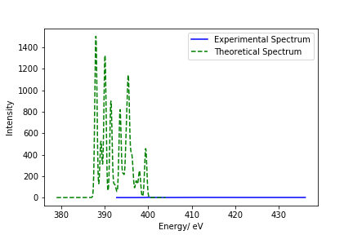

***show plot of experimental and theoretical data after normalization (before translation)

Image saved as: Comparison of normalized experimental and theoretical spectra.png

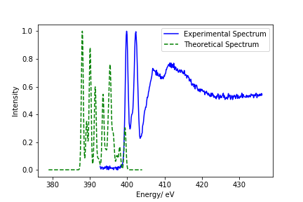

*** print out the value by which the first peak in the theoretical data was translated to match the first peak in the experimental data

***show plot of experimental and theoretical data after normalization and translation

Image saved as: Comparison of normalized and translated experimental and theoretical spectra.png

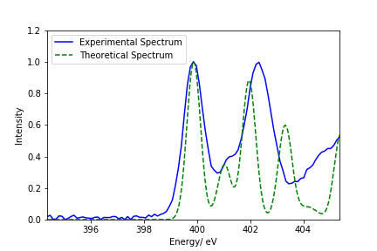

*** show plot of experimental and theoretical data with assigned peaks

*** Assigned peaks information

|  |  |  |  |  |
| --- | --- | --- | --- | --- |
| Peak number | Peak energy | Orbital from which excitation takes place | Atom type, Atom number from which excitation takes place | Orbital to which excitation takes place |
|  |  |  |  |  |
|  |  |  |  |  |
|  |  |  |  |  |