**Aim of the study:** Investigating association between metabolic parameters related to diabetes mellitus (DM) and retinal thickness measures as analyzed by optical coherence tomography (OCT).

**PI:** Mira Sachdeva

Diabetic metabolic parameters included are; body mass index (BMI), glycated hemoglobin (HbA1c), mean arterial blood pressure (MAP), systolic blood pressure, heart rate, insulin, cholesterol, HDL, LDL, triglycerides, non-HDL cholesterol, total cholesterol/HDL ratio, blood urea nitrogen (BUN), creatinine, BUN/creatinine ratio, ketones, non-esterified fatty acids, adiponectin, leptin and receptor for advanced glyceration end products (RAGE)

The participants are evaluated in **3 groups**;

1. DM (HbA1c>6.4)
2. Pre-diabetes (HbA1c: 5.7-6.4)
3. Control (HbA1c<5.7)

OCT analyses are evaluated according to 9 anatomical localizations (image 1) ;

1. Central retinal thickness (CST)
2. superior Inner (SI)
3. temporal Inner (TI)
4. inferior Inner (II)
5. nasal Inner (NI)
6. superior Outer (SO)
7. temporal Outer (TO)
8. inferior Outer (IO)
9. nasal Outer (NO)

Retinal layer thickness values are evaluated according to 8 different measurements (image 2);

1. Total thickness
2. Nerve fiber layer (NFL)
3. Ganglion cell layer (GCL)
4. Inner plexiform layer (IPL)
5. Inner nuclear layer (INL)
6. Outer plexiform layer (OPL)
7. Outer nuclear layer (ONL)
8. Retinal pigment epithelium (RPE)

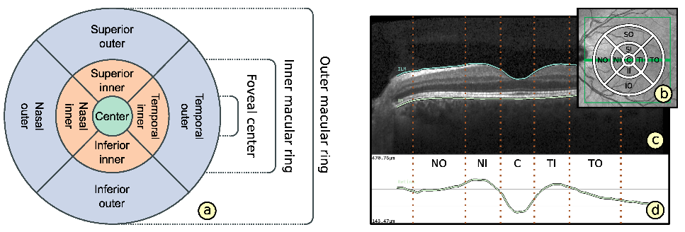 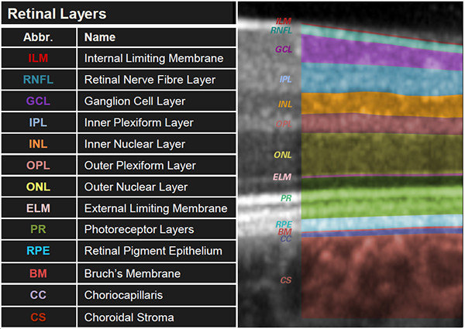

Main outcome expected from this study is the correlation of metabolic parameters with the following thickness values for all 9 anatomical locations;

* Total thickness
* NFL
* GCL-IPL complex
* INL
* Outer retinal thickness (OPL-RPE)

*Both eyes are included for most of the patients, would need to be adjusted accordingly.