**Aim of the study:** Investigating association between metabolic parameters related to diabetes mellitus (DM) and retinal thickness measures as analyzed by optical coherence tomography (OCT).

**PI:** Mira Sachdeva

* The participants should be evaluated in **3 groups** according to their HbA1c values;

1. DM = HbA1c > 6.4
2. Prediabetes = HbA1c: 5.7-6.4
3. Control = HbA1c < 5.7

* IRB = refers to the patient’s specific identification number
* Gender: 1 = male 2= female
* **Metabolic parameters** included are (in order of appearance in the table);
  + Heart rate
  + Mean arterial pressure = MAP
  + Blood pressure (systolic) = SBP
  + Body mass index = BMI
  + Glycated hemoglobin = HbA1c
  + Blood urea nitrogen = BUN
  + Creatinine = Cr
  + Blood urea nitrogen/ creatinine ratio = BUN/Cr
  + High density lipoprotein = HDL
  + Low density lipoprotein = LDL
  + Triglycerides
  + Cholesterol
  + Non-esterified fatty acids = NEFA
  + Glucose
  + Ketone
  + Insulin
  + Adiponectin
  + Leptin
  + Receptor for advanced glycosylation end products = RAGE
* OCT analyses of retinal thickness are evaluated according to 9 anatomical regions in the retina, in order of appearance in the table (image 1);

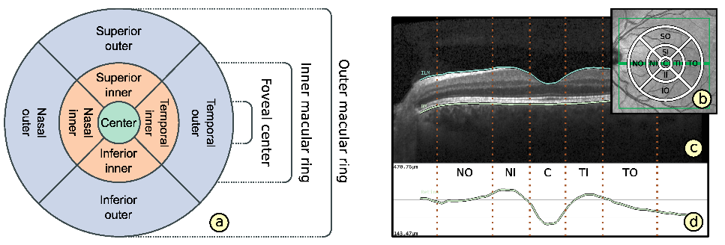

* + Central subfield = CSF
  + Superior Inner = SI
  + Superior Outer = SO
  + Nasal Inner = NI
  + Nasal Outer = NO
  + Inferior Inner = II
  + Inferior Outer = IO
  + Temporal Inner = TI
  + Temporal Outer = TO
* Retinal layer thickness values are evaluated according to 8 different measurements;
  + Total thickness = TOT
  + Nerve fiber layer = NFL
  + Ganglion cell layer = GCL
  + Inner plexiform layer = IPL
  + Inner nuclear layer = INL
  + Outer plexiform layer = OPL
  + Outer nuclear layer = ONL
  + Retinal pigment epithelium = RPE
* **Main outcome expected from this study is the correlation/association of metabolic parameters with the following retinal thickness values in each of the 9 anatomical locations, among all participants and the within each group (control, DM, prediabetes);:**
  + **Total thickness (sum of all layers) = TOT**
  + **NFL**
  + **GCL-IPL complex (sum of GCL + IPL layers) = GCL-IPL**
  + **INL**
  + **Outer retinal thickness (sum of OPL + ONL + RPE) = ORT**
* Right eye = OD
* Left eye = OS

**TERMINOLOGY NOTES RE: DATASET IN EXCEL**

***Retinal thickness measures are named in order of region + layer + eye

e.g. = Superior outer region, inner nuclear layer of the right eye is labeled as = SO_INL_OD

***The table consists one patient per row; however, retinal thickness measures are reported as right eye values first and then left eye values.

**ADDITIONAL IMPORTANT NOTES RE: POTENTIAL INTERACTIONS:**

\*\*\***Confounding** factors to take into consideration that may affect retinal thickness = **age** and **gender**

***Biological explanation of, and known relationships between, metabolic parameters:

* + MAP = is an arithmetic mean of SBP and diastolic blood pressure therefore affected by SBP
  + BUN, Cr and BUN/Cr ratios = kidney function tests. BUN and CR are **not**affected by each other. BUN/Cr ratio **is** affected by both.
  + HDL, LDL, Triglycerides, Cholesterol and NEFA = blood lipid profile. **None** of the parameters are affected by each other.
  + Glucose, insulin and ketones= all part of glucose metabolism. **All** are affected by others. (Image 2 and 3)
  + Adiponectin and leptin= both are released from the fat tissue and are a part adipokines. They are **not** affected by each other.
  + 