[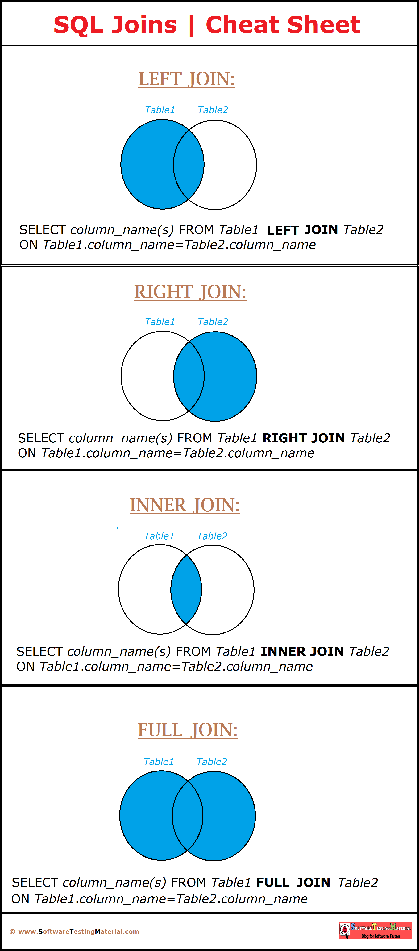](https://i2.wp.com/www.softwaretestingmaterial.com/wp-content/uploads/2017/02/SQL-Joins-Cheat-Sheet.png?ssl=1)