Q1. Readings completed

Q2.

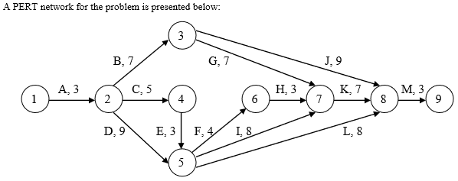

|  |  |  |
| --- | --- | --- |
| **Path** | **Length** | **Slack** |
| 1-2-3-8-9 | 22 | 30-22 = 8 |
| 1-2-3-7-8-9 | 27 | 30-27=3 |
| 1-2-4-5-6-7-8-9 | 28 | 30-28=2 |
| 1-2-4-5-7-8-9 | 29 | 30-29=1 |
| 1-2-4-5-8-9 | 22 | 30-22=8 |
| 1-2-5-6-7-8-9 | 29 | 30-29=1 |
| 1-2-5-7-8-9 | 30 | 30-30=0 |
| 1-2-5-8-9 | 23 | 30-23=7 |

1. The critical path is 1-2-5-7-8-9
2. The critical activities are 1-2, 2-5, 5-7, 7-8, 8-9
3. It will take 30 weeks to complete the entire project
4. The slack for the non-critical paths are -
   1. 1-2-3-8-9 = 8
   2. 1-2-3-7-8-9 = 3
   3. 1-2-4-5-6-7-8-9 = 2
   4. 1-2-4-5-7-8-9 = 1
   5. 1-2-4-5-8-9 = 8
   6. 1-2-5-6-7-8-9 = 1
   7. 1-2-5-8-9 = 7
5. Since activity 5-7 is part of the critical path 1-2-5-7-8-9, increasing its duration by a week would increase the project duration be a week too
6. Activity 5-8 is present in the following paths with their slacks mentioned
   1. 1-2-4-5-8-9 = 8
   2. 1-2-5-8-9 = 7

In both the above paths, increasing the duration of activity 5-8 would still keep the slack positive and as a result increasing the duration of activity 5-8 by 5 weeks will not affect the duration of the project.

Q3.

PERT Network -

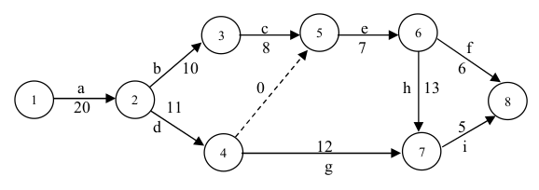

Computational analysis -

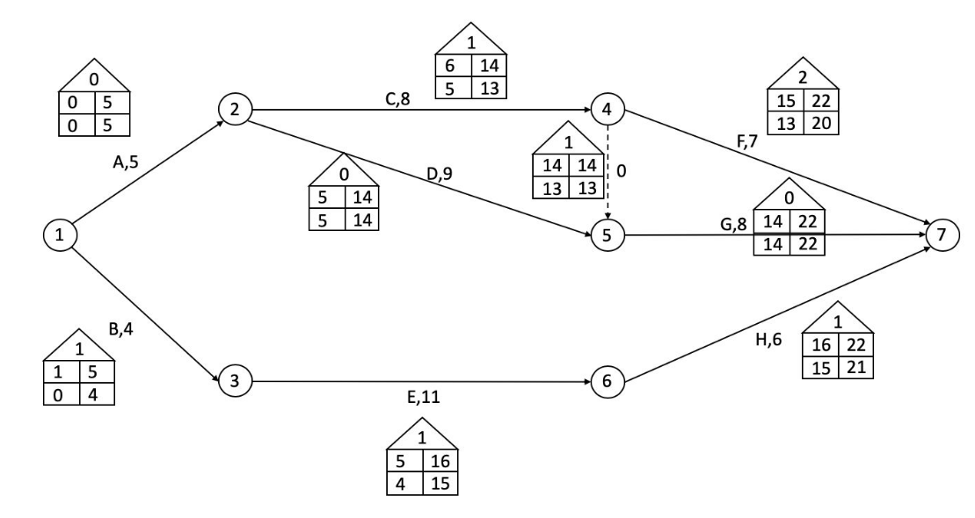

Critical Path: 1-2-5-7

Critical Activities: 1-2(A), 2-5(D), 5-7(G)

Total time = 22 days

Q4.



Let ‘J’ be an imaginary activity starting at node 8 and ending in an imaginary node 9.

Minimize Z = XJ

Subject to:

Xa = 0

Xb ≥ Xa + 20

Xc ≥ Xb + 10

Xd ≥ Xa + 20

Xe ≥ Xc +8

Xf ≥ Xe + 7

Xg ≥ Xd +11

Xh ≥ Xe + 7

Xi ≥ Xh +13

Xi ≥ Xg + 12

Xj ≥ Xf + 6

Xj ≥ Xi +5

Xa, ... , Xj ≥ 0

Q5.

Q6.

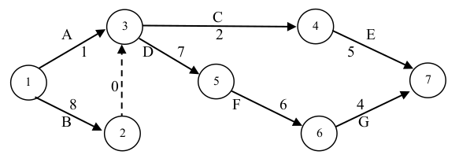

|  |  |  |
| --- | --- | --- |
| **Path** | **Length** | **Slack** |
| 1-3-4-7 | 8 | 25-8 = 17 |
| 1-3-5-6-7 | 18 | 25-18 = 7 |
| 1-2-3-4-7 | 15 | 25-15 = 10 |
| 1-2-3-5-6-7 | 25 | 25-25 = 0 |

The critical path is 1-2-3-5-6-7, and the critical activities are 1-2, 2-3, 3-5, 5-6, 6-7. It will take 25 weeks to complete the entire project.

Q7.

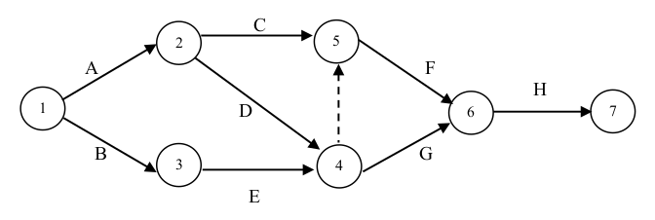

|  |  |  |  |  |  |  |  |  |
| --- | --- | --- | --- | --- | --- | --- | --- | --- |
| Path | Activity | a | m | b | t = (a+4m+b)/6 | t-path | s^2 = (b-a)^2/36 | s-path (√(Σs^2) |
| 1-2-5-6-7 | 1-2 (A) 2-5 (C) 5-6 (F) 6-7 (H) | 1 1 3 2 | 3 2 4 4 | 5 3 5 5 | 18/6 = 3 12/6 = 2 24/6 = 4 23/6 = 3.83 | 12.83 | 16/36  4/36 4/36 9/36 | 0.957 |
| 1-2-4-6-7 | 1-2 (A) 2-4 (D) 4-6 (G) 6-7 (H) | 1 2 1 2 | 3 3 4 4 | 5 4 6 5 | 18/6 = 3 18/6 = 3 23/6 = 3.83 23/6 = 3.83 | 13.66 | 16/36 4/36 25/36 9/36 | 1.2247 |
| 1-3-4-6-7 | 1-3 (B) 3-4 (E) 4-6 (G) 6-7 (H) | 1 3 1 2 | 2 4 4 4 | 3 11 6 5 | 12/6 = 2 30/6 = 5 23/6 = 3.83 23/6 = 3.83 | 14.66 | 16/36 64/36 25/36 9/36 | 1.7795 |

We have t0 = 16 weeks

Finding the z-scores

1. Path 1-2-5-6-7

Z = (16-12.83)/0.957 = 3.3124

P(Z ≤ 3.3124) ≈ 0.9995

1. Path 1-2-4-6-7

Z = (16-13.66)/1.2247 = 1.911

P(Z ≤ 1.911) ≈ 0.9719

1. Path 1-3-4-6-7

Z = (16-14.66)/1.7795 = 0.753

P(Z ≤ 0.753) ≈ 0.7734

The probability that the project will be completed in under 16 weeks is equal to the joint probability for the three paths mentioned above which is (0.9995)*(0.9719)*(0.7734) ≈ 0.7513