**Jianming Dong**

**Haiyang Yu**

**Conclusion: The highest chance of an on time flight is on Tuesday-Saturday before 15pm, on Delta, Comair, United, or USAirways. (And of course a good weather).**

**Logistic regression:**

The probability of delay =

Log(odds) =

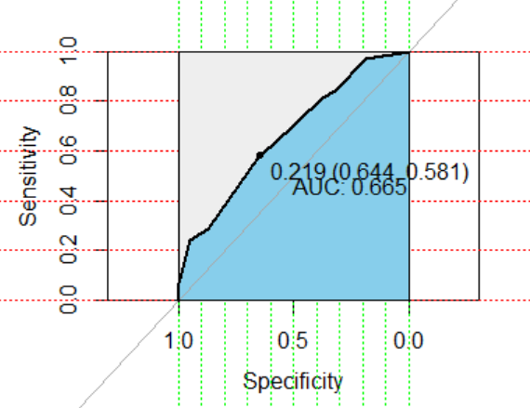

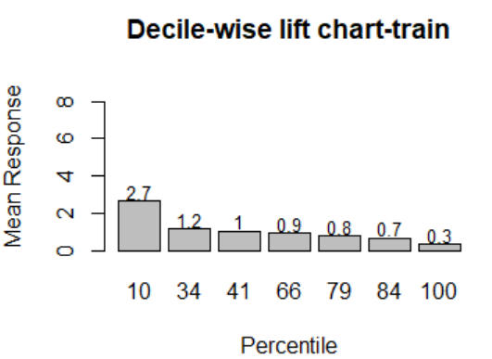

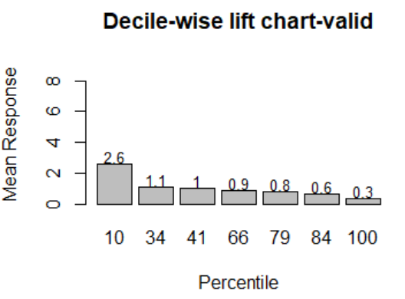

Confusion Matrix for logistic regression - valid

Reference

Prediction 0 1

0 662 129

1 44 46

Accuracy : 0.8036

**Neural net (nodes = 3):**

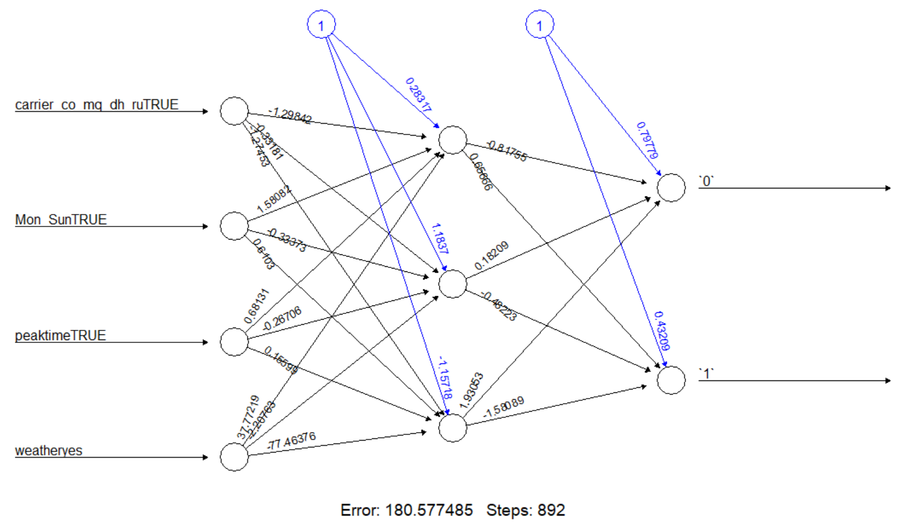

Confusion Matrix for nn_nodes = 3 - train

Reference

Prediction 0 1

0 1067 233

1 0 20

Accuracy : 0.8235

Confusion Matrix for nn_nodes = 3 - valid

Reference

Prediction 0 1

0 706 163

1 0 12

Accuracy : 0.815

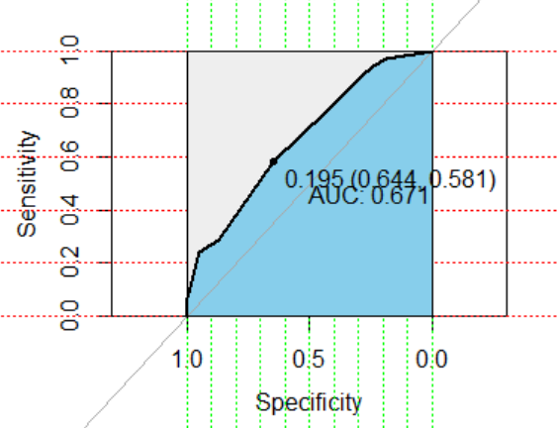

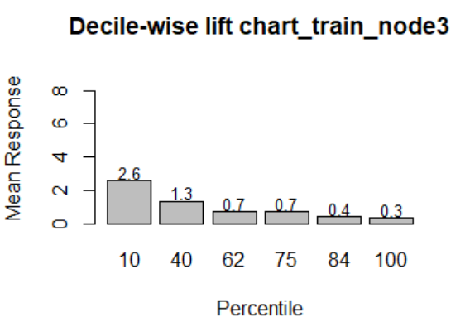

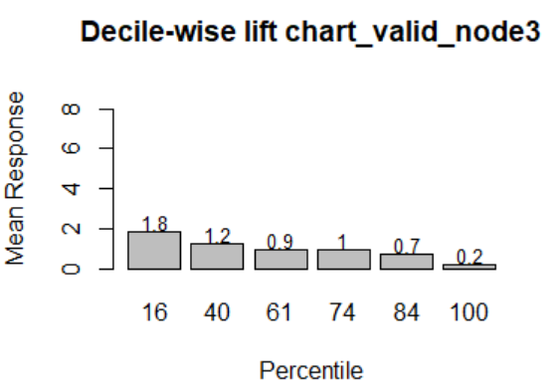

**Naïve bayes:**

Priori probabilities

Ontime(0) delayed(1)

0.8022727 0.1977273

Confusion Matrix for naïve bayes - train

Reference

Prediction 0 1

0 1067 233

1 0 20

Accuracy : 0.8235

Confusion Matrix for naïve bayes - valid

Reference

Prediction 0 1

0 706 163

1 0 12

Accuracy : 0.815

