TEAM 40
Test Report
Login → Redirect → Team Page — Happy Path Test (Deployed Environment)
Tester | Faridullah Jabbar Khil
Date tested | 15/08/2026
Deployed URL | https://garage-boilerplate-basic-s3935651-f.vercel.app/
Browser / device | Google Chrome (Desktop/Phone), Microsoft Edge (Desktop)
Test account used | Valid, non-dev test account
Related Planner card | [BOOTSTRAP RESTYLING] Test Login → Redirect → Team Page

Per the card instructions: this test is performed on the deployed URL (not localhost), by someone other than the developer who built the feature, covering the full happy-path flow only — valid login, redirect to the Team Page, and full content verification.

1. Test Checklist Results
Complete each row after performing the corresponding step. Mark Pass or Fail and add a short note — especially for any Fail.
Checklist Item | Result | Notes
Valid login tested end-to-end on deployed URL | ☑ Pass ☐ Fail | Signed in with a valid email/password; "Signed in successfully" confirmation shown.
Redirect to Team Page confirmed (URL reads /team) | ☑ Pass ☐ Fail | Redirected to the Team Page immediately after sign-in.
All required content verified correct and complete | ☑ Pass ☐ Fail | All four member cards loaded with real photo, name, role and blurb.
Document updated | ☑ Pass ☐ Fail | This report.

2. Team Page Content Verification
Check each required field for every Team 40 member, per the BA requirements (Section 5 — Field and Display Rules).
Member | Photo | Name | Role | Blurb
Jianqi Lu (PM) | ☑ | ☑ | ☑ | ☑
Chan Hoang Truong (DEV) | ☑ | ☑ | ☑ | ☑
Faridullah Jabbar Khil (UX) | ☑ | ☑ | ☑ | ☑
Shakthijhaa Sivagnanam (BA) | ☑ | ☑ | ☑ | ☑

Also confirm:
- ☑ "Team 40" is clearly displayed on the Team Page.
- ☑ All four member cards are visually consistent (spacing, layout, styling).
- ☑ No content overlaps, overflows, or is cut off at the tested screen size.

3. Evidence (Screenshots)
Screenshots captured during testing on the deployed URL, confirming the happy-path flow end to end.
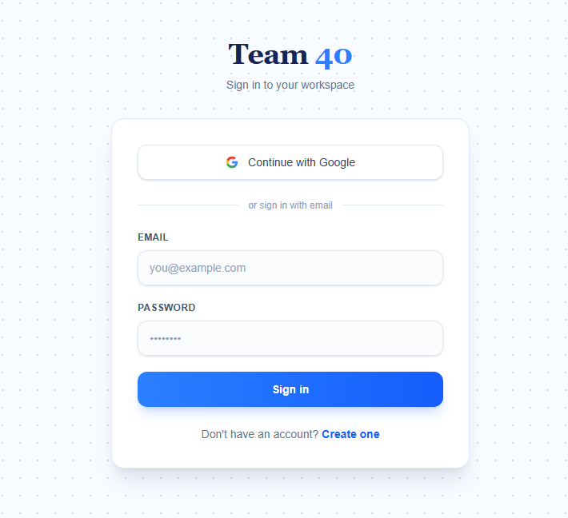
Fig. 1 — Login Page on the deployed URL, before sign-in.
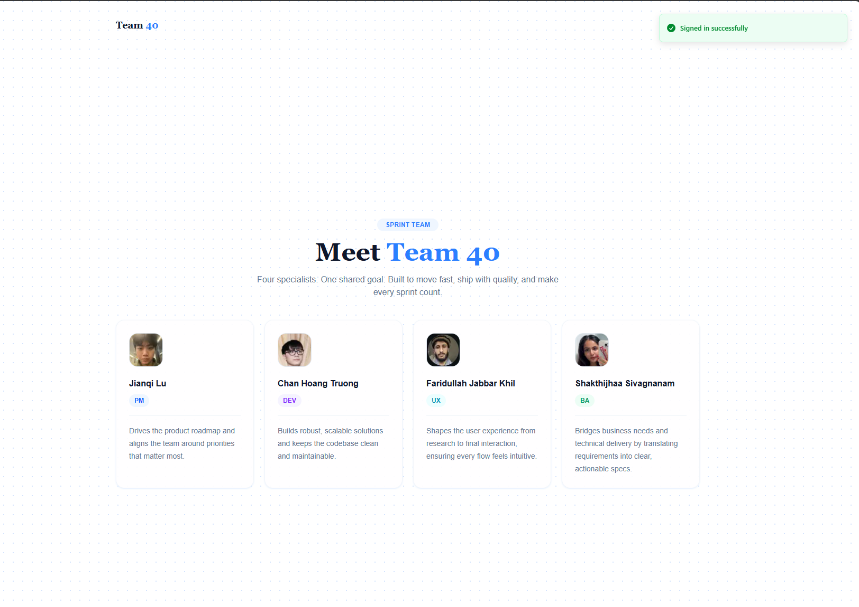
Fig. 2 — Team Page immediately after successful sign-in. "Signed in successfully" confirmation shown; all four member cards loaded with real photo, name, role, and blurb.

4. Issues Found
None. The happy-path flow passed cleanly: valid login succeeded, the user was redirected to the Team Page, and all required content (photo, name, role, blurb) displayed correctly for all four members.

5. Test Sign-off
Per the card requirements, this test was performed by someone other than the developer who built this feature, on the deployed URL.
Overall Result | Tester | Date
☑ Pass ☐ Fail | Faridullah Jabbar Khil | 15/08/2026

Once this test passes, check off the corresponding items on the Planner card and update its status.

