Master Document — Team Page Mock Sprint

[Login Restyling Bootstrap] Task 1 —Write Requirements: Team Page & Login Styling
Role | BA —  Shakthijhaa Sivagnanam | Date | Friday, 7 August 2026 ( Example)
Completion comment
Done: Documented required fields for the team page (team name, project name, per-member photo/name/role, about-us blurb) and confirmed login work is styling-only, no auth logic changes. (example)
Deliverable: Requirements document, committed to the team repo.
Note for next role: UX — we have 5 team members, one doesn't have a headshot yet, so the design needs a placeholder-avatar treatment. Two members also have longer blurbs, so don't assume a one-line blurb.
Git URL:

[Login Restyling Bootstrap] Task 2 — Design Login Style & Team Page Layout
Role | UX —  Faridullah Jabbar Khil | Date
Completion comment
Done: Produced mockups for the restyled login page and the team page layout, including the placeholder-avatar and long-blurb cases BA flagged.
Deliverable: Figma file, linked from the team repo.
Note for next role: BA — the long-blurb case is handled with a "read more" expand rather than truncation. Please confirm that's acceptable before you approve.

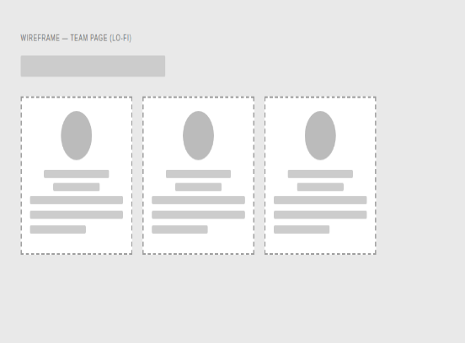

[Login Restyling Bootstrap] Task 3 — Validate Design Against Requirements
Role | BA —  Shakthijhaa Sivagnanam | Date
Completion comment
Done: Checked both mockups against the requirements doc. All fields present, login scope stayed to styling only, placeholder-avatar and long-blurb cases both covered. Approved as-is, no changes requested.
Deliverable: Design validation sign-off, committed to the team repo.
Note for next role: Dev — you're clear to build exactly to the Figma file, no open questions from BA's side.
Git URL:

[Login Restyling Bootstrap] Task 4 — Style Login Page
Role | Dev 1 —  Chan Hoang Truong | Date
Completion comment
Done: Applied the approved login styling (colors, layout, branding). Confirmed auth logic, validation, and session handling are all untouched.
Deliverable: Branch/commit with the styling changes.
Note for next role: Nothing blocking — moving straight on to the team page build myself.
Git URL (commit):

REAL OUTPUT — rendered login page
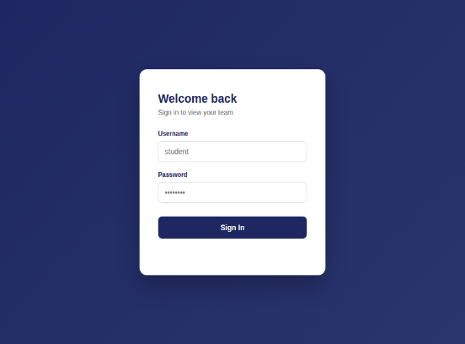

[Login Restyling Bootstrap] Task 5 — Build Team Page & Auth Redirect
Role | Dev 1 —  Chan Hoang Truong | Date
Completion comment
Done: Team page built per the design (name, member cards with photo/role, about-us blurb with expand-on-long-text). Login now redirects here on success; team page redirects back to login if accessed directly without a session.
Deliverable: Branch/commit with the team page and route guard.
Note for next role: Dev 2 — please test against the deployed URL once it's live, not localhost.
Git URL (commit):
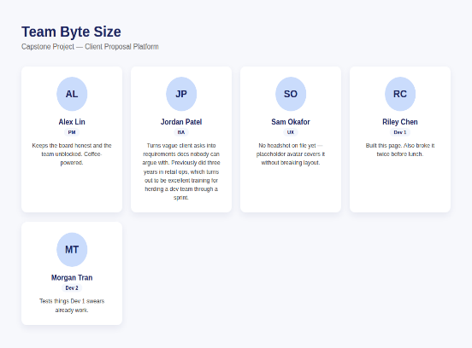

[Login Restyling Bootstrap] Task 6 — Test Login → Redirect → Team Page Flow
Role | Dev 2 — Alexander Gusman | Date
Completion comment
Done: Tested the full happy path on the deployed URL — valid login, redirect fires, all member cards render correctly with photo/role/blurb, expand-on-long-text works.
Deliverable: Test script and test report.
Note for next role: No issues found on the happy path. Moving on to edge cases next.
Git URL (test script):
Git URL (test report):

[Login Restyling Bootstrap] Task 7 — Test Edge Cases & Log Bugs
Role | Dev 2 — Alexander Gusman | Date
Completion comment
Done: Tested invalid login, direct team-page URL access without login, missing-photo member, and an unusually long blurb. No bugs found.
Deliverable: Edge case test report.
Note for next role: PM — everything passed, nothing outstanding for Dev 1 to fix before your review.
Git URL (test script):
[ IMAGE PLACEHOLDER — Invalid login error state screenshot — replace with actual screenshot ]

[Login Restyling Bootstrap] Task 8 — Final Review & Sign-Off
Role | PM — Jianqi Lu | Date
Completion comment
Done: Reviewed the feature end-to-end against the requirements and design. Verified every prior task's checklist and completion comment. Everything matches — approved.
Deliverable: Sign-off note.
Note for next role: None — feature complete, board closed out.
Git URL:

