TEAM 40
Test Report
Negative & Edge-Case Testing — Login & Team Page (Deployed Environment)
Tester | Shakthijhaa Sivagnanam
Student ID | s4065078
Role | Business Analyst / Independent Tester
Date tested | 15/08/2026
Deployed URL | https://garage-boilerplate-basic-s3935651-f.vercel.app/
Browser / device | Google Chrome (Desktop, macOS); Chrome Incognito; responsive viewport at 390 × 725
Test data | Dummy invalid credentials; existing authenticated session for Team Page edge-case tests
Related work | Task 2 — Mock Sprint: Styled Login Page & Team Page
Testing status | COMPLETE — all assigned test activities executed

1. Purpose and Scope
This report records the negative and edge-case QA testing assigned to Shakthijhaa Sivagnanam for Team 40's Task 2 Mock Sprint. The testing was performed against the deployed Vercel environment and focuses on authentication failure behaviour, unauthenticated route protection, missing-profile-photo handling, and long-profile-blurb layout resilience.
The tester is not the developer who implemented the feature. Browser Developer Tools were used only to simulate edge cases in the local browser DOM; those temporary changes were not committed to Git or persisted to the deployed application and were reset by refreshing the page.
2. Planner Checklist Results
Checklist Item | Completion | Outcome / Evidence
Invalid login tested | COMPLETE | PASS
Direct team-page access without login tested (must redirect) | COMPLETE | PASS
Missing-photo and long-blurb edge cases tested | COMPLETE | 1 FAIL / 1 PASS
Bugs logged with repro steps, or none-found confirmed | COMPLETE | BUG-01 documented with reproduction steps and evidence
Update Document | COMPLETE | This QA report updated with results, screenshots, issue log and sign-off
Test suite outcome: FAIL — 3 of 4 test cases passed; 1 open defect (BUG-01).
3. Requirements Traceability
Test Case | Requirement / Edge Case | What Was Verified | Result
TC-01 | FR-07 / EC-01 | Invalid login remains on Login Page and displays a clear error | PASS
TC-02 | FR-11 / EC-02 | Unauthenticated direct access to /team is redirected to sign-in | PASS
TC-03 | FR-14 / EC-04 | Missing/failed photo displays monogram or placeholder fallback | FAIL
TC-04 | EC-05 / EC-06 / NFR-01 | Long blurb does not break cards; remains usable at smaller screen width | PASS
4. Detailed Test Results
4.1 TC-01 — Invalid Login
Objective: Confirm that invalid credentials are rejected without redirecting the user away from the Login Page.
Steps performed: Entered invalid-test-s4065078@example.com with an incorrect password on the deployed Login Page and selected Sign in.
Expected result: The user remains on /auth/signin and receives a clear authentication error message.
Actual result: The login attempt was rejected. The browser remained on /auth/signin and a red notification displayed “Invalid email or password”. No Team Page access was granted.
Result: PASS
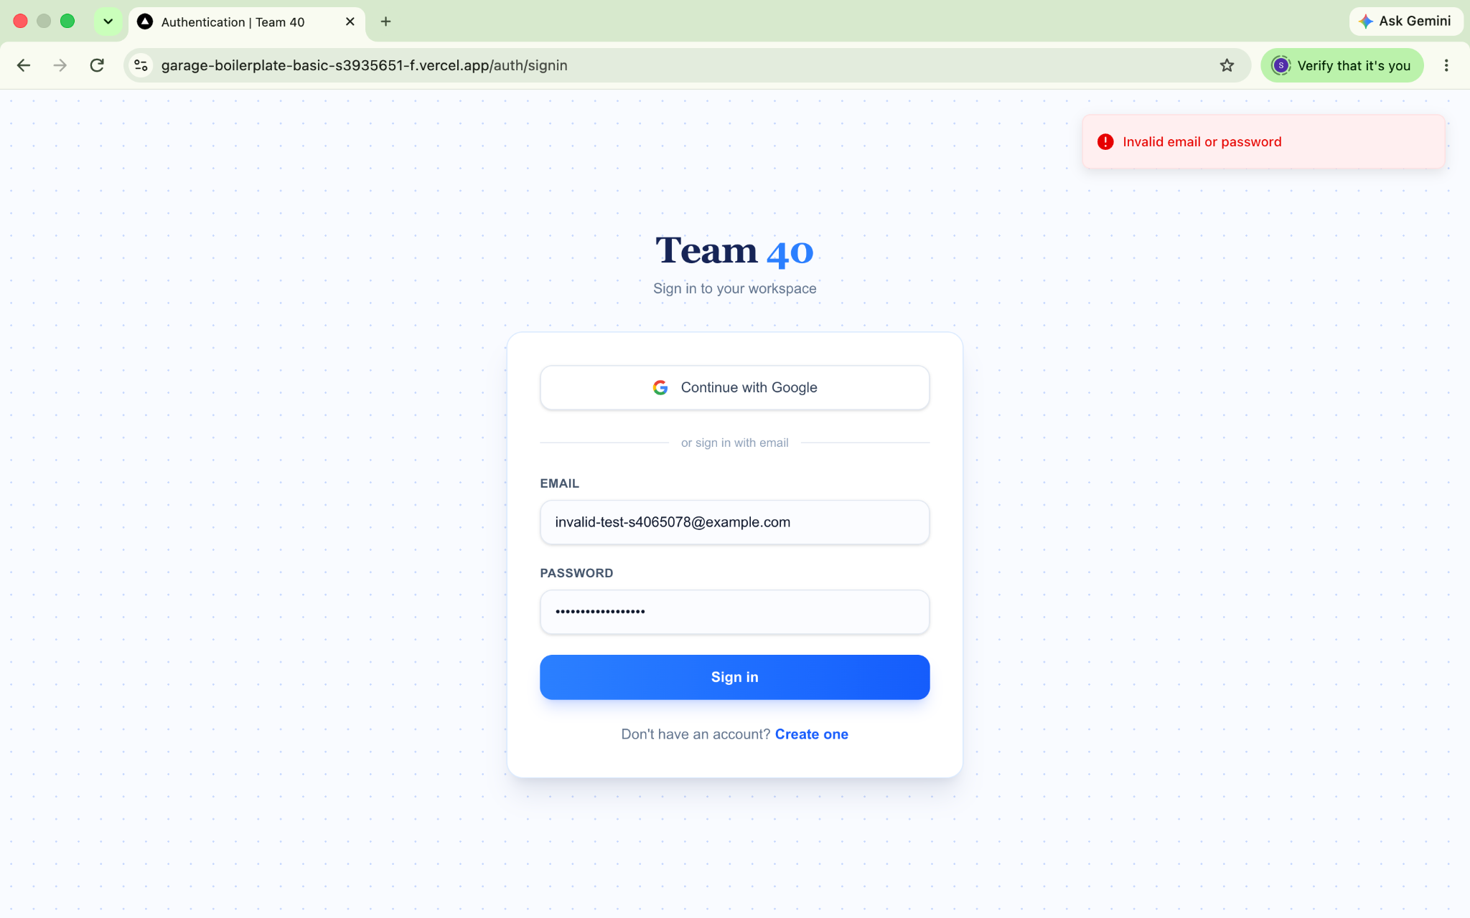
Fig. 1 — Invalid login test on the deployed environment. The invalid credentials were rejected and the “Invalid email or password” error was displayed while the URL remained /auth/signin.

4.2 TC-02 — Direct /team Access Without Login
Objective: Confirm that an unauthenticated user cannot access the Team Page directly.
Steps performed: Opened a fresh Chrome Incognito session, navigated directly to /team without signing in, and observed the resulting route.
Expected result: The user is redirected to the Login Page and Team Page content is not displayed.
Actual result: The unauthenticated request was redirected to /auth/signin. The Login Page was displayed and the Team Page was not accessible.
Result: PASS
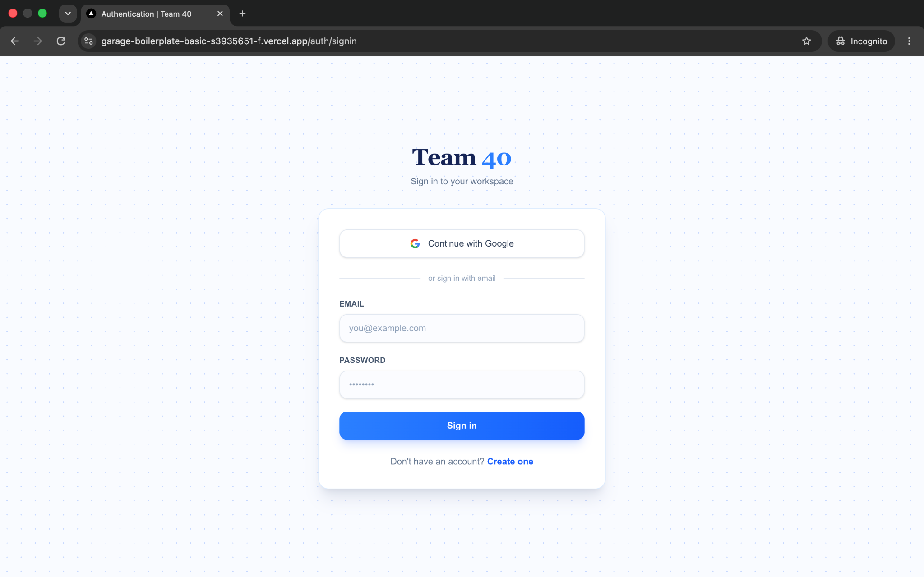
Fig. 2 — Direct Team Page access test in a fresh Chrome Incognito session. After attempting to access /team while unauthenticated, the application presented /auth/signin.

4.3 TC-03 — Missing-Photo Edge Case
Objective: Verify that a missing or failed member photo is replaced by the required placeholder/monogram avatar without breaking the member card.
Test method: Selected Shakthijhaa Sivagnanam's profile image in Chrome DevTools, removed responsive image attributes (srcset and sizes), and temporarily changed src to /missing-test-photo.jpg to force an image-load failure.
Expected result: The failed image should be replaced by the designed initials/placeholder avatar (for example, “SS”), while the rest of the profile card remains intact.
Actual result: The forced image request returned HTTP 404. Instead of the required fallback avatar, Chrome displayed a broken-image indicator and the image alt text. The member name, BA badge, blurb and card structure remained visible.
Result: FAIL — BUG-01
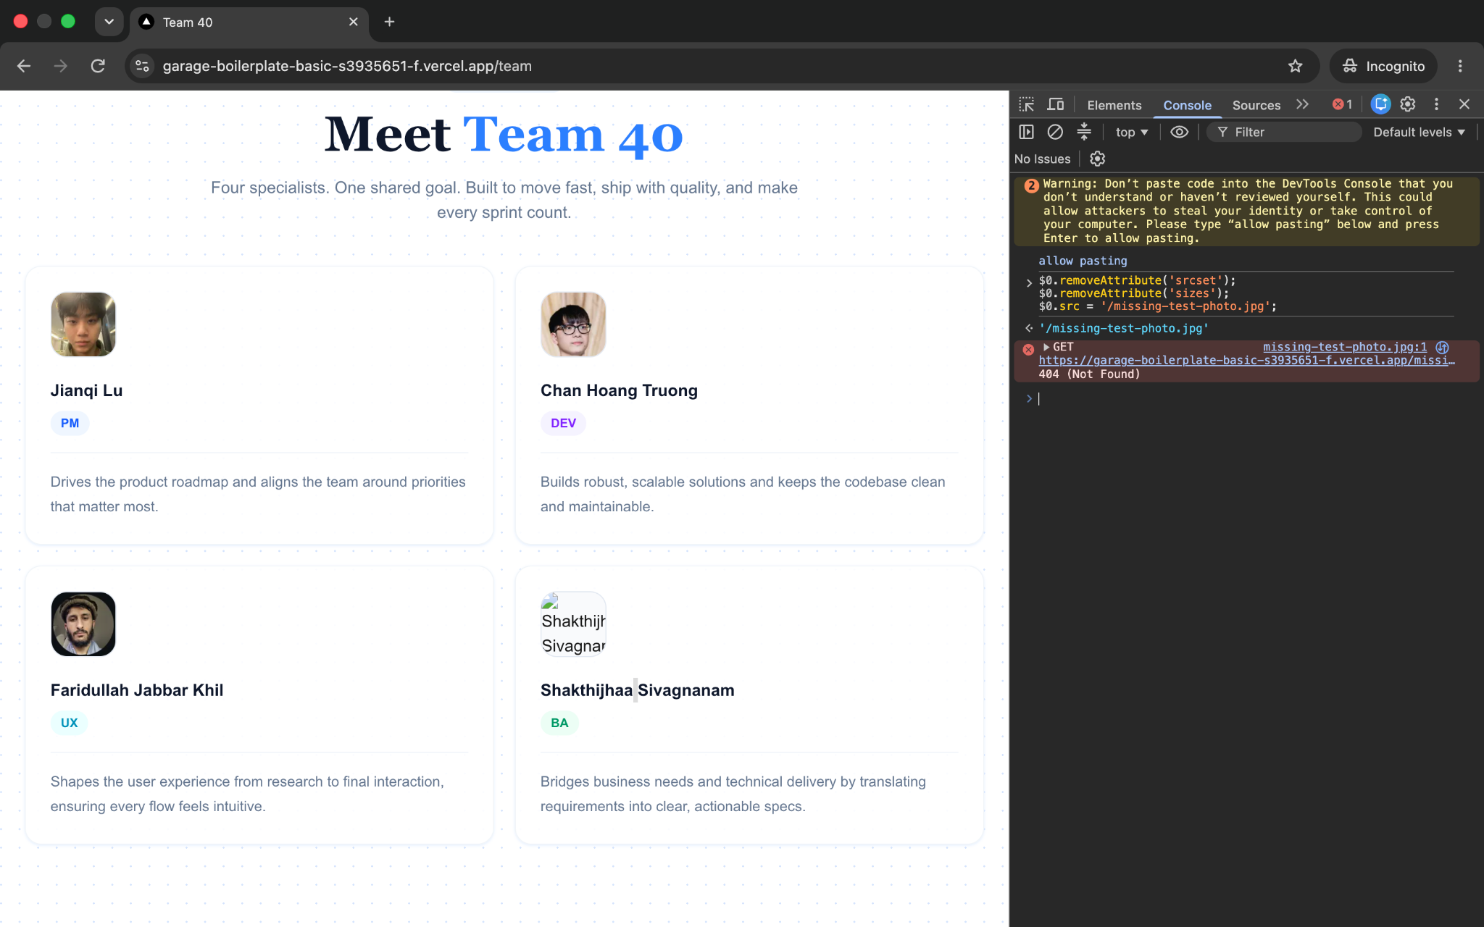
Fig. 3 — Missing-photo edge-case failure. DevTools shows the deliberately invalid image source and a 404 (Not Found) response; the profile card displays a broken image/alt text instead of the required fallback avatar.

4.4 TC-04 — Long-Blurb Edge Case
Objective: Verify that substantially longer profile text remains contained and does not break the Team Page card layout.
Test method: Temporarily replaced Shakthijhaa Sivagnanam's profile blurb in Chrome DevTools with a substantially longer QA test paragraph.
Expected result: Text wraps naturally within the card; no clipping, overlap or horizontal overflow occurs; neighbouring content remains readable.
Actual result — Desktop: The extended blurb wrapped correctly and remained fully contained within the member card. No text overlapped neighbouring elements, no content was clipped, and the surrounding cards remained readable. The grid row increased in height cleanly to accommodate the additional content.
Desktop result: PASS
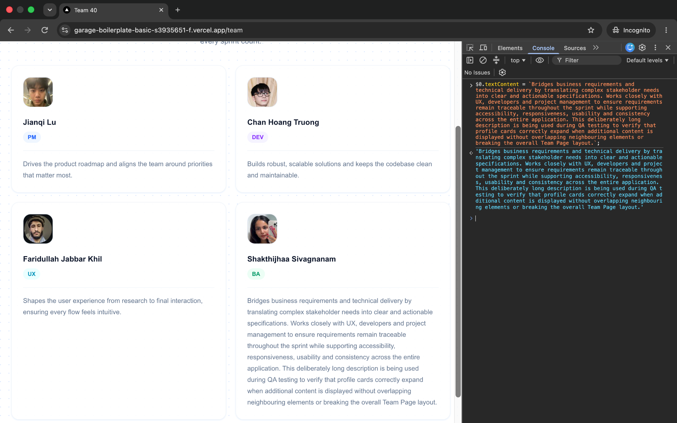
Fig. 4 — Long-blurb edge-case test at desktop width. The extended content remains inside Shakthijhaa Sivagnanam’s card without clipping, overlap or horizontal overflow.

4.5 TC-04 Responsive Confirmation — 390 px
Responsive viewport: 390 × 725 pixels in Chrome DevTools device emulation.
Expected result: The profile card remains usable in the mobile single-column layout and all long-blurb content stays within the card without horizontal scrolling or overlap.
Actual result: The long blurb remained readable in the single-column mobile layout, wrapped correctly, and stayed within the card boundaries. No horizontal overflow or overlap was observed.
Mobile result: PASS
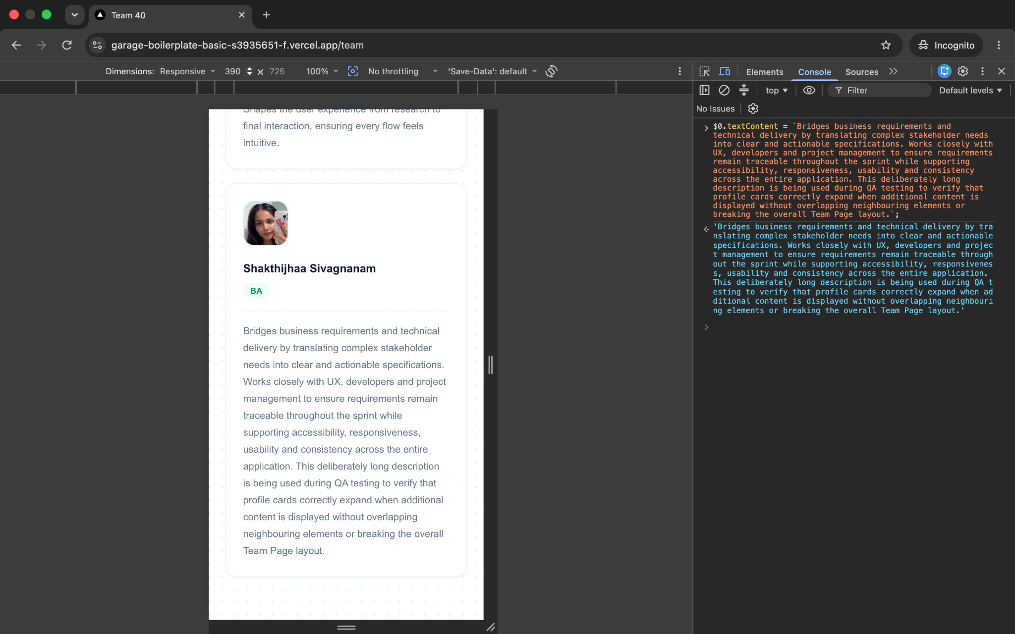
Fig. 5 — Responsive long-blurb confirmation at 390 × 725. The extended profile content remains contained and readable in the mobile single-column card layout.

5. Issues Found
One defect was identified during the assigned negative and edge-case test suite. The defect affects the missing-photo fallback requirement. Authentication failure handling, unauthenticated route protection, and long-blurb layout behaviour passed the performed tests.
5.1 BUG-01 — Missing Profile Photo Does Not Display Fallback Avatar
Field | Details
Bug ID | BUG-01
Summary | Missing profile photo does not display the required fallback/initials avatar
Environment | Deployed Vercel application; Google Chrome Desktop on macOS
Requirement | EC-04 / FR-14 — missing or failed photo should display a placeholder/monogram avatar
Severity | Medium — visible requirements defect; core authentication/navigation remains usable
Status | OPEN — requires developer fix and QA retest
Expected | If the member photo is unavailable or fails to load, display the designed initials/placeholder avatar (e.g., SS).
Actual | The failed image request returned HTTP 404 and Chrome displayed a broken-image indicator and alt text instead of the fallback avatar.
Evidence | Fig. 3
5.2 Reproduction Steps
1. Sign in to the deployed application and navigate to /team.
2. Open Chrome DevTools and inspect a member profile image (Shakthijhaa Sivagnanam was used for this test).
3. Remove the image srcset and sizes attributes so the browser uses the manually supplied src value.
4. Change the image src to /missing-test-photo.jpg (an intentionally nonexistent resource).
5. Observe the network/console 404 response and the rendered member card.
6. Confirm that a broken image/alt text is displayed instead of the required placeholder/initials avatar.
5.3 Required Fix / Retest Condition
Implement a reliable image-load fallback that replaces a failed member photo with the approved initials/placeholder avatar. After the fix is deployed, repeat TC-03 using the same invalid-image method and confirm that the placeholder appears, the broken-image indicator is not visible, and the member card remains intact.

6. Test Summary and Sign-off
Metric | Result
Assigned test activities | COMPLETE
Test cases executed | 4
Passed | 3
Failed | 1
Defects logged | 1 (BUG-01)
Overall QA result | FAIL — open requirements defect requires fix and retest
Tester sign-off
Overall Result | Tester | Student ID | Date
FAIL — BUG-01 OPEN | Shakthijhaa Sivagnanam | s4065078 | 15/08/2026
Completion note: All assigned negative and edge-case QA activities were completed. TC-01, TC-02 and TC-04 passed. TC-03 failed and is documented as BUG-01, which requires a developer fix and QA retest before final feature acceptance.

