TEAM 40
UX Design Deliverable
Styled Login Page & Team Page
Validation against BA Requirements — Task 2 Mock Sprint

Prepared by | Faridullah Jabbar Khil — UX
Prepared for | Shakthijhaa Sivagnanam — Business Analyst (validation)
Team | Team 40
Sprint | Task 2 — Mock Sprint
Feature | Styled Login Page and Team Page
Date | 10 August 2026
Status | Ready for BA validation

1. Purpose
This document presents the UX design for the "Styled Login Page and Team Page" feature and maps every element of the design back to the Business Analysis Requirements document (Task 2 — Mock Sprint, dated 10 August 2026). It is submitted to the Business Analyst for validation, as required before development may begin.
Per the requirements: "UX design must be validated by the BA before development begins." This document is intended to make that validation quick and traceable — every functional requirement, edge case, and non-functional requirement is listed alongside the specific design evidence that satisfies it.

2. Scope Covered
- A visually styled version of the existing Login Page (desktop, tablet, and mobile).
- A new Team Page for Team 40, reachable at /team.
- Team member profile cards for all four members, including photo/avatar, name, role, and blurb.
- Responsive behaviour across desktop, tablet, and mobile breakpoints.
No changes to authentication logic, sign-up flow, or any item listed as Out of Scope in the BA requirements have been proposed as part of this design.

3. Login Page Design
The Login Page has been redesigned visually while preserving every existing field, button, and link required by FR-01 to FR-07. The layout keeps the email field, password field, Sign In button, Google sign-in button, and account creation link in familiar, clearly labelled positions.
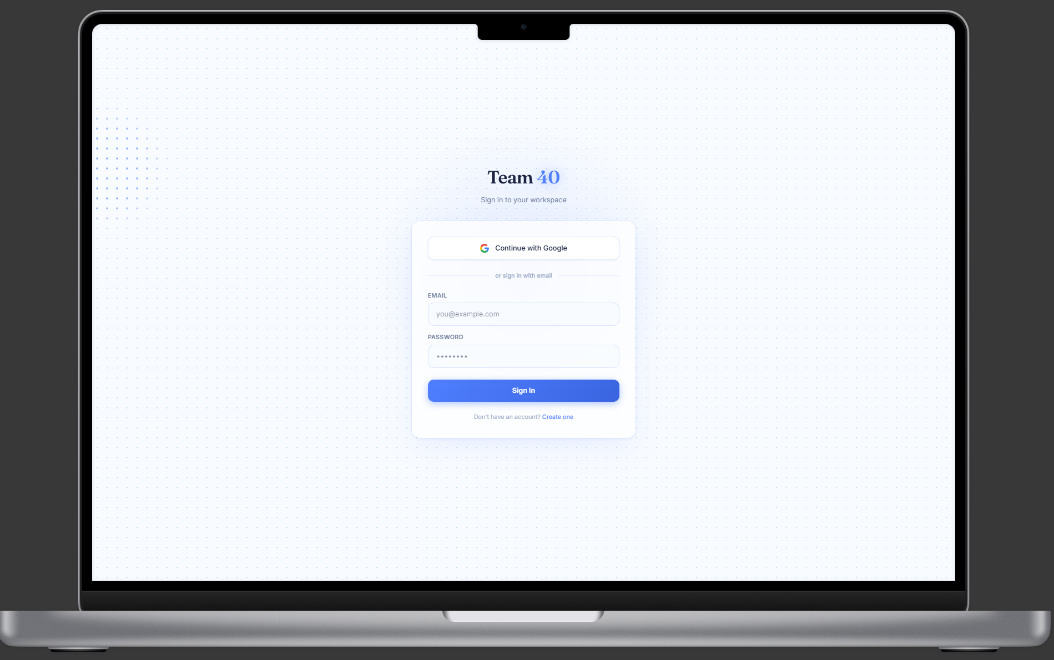
Fig. 1 — Styled Login Page (desktop). "Team 40" workspace branding, Google sign-in, and email/password fields with labels.
Design notes:
- EMAIL and PASSWORD fields carry visible, uppercase labels for clarity (supports NFR-02).
- The "Create one" account-creation link remains present and clearly separated from the primary action.
- The primary Sign In button uses high-contrast colour and full-width sizing for easy targeting on any device.
- A fully designed error state (Fig. 1b, below) shows exactly how validation/error messaging appears. Loading-state visuals have not been separately mocked up; existing loading behaviour is intended to be preserved unchanged and will be verified during implementation (FR-05).

3.1 Error State
The mockup below shows the Login Page in its error state, satisfying FR-07 and EC-01: on an invalid login attempt, the user remains on the Login Page and a clear, styled error message is displayed rather than being silently redirected or shown a generic browser alert.
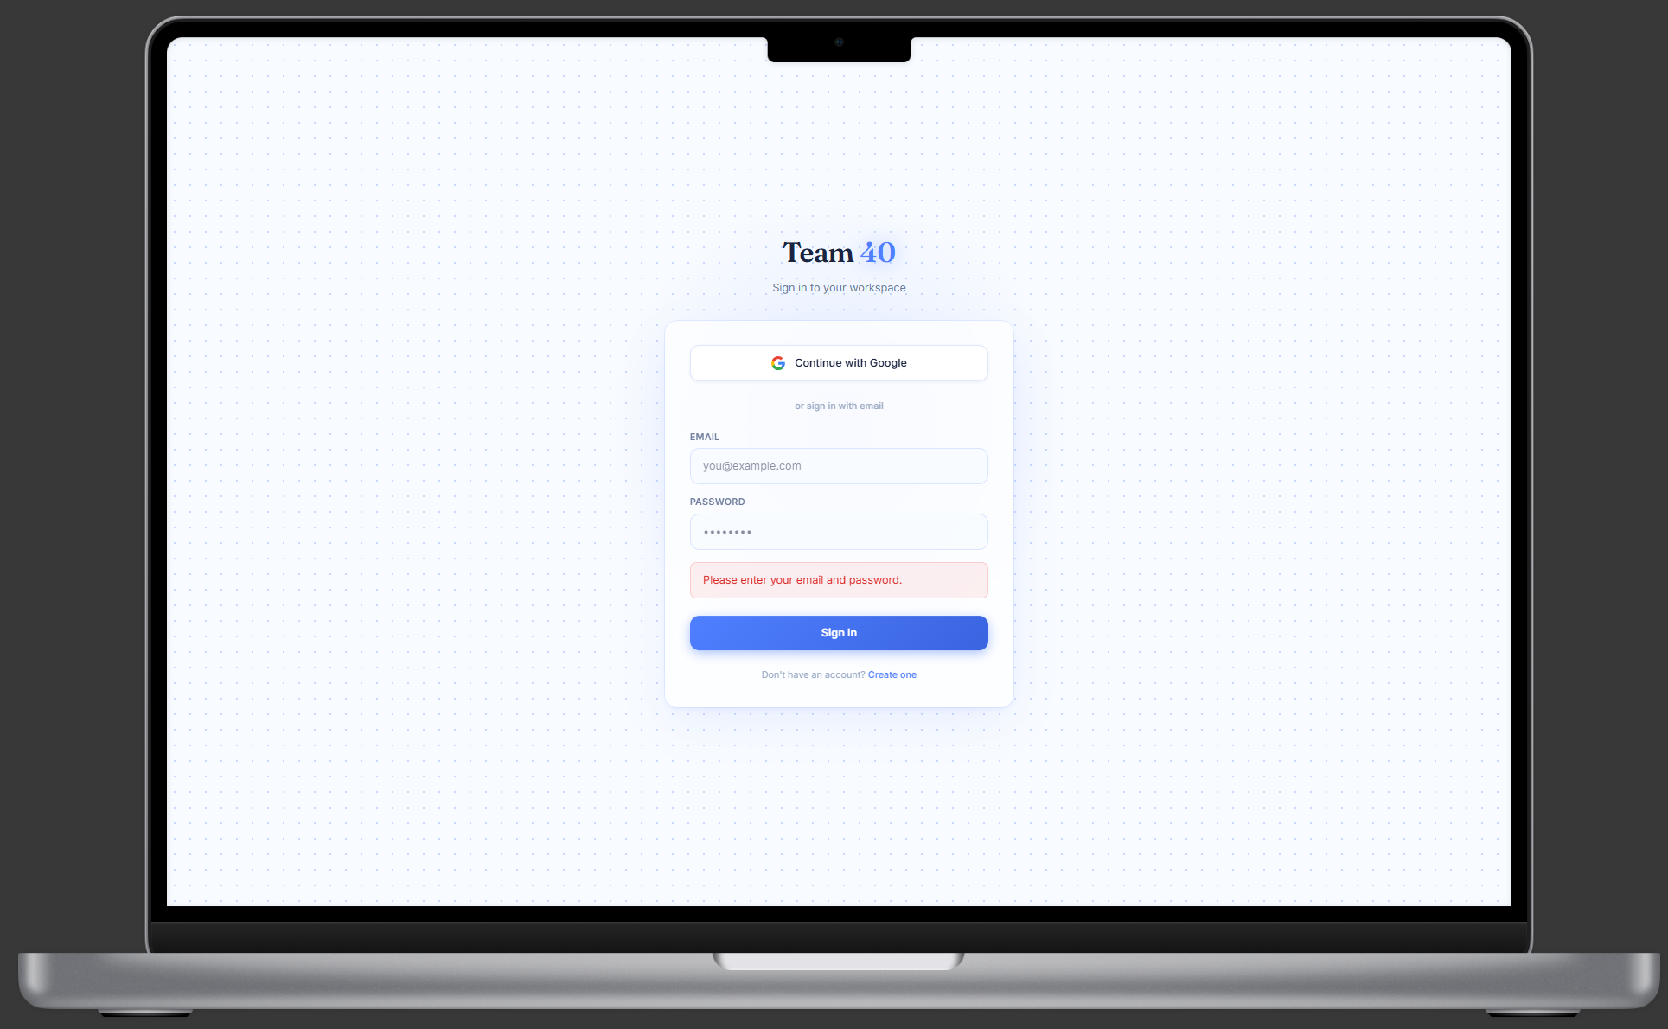
Fig. 1b — Login Page, invalid-credentials error state. A soft red banner with red text — "Incorrect email or password. Please try again." — appears between the Password field and the Sign In button.
Design notes for the error state:
- The message uses a light red background with darker red text and rounded corners, matching the card and input styling already established elsewhere on the page — keeping the error visually consistent with NFR-03.
- The error banner sits directly below the fields being validated (email/password) and above the Sign In button, so it is immediately visible without scrolling.
- Copy is plain-language ("Incorrect email or password. Please try again.") rather than a technical/system-level error, so it remains clear to any user.
- This mockup illustrates the error state only. Whether the email/password fields are cleared or retained after a failed attempt is existing application behaviour, not something newly defined by this design — the BA requirements do not specify it, and it is intentionally left unchanged rather than introduced as a new UX decision.

3.2 Responsive Login Page
The Login Page has also been validated at tablet and mobile widths, so the responsive requirement (NFR-01) is fully traceable for both pages in this deliverable, not just the Team Page.
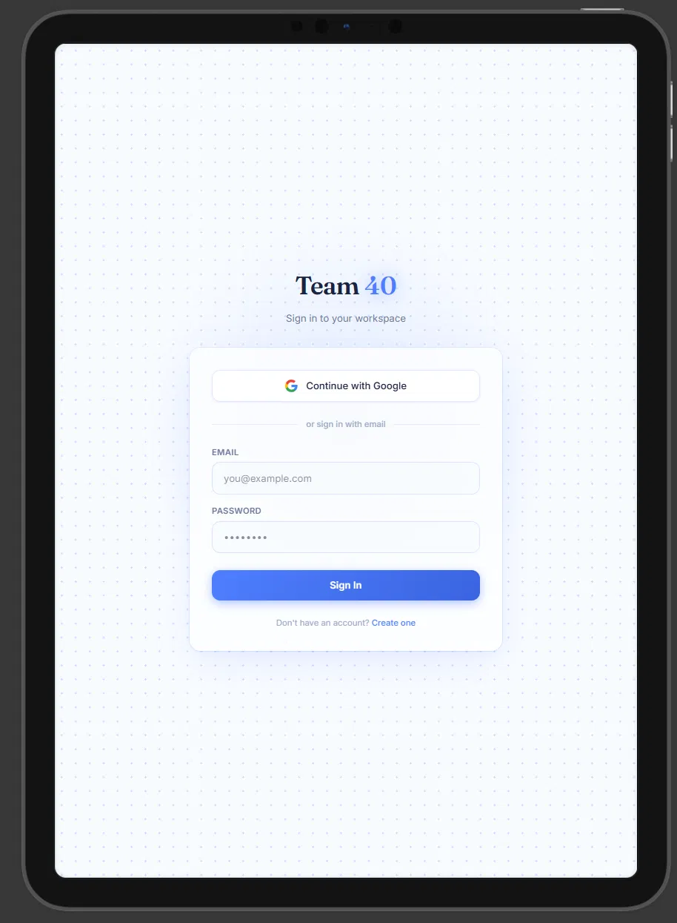
Fig. 1c — Login Page at tablet width. Layout and field sizing scale down cleanly with no overlap or overflow.
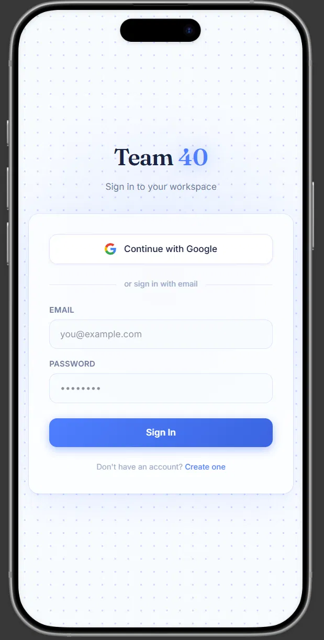
Fig. 1d — Login Page at mobile width. All fields, labels and buttons remain fully usable and readable in a single-column layout.

4. Team Page Design
The Team Page introduces "Team 40" with a card for each of the four team members, satisfying FR-12 through FR-16 and the field/display rules in Section 5 of the BA requirements.
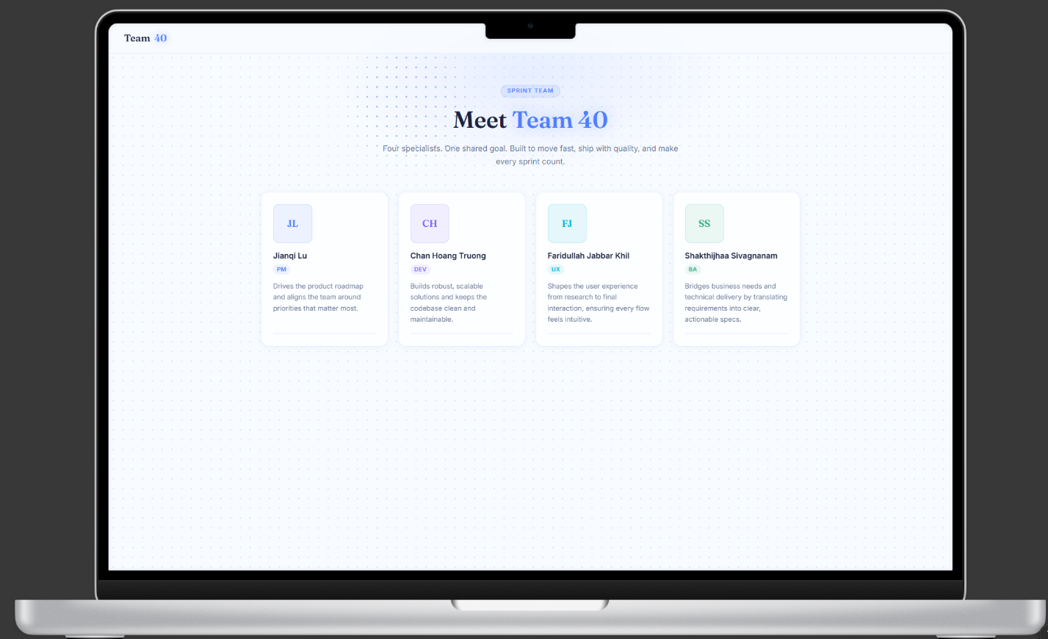
Fig. 2 — Team Page (desktop). Four member cards, each with avatar, name, role badge, and blurb.
Field and display rule mapping:
- Team Name — "Meet Team 40" is displayed prominently as the page headline, with "Team 40" repeated in the persistent top-left header.
- Member Photo — the current mock-up uses coloured monogram avatars (initials) for each member. Actual team member photos will be added during the development phase; the monogram avatar remains as the fallback if a photo is unavailable or fails to load (EC-04).
- Member Name — each card displays the member’s full name in bold, unabbreviated.
- Member Role — each card shows a coloured role badge: PM, DEV, UX, and BA respectively.
- Member Blurb — each card includes a short, role-relevant blurb; the card layout accommodates the varying blurb lengths visible across the four members without breaking alignment (EC-05).
- Member Card / Section — each member’s photo, name, role, and blurb are grouped within one clearly bordered card, satisfying the grouping requirement in Section 5.

5. Responsive Behaviour
The design has been validated at three breakpoints — desktop, tablet, and mobile — to satisfy NFR-01 and EC-06.

5.1 Tablet view
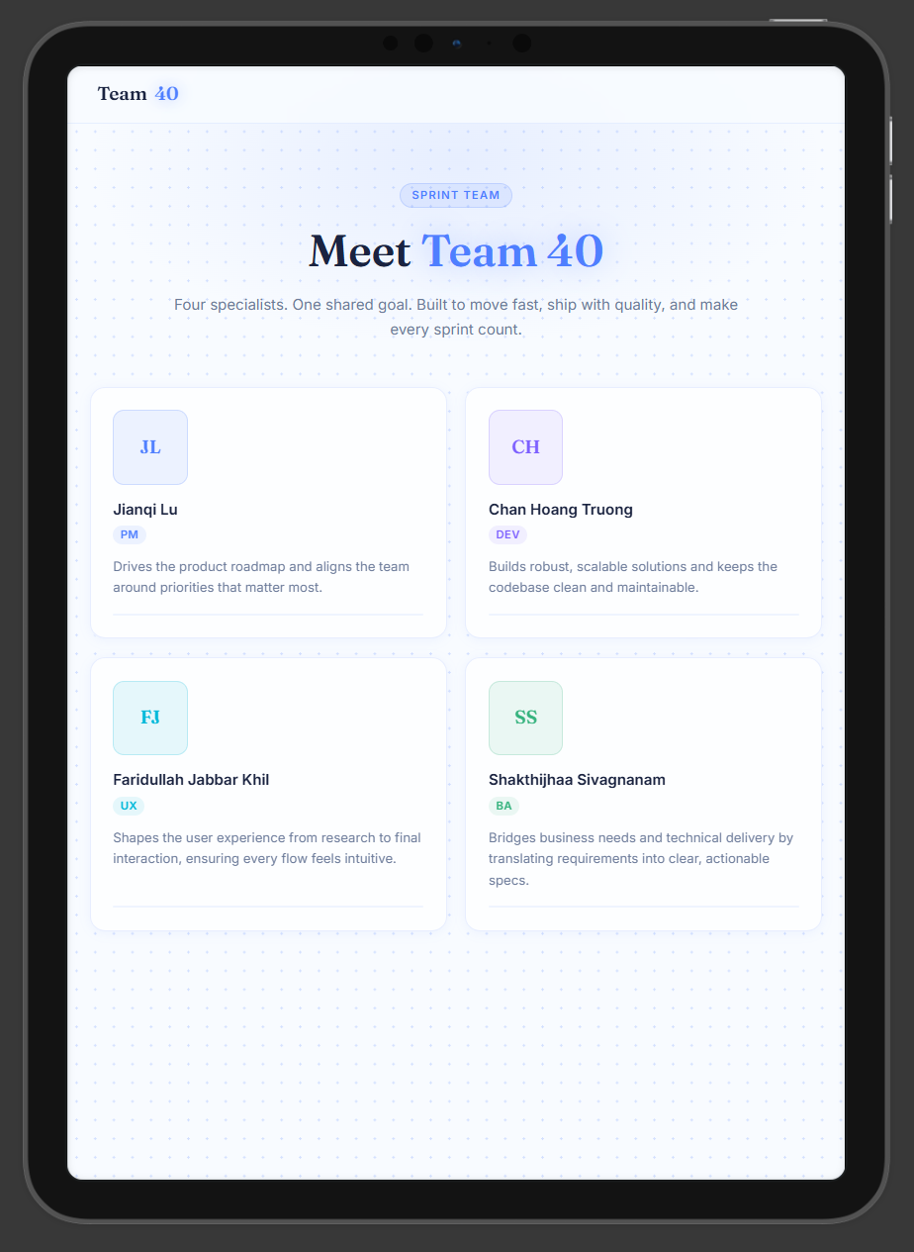
Fig. 3 — Team Page at tablet width. Cards reflow into a 2-column grid; all card content remains fully readable.

5.2 Mobile view
On mobile, the card grid collapses to a single column so no content overlaps or overflows, and every card remains fully legible without horizontal scrolling.
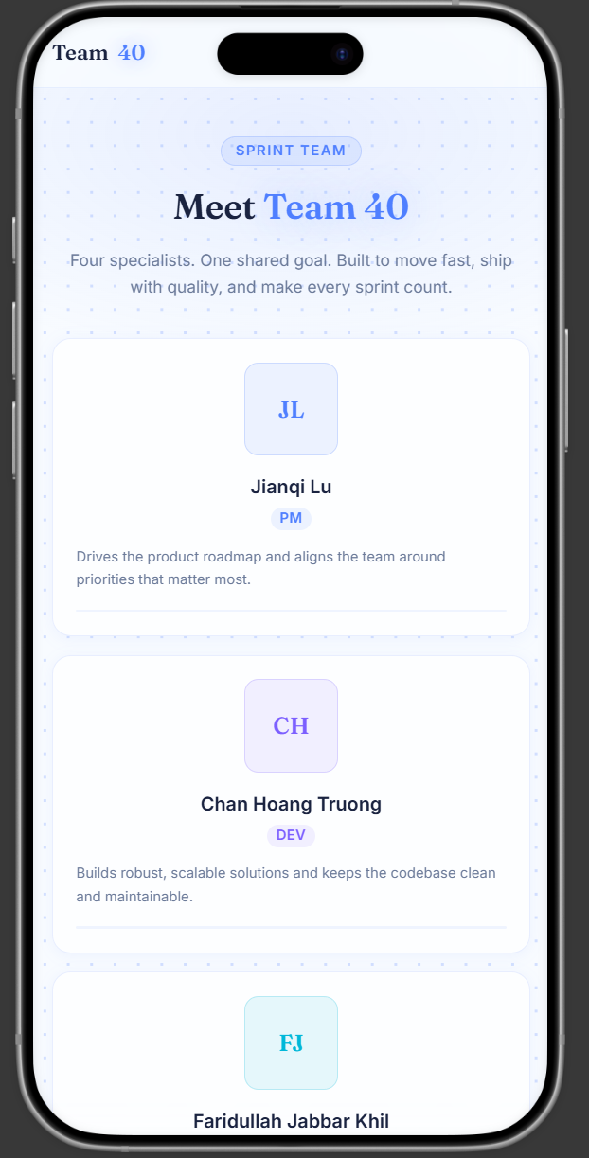
Fig. 4 — Mobile view (top of page): header, hero copy, and first two member cards in single-column layout.
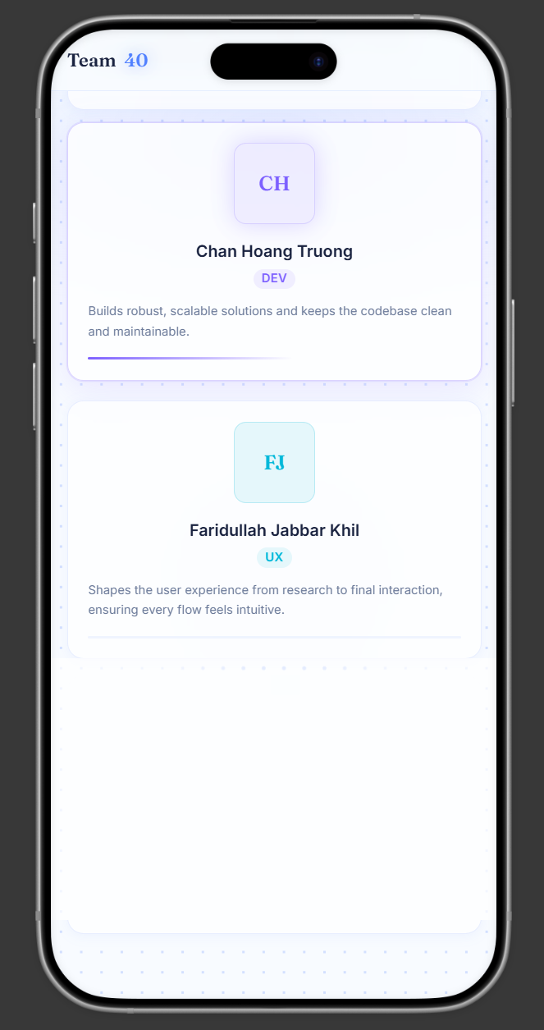
Fig. 5 — Mobile view (continued): remaining member cards, confirming consistent single-column card treatment.

6. Requirements Traceability — Functional Requirements
The table below maps every functional requirement from the BA document to the specific design evidence in this deliverable. Status reflects what can genuinely be confirmed at the UX design stage — items that depend on implementation or further confirmation are marked accordingly rather than as fully addressed.
- Green — Addressed: fully satisfied by this design.
- Amber — Design supports the requirement; final confirmation depends on development, testing, or further team input. This is expected for functional/behavioural requirements and does not indicate a design gap.
ID | Requirement | Design Evidence | Status
FR-01 | Login Page visually styled per approved UX design | Full redesign delivered — see Section 3 / Fig. 1 | ✓ Addressed
FR-02 | Email/password login remains available | Email + Password fields retained in design, unchanged positions | ✓ Addressed
FR-03 | Google sign-in option remains available | "Continue with Google" button retained as primary action | ✓ Addressed
FR-04 | Styling changes do not alter auth logic | Design is visual-only; no field names, IDs or logic proposed to change | ✓ Addressed
FR-05 | Validation, error and loading states continue to work | Error state fully mocked up — Fig. 1b. Loading-state visuals not separately designed; existing loading behaviour is to be preserved unchanged and verified during implementation. | Design supports requirement — to be verified during development/testing
FR-06 | All controls remain clearly identifiable and usable | Email, Password, Sign In, Google, and Create-account link all present — Fig. 1 | ✓ Addressed
FR-07 | Invalid attempts remain on Login Page with error message | User stays on Login Page; styled error banner shown — Fig. 1b | ✓ Addressed
FR-08 | Successful auth redirects to Team Page | Design supports a /team destination; redirect logic is a Dev-layer implementation, not a UX-layer change | Design supports requirement — to be verified during development/testing
FR-09 | Team Page uses route /team | Design targets the /team route | Design supports requirement — to be verified during development/testing
FR-10 | Both auth methods land on the same Team Page | Single Team Page design serves both entry paths — no separate variant needed | Design supports requirement — to be verified during development/testing
FR-11 | Already-authenticated users skip sign-in | Functional/routing requirement; design itself has no dependency on how this is triggered | Design supports requirement — to be verified during development/testing
FR-12 | Team Page clearly displays "Team 40" | "Meet Team 40" heading + persistent header — Fig. 2 | ✓ Addressed
FR-13 | A profile/card exists for every member | Four cards shown — Jianqi Lu, Chan Hoang Truong, Faridullah Jabbar Khil, Shakthijhaa Sivagnanam — Fig. 2. Roster completeness to be confirmed — see Section 10. | ✓ Addressed
FR-14 | Each profile has photo, name, role, blurb | Card structure includes photo/avatar, name, role badge and blurb — Fig. 2. Monogram avatars used in this design; actual member photos to be added during the development phase. | Design supports requirement — real photos to be added during development
FR-15 | Team info presented in a clear, consistent layout | Uniform card structure and spacing applied to all four members | ✓ Addressed
FR-16 | Team Page follows approved UX design | This design has been submitted for BA validation; approval pending | ✓ Addressed

7. Requirements Traceability — Edge Cases
ID | Requirement | Design Evidence | Status
EC-01 | Invalid login → stay on page + error message | Full error-state mockup provided: "Incorrect email or password. Please try again." — Fig. 1b | ✓ Addressed
EC-02 | Already-authenticated user → redirect to /team | Routing/behavioural requirement; no design conflict identified | Design supports requirement — to be verified during development/testing
EC-03 | Email/password and Google both reach Team Page | Single shared Team Page destination designed for both auth paths — no separate variant needed | Design supports requirement — to be verified during development/testing
EC-04 | Missing photo → placeholder avatar | Two-letter monogram avatar (e.g. "JL", "FJ") is designed as the fallback for when a photo is unavailable or fails to load — Fig. 2. Once real photos are added, the monogram becomes the fallback state rather than the default. | ✓ Addressed
EC-05 | Different blurb lengths do not break cards | Card height flexes with content; tested with short and longer blurbs — Fig. 2 | ✓ Addressed
EC-06 | Cards remain usable on smaller screens | Dedicated mobile layout — single column, full-width cards — Fig. 4 & 5 | ✓ Addressed
EC-07 | Incomplete member profile is flagged as not-done | Current mock-up shows all four members with complete data (Fig. 2); incomplete member information should be flagged during content/design validation and that profile treated as not complete | Design supports requirement — to be verified during development/testing
EC-08 | Login styling must not break auth validation/loading | No functional elements removed or altered in the visual redesign; actual behaviour to be confirmed once implemented | Design supports requirement — to be verified during development/testing

8. Requirements Traceability — Non-Functional Requirements
ID | Requirement | Design Evidence | Status
NFR-01 | Responsive on desktop and mobile | Login Page: desktop (Fig. 1), tablet (Fig. 1c), mobile (Fig. 1d). Team Page: desktop (Fig. 2), tablet (Fig. 3), mobile (Fig. 4–5). Both pages fully covered. | ✓ Addressed
NFR-02 | Accessible: readable text, focus states, labels, alt text | High-contrast text and labelled EMAIL/PASSWORD fields shown in mockups; focus states and image alt text can only be fully verified once implemented — alt text is planned to be added at build time. | Design supports requirement — to be verified during development/testing
NFR-03 | Consistent fonts, spacing, colours, buttons, cards | Single type system (serif headings / sans body) and consistent card component reused throughout | ✓ Addressed
NFR-04 | Existing functionality not broken | No functional/auth logic changed in the design — styling and a new page only; this is existing boilerplate functionality being reused, not new functionality introduced | Design supports requirement — to be verified during development/testing
NFR-05 | No lint/typecheck/build/test failures introduced | This is a design-only deliverable; no code has been written yet, so this cannot be verified at the UX stage | Design supports requirement — to be verified during development/testing

9. Out-of-Scope Confirmation
In line with Section 9 of the BA requirements, this design deliverable does not include, and was not intended to include, any of the following:
- A redesigned sign-up page
- New authentication providers
- Any rebuild of the existing authentication system
- A database-driven team management system
- User-facing add/edit/delete controls for team members
- Changes to the Notes feature or unrelated Dashboard functionality
- Administrative functionality
- User photo upload/edit functionality
Team member information is designed to be implemented as static content, consistent with the Mock Sprint constraint in Section 9 of the requirements.

10. Outstanding Items Before Final Sign-off
No outstanding items remain for this deliverable. Actual team member photos will be added during the development phase, per the note on FR-14 above.

11. BA Validation Sign-off
Per the project’s Dependencies (Section 11 of the BA requirements): "UX design must be validated by the BA before development begins." This section is for the Business Analyst to record that validation.
Reviewed by | Decision | Date | Notes
Shakthijhaa Sivagnanam (BA) | ☐ Approved ☐ Changes requested | 14 August 2026 | UX design reviewed and validated against the Task 2 BA requirements. Previously identified gaps have been addressed. Design approved to proceed to development.
Once approved, development on the Login Page styling and the Team Page (route /team) may proceed per the team’s Git feature-branch and Pull Request workflow.

