Q1

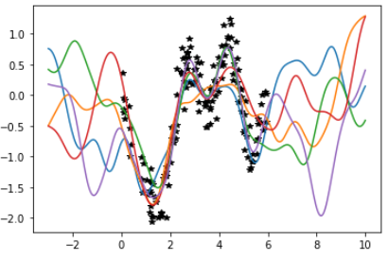

Q2

d = 1

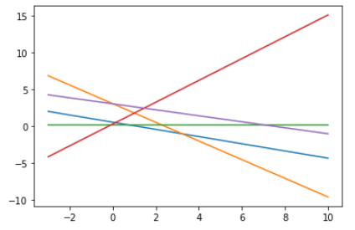

d = 2

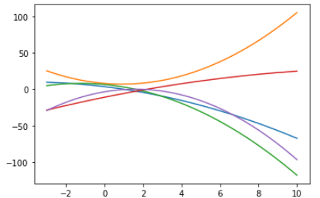

d = 3

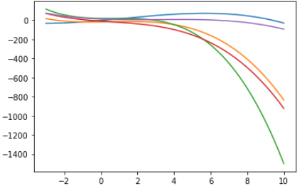

Q3

When d = 1, the covariance function represents linear function.

When d = 2, the covariance function represents quadratic function.

When d = 3, the covariance function represents cubic function.

Q4

1. *p*(y|X, w)= *N* ( Xw, σ2n *I* )

log() = log($p\left(\left.y\right|w,X\right)$) + log($p\left(w\right)$) – log($p\left(\left.y\right|X\right)$)

log($p\left(\left.w\right|X,y\right)$) = $-\frac{1}{2σ_{n}^{2}}{\left(y-Xw\right)}^{T}\left(y-Xw\right)-\frac{1}{2}{\left\|w\right\|}^{2}+c$

1. Yes, it does. Ridge regression
2. Linear covariance function