IE 332

Project Phase 1

02/29/2016

Tao Li - 0027010989

Xiji Hong - 0027002394

Jianxing Wan - 0026720838

Junyan Qiu - 0026701412

Yingnan Guo - 0025829159

Yongqiang Zhu - 0027449604

“I am aware of, and understand, the Purdue Academic Misconduct Policies and attest that this submitted work is solely my own. I accept any repercussions if found in violation.”

Abstract 1

Introduction 2

Production Plan(Simulation) 3

Data Analysis 4

Inventory Management System 5

Website Design 6

Appendices 7

This project aimed to create a new efficient assembling plan and inventory management system of two propulsion engines, WARP drive, from Roswell Aerospace company based on the assembling requirement for each engine.

The team plans to simulate the whole manufacture processing system by using Arena software to generate the most efficient plan and working time of each workstation. Simultaneously the team creates a proper inventory system to ensure production line run smoothly with varied customers’ orders of engine. As a result, Roswell company can utilize the production simulation and inventory system to upgrade their management system for the sake of maximizing profits and raising labor efficiency.

Abstract

This project aims to deal with the introduction of two new products, a large increase in orders, the production plan and inventory management system, which is based on demand, are upgraded for Roswell Aerospace to increase profits. An interactive website is designed to enable consumers to create new orders, track orders, make modifications to existing order(if assembly has not yet begun) and also report any defects upon receipt of the products.

Introduction:

In order to efficiently manage a large increasing orders of the. The team focuses on simulating a relatively efficient production line assemblying different WARP drives. The team plans to simulate the whole manufacture processing system by using Arena software to generate the most efficiet plan and working time onf each workstation. Simultaneously the team creates a proper inventory system to ensure production line run smoothly with varied customers’ orders of WARP drive. As a result, Roswell company can utilize the production simulation and inventory system to upgrade their management system for the sake of maximizing profits and raising labor efficiency. Moreover, based on simulation product situation of real time, the manufacturer can build a interactive website for consumers to create new orders, track orders, make modifications to existing order, and also report any defects upon receipt of the products.

By implementing our team’s solutions, the production process’ effciency and working time can be maximized.

Production Plan(Simulation)

Arena is used by the team to create an efficent product system. The product system is consisted of two assembly lines, and each line can produce five products. The basic idea of the product system is working by sequence, which means that each product is installed by its own sequence according to the task lists given by Roswell. For one product, the series of tasks are accomplished by sequence.Tasks for different products can be accomplished simultaneously in one workstation. Furthermore, each assembly line consists of different workstations, and when product is in assembly line, it could choose to go into the workstation or not, and in a particular workstation, the assembling product could choose to do all tasks in that workstation or only do one task in that workstation. Moreover, the system is schedule-driven, and every work not completed during the time a product is at a workstation will be sended downstream to the next workstation. As a result, there would be two five product lines.

The following figure is the overview of production system.

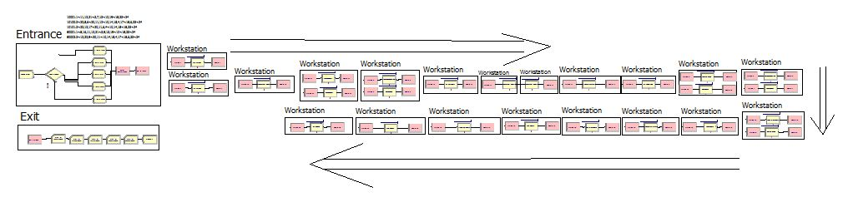

Figure1.0 the overview of production system

In entrance, create model is used to represent purchase orders. The team used random number with mean of 5 days and 30 days to represent the time arrive between each order. The decide model set the probability of all five products are all 20 percent. After create model and a decide model, five assign models are bulit to assign attributes to each production. After assign model, each product will have productionID, production sequence, and a production picture. Afterwards, the product will be transfered into workstations and installed by their assigned task ID automatically. Each workstation will have a schedule of 9 days, and this schedule is decided by the data analysis, which will be shown in the following report. When each product exits the workstation, its profit will be recorded by the record model. The team simulates the production system with 1 replication with replication length 1095 days.

Detailed product system is in Appendice.

Data Analysis

Adding more workers in each work station will decrease the time required to finish the task but it will also increase the cost for the manufacturer at the same time. An appropriate time requirement is necessary to maximize the profits. The team tests different time reqiurement, ranging from 7 days to 21 days with a two-day increment. This critical range is determined with the concern about the labor limit for each work station, how tasks can be accomplished by employing more workers, and the demand for hiring managers to manage each work station.

In order to find the ideal value, the team uses the simulation model to obtain revenues for each product based on the assumption that purchase orders are exponentially distributed with mean of 5 days (booming) and 30 days(recession). After testing each time requirement, the team calculates the profits for each senario (Profits = Revenue - Wage * Number of Labors).The following two plots show the relationship between the amount of profts Roswell will obtain versus time requirement.

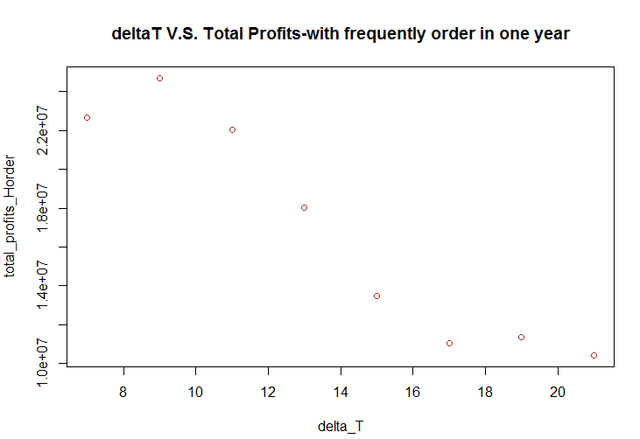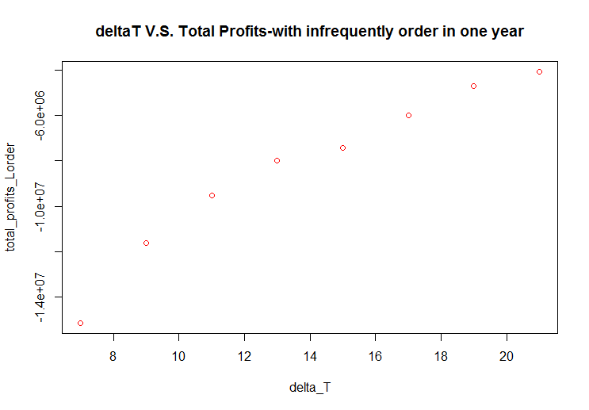

Senario 1: Insufficient order for Roswell

Senario 2: Sufficient order for Roswell

If Roswell does not have enough orders each year, it will suffer a huge loss. And to minimize loss, the manufacturer should set time requirement to 21 days. On the contrary, when Rosewell receive sufficient number of orders, it is a wise choice to set time requirement to 9 days to maximize profits.

**Inventory Management System**

The inventory management system is designed for ensuring the production line will work consistently. The system is integrated with the production plan in order to ensure that inventory availability will not be a concern at each workstation. This strategy will be considerd to satisfy different amounts of order in the long-run.

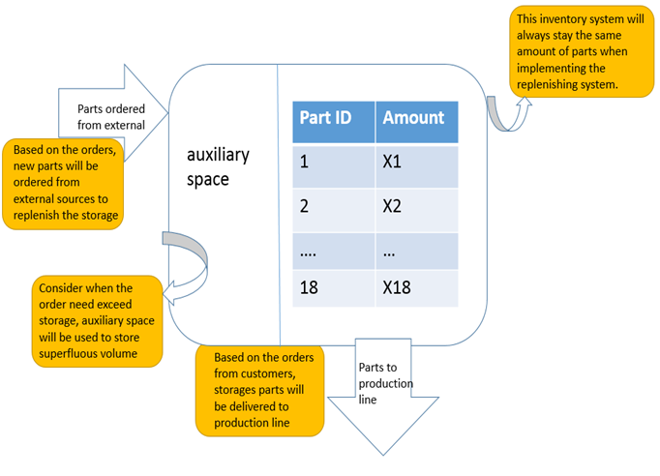

Initially, the inventory stores certain amounts of parts depend on the forecast of the initial purchase order condition. The whole assembly line starts to work as the first order has been made and parts retrieved from warehouse will be supplied by purchasing from outside supplier. When order exceed the storage, the auxiliary space will be utilized for storing extra parts. In other words, each production will be installed completely before the last order is being reached. the inventory will always stay equilibrium and is capable of satisfying the need of production plan.

Website Design

The website is designed to provide users a easy way to find basic information and make purchase orders of WRAP engine. The homepage consists of three parts. The first part is the login and password. Each user is required a personal ID and password to log in their own account. Users can see an order list which includes some basic information of current and past orders. A “create new order” bottom is also on their personal homepage. By clicking this button, users can see a list of the five products. Then they can enter the quantity of each product and click the “Check Out” button to create their order.The user will be notified by a “thank you” page displayed, acknowledging that the payment has been received. Also, users can find more details by clicking the order number of each order in their personal homepage. Then, the new page will display the order time, product information, delivery date and so on. At the same time, users can also change/cancel their order in this page, if the time is under 24 hours after their order placed. The second part is the production information. Users can check relative information of the five productions by clicking the five bottoms in the website homepage. The numbers on each bottom are the product IDs. The information page includes the picture, the use, the production time of the products and so on. The last part includes two small parts, “About us” and “help”. As for the “About us” part, users can get more information of this company, Roswell Aerospace. The “help” part is an approach for users to evaluate this website by sending emails to this company. They can report some comments back to Roswell about what this team did well and what needs to be improved. Don’t forget to logout after finished all of you operations. 

Appendices

