Call procedure with country Canada, 4 total medals, 1 gold/3 silver/0 bronze

Procedure does prints all countries with less total medals \*

It noticed that Canada doesn’t have 4 total medals and complained \*\*

Image1:

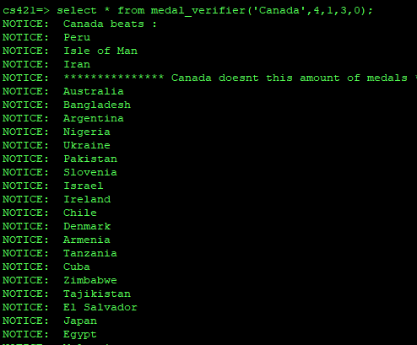

Image 1 follow up

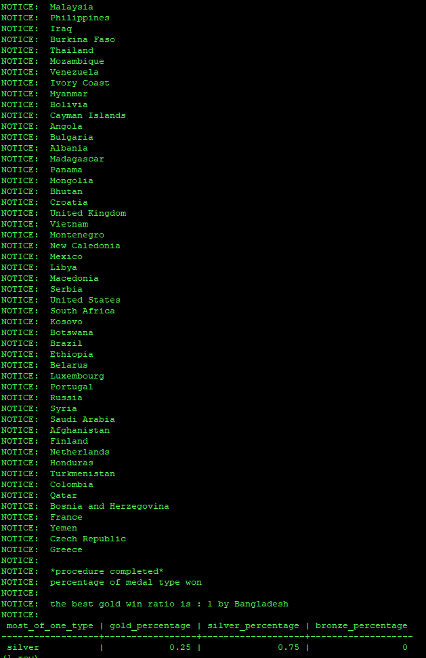

It also prints the proper table given input

And the country with the best gold win ratio (1 = 100% they only won gold)\*\*\*

Confirmation that all the output where correct :

\* all countries with less total medals is good

(the countries with zero medals aren’t show in this query)

(Canada is there because we wanted to test that the procedure would notice it was given the wrong number for the given country which it did )

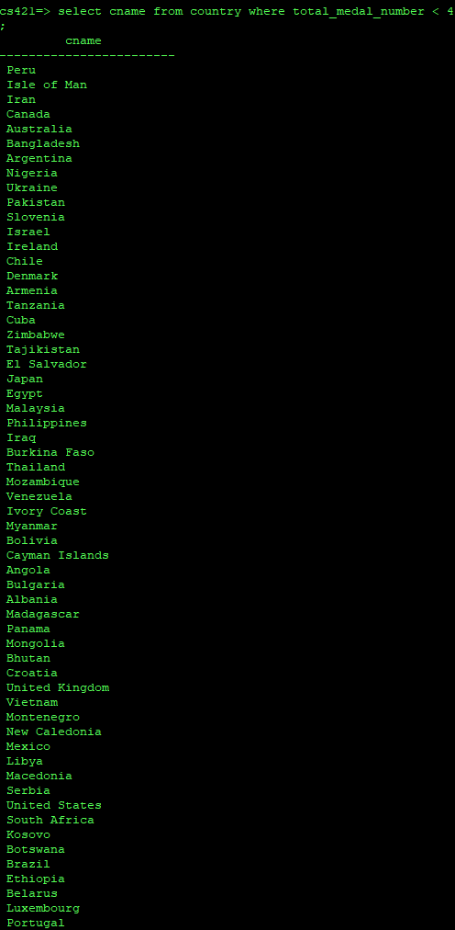

\*\* we said that Canada had 4 total medal which it didn’t , the procedure complained rightfully

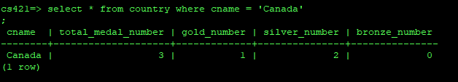

\*\*\* Bangladesh does have 100% gold win ratio and there shouldn’t be anyone with a higher than 100% ratio

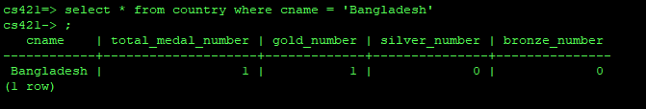

It should be noted that this procedure would be more 3-4 useful feature rather then a single one, they were combined for convenience and to exposed as much concepts as possible.