**Name:** Samuel Acuña

**Date:** 14 Nov 2016

**Class:** ME 751

**Subj:** Final Project — simEngine3D benchmark — **N Four-bar mechanism**

My simEngine3D dynamics engine was successfully able to simulate the N four-bar mechanism benchamark (<http://lim.ii.udc.es/mbsbenchmark/dist/A02/A02_specification.xml)>.

All code to run the simulation, including plots and recorded animations, can be found at <https://github.com/saacuna/simEngine3D> under the *final_project* folder. The driver file is called *simEngine3D_n4BarMechanism.m*

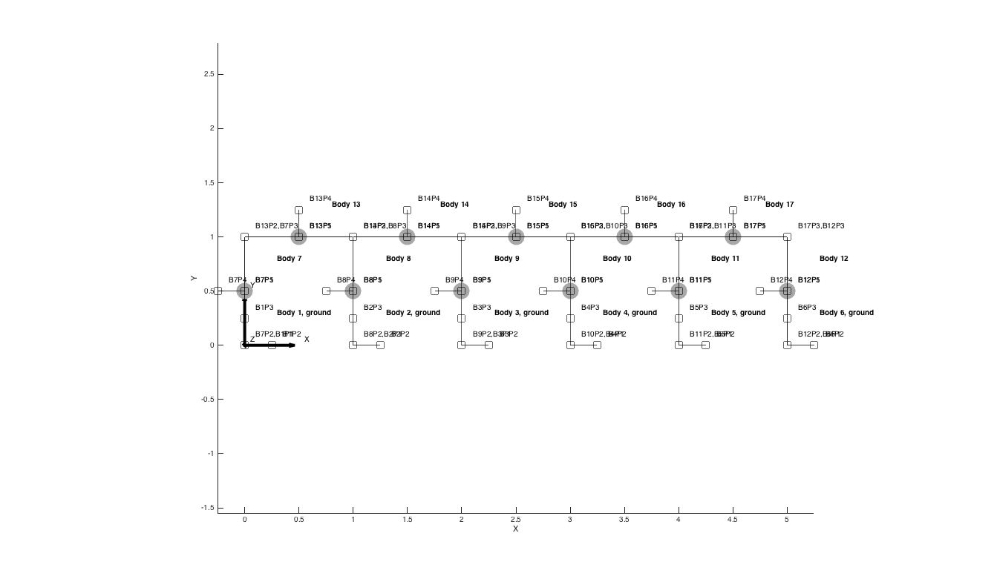**Plot of dynamic system: (N = 2, and N = 5)**

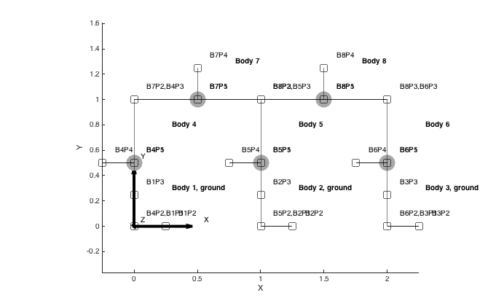

**Simulation Run Time:**

For step-size h=0.01 seconds, and N = 2, time to compute Quasi-Newton Solution: 253.9681 seconds

For step-size h=0.001 seconds, and N = 1, time to compute Quasi-Newton Solution: 1395.8112 seconds

For step-size h=0.001 seconds, and N = 5, time to compute Quasi-Newton Solution: 2859.6378 seconds

**Comparison to benchmark solution:**

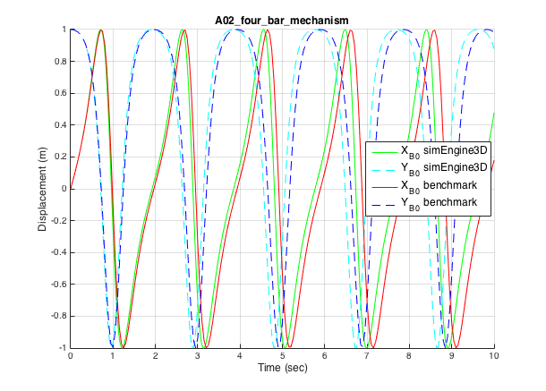

**Benchmark Tolerances: (comparing 201 data points)**

*Low Precision Error tolerance =* 1e-1

*X coordinate*: There are 131 entries outside of allowable low precision error

*Y coordinate*: There are 98 entries outside of allowable low precision error

*High Precision Error tolerance =* 1e-3

*X coordinate*: There are 131 entries outside of allowable high precision error

*Y coordinate*: There are 98 entries outside of allowable high precision error

***Thus, the simulation is NOT considered to have reached the benchmark.***  The simulation starts correctly, but my simulation is slightly accelerating. The position plot above shows my simulation peaking increasingly sooner than expected.