**Name:** Samuel Acuña

**Date:** 14 Nov 2016

**Class:** ME 751

**Subj:** Final Project — simEngine3D benchmark — **simple pendulum**

My simEngine3D dynamics engine was successfully able to simulate the simple pendulum benchmark (<http://lim.ii.udc.es/mbsbenchmark/dist/A01/A01_specification.xml)>

All code to run the simulation, including plots and recorded animations, can be found at <https://github.com/saacuna/simEngine3D> under the *final_project* folder. The driver file is called *simEngine3D_simplePendulum.m*

**Plot of dynamic system:**

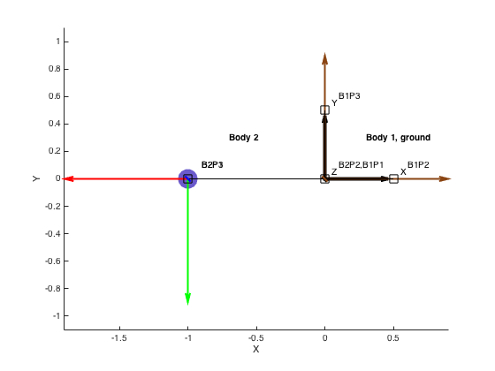

**Simulation Run Time:**

For step-size h=0.01 seconds, time to compute Quasi-Newton Solution: 59.8413 seconds

**Comparison to benchmark solution:**

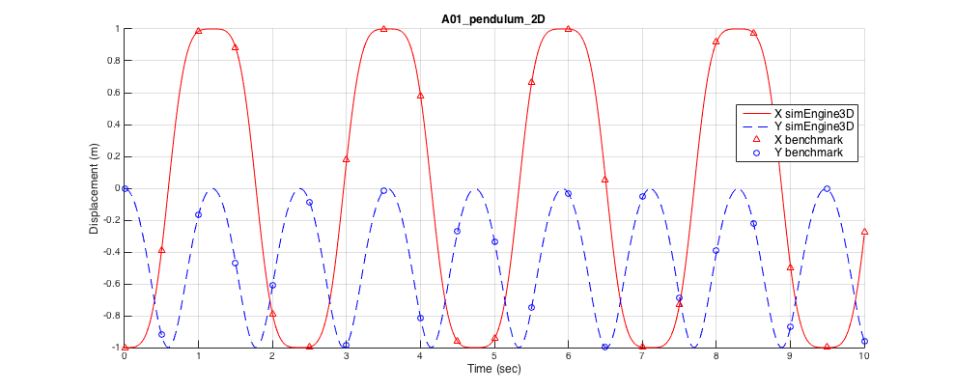

**Benchmark Tolerances:**

*Low Precision Error tolerance =* 1e-1

*X coordinate*: There are 0 entries outside of allowable low precision error

*Y coordinate*: There are 0 entries outside of allowable low precision error

*High Precision Error tolerance =* 1e-3

*X coordinate*: There are 0 entries outside of allowable high precision error

*Y coordinate*: There are 0 entries outside of allowable high precision error

***Thus, the simulation is considered to have reached the benchmark.***