Read Me

The code folder contains 2 “main” files that include the codes to generate the main results for the paper.

The full “main.R” include generating results for both Tree methods and the baseline triple sorting based portfolios.

The “main_simplified.R” file runs faster and only contains the main results such as Sharpe ratios of the generated “SDF” portfolio and the corresponding asset pricing test results.

The Data folder contains sample intermediate data from the outputs of “step 1” below, which includes yearly data with returns and characteristics (additional noise added to return and raw size numbers to avoid violating WRDS data sharing agreements, see below for more details).

Data Generation Steps:

Step 1: the raw input files are tables of characteristics (T * N). In this step we combine the returns, size and the 3 characteristics information (which are also transformed into quantiles) and saved as yearly files

Function:
create_yearly_chunks(y_min,y_max,feats_list,feat1,feat2,input_path,output_path,add_noise=FALSE)

In this step random noises are added to the return and raw size values (for value weighted portfolios weighting), the add noise part of code is below:
if (add_noise){
n = nrow(data_train)
data_train[,'ret'] = pmax(data_train[,'ret'] + rnorm(n, 0, 0.05),-0.99)
data_train[,'size'] = pmax(data_train[,'size'] + rnorm(n, 0, 0.05),0.01)
}

Inputs:
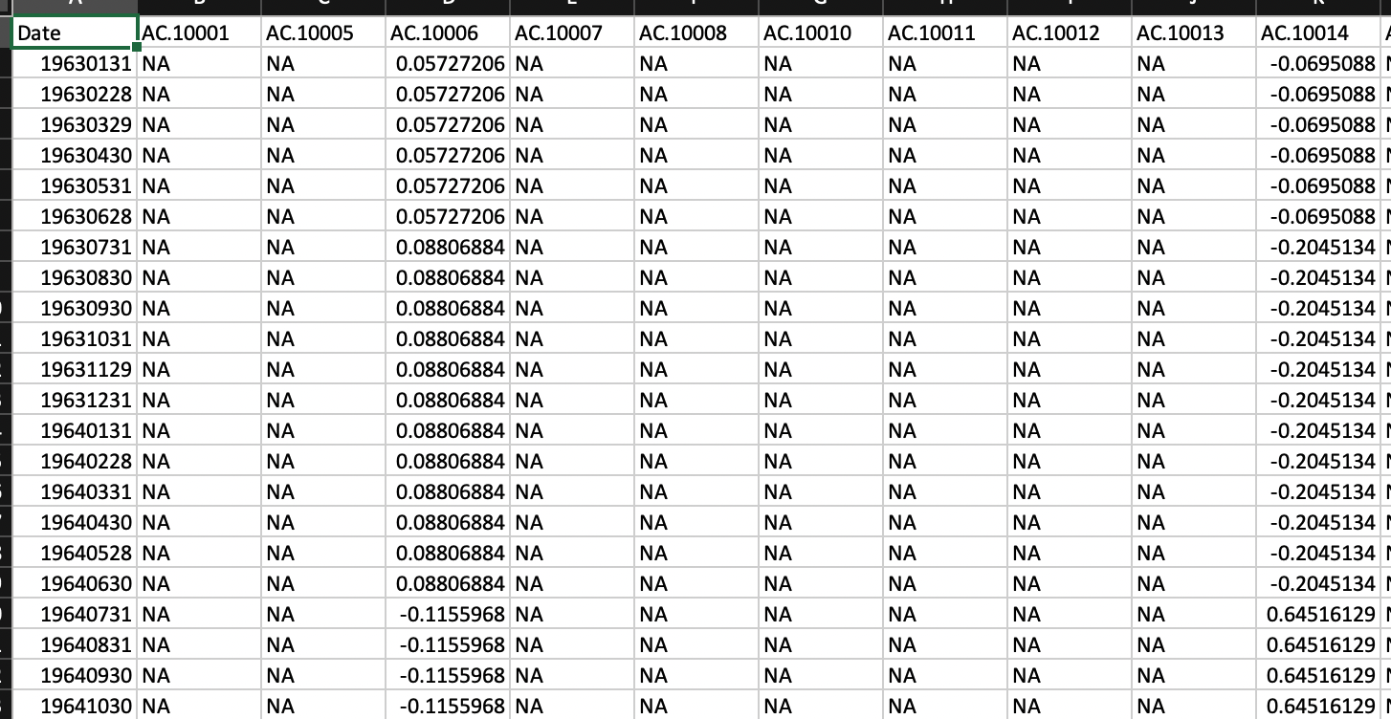

Outputs:
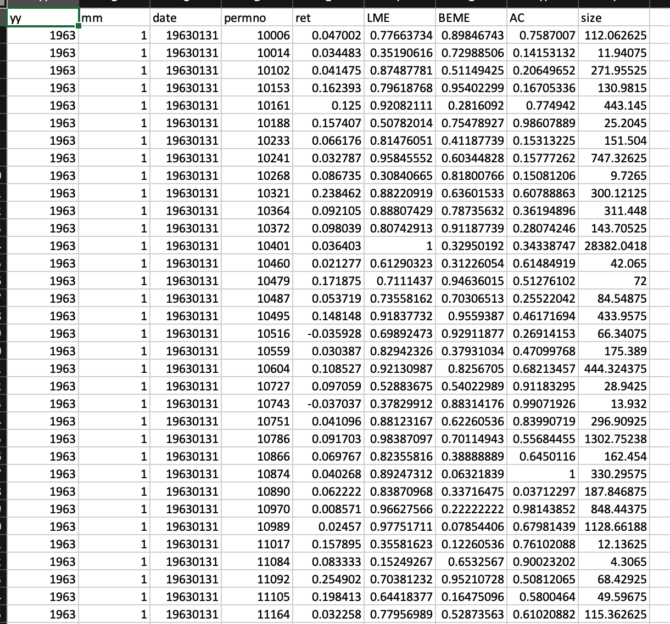

Step 2: We then use the outputs from the previous step to generate tree portfolios. We need value-weighted returns at all levels of the trees, and the characteristics min/max (for plotting portfolio boundary in heatmaps and other statistics purpose).

When tested on a MacBook Pro (2020, M1 CPU, 8 cores, 16GB RAM), it takes about 1 hour to run the code sequentially with single-core processing, and takes about 20 mins to do it in parallel, using 6 cores (that is, using paralleln=6)

Function:
create_tree_portfolio(y_min,y_max,tree_depth,feats_list,feat1,feat2,input_path,output_path,runparallel,pralleln)

Outputs:
Tree portfolio value-weighted returns for one single tree
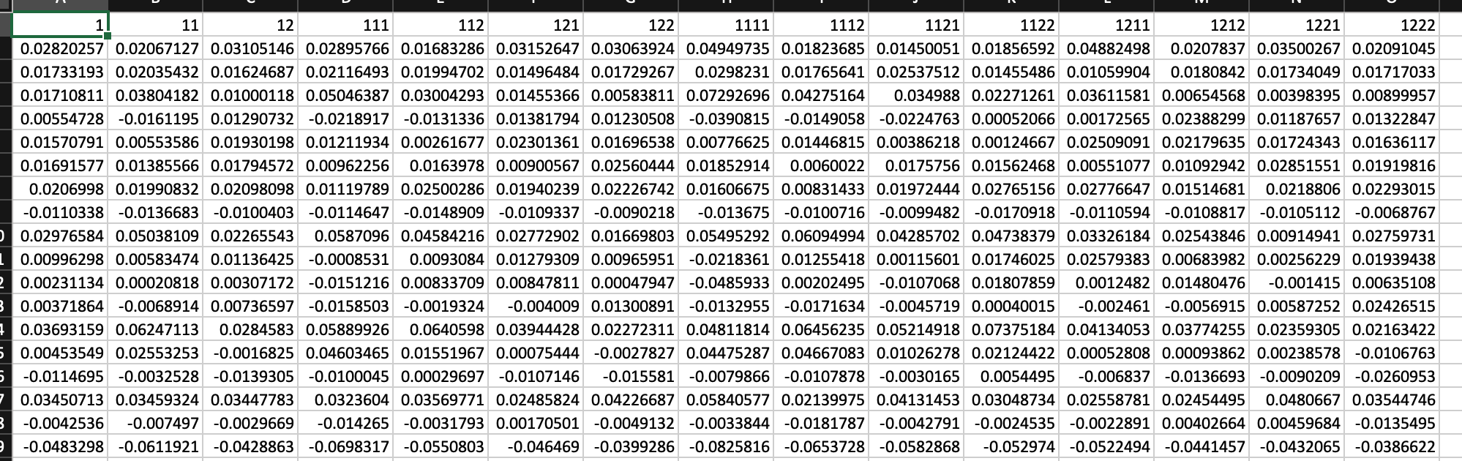

Tree portfolio characteristic min/max for one tree (will have 2*3 such files for one single tree)
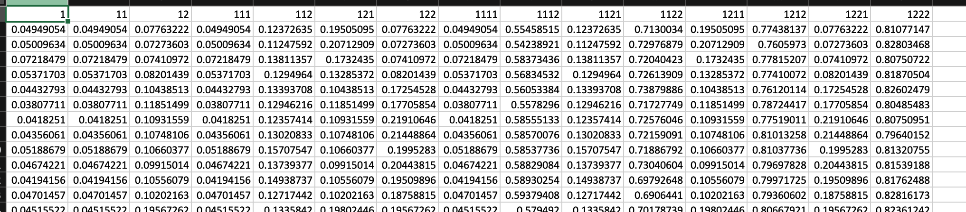

Step 3: in this step we combine the tree portfolios from all trees into one file and calculate the excess return over risk free rates. We also need to remove the duplicated upper-level tree portfolios.

Function:
combinetrees(feats_list, feat1, feat2, tree_depth, factor_path, tree_sort_path_base)

Outputs: value-weighted returns for all trees combined, similar format for characteristics min/max
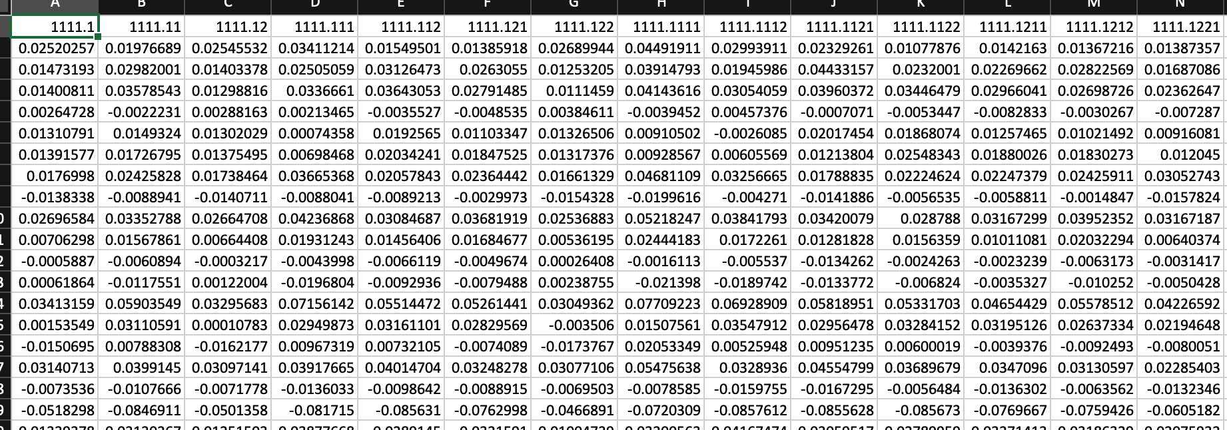

Step 4: remove the columns where the level 4 portfolios are sorted solely based on one characteristic.

Function:
filterTreePorts(feats_list, feat1,feat2,tree_portfolio_path)

AP-Pruning
The main file to run is AP-Pruning.R where the tree portfolios are imported and normalized according to the depth of each portfolio. Then the helper functions are called to: 1) split data into train/valid/test period 2) transform the optimization into regression according to the appendix 3) use lars for the regression 4) calculate sparsity and the Sharpe ratios in each period.

For each pair of hyperparameter lambda0 and lambda2, we have outputs as below where the first three columns are SRs, 4th column is sparsity, and the remaining columns are the weights.
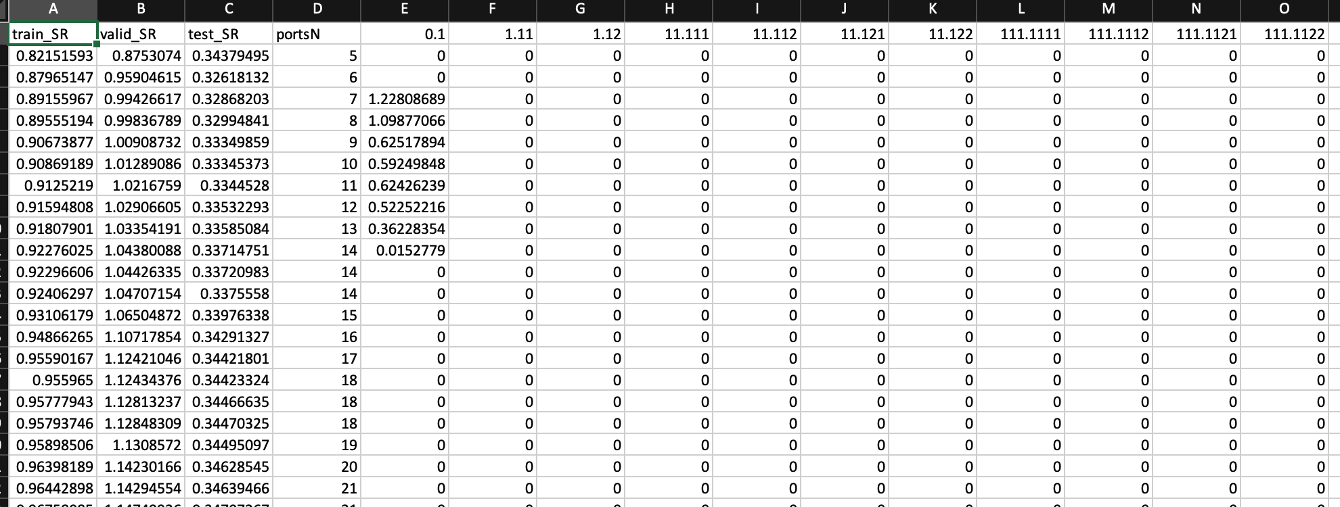

In the paper we used a much larger grid search on the following parameter, but doing the full parameter search can take hours to finish:
lambda0 = seq(0, 0.9, 0.05)
lambda2 = 0.1^seq(5, 8, 0.25)

For demonstration, we use lambda0=0.15 and lambda2=0.1^8 in the simplified sample code main file, which takes 1 mins calculation time when tested on the M1 Macbook Pro with 6 cores.

